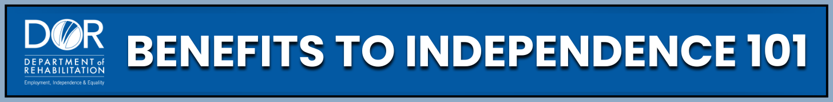
NEW ONLINE COURSE
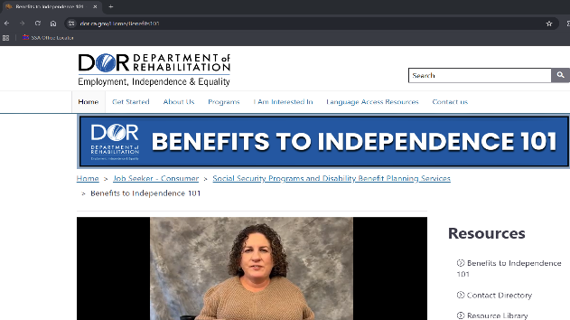

A self-paced course designed for people receiving Social Security disability benefits. Check it out, now available on the Department of Rehabilitation website:
www.dor.ca.gov/home/benefits101
