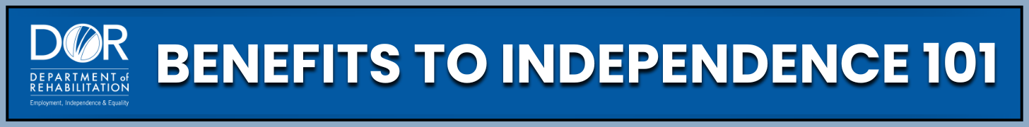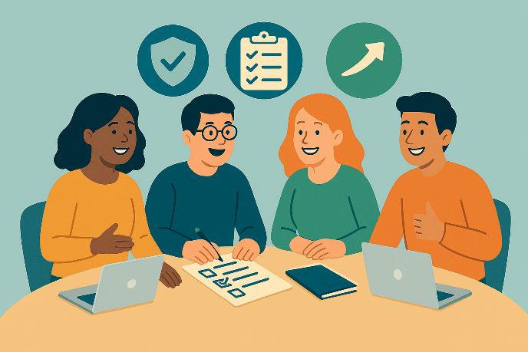
Ready to work?
Keep your benefits.
Gain independence.
A self paced course for Supplemental Security Income (SSI) and Social Security Disability Insurance (SSDI) recipients to understand benefits, explore work, and achieve financial independence.
What you will learn:
- How employment affects SSI/SSDI
- Safety nets to keep cash and medical benefits while working
- Where to get extra support
Start the course today at www.dor.ca.gov/home/benefits101


