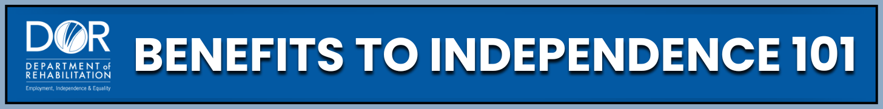
ONLINE COURSE

Think working means losing benefits?
Think again.
- Understand myths vs. facts about Social Security disability benefits (SSI/SSDI)
- Explore work incentives
- Keep health coverage while working
- Build confidence and financial independence
www.dor.ca.gov/home/benefits101

