ONLINE COURSE  Social Security Disability Made Simple    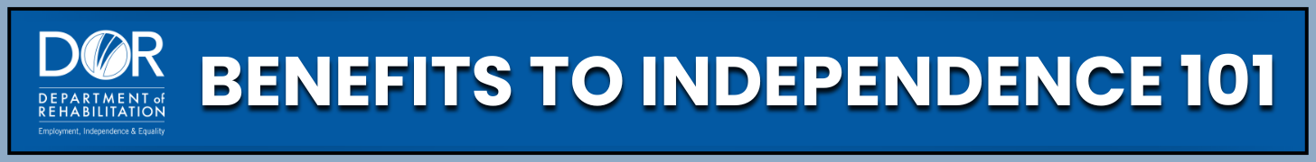  www.dor.ca.gov/home/benefits101 | ONLINE COURSE  Social Security Disability Made Simple  www.dor.ca.gov/home/benefits101
ONLINE COURSE  Social Security Disability Made Simple  www.dor.ca.gov/home/benefits101 | ONLINE COURSE  Social Security Disability Made Simple  www.dor.ca.gov/home/benefits101
ONLINE COURSE  Social Security Disability Made Simple  www.dor.ca.gov/home/benefits101 | ONLINE COURSE  Social Security Disability Made Simple  www.dor.ca.gov/home/benefits101
ONLINE COURSE  Social Security Disability Made Simple  www.dor.ca.gov/home/benefits101 | ONLINE COURSE  Social Security Disability Made Simple  www.dor.ca.gov/home/benefits101

