Online Course  BASICS, PLAIN AND SIMPLE  Receive Social Security disability benefits? Want to work but have doubts or fear? Take this course and fear not!  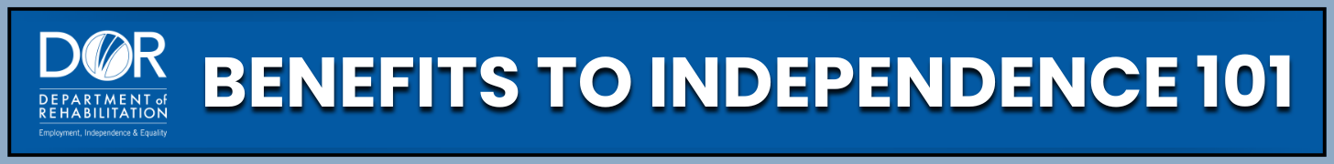    www.dor.ca.gov/home/benefits101 | Online Course  BASICS, PLAIN AND SIMPLE  Receive Social Security disability benefits? Want to work but have doubts or fear? Take this course and fear not!  www.dor.ca.gov/home/benefits101
Online Course  BASICS, PLAIN AND SIMPLE  Receive Social Security disability benefits? Want to work but have doubts or fear? Take this course and fear not!  www.dor.ca.gov/home/benefits101 | Online Course  BASICS, PLAIN AND SIMPLE  Receive Social Security disability benefits? Want to work but have doubts or fear? Take this course and fear not!  www.dor.ca.gov/home/benefits101
Online Course  BASICS, PLAIN AND SIMPLE  Receive Social Security disability benefits? Want to work but have doubts or fear? Take this course and fear not!  www.dor.ca.gov/home/benefits101 | Online Course  BASICS, PLAIN AND SIMPLE  Receive Social Security disability benefits? Want to work but have doubts or fear? Take this course and fear not!  www.dor.ca.gov/home/benefits101
Online Course  BASICS, PLAIN AND SIMPLE  Receive Social Security disability benefits? Want to work but have doubts or fear? Take this course and fear not!  www.dor.ca.gov/home/benefits101 | Online Course  BASICS, PLAIN AND SIMPLE  Receive Social Security disability benefits? Want to work but have doubts or fear? Take this course and fear not!  www.dor.ca.gov/home/benefits101

