California Traumatic Brain Injury Program State Plan 2025

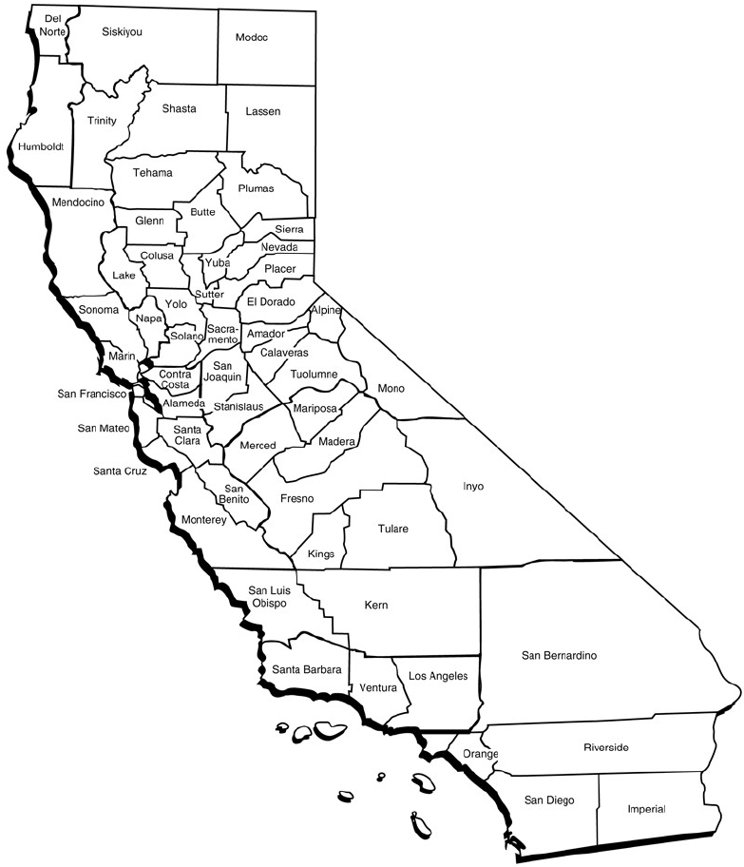

California’s TBI Advisory Board
Mission Statement
The California Traumatic Brain Injury (TBI) Advisory Board advises state leadership on policies, programs, and services impacting people with TBI, their families, and support systems. The board has four active committees working toward their respective missions and the goals outlined in this document.

The Brain Injury Survivor Committee will ensure the State of California creates person-centered, culturally competent programs that are for TBI survivors, with input from all brain injury survivors, to meet the needs of TBI survivors, their families, and caregivers.

The mission of the Data Analytics Committee is to identify, collect, and analyze data on survivors of TBI in California to inform public awareness, policy, and service provision.

The mission of the Education and Public Outreach Committee is to identify appropriate educational resources and disseminate them in an accessible manner for TBI survivors, caregivers, organizations, and the public.

The Public Policy and Funding Committee expands systems to support people with Traumatic Brain Injury, their family members, caregivers, and community organizations through resources, funding, and policy initiatives.

Executive Summary
The Centers for Disease Control (CDC) defines a Traumatic Brain Injury (TBI) as a disruption in the normal function of the brain that can be caused by a bump, blow, or jolt to the head, or penetrating head injury. The California Traumatic Brain Injury State Plan is a living document that provides an actionable, measurable, blueprint to leverage partnerships and funding to meet the needs of all Californians affected by TBI. The following objectives will be addressed by September 30th, 2026.

Objective 1: Resources and Education
- Utilization of the statewide resource list, and refinement of its presentation and formatting to improve readability and simplicity.
- Finalize the TBI 101 presentation and implement its use in public and professional education.
- Publish a professional article summarizing the results of the California State Survey Panel (CalSpeaks), which collected data on the prevalence of physical, cognitive, emotional, and behavioral symptoms most associated with brain injury in a randomized and representative sample of Californians. The CalSpeaks results estimate the impact of TBI in California and contextualize the findings of the HARC needs assessment, which suggests potential areas for improving support services.
- Share information on best practices in Brain Injury Resource Facilitation with TBI sites.

Objective 2: Sustainable Funding
- Continued exploration of funding opportunities for the Statewide TBI Program including Advisory Board work, DOR program oversight, and TBI Site service provision.
- Collaborate with the Department of Health Care Services on access to Medicaid Waivers that can support TBI survivors.

Objective 3: Statewide Impact
- Program Structure
- Develop a second Needs Assessment that focuses on service delivery of the TBI Sites and the experience of TBI survivors, families and caregivers engaged in state funded TBI programs.
- Recommend to DOR changing the program structure from periodic re-bidding to a certification model for program contracts.
- Develop partnerships with state agencies and organizations that also support TBI survivors such as the Master Plan on Aging, Master Plan on Developmental Services, and the California Interagency Council on Homelessness.
- Consideration of screening tools and connecting people to Enhanced Information and Assistance with partner organizations with a high percentage of TBI survivors. Target populations could include interpersonal violence, homelessness, justice involved, and behavioral health.

Objective 4: Employment and Vocational Rehabilitation:
Increase the participation rate of people with TBI in employment.
- Discuss with TBI survivors their experience with vocational rehabilitation.
- Perform an initial review of vocational rehabilitation staff resources and available training regarding brain injury.
- Request data from DOR on TBI consumers in vocational rehabilitation (employment rate, closure status, cost per plan).

Supporting Documents
Available upon request

- 2022 TBI State Plan
- TBI Program General Information and History
- TBI Data
- CA TBI Advisory Board Work 2019-2024
- HARC Needs Assessment Report (2022)
- Cal SPEAKS (2022)

ACKNOWLEDGEMENTS

TBI Advisory Board
Theresa Woo, Chair  TBI Advisory Board  Education and Public Outreach Committee  Randy Dinning  TBI Advisory Board  Data Analytics Committee  Education and Public Outreach Committee  Dr. Vivian Harvey, MA, PhD  TBI Advisory Board  Education and Public Outreach Committee  Todd Higgins  TBI Advisory Board  Data Analytics Committee  Brain Injury Survivor Committee  Dr. Daniel Ignacio, PhD, MS, MA, PSY, LMFT, CBIS  TBI Advisory Board  Data Analytics Committee  Ryan Johnson  TBI Advisory Board  Data Analytics Committee  Michael Roscoe  TBI Advisory Board  Public Policy and Funding Committee  Brain Injury Survivor Committee  Esther Stauffer  TBI Advisory Board  Data Analytics Committee | Dr. Katie Shinoda, PT, DPT, MSCS, Vice Chair  TBI Advisory Board  Data Analytics Committee  Public Policy and Funding Committee  Dan Clark  TBI Advisory Board  Public Policy and Funding Committee  Heidi Frye  TBI Advisory Board  Education and Public Outreach Committee  Brain Injury Survivor Committee  Dr. Henry Huie, MD  TBI Advisory Board  Education and Public Outreach Committee  Erin Johnson  TBI Advisory Board  Public Policy and Funding Committee  Brain Injury Survivor Committee  Vincent Martinez  TBI Advisory Board  Education and Public Outreach Committee  Kristie Warren  TBI Advisory Board  Public Policy and Funding Committee  Brain Injury Survivor Committee

California Department of Rehabilitation
Kim Rutledge, Director  California Department of Rehabilitation  Ex-Officio Member | Sarah Harris, Chief  Independent Living and Assistive Technology Section  Ex-Officio Member, Chief TBI Program
LaCandice Ochoa, Deputy Director Independent Living and Community Access Division | Tanya Thee, Grant Administrator  Independent Living and Assistive Technology Section, TBI Program
Peter Saechao, TBI Board Liaison
Independent Living and Assistive Technology Section, TBI Program

