California Traumatic Brain Injury Program State Plan 2022

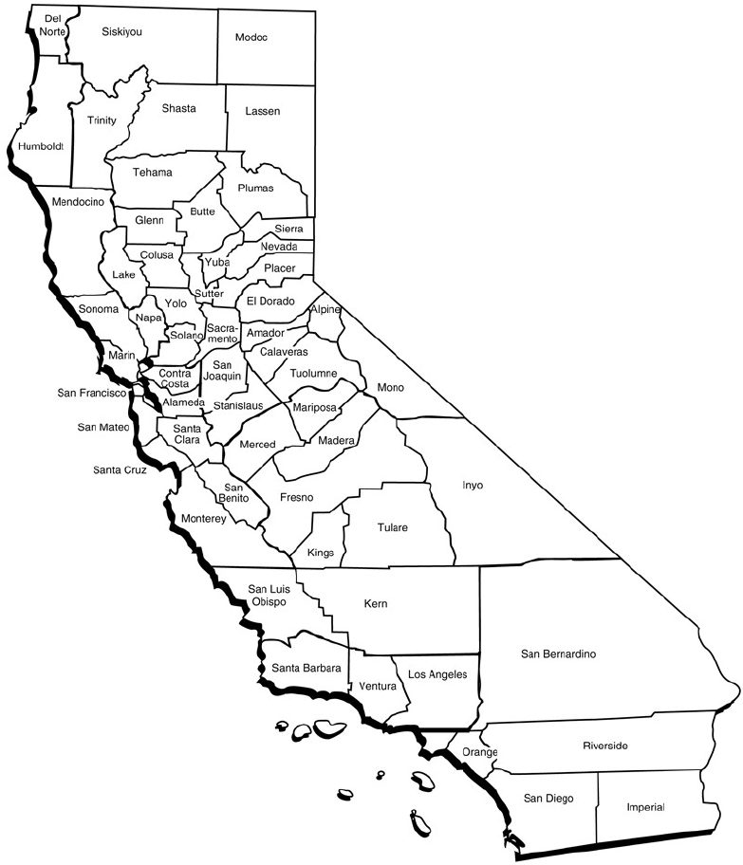

Table of Contents
Acronyms 1
Executive Summary 2
Who We Are 2
What We Know 2
What We Are Currently Doing 3
Where We Will Go Next 3
California’s TBI Program 4
Background 4
TBI Program Design 4
State-Funded Program 4
Federally Funded Program 5
Contact Information 6
Introduction to Brain Injury 7
Definitions of Brain Injury 7
Common Causes of TBI 7
Common Causes of nTBI 8
TBI in California and the Silent Epidemic 8
California’s TBI Advisory Board 13
Mission Statement 13
History 13
Registry Committee 15
Mission Statement 15
Goals and Objectives 15
Purpose 15
Characteristics and Functions of California’s TBI Registry 16
Data Collection 16
Data Findings 17
Linkage to services 22
Future Areas of Focus 24
Needs Assessment Committee 25
Mission Statement 25
Goals and Objectives 25
Summary of Tasks Completed 25
TBI California Community Health Assessment Executive Summary 25
Sustainable Funding Committee 30
Mission Statement 30
Funding History 30
Goals and Objectives 30
Purpose 31
Areas of Interest 34
Future Areas to Explore: 34
Brain Injury Survivor Committee 36
Mission Statement 36
Goals and Objectives 36
Purpose 37
Reasons for Needs Not Being Met 39
How to Apply 40
California’s Focus 41
2021 through 2026 TBI State Partnership Program Goals 41
Objectives 41
Anticipated Outcomes 41
Expected Products 42
Objective 1: Brain Injury Survivor Committee 42
Objective 2: Resources and Education 43
Objective 3: Sustainable Funding 43
Objective 4: Statewide Impact 44
Special Target Populations 44
Domestic Violence 44
Homeless Population 45
Future Areas of Focus 46
TBI and Incarceration 46
Examination of Helmet Laws 47
Military Service Members and Veterans with TBI 48
Appendix I 51
Needs Assessment Survey Questions 51
Appendix II 54
Acknowledgements 54
TBI Advisory Board 54
California Department of Rehabilitation 55
Former Board Members 55

Acronyms
ABI Acquired Brain Injury
ACL Administration for Community Living
BI Brain Injury
CA California
CalAIM California Advancing and Innovating Medi-Cal
CDC Center of Disease Control
CIQ Community Integration Questionnaire
CVC California vehicle code
DMH Department of Mental Health
DOR Department of Rehabilitation
EMS Emergency Medical Services
HARC Health Assessment and Research for Communities
HRSA Health Resources and Services Administration
LEMSA Local Emergency Medical Service Agencies
MPAI-4 Mayo-Portland Adaptability Inventory
nTBI Non-Traumatic Brain Injury
PTSD Post-Traumatic Stress Disorder
SB Senate Bill
SD Standard Deviation
TBI Traumatic Brain Injury
VA Veterans Affairs

Executive Summary
The California Traumatic Brain Injury (TBI) Program State Plan is a living document that provides an actionable, measurable, blueprint to leverage partnerships and funding to meet the needs of all Californians affected by TBI. This State Plan lays out a brief history of the TBI Program and the work of the committees to guide the Program towards its goals.

Who We Are
The California Department of Rehabilitation’s (DOR) TBI Program acts as the umbrella entity to the TBI Advisory Board (Board), its committees, and TBI Sites, which provide direct services to individuals living with TBI.
The current Board composition includes the State Plan Committee, the Registry Committee, the Needs Assessment Committee, the Sustainable Funding Committee, and the Brain Injury Survivor Committee.

What We Know
The Center for Disease Control (CDC) defines a TBI as a disruption in the normal function of the brain that can be caused by a bump, blow, or jolt to the head, or penetrating head injury. This happens to about 1.7 million Americans each year. 53,000 deaths, 235,000 trips to the hospital, and 1.1 million trips to the ER each year are because of TBI.
In May 2022, the Traumatic Brain Injury California Community Health Needs Assessment (TBI Needs Assessment) was completed in partnership with the Health Assessment and Research for Communities (HARC).
The needs expressed by individuals with TBI, caregivers, and professionals are wide in scope and complex in nature, but these needs can be simply summarized: individuals with TBI need ways to reintegrate themselves into their communities in addition to necessities like health care and income. Caregivers need social support and respite care, and professionals emphasize the need for mental health and community-based services that they can offer to patients and their families. Most of all, survivors, caregivers, and practitioners need help finding TBI resources.

What We Are Currently Doing
With these needs in mind, the TBI Program has created this State Plan with the following goals:
- Establish and engage a TBI Advisory Board with collective knowledge to work with DOR to identify policies, practices, and an applicable and stable funding source which could include a private public partnership.
- Improve resource facilitation and coordination for people with TBI and their caregivers by creating statewide TBI needs assessment surveys that provide data on gaps in services and supports.
- Identify funding mechanisms to support locally based services and outline ideas for funding mechanisms for expansion of services and usable resources for longer-term funding.
- Create a statewide TBI registry with appropriate interagency agreements between state departments.
- Create a Survivor Committee comprised of survivors of all brain injuries to establish and promote plain language materials, education, and training about TBI for survivors and the and public, medical, rehabilitation, and community support professionals about the needs of TBI survivors and their families.
- Provide culturally competent resources to entities that intersect with homeless and domestic violence populations to expand systems to support early identification, interventions, resource facilitation, and coordination for people with TBI.
- Utilize data to inform policy, education, and training leading to expanded services and supports through a statewide network for TBI Survivors.
- Ensure all resources, products, and information are readily available and made public through the DOR website.

Where We Will Go Next
Our focus is always on ways in which we can provide information about prevention, self-identification, resources, and education. Our goals will continue to evolve as we learn more about the needs of Californians with TBI, but we strive to serve those who need us the most: the underserved and unserved populations in California, rural areas, ethnic minorities, homeless individuals who are disproportionately impacted by TBI, survivors of intimate partner violence, veterans, and TBI survivors incarcerated due to lack of appropriate services and supports for recovery.

California’s TBI Program

Background
The California Department of Rehabilitation works in partnership with consumers and other stakeholders to provide services and advocacy resulting in employment, independent living, and equality for individuals with disabilities.
California’s TBI Program is located within the Independent Living and Community Access Division. This Division, its sections, and programs are dedicated to transforming the lives of people with disabilities through education, advocacy, and partnerships to help build a world without barriers for people with disabilities.

TBI Program Design
California’s TBI Program is dually funded; the state-funded program provides grants to non-profit organizations that directly serve individuals living with TBI, and a federally funded program, through which this State Plan has been created, to strengthen the system of services and supports to maximize the independence, well-being, and health of people with brain injuries, their caregivers, and families.

State-Funded Program
For more than 20 years, the TBI Program sites have provided unique pre-vocational and community reintegration services that help bridge the gap for post-acute services needed by individuals with TBI who are not eligible for nursing facilities, in-patient care programs, or DOR’s Vocational Rehabilitation program. In addition, the TBI sites provide leadership to establish new services and partnerships for TBI survivors in their communities.
The TBI Program is authorized to provide direct services to adult Californians living with TBI through six state-funded community-based organizations. The sites are determined through a competitive bidding process and the TBI Program Sites are statutorily required to provide core services designed to increase independent living skills to maximize the ability of individuals with TBI to live independently in a community of their choice.
The TBI core services include community reintegration, supported living, vocational supportive services, professional and public education, and information and referral. These core services are also preventative as many TBI survivors who do not have access to a network of services and supports are at a higher risk of chronic homelessness, institutionalization, imprisonment, and placement in skilled nursing facilities due to an inability to perform activities of daily living and impaired emotional regulation.
From April 1, 2022, through March 31, 2024, the TBI Program has been authorized to provide additional funding to the TBI Program Sites and fund up to six new sites utilizing Home and Community-Based Services (HCBS) Spending Plan funding through the American Rescue Plan Act. The HCBS funding will expand the capacity of the six TBI Program Sites and add six new TBI HCBS Program Sites to provide services in unserved and underserved areas.

Federally Funded Program
In 2018, DOR was awarded a TBI State Partnership Program grant by the U.S. Department of Health and Human Services, Administration for Community Living (ACL). The goal of this project was to establish a statewide network of resources, services, and supports that foster independence and improve the quality of life for persons with traumatic brain injury.
Under the 2018 grant, the TBI Program identified four areas for program expansion and outlined the outcomes and products it intended to create through the term of the grant.
The goals and intended outcomes were to create an advisory body to support the program, develop a statewide needs assessment, create a state plan to identify mechanisms for expansion of services and funding, and begin the process of developing and designing the framework for of a TBI registry in California. The work described herein is a result of the framework built between 2018 and 2022 by our TBI Advisory Board, staff, and stakeholders.
In 2021, DOR’s TBI Program was awarded another TBI State Partnership Program grant from ACL to continue and expand the work of the TBI Advisory Board, Committees, and Program staff. For detailed information about the current work under the 2021 TBI State Partnership Program grant, please see California’s Focus.

Contact Information
Website: https://dor.ca.gov/Home/TraumaticBrainInjury
Email: TBI@dor.ca.gov
Voice: (916) 558-5780

Introduction to Brain Injury

Definitions of Brain Injury
An acquired brain injury (ABI) is an injury to the brain that is not hereditary, congenital, degenerative, or induced by birth trauma. This type of brain injury is one that has occurred after birth and results in a change to the brain’s activity, affecting the physical integrity, metabolic activity, or functional ability of nerve cells in the brain. Brain injuries that occur from birth, or just before or after birth, are called congenital brain injury.
An ABI is the umbrella term for brain injuries after birth. There are two types of ABI: traumatic and non-traumatic.
Traumatic Brain Injury (TBI) is defined as an alteration in brain function, or other evidence of brain pathology caused by an external force such as a jolt, blow, or penetration to the head. Most non-fatal TBI are caused by falls, motor vehicle accidents, or being struck by a person or an object, such as in sports.
Non-Traumatic Brain Injury (nTBI) is defined as an injury to the brain that is caused by internal factors, such as lack of oxygen, exposure to toxins, pressure from a tumor, etc.
TBI can be classified as mild, moderate, or severe based on the individual’s clinical presentation, and the effects of TBI can be temporary or permanent. TBI affect different areas of the brain in diverse ways, meaning that no two TBI are alike. According to hospital discharge records in California for 2018 and 2019, more than 50 percent of moderate to severe TBI patients did not go directly home. Thus, it is necessary and vital to have a wide range of services to meet individual and community needs and ensure that people have access to these services.

Common Causes of TBI
- Falls, trips, and slips lead to half of TBI hospitalizations, with the risk increasing for older adults.
- Assault, including but not limited to community altercations, firearm violence, elder abuse, intimate partner violence, and child abuse, which can affect brain development in children and is often missed by professionals.
- Motor vehicle accidents, which are a leading cause of death in the United States.
- Sports concussions.

Common Causes of nTBI
- Lack of oxygen to the brain which can occur in cases of near drowning, intimate partner violence, electrical injury, or choking.
- Blood infections due to untreated infections in the lungs, skin, urinary tract, abdomen, sinuses, or teeth
- Bacterial infections like meningitis, endocarditis, and myelitis.
- Degenerative brain conditions such as Parkinson's disease, Alzheimer's disease, or some other form of dementia.
- Alcohol and drug use.
- Tumors, seizures, and surgery to remove tumors or stop seizures.
- Stroke, either through a blocked artery (80 percent of strokes) or bleeding due to an aneurysm, which is when an artery may have a damaged or weak spot from birth.

TBI in California and the Silent Epidemic
Each year, thousands of emergency visits, hospitalizations, and deaths occur in California due to TBI. TBI disables six times more people each year than spinal cord injuries, multiple sclerosis, HIV/AIDS, and breast cancer combined. While brain injury can cause physical challenges, the cognitive, emotional, behavioral, and social challenges caused by brain injury are often the most disabling and they are also exceedingly difficult for the public to understand. This is one of the primary reasons brain injuries are referred to as the “Silent Epidemic.”
In addition to injury-related challenges, individuals and families experience difficulties and stresses associated with navigating, accessing, receiving, and paying for services. Adjustment to disability after brain injury is extremely difficult. Without appropriate care management, rehabilitation and long-term services and supports, survivors and family members frequently experience unemployment, social isolation, re-occurring hospitalizations, institutionalization, and homelessness.
TBI is a growing public health concern. Along with spinal cord injury, TBI is the greatest contributor to death and disability globally, among all trauma-related injuries. According to the World Health Organization (WHO), in 2020 TBI became the main cause of death and disability in the world and affects over 10 million people annually. Within the United States, the CDC estimated that TBI accounted for 2.87 million emergency department visits, hospitalizations, and deaths in 2014, and 5.3 million Americans live with disabilities as a result of TBI.^{2,4} In 2014, the CDC also estimated that TBI took the lives of an average of 155 people each day in the U.S.⁵
Of those that survive a TBI, over 50 percent are moderately to severely disabled at five years post-injury, and over 85 percent experienced a psychiatric disorder within the first-year post-injury. ^{2,4}
Individuals with TBI can experience a variety of different symptoms depending on the type of injury, the severity, and the area of the brain.
In the 2022 TBI Needs Assessment, individuals with TBI were asked about the most challenging symptoms they experience due to their TBI. Most participants responded that they struggled with memory, cognitive fatigue, feeling physically tired or fatigued, difficulty maintaining concentration, and mental health challenges.
The following table indicates the symptoms identified, the percentage of participants who indicate they have difficulty with that symptom, and the number of participants who selected that option.
SYMPTOM | PERCENTAGE | “n”
Difficulty with memory | 80.7% | 109
Difficulty thinking or being mentally overwhelmed (Cognitive fatigue) | 77.0% | 104
Feeling physically tired or fatigued | 73.3% | 99
Difficulty maintaining concentration | 71.9% | 97
Mental health (depression, anxiety, etc.) | 68.1% | 92
Difficulty solving problems | 62.2% | 84
Difficulty with balance or feeling dizzy | 61.5% | 83
Difficulty controlling emotions | 60.0% | 81
Less social | 58.5% | 79
Discomfort in public/crowds | 57.8% | 78
Difficulty sleeping | 57.0% | 77
Sensitivity to noise | 54.8% | 74
Difficulty with daily living tasks | 54.1% | 73
Headaches | 50.4% | 68
Sensitivity to light | 47.4% | 64
Difficulty walking | 41.5% | 56
Difficulty speaking | 40.7% | 55
Poor eyesight | 34.8% | 47
Difficulty with sexual function | 28.1% | 38
Difficulty visualizing images in your mind | 28.1% | 38
Other | 25.2% | 34
Hearing loss | 17.0% | 23
Experiencing seizures | 17.0% | 23
Total | - | 135
One quarter of participants marked “Other,” which included chronic or physical pain, having no taste or smell, ringing ears, autonomic dysfunction, proprioception impairment, aphasia, and apraxia.
“Most people don’t know you have [a TBI]. Most people treat you like you don’t have one, and you are truly suffering in silence.”
- Individual with TBI
One theme that appeared in the interviews was the injury’s invisibility. TBI can be outwardly evident with, for example, speech impairments or signs of physical trauma. However, a TBI survivor might be able to speak “normally” and present as “unimpaired,” but still live with the symptoms listed above, completely unnoticed by others, but severely disabling to the individual. These invisible symptoms can result in profound social isolation.
TBI has far-reaching implications, with studies demonstrating its close ties with homelessness, incarceration, substance abuse, mental health concerns, domestic violence, and US military service.³ For example, a systematic review of homelessness and TBI revealed that the lifetime prevalence of TBI in the homeless population was over 53 percent, with between 51 percent and 92 percent sustaining their head injury prior to the onset of homelessness.⁷ These consequences of a TBI negatively impact families, communities, and the economy; and they create a significant public health burden across the country, including California.
“I have lost every relationship in my life. There is not anyone that’s still there.”
- Individual with TBI
In the 2022 TBI Needs Assessment interviews, a common theme was the sudden, often devastating loss of close relationships. Among the 25 interviews, there were 15 mentions of losing close relationships, such as spouses, siblings, or best friends. Other relationships, like with caregivers, may also be strained. These effects were sometimes attributed to friends and family not being able to understand the injury and the survivor’s experience (mentioned by 8 of the 25 caregivers). Such changes in relationships could be disorienting and distressing, adding to the challenge of accepting and adapting to the injury.
“A lot of people… can’t see [the injury]… At first, it’s important to them, and then as time goes on, they get tired of it. It’s not that they don’t care it's just that they get desensitized to it. They feel helpless because they don't know what to do. They just start distancing themselves, and I don't blame them.”
- Individual with TBI
Although negative impacts were universally found across interviews, some key informants also spoke of positive impacts. These included new friendships, a sense of solidarity with the TBI community, and a new life perspective. These positive impacts were not due to a lack of struggle or hardship. Rather, these positive impacts were due to the presence of social support, medical care, and economic resources. Some survivors take up new hobbies, some grow closer to their spouse, and others find community with fellow TBI survivors. Such outcomes are a result of accepting one’s injury, embracing a new reality, and having the support necessary to turn devastating hardship into new meaning and connections.
“My goal was to completely let go of who I was, and completely accept who I am now, and be totally open to whatever life I'm meant to have…. It forced me to add more dimensions to my life. I had to exercise. I had to get emotional therapy, physical therapy… I had to eat better. I had to be vulnerable. I had to cry. I had years' worth of crying that apparently needed to come out. I got really into caring for plants and having pets. I learned to play the piano. I made a lot of new connections with people I never would have made.”
- Individual with TBI

California’s TBI Advisory Board
Mission Statement
The California TBI Advisory Board advises state leadership on policies, programs, and services impacting people with TBI, their families, and support systems.

History
California’s initial Advisory Board was created in 1999, as an advisory body to the California Department of Mental Health (DMH). The Advisory Board received two Health Resources and Services Administration (HRSA) Grants. The first grant, in 2002, was a one-year planning grant. The second grant, in 2006, was a three-year TBI Implementation Grant. DMH obtained a fourth year, no-cost extension to allow the Advisory Board to complete the Advancing California’s Traumatic Brain Injury Service System: Next Steps report and to participate in a critical strategic planning session in June 2010 to plan for the future of the Advisory Board.
In 2009, Senate Bill (SB) 398 transferred the California TBI Program from DMH to the California Department of Rehabilitation. However, the state instituted significant government spending cutbacks in 2010 due to the Great Recession, and the Advisory Board was disbanded. Therefore, no funding existed for an Advisory Board between July 2010 and September 2018.
In 2018, DOR’s TBI Program received a grant from ACL and created an Advisory Board to guide the development of the state plan. DOR’s Directorate appointed members to the Advisory Board who were residents of California and reflected the diversity of the state with respect to race, ethnicity, gender, geography, types of disabilities across the age span, and users of types of services that an individual with a disability may receive. At least 51 percent of the Board members (including committee members) must consist of TBI survivors, ensuring a majority representation for the purpose of ensuring that all TBI Advisory Board actions and projects are aligned with the person-centered approach and maintain a focus on individuals with TBI, their families, and their caregivers.
The California TBI Advisory Board is led by its chair and vice chair and currently has five active subcommittees:
- Registry
- Needs Assessment
- State Plan
- Sustainable Funding
- Survivor
The Board meets quarterly, while the committees meet monthly. All meetings are publicly noticed and encourage public stakeholder engagement.
Each committee has worked collaboratively with the Advisory Board and the TBI Program to meet the goals and objectives outlined in the State Plan.

Registry Committee

Mission Statement
The California TBI Registry Committee gathers demographic and clinical data on TBI to guide public policy and improve the quality of life of all Californians affected by TBI.

Goals and Objectives
- Develop a plan for creating a statewide TBI registry, which will assist in improvements to California’s TBI Program.
- Create a workgroup to design and develop a statewide TBI registry with appropriate interagency agreements between state departments.
- Collaborate with TBI State Partnership Program mentor states to explore steps and develop resources to establish a statewide TBI registry to better support California’s population with TBI.

Purpose
In the Children’s Health Act of 2000, Congress authorized the CDC to develop a “National Program of TBI Registries” to collect data about TBI. TBI registries require the following primary functions: data collection; identification (maintaining personal identifiers and contact information); and linking people to services (helping them get information about available services).
California does not have a TBI registry or data system in place; however, it has a variety of data collected through diverse sources based on specific metrics from the needs assessment, trauma registry, California Health and Human Services Agency, and a survey through California’s Center for Data Insights and Innovation. California Health and Human Services Agency collects data from a variety of State departments including the California Department of Aging, California Department of Public Health, Department of Health Care Services, Department of Managed Health Care, and the Department of State Hospitals.
“I think that in the really hyper early days, it's the caregivers who actually need the most support and resources in both learning to anticipate and prepare for what their new universe is going to be, but also dealing with their own trauma around it.”
-Physician specializing in brain injury rehabilitation
California’s TBI Registry is being developed to connect individuals to services by identifying the key policies, resources, and education required to remove the barriers and gaps in services currently in place. A registry itself is a collection of data, or information, about a particular group of individuals who share a common characteristic, which in this case are twofold: 1) they are California residents and 2) they obtained a traumatic brain injury. The ways in which this data is compiled and utilized determines the purpose of the registry; some can be as simple as compiling a list of individuals, while others can be complex systems that provide case coordination.

Characteristics and Functions of California’s TBI Registry
California is developing its registry using a combination of data collection, and identification to create linkage to services.

Data Collection
- California’s 28 Independent Living Centers who serve individuals with disabilities statewide: services received, disability type, age, location, and other data elements.
- California’s Assistive Technology Program: qualitative and quantitative information about the types of assistive technology requested and received by individuals with disabilities throughout California
- California Department of Rehabilitation: services received, disability type, age, location, and other data elements.
- TBI sites: outcomes data, through quarterly collection of the Community Integration Questionnaire (CIQ) and Mayo-Portland Adaptability Inventory (MPAI-4).
- California Emergency Medical Services Authority. The California Trauma Registry accumulates data from the 81 statewide Level 1 Trauma Centers. The Registry Committee worked with the California Trauma Registry to extract TBI-related data for people who presented to those designated Trauma Centers. This data is skewed toward more moderate and severe TBI and does not capture mild TBI survivors who may present to alternate healthcare resources – whereas the vast majority of TBI are mild to moderate.
- The Registry Committee is in the process of conducting a statewide survey with CalSpeaks, an organization based at Sacramento State University, which conducts large state-wide surveys to gather qualitative and quantitative data. The survey will include TBI survivors, caregivers, and medical professionals.

Data Findings
Figure 1
Illustrated is the frequency of TBI-related visits (both CDC Definition and S09: Unspecified) to the Emergency Department, Hospitalizations, and Deaths in California for years 2016 (1), 2017 (2), 2018 (3), 2019 (4), and 2020 (5). Regrettably, up to 30% of the estimated two and a half million emergency department visits that were classified as “unspecified head injury” (ICD 10 code: S09.90; CDC, 2022, p. 57) had sufficient evidence to fit a formal TBI diagnosis (CDC, 2019); therefore, the numbers below reflect the summation of Proposed Definition TBI and 30% of S09: Unspecified Head Injury.
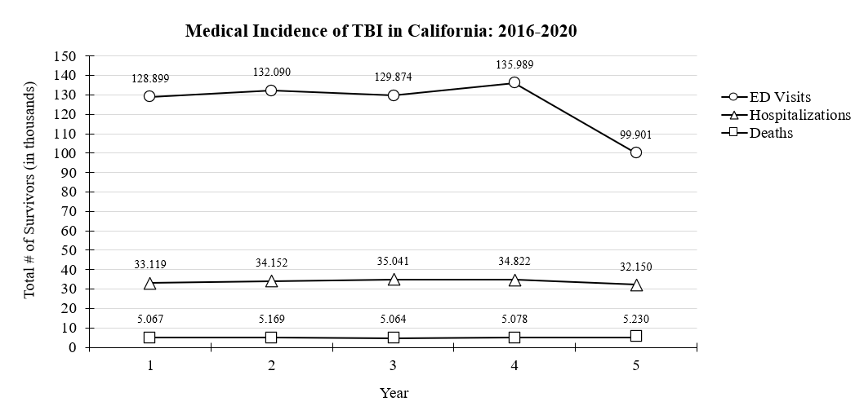
Figure 2
Total number of Emergency Department visits due to TBI from medical centers in California (2016 to 2020) separated by Age Group, Year, & Gender 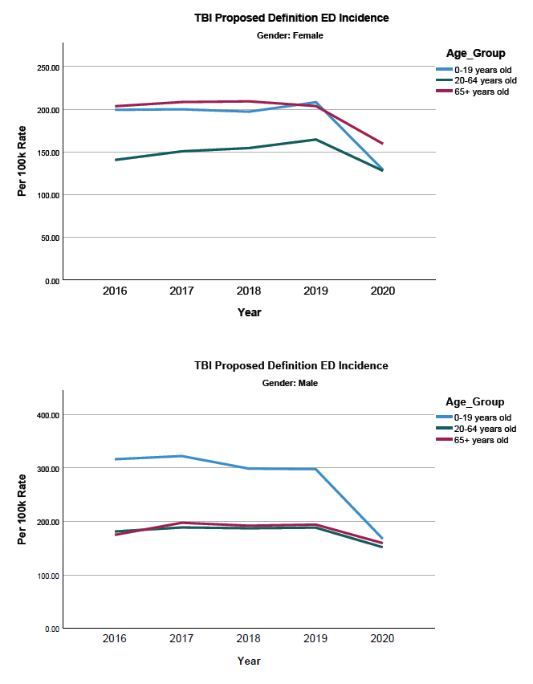

Figure 3
Total number of Emergency Department visits due to “Unspecified Head Injury” from medical centers in California (2016 to 2020) separated by Age Group, Year, & Gender
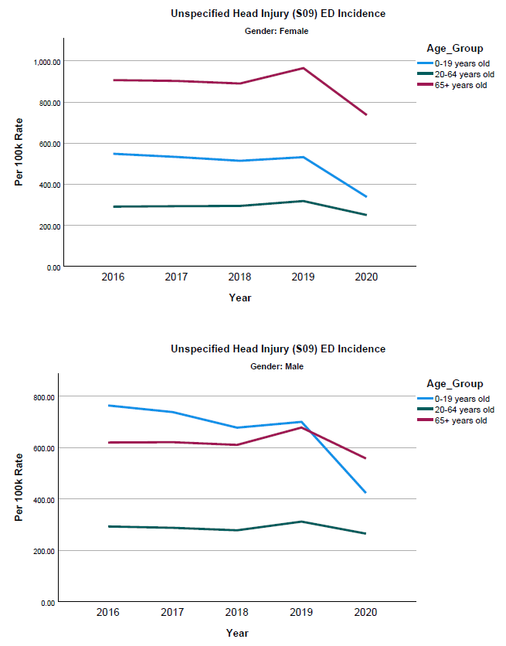
Figure 4
Total number of Hospitalizations due to TBI from medical centers in California (2016 to 2020) separated by Age Group, Year, & Gender

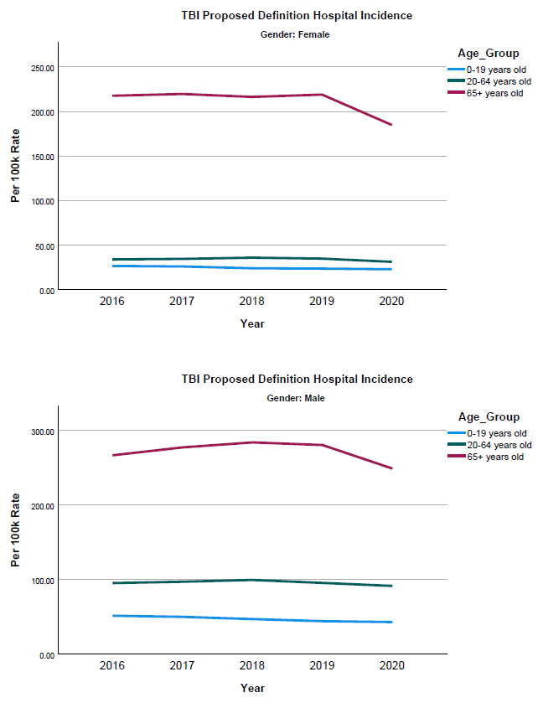
Figure 5
The mortality rate of TBI in California is currently the highest it has been historically.
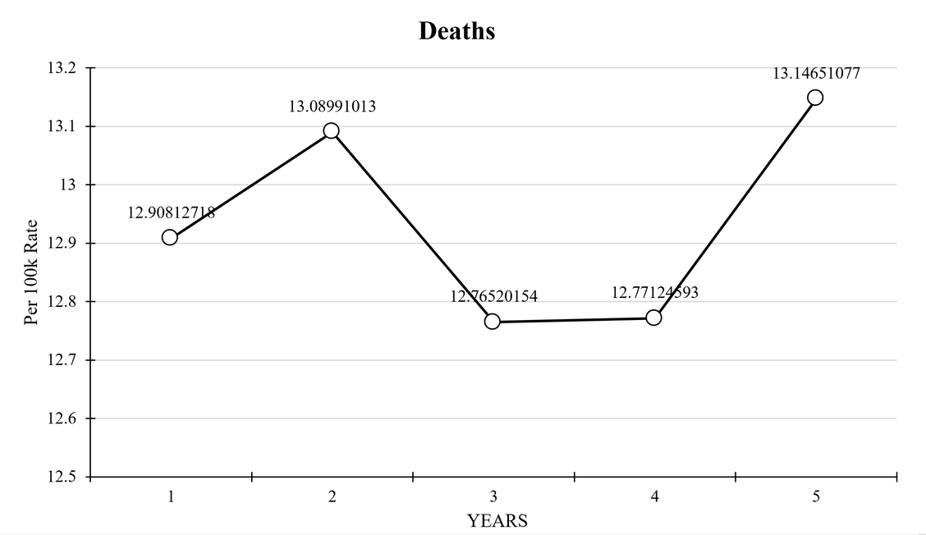
The age groups most seen in the emergency department are individuals 0 to 19 years old, and individuals 65 and older. Those 65 and older were more likely to be admitted to hospitals, and had a significantly higher risk of death than any other age group.
Males of all ages are significantly more likely to be seen in emergency departments for a head injury and have a higher mortality rate than females. However, males seen in the emergency department with a proposed TBI are significantly more likely to receive a correct diagnosis than females. Females have a higher rate of misdiagnosis leading to death, indicating that proper diagnosis in the emergency department may reduce deaths resulting from TBI.
Males are far more likely to receive a diagnosis of a TBI in emergency departments and hospitals, with males 0-19 most likely to be diagnosed in the emergency department and males 65 or older diagnosed in a hospital setting. Conversely, females over the age of 65 are most likely to be diagnosed with an “unspecified head injury” in either setting.
“Obviously, I got a divorce. That impacted my life. The brain recovery was just too much for [my ex-husband] to deal with…. I now have more of a circle [of] the friends that I do have. They're there for me no matter what…. Even though I've lost a lot, I have gained a lot as well. My relationships are closer.”
- Individual with TBI

Linkage to services
Progress and learnings to date include:
- Determining outcomes data for post-acute services – California currently has 12 statewide TBI sites that provide services for TBI survivors and their families. These sites include outpatient rehabilitation centers, community-based services, and independent living centers.
- The TBI Program changed reporting metrics from Community Integration Questionnaire (CIQ) to a more comprehensive Mayo-Portland Adaptability Inventory (MPAI-4).
- Creation of the Brain Injury Survivor Committee to provide insight into specific initiatives related to findings.
- Utilizing the data collected to date, in addition to population data surrounding access to transportation, median income levels, and access to healthcare, it became apparent that there is a tremendous need for TBI services in Central California. Stanislaus, Merced, Madera, Fresno, Kings, Tulare, and Kern County ranked among the bottom 25 percent in all these categories when compared to the rest of California, with no access to State-funded sites and minimal access to other TBI Programs through other funding sources. As a result, the TBI Program will be targeting organizations in this area to serve these counties utilizing funding through its Home and Community-Based Services opportunity with the intention of funding up to three sites to directly serve TBI survivors.
In the 2022 TBI Needs Assessment, professionals were asked about the types of resources and services they believed survivors needed the most. The majority feel that TBI survivors need help finding TBI resources, such as therapists, support groups, etc.; mental health counseling; assistive technologies; help with transportation; financial assistance; and support groups. The following is a list of services and resources that professionals believe are instrumental to a successful recovery for someone living with TBI.
Needs of Individuals with TBI - As Reported by Professionals
CATEGORY | PERCENTAGE | n
Help finding TBI resources, such as therapists, support programs, etc. | 84.9% | 62
Mental health counseling | 84.9% | 62
Assistive technologies | 83.6% | 61
Help with transportation | 83.6% | 61
Financial support | 75.3% | 55
Support groups | 75.3% | 55
Help with finding employment | 74.0% | 54
Education on what TBI is and what to expect | 72.6% | 53
Help accessing community events/services/activities | 72.6% | 53
Help with activities of daily living (for example, going shopping or doing chores at home, etc.) | 65.8% | 48
Help returning to pre-injury employment | 64.4% | 47
Adult day programs | 63.0% | 46
Medical treatment and services | 61.6% | 45
Housing assistance | 58.9% | 43
Help with developing and maintaining friendships | 50.7% | 37
Help with medication management | 50.7% | 37
Food assistance | 47.9% | 35
Educational materials in Spanish | 43.8% | 32
Home modifications | 43.8% | 32
Legal assistance | 43.8% | 32
Substance use counseling | 43.8% | 32
Educational materials in languages other than Spanish or English | 34.2% | 25
Sexuality counseling | 28.8% | 21
Help with dating | 27.4% | 20
Total |  | 73

Future Areas of Focus
- Report on and publish findings on the impact of TBI in California.
- Advocate for state legislation and funding to establish and maintain a central ongoing registry for TBI data.
- Use registry data to increase access to support resources and services.
- Use registry data to guide public policy regarding TBI and services.

Needs Assessment Committee
Mission Statement
The Needs Assessment Committee is committed to identifying a needs assessment tool to provide a voice for individuals with TBI, their families, and professionals in California to identify their needs for services.

Goals and Objectives
To create a person-centered needs assessment tool that will identify the appropriate services needed by the individual to achieve their stated goals.
Summary of Tasks Completed
In the creation of California’s needs assessment, the Needs Assessment Committee reviewed the needs assessment reports from partner states to determine domains focused on, which included public education, awareness, prevention, and research; case management and neuropsychological evaluation; rehabilitation services including, physical, occupational, speech, and cognition; psychological services for survivors and family members; supported, assisted, and future employment.
Following many months of in-depth reviews and discussions, the committee interviewed colleagues from the following states on best practice approaches in conducting needs assessments: Vermont, Idaho, Alaska, North Carolina, Virginia, Minnesota, Nebraska, Tennessee, and Massachusetts. Thereafter, the committee produced a summary report on best practice approaches in needs assessments in Alaska, Idaho, Maryland, and Massachusetts with distribution, outreach to underrepresented communities, survey design, survey funding, and what they would do the next time they conducted a needs assessment.
From this information the Needs Assessment Committee built the framework for California’s first needs assessment, from concept to contractor, to determine the needs of Californians living with TBI.

TBI California Community Health Assessment Executive Summary
The needs assessment focuses on the needs of three groups: individuals with TBI, caregivers who provide care for individuals with TBI, and professionals who serve individuals with TBI. The needs assessment sought to gain a multi-faceted view of TBI needs.
HARC undertook data collection through key informant interviews with TBI survivors, caregivers, and professionals through three online surveys, one for each of the groups. The following summary of the report offers the findings and conclusions from this data collection.
A mixed-methods approach was utilized to understand the unique experience and needs of individuals with TBI, caregivers of individuals with TBI, and professionals providing services to individuals with TBI. Interviews and open-ended questions were the starting point of this needs assessment as to inform specific questions and further areas of exploration in the survey.
HARC created three interview guides with approximately ten questions each, as well as follow-up prompts for the interviewer. Each interview guide (as well as the survey described below) was customized to provide insight into the needs/experiences of the following groups: 1) individuals with TBI, 2) Caregivers of individuals with TBI, and 3) Professionals/ services providers of individuals with TBI. The interview guides and stakeholder surveys were developed in partnership with the Needs Assessment Committee, DOR TBI Program staff, and members of the public.
Interviews were conducted from February 23 to April 21, 2022. Interviews were conducted virtually in 40-to-60-minute sessions. After a substantial portion of interviews were completed, HARC began developing three surveys, one for each target group.
Persons with TBI
A total of 135 individuals with TBI responded to the survey, and 25 individuals with TBI were interviewed. 98.5 percent of TBI participants completed a survey in English with the remaining surveys completed in Spanish. Individuals with TBI who were surveyed tended to be middle aged, with the largest proportion (24.0%) being ages 45-55 years, followed by ages 35-44 (21.6%) and ages 55-65 (20.8%). Over two thirds (67.8%) identified as White, and 16.3 percent identified as Hispanic. Half of the participants self-identified as female, two quarters as male (41.1%), 2.3 percent as transgender, and 6.2 percent as nonbinary (neither female, male, nor transgender). These demographics, compared with statewide TBI hospitalization and emergency department records, show that individuals with TBI who were either White, non-Hispanic, or female were overrepresented in the survey dataset. These differences were statistically significant.
Caregivers of Persons with TBI
A total of 53 caregivers responded to the survey, and 12 caregivers were interviewed. Most (98.1%) completed an English survey. Caregivers trended towards older adults, with 26.0 percent between 55 to 64, 38.0 percent between 65 to 74, and 14.0 percent ages 75 and older. Over three-quarters (77.8%) of caregivers identified as White and non-Hispanic (74.5%). About three-quarters of caregivers identified as female, (73.5%) and slightly over a quarter identified as male (26.5%). These demographics, compared with statewide data on all types of caregivers, show that caregivers who were either White, non-Hispanic, or female were statistically significantly overrepresented in the survey dataset. Most caregivers live in households with two (37.3%) or three (37.3%) people, and most caregivers live with a spouse or partner (62.7%).
Professionals Who Work with Persons with TBI
A total of 97 professionals completed surveys, and 13 participated in a key informant interview. All professionals completed the survey in English. The mean age of professionals was 52 years old, and the majority identified as White (70.7%) and non-Hispanic (70.3%). About three-quarters (75.4%) identified as female, and slightly less than a quarter identified as male (24.6%). These demographics, compared with statewide data on the general adult population, show that professionals who were either White, non-Hispanic, or female were overrepresented in the survey dataset.
Collective Needs Across Groups
All three survey groups (individuals with TBI, caregivers, and professionals) were asked which services and resources individuals with TBI needed. Responses were consistent across groups, with a few important variations.
Individuals with TBI reported that the most needed services and resources include “help finding TBI resources, such as therapists, support groups, etc.” (61.9%); “mental health counseling” (51.2%); “support groups” (49.6%); “financial support” (41.6%); “help with developing and maintaining friendships” (41.6%); and “help accessing community events/services/activities” (40.8%).
Caregivers reported that the top unmet needs of individuals with TBI include “help finding TBI resources, such as therapists, support groups, etc.” (62.5%); “help with developing and maintaining friendships” (56.3%); “mental health counseling” (52.1%); “support groups” (50.0%); “help with activities of daily living” (47.9%), and “medical treatments and services” (45.8%).
Professionals reported that the top unmet needs of individuals with TBI include “help finding TBI resources, such as therapists, support groups, etc.” (84.9%); “mental health counseling” (84.9%); “assistive technologies” (83.6%); “help with transportation” (83.6%); “financial assistance” (75.3%); and “support groups” (75.3%). “Help finding TBI resources” was the highest ranked need among all three groups. In interviews, this manifested as a need to find experienced TBI care providers, to find financial support, or to find employment. All three groups also highly ranked “mental health counseling” and “support groups.”
The need for “educational materials in Spanish” and “educational materials in languages other than English and Spanish” was rated considerably higher by professionals (43.8% and 34.2%) than by individuals with TBI (4.0% and 2.4%) or caregivers (2.1% and 2.1%). This reflects the nature of the survey samples. The surveyed individuals with TBI and caregivers overrepresented English-speaking people for each group when compared with demographics from the general population. However, professionals, because they might serve a patient/client population that is more linguistically and culturally diverse than the survey sample, provide a more accurate reflection of need for educational materials in languages other than English.
The needs expressed by individuals with TBI, caregivers, and professionals are wide in scope and complex in nature, but these needs can be simply summarized. Individuals with TBI need, in addition to necessities like health care and income, ways to reintegrate themselves into their communities. Caregivers need social support and respite care. Professionals emphasize the need for mental health and community-based services they can offer to patients/clients. And all three groups need help finding TBI resources.
Foremost, individuals with TBI need help finding TBI resources, funding for treatments (including mental health), greater economic support (both for employment and disability benefits), and services that reintegrate them into their communities. To meet these many needs, individuals with TBI need tools or guidance that helps them access resources. Specifically, there is a need for lists of programs, therapies, and other resources. Additional guidance is needed on the requirements for health insurance to cover needed TBI medications/therapies. There is a need for improved vocational training/job placement and expansion of disability income (SSI or SSDI). Lastly, there is a need for services that prioritize community reintegration (such as support groups, adult day care, and assistance with employment).
Caregiver and professional needs mirror the above. Caregivers need help finding TBI resources, along with mental health counseling and respite care. To meet these needs, caregivers would need access to caregiver support groups, mental health counseling, and respite care, as well as tools to help find TBI resources.
Professionals also need help finding TBI resources, as well as the ability to refer patients/clients to mental health counseling and community-based service options. In interviews, professionals often expressed a strong need to have a list or record of all available TBI resources (i.e., employment programs, disability income assistance, in-home care support, non-profit community organizations, therapies, advocates, etc.). To meet these needs, in addition to the above, professionals would need a list of statewide resources as well as educational seminars or workshops on TBI care and resources. These educational forums could fulfill requirements for continuing education or continuing medical education.

Sustainable Funding Committee

Mission Statement
Explore, identify, and facilitate sustainable funding for TBI Programs and initiatives in the State of California.

Funding History
In 1998, the California Legislature passed SB 2232. The legislative intent was to establish a coordinated service model to address existing gaps and assist individuals with TBI in leading productive, independent lives. SB 2232 authorized $500,000 to fund four TBI pilot project service sites to be administered by the Department of Mental Health (DMH), and Section 1464 of the Penal Code, provided 0.66 percent allocation of the Seat Belt Penalty Fund to provide ongoing funding. The original intent of the funding was to establish demonstration projects for community based post-acute TBI services with the goal of creating a new model of service delivery that would address existing gaps in services to TBI survivors.
In 2009, SB 398 – Monning, Chapter 439 moved the TBI Program from DMH to DOR. As seat belt usage normalized, revenue from the Seat Belt Penalty fund decreased steadily until it was no longer a viable source of funding for the program. In compliance with one of the mandates of SB 398, DOR pursued federal grants, 1915(c) waivers, Budget Change Proposals, and a vocational rehabilitation funded service delivery model to establish sustainable statewide funding for the Program. Currently, the Program is funded through the California General Fund.

Goals and Objectives
- To sustain funding for the TBI Program.
- Increase funding to California’s 6 sites and grow the program to include more sites in unserved and underserved areas.
- To provide adequate funding to the TBI Advisory Board to compensate for the end of the TBI State Partnership Program grant funding.
- Provide education materials to survivors, caregivers, and families of survivors and future initiatives.

Purpose
In California, there are more than 200,000 incidents each year of non-fatal TBI injuries, affecting populations that are culturally and linguistically diverse and live in both rural and urban communities. In 2015, the most recent year of statewide data collected; there were 32,627 non-fatal hospitalizations and 210,910 non-fatal emergency department visits in California with a diagnosis of TBI. According to a 2019 retrospective analysis on healthcare resource utilization and costs within the first year following a mild TBI, the mean follow-up healthcare costs were $13,564. A systematic review and quality assessment of in-hospital costs after severe TBI reported costs within the US between $258,790 to $401,808.
Through SB 398, California’s Governor and Legislature have augmented the funding source through the State General Fund to maintain services at the existing TBI sites through June 2024, but stakeholders report that even if the services can be maintained, more TBI sites and services are needed, especially in rural areas of California. With the current amount of funding, in 2021 the six state-funded sites provide direct ongoing services to 794 individual consumers and 31,591 services covering only 23 of the 58 counties in California. Due to socioeconomic and distance barriers to regional medical centers, in addition to decreased access to neuroimaging and consultants, and an increased risk of vehicular injuries, California needs funding to expand its services to reach all populations within the state.
In the 2022 Needs Assessment, professionals were asked about resources they might need. Mental health counseling available for persons with TBI was rated by many professionals as vital (77.1%), along with community-based service options for persons with TBI (75.4%), and funding programs available for persons with TBI (72.5%).
Other Resources Needed for Professionals - Self

Note: n = 70, n = 69, n = 69, n = 68, n = 70, n = 69, respectively.
“I think support services and community-based services, like what the Schurig Center provides, I think are really needed. Services that address some things that [health] insurance doesn't necessarily address. Art therapy, socialization, those kinds of things. It's a real need for that kind of stuff.”
- Neuropsychologist
A major theme in interviews was the need for community-integrated services that meet the full needs of the individual with TBI. In addition to medical treatment, this approach would include social support, assistance with housing, or vocational training, among other services. One major barrier is simply funding, as these community-integrated services are typically offered by non-profit organizations with unstable and insufficient funding sources.
Californians with TBI need more services and community integration resources. The funding and infrastructure do not currently support the maintenance or expansion of the program to also include the unserved counties in California. The TBI Program has relied on federal grants for funding to provide California much-needed tools, such as the TBI Advisory Board’s collective knowledge to work with the Department to identify the systems to create a better coordinated public investment. The systems should be effective, high-quality, equitable, evidence-based services and supports for all individuals with TBI, their families, and their support networks and result in fewer people with TBI encountering barriers to needed services and supports. These grants have also been used to provide usable resources to propose sustainable funding for the TBI Program to increase collaboration and coordination of state level activities across systems and supports. These grants have also ensured all people with TBI, including those from diverse and underserved populations, and other stakeholders are provided many opportunities to contribute meaningfully to needs assessments and state plans that will drive improvement of TBI services and supports.
When asked what other professionals needed to better meet the needs of people with a TBI, most stated education on TBI was as vital for other professionals (83.1%), as well as a centralized list of TBI resources (76.1%), and specialty training (70.8%).
Resources Needed for Professionals - Others

Note: n = 71, n = 72, n = 71, n = 70, n = 71, respectively.
“I think it’s something that needs to be at the forefront of research and development because the longer they go undiagnosed or not treated, the worse the person’s going to get and the higher the likelihood of somebody else with the same injury is suffering through it without any idea of what’s going on.”
- Personal Injury Attorney
In these interviews, professionals spoke of how diverse types of care and services for individuals with TBI are interconnected. For example, psychological counseling or community-integrated services can help only so far if a client/patient does not have adequate housing, income, or medical treatment. Support must be made available to the client/patient that meets the full range of their needs.
Moreover, the following need to be taken into consideration:
- The COVID-19 pandemic and other economic stresses on the General Fund do not guarantee stable, long-term funding, nor funding increases, to expand the program.
- Many existing healthcare and service delivery systems have gaps, including unavailable or insufficient post-acute therapies (physical, occupational, speech), vocational rehabilitation, neuropsychological support, mental health therapy, and peer-based counseling and support groups.
- As California’s population continues to grow, so will the need to generate increased revenue to sustain funding for state-funded sites, the TBI Advisory Board, and the TBI Program. The DOR continues to pursue other funding sources to ensure that the California TBI service sites can continue to provide critical post-acute care to TBI survivors.

Areas of Interest
- Funds allocated for homelessness, veterans, and inmates (specifically for direct education for inmates, job readiness, education of correctional staff at all levels, TBI site in prison)
- Additional federal funding
- SAMSA
- Additional ACL State Partnership Program grants
- California Advancing and Innovating Medi-Cal (CalAIM)
- Elder and Disability Justice Coordinating Council

Future Areas to Explore:
- Trust Funds
- TBI Waiver Programs
- Medicare/Medi-Cal waivers
- Registration fees for motorcycles
- Personalized license plates (TBI theme)
- State legislative appropriations
- Expand Registry to include a housing component to match people with housing with moderate fee-for-service for renters
- Alcohol Tax
- Bonds surrounding arrests for assault

Brain Injury Survivor Committee

Mission Statement
The Brain Injury Survivor Committee will ensure the State of California creates person-centered, culturally competent programs that are for TBI survivors, with input from all brain injury survivors, to meet the needs of TBI survivors, their families, and caregivers.
“The one thing I want to mention, I think that when a person has a TBI in the hospital, before they're discharged, as soon as they're conscious, they should be given a packet along with a family member or whoever's there for them. Here is a TBI information packet, what you could expect, things you could look for, here's some resources. That would have been helpful.”
- Individual with TBI

Goals and Objectives
- The Brain Injury Survivor Committee’s first initiative is to create Peer Support Specialist TBI curriculum that would allow TBI survivors to become certified TBI Peer Support Specialists. The curriculum would meet the requirements of the US Substance Abuse and Mental Health Services Administration core competencies for "Peer Workers," allowing for services to be reimbursed by Medi-Cal/Medi-Care, so survivors can be paid to support fellow survivors in rehabilitation facilities and other community settings.
- Develop and promote plain language materials and definitions about TBI regarding signs, symptoms, recovery, and self-advocacy to construct educational materials for the public and TBI survivors.
- Identify the needs of people living with TBI, their families, and their support networks. For example: create a pamphlet of information for new survivors to help them to navigate to a single repository of information that will guide them on their recovery.
- Ensure work produced by the TBI Advisory Board and the Department’s TBI Program is person-centered, culturally competent, and responsive to the needs of individuals with TBI and their support systems.
- Provide personal insight into experiences accessing healthcare, including essential resources and information, and the barriers to services and supports a survivor could encounter. For example: identifying free services available, how to navigate the medical system, who to turn to for help with mental health, and identifying the services needed.
- Create culturally competent resources, education, and outreach to organizations that intersect with populations that have a higher prevalence of TBI, such as people experiencing domestic violence or homelessness.
- Work collaboratively with the Department to expand existing systems that support early identification, intervention, resource facilitation, and coordination for people with TBI
“What I would say is that the Department of Rehabilitation, if they’re capable of helping, even more, it would be nice to have those resources out in the community or having the neurologist bring that up. I heard it from my vestibular therapist. She was a specialist and she's the one who turned me on to the Department of Rehab. She's like, ‘They have these programs.’ I was like, ‘Well, this is great.’ More of that I think would be great.”
- Individual with TBI

Purpose
The Brain Injury Survivor Committee was established under the 2021 ACL State Partnership Program Grant as one of the goals and objectives to ensure the survivor’s perspective and contribution to the State’s TBI Program.
The Brain Injury Survivor Committee is comprised of brain injury survivors (both acquired and traumatic) who work in collaboration with the TBI Advisory Board to maintain a focus on individuals, their families, support networks, and their caregivers. The Brain Injury Survivor Committee works to establish and promote plain language materials surrounding TBI to improve education and awareness about TBI, expectations for new survivors, and assist in closing gaps in services, supports, and information surrounding TBI. The Brain Injury Survivor Committee reminds the TBI Advisory Board that all work of the Board, Committees, and Program must be person-centered, not provider-centered, and focused on the needs of the survivor, their families, and their support networks.
In the 2022 TBI Needs Assessment it was discovered that 10 percent of individuals never received a formal TBI diagnosis from their healthcare provider, and of those who were formally diagnosed, more than 30 percent could not recall ever receiving information or resources about TBI from their practitioner or healthcare provider
Individuals with TBI - Year Diagnosed and Year Received TBI Information

Note: n = 131 and n = 133, respectively.
Across all three groups (individuals with TBI, caregivers, and professionals), several needs were consistently ranked highly. “Help finding TBI resources” was the highest ranked need among all three groups. All three groups also ranked highly “mental health counseling” and “support groups.”
The need for “educational materials in Spanish” and “educational materials in languages other than English and Spanish” was rated higher by professionals (43.8% and 34.2%) than by individuals with TBI (4.0% and 2.4%) or caregivers (2.1% and 2.1%). This reflects the nature of the survey samples. The individuals with TBI and caregivers who were surveyed overrepresent the number of native English-speaking people for each group. However, professionals, because they might serve a patient/client population that is more linguistically and culturally diverse than the survey sample, provide a more accurate reflection of need for educational materials in languages other than English.

Reasons for Needs Not Being Met
During these 2022 interviews, were asked to identify the barriers to their unmet needs, with most of those interviewed stating that services were too expensive, resources were either unavailable or completely unknown, or services were not covered by their health insurance.
Individuals with TBI - Reasons for Needs Not Being Met
CATEGORY | PERCENTAGE | n
Limited personal finances | 61.0% | 72
I didn't know about the resource | 48.3% | 57
Limited health insurance | 43.2% | 51
The resource was not available | 42.4% | 50
Lack of family/social support | 33.1% | 39
Lack of transportation | 31.4% | 37
Other | 16.9% | 20
Total | - | 118

Amongst all interviewed, a lack of resources or access to resources was identified as the biggest barrier to care for individuals with TBI, a sentiment echoed by the members of the Brain Injury Survivor Committee. In interviews, help finding TBI resources was mentioned in the context of other needs (for example, getting support for employment, finding therapists, or accessing recovery programs). For many individuals with TBI, it is daunting to navigate an unknown landscape of treatment options and support programs. Some individuals mentioned connecting to resources through support groups or health care providers. Yet these modes of finding resources were fortuitous and happenstance—individuals with TBI expressed a need for assistance that would be standardized and comprehensive.
Receiving the correct diagnosis for a TBI can be difficult, but once a diagnosis has been received, there is rarely additional information provided to patients. Many are left to find information and resources on their own through online research, searching for support groups, or living without care or resources at all.
“The biggest challenges… that I’ve had would be probably navigating the system, trying to find the resources that were needed. There were things that we didn't even know existed as possibilities, like the neurofeedback program.”
- Caregiver of Person with TBI
Both caregivers and professionals, in these interviews, spoke of the major need of connecting individuals with TBI to resources. The burden of finding care is often placed on patients/clients, who encounter barriers to access due to both socio-economic challenges and the cognitive challenges presented by their injury.
The resources and education established by the Brain Injury Survivor Committee will be distributed to agencies centered around homelessness and housing disparities, law enforcement, domestic violence support networks, and medical practitioners, including urgent care and free clinics, to better serve TBI survivors.

How to Apply
If you have a brain injury and would like to participate in the Brain Injury Survivor Committee , please email TBI@dor.ca.gov for further information.

California’s Focus
Under the 2021 ACL TBI State Partnership Program grant, the goal is to improve the delivery and quality of person-centered services available to TBI survivors, their families, and caregivers by fostering partnerships, providing public education about TBI, and informing culturally competent policies statewide.

2021 through 2026 TBI State Partnership Program Goals
The TBI Program, in partnership with the Advisory Board and community stakeholders have outlined the following objectives, outcomes, and anticipated products:

Objectives
- Expand the TBI Advisory Board to include a Survivor Committee.
- Provide culturally competent resources to entities that intersect with homeless and domestic violence populations.
- Identify options for long term funding to continue California’s state and federal programs past SB 398 and the 2021 ACL State Partnership Program grant.
- Utilize the TBI Needs Assessment and Registry data to inform policy, education, and training statewide.

Anticipated Outcomes
- Establish and promote plain language materials about TBI for public education through the Brain Injury Survivor Committee .
- Expand systems to support early identification, intervention, resource facilitation, and coordination for people with TBI.
- Identify sustainable funding mechanisms to support locally based TBI services.
- Create data informed education and training leading to expanded services and supports for TBI survivors.

Expected Products
- Education and training materials for medical, rehabilitation, and community support professionals about the needs of TBI survivors and their families.
- A funding model proposal for TBI survivors to receive locally based services through DOR’s TBI sites.
- Culturally competent and evidenced-based policies, education, and training informed by data gathered in the Needs Assessment and Registry.
“I do not feel that anyone cares about the caregivers really. From that standpoint, I’m just going to plug myself here. I created a caregiver support group for TBI because there’s no one to help us.”
- Caregiver of Person with TBI

Objective 1: Brain Injury Survivor Committee
The TBI Program expanded its existing TBI Advisory Board to include a Survivor Committee to engage as active and meaningful key decision makers with the TBI Program on all grant funded activities. This committee will assist in establishing and promoting plain language materials and definitions about TBI regarding signs, symptoms, recovery, and self-advocacy to inform educational materials for the public and TBI survivors. This committee will help the TBI Program to identify the needs of people living with TBI, their families, and their support networks, barriers to services and supports, and needed outreach and education within the community.
“I am so angry. I’m so angry. I'm angry every day. I'm irritable and I'm cranky and everything irritates me…. I seem ungrateful, but I'm really grateful. It seems like I'm complaining, but I just feel trapped, like I can't do anything for myself anymore…. The worst part about it is it's so hard to get connected to mental health [resources].”
- Individual with TBI
Additionally, they will ensure that all work produced by the TBI Advisory Board and the TBI Program is person-centered, culturally, and linguistically competent, and responsive to the needs of individuals with TBI, their families, and their support systems. This committee will provide first-person insight into culturally and linguistically diverse survivor experiences with healthcare professionals, availability of information to all survivors regardless of location, and barriers to services and supports. Transcripts from these meetings will be used to assist in developing plain language for public resources and education to describe survivorship, recovery, advocacy, and ways to obtain services and support. While this program is specifically focused on TBI, the Brain Injury Survivor Committee is open to all survivors of acquired brain injury, traumatic or non-traumatic.

Objective 2: Resources and Education
California intends to provide culturally competent resources, education, and outreach to entities that intersect with populations with higher prevalence of TBI, such as people experiencing domestic violence or homelessness. The TBI Program and its advisory bodies will expand existing systems to support early identification, intervention, resource facilitation, and coordination for people with TBI.
“They didn't bother to do speech therapy; they didn't know that my daughter wasn't understanding the commands because they were getting messed up in her head. They thought she just wasn't listening, wasn't focusing, wasn't paying attention, but she was hearing every word, she just wasn't understanding the words properly. They need to get out[side] the box, and it would be nice if the medical community would just continue in some way, but for anybody who's two or three years out, they're done with the insurance paying for things.”
- Caregiver of a person with TBI
In partnership with the Brain Injury Survivor Committee, the Advisory Board will establish and promote plain language surrounding TBI to improve education and awareness about recognition of a TBI, immediate treatment of suspected TBI, recognition of a TBI survivor, and communication strategies in assisting individuals with TBI at various levels of severity. This information will be disseminated to law enforcement, agencies centered around homelessness and housing disparities, agencies and networks centered around domestic violence, and medical practitioners, including urgent care and free clinics, to better serve TBI survivors.

Objective 3: Sustainable Funding
It is the State’s intention to identify options for long term funding to support locally based services for individuals with TBI in addition to both state and federal sustainable funding for California’s TBI Program. To identify funding mechanisms to support locally based TBI services, the Advisory Board will identify coverage barriers and actively participate in solutions including CalAIM, which provides funding for In Lieu of Services: medically appropriate and cost-effective alternatives to services across Medi-Cal, California’s Medicaid program. While short-term funding options are more readily recognizable, the Advisory Board’s objective will be to identify and make sustainable funding option proposals to DOR for Advisory Board activities, Home and Community-Based Services programs, and the expansion of the State’s TBI sites to further provide no-cost programs to TBI survivors including physical therapy, occupational therapy, speech therapy, neuropsychology services, and other services related to TBI.
“One of the things I’ve struggled with as a provider, for people in later stages of rehabilitation, is supportive access to return to the highest level of functioning. Some people return to their work in an adaptive format. There seems to be a lot of—inequalities in work—There should be more support in OT [occupational therapy] and vocational support, which are important for those with TBI who have the capacity and will.”
- Neuropsychologist

Objective 4: Statewide Impact
The fourth objective is to use the Needs Assessment and Registry generated from the 2018 TBI State Partnership Program grant to inform TBI policy, education, and training statewide. Through thoughtful examination of data, in addition to information gathered through partnerships with sister agencies, Independent Living Centers, Aging and Disability Resource Connections, and the State-funded TBI sites, DOR and the Advisory Board will create data informed education and training to break down barriers and expand services and supports for TBI survivors. Additionally, data gathered will help inform initiatives and drive policy that may lead to sustainable funding options

Special Target Populations
Based upon the current research, data, and issues facing persons with TBI in California, in addition to the long-standing historical and structural racism that disproportionately impact minority groups, the two underserved populations that this grant will focus on are TBI survivors experiencing domestic violence and homelessness.

Domestic Violence
In 2019, 161,123 domestic violence-related calls were made in California to law enforcement for assistance. Of those, 8,552 involved strangulation and suffocation. In the absence of death, acquired and traumatic brain injuries are the most long-lasting consequences of intimate partner violence due to strangulation, blows to the head, and other assaults.
In July of 2019, researchers conducted a community-based study and identified a definitive link between domestic violence and TBI. The study found that one in three women in the United States has experienced intimate partner violence; 81 percent of those women who sought help had sustained a head injury and 83 percent had been strangled. Those who experience domestic violence often develop post-traumatic stress disorder (PTSD), and as a result, those with long-term neurological symptoms will often receive treatment for PTSD and other mental health problems without ever receiving diagnosis or treatment for their TBI. This is due, in part, to incomplete assessments as many clinicians fail to understand the repetitive nature of intimate partner abuse.
With the assistance of the TBI Advisory Board, California’s TBI Program will develop a strategy to address education and advocacy for individuals experiencing intimate partner violence. Through collaborative efforts with agencies and organizations centered around the protection and support of individuals who have experienced domestic violence, the TBI Advisory Board will assist in advocating for resources to expand the program to better support outreach, awareness, and services for TBI cases linked to domestic violence across California.

Homeless Population
As of January 2019, 27 percent of people experiencing homelessness in the entire United States are in California. California also has the highest rate of unsheltered homeless individuals in the nation, with 33,000 individuals experiencing chronic homelessness, and costs to shelter all homeless individuals estimated to be between $2 billion and $3 billion annually. Studies have shown co-occurring conditions between TBI and homelessness, and that homelessness is disproportionately a byproduct of systemic inequality: the lingering effects of racism continue to perpetuate disparities in critical areas that impact rates of homelessness. Approximately 53 percent of homeless individuals and others living in unstable housing have had at least one TBI, and the lifetime prevalence of obtaining either a moderate or severe TBI was 22.5 percent. Comparatively, the Centers for Disease Control estimate the lifetime prevalence of TBI for the general population to be 21.7 percent, with a lifetime prevalence of moderate or severe TBI at 2.6 percent.
The California TBI Program with the support of the TBI Advisory Board will identify and outreach to organizations that provide services to underserved and unserved populations with TBI who experience a higher prevalence of homelessness. Future funding and partnerships would give California the preliminary tools to be able to identify key partnerships and work with entities who intersect with those populations to provide training on behavioral indicators to help identify a person who may have a brain injury. State agencies centered around homelessness and housing disparities could assist with best practices on this training, cross-systems collaboration, and development of confidentiality agreements between collaborating organizations and agencies

Other Future Areas of Focus

TBI and Incarceration
A close relationship exists between TBI and incarceration. A history of TBI is highly prevalent amongst those in the criminal legal system. For example, one study showed that approximately 70 percent of youth in the criminal justice system internationally have reported a history of at least one TBI, and the TBI predated the first incarceration 30-50 percent of the time; most had 2.5 or more TBI; and many acquired additional TBI while in the justice system. A two-year study by The Disabilities Trust in England found that, of 173 women screened at a local prison, 64 percent had symptoms consistent with a brain injury, of which 96 percent reported a history indicative of a TBI.
There are many reasons why TBI and justice involvement are closely linked. After a TBI, a person may experience difficulties with cognition, (attention, memory), communication (difficulty understanding instructions, difficulty expressing thoughts), behavior (anger, disinhibition), and mood (depression, anxiety). Many of these impairments frequently have been identified as “risk factors” within criminological research.

Goals:
- Educate those involved in the California judicial system, Department of Corrections, and Probation about TBI and its effects.
- TBI screening for those in the justice system.
- Ensure that TBI rehabilitation programs automatically are considered as part of sentencing and probation in California. One study reported a significant decrease in severe anxiety and depression after implementation of brain injury services at the local prison.
- Encourage future research on possible effects of TBI neurorehabilitation and reduced recidivism.

Examination of Helmet Laws
Helmets have been proven to be effective protection against severe and lethal intracranial injuries such as penetrating traumatic brain injury (TBI). Various studies on helmet use for motorcyclists and bicyclists have demonstrated reduced frequency of severe TBI in accidents. In the state of California, California Vehicle Code (CVC) 27803 requires that all motorcycle drivers and passenger wear a helmet when on a motorcycle, motorized bicycle, or motor-driven cycle. CVC section 21212 states that anyone under the age of 18 must use a helmet when using a bicycle, a nonmotorized scooter, a skateboard, or using roller skates. As of Jan 2019, CVC section 21235 now requires that anyone under the age of 18 must have a properly fitted helmet to operate a motorized scooter. However, there does not exist a statewide all age helmet law addressing bicycles, motorized or non-motorized scooters, skateboards, or roller skates. TBI and closed head injuries in motorized scooter use is commonly associated with lack of helmet use. California also does not have a law requiring helmet use for skiers or snowboarders under the age of 18. Helmet use in skiing and snowboarding have been shown to be effective in preventing fractures of the skull and for risk reduction in TBI.
Literature currently lacks consensus on whether helmets are protective against mild TBI such as concussions. Football helmets have been shown to reduce the risk of skull fracture by 60 to 70 percent and the risk of focal brain contusion by 70 to 80 percent, but concussion was only reduced by 20 percent. California AB1 known as the California Youth Football Act requires that each football helmet shall be reconditioned and recertified every other year, unless stated otherwise by the manufacturer. Helmets are most effective when well maintained, age appropriate, worn consistently and correctly, and appropriately certified.

Goals:
- Education about helmet use in prevention of TBI
- Consideration of law requiring helmet use for skier or snowboarders under the age of 18
- All age helmet requirements

Military Service Members and Veterans with TBI
Over the past 20 years, the United States and its allies have engaged in the “Global War on Terrorism,” with military operations focused on Afghanistan, Iraq, and other areas in the greater Middle East. Between 2001 and 2015, it was estimated about 2.5 million U.S. military personnel served in Iraq and Afghanistan. These conflicts present tremendous human and financial costs to veterans with TBI and their family caregivers.
One of the most insidious weapons of war in the Global War on Terrorism involves the use of improvised explosive devices, which can result in simultaneous injuries to multiple body systems. Among the areas of the body injured, TBI has emerged as the “signature wound of war.” In 2015, Baldassaree and associates estimated 15 percent to 20 percent of all military personnel that served in Iraq and Afghanistan incurred TBI. TBI is not only a risk factor in combat but in all areas of military service, such as TBI caused during training-related accidents. From the year 2000 to the first quarter of 2021, a total of 439,609 incidences of TBI were diagnosed among all U.S. military personnel worldwide, including those deployed and those serving stateside. TBI among military service members is qualitatively different than TBI in the civilian population. An example is the risk that military service members face for incurring TBI, along with PTSD and other polytrauma injuries.
Service members leaving the military with service-connected disabilities face significant challenges when transitioning out of military life. These challenges include difficulties with maintaining relationships, engaging in employment, and responding to negative indicators of mental health such as elevated anxiety, depression, substance abuse, and diminished quality of life. All of these challenges can be especially challenging when being a survivor of TBI. It is estimated that less than half a percent (.005) of the U.S. population serves in the military. The challenges veterans with TBI face are extremely difficult for civilian professionals and members of the public to relate to, given this small number of persons who serve in the military.
Many veterans with TBI returning home rely on the support of family to meet their basic needs, which can range from limited to extensive amounts of care. At times, family care is provided out of necessity. Some veterans with TBI may choose not to utilize the services of the U.S. Department of Veterans Affairs (VA), while others might not qualify for various types of income support, rehabilitation, and education benefits. Those looking for civilian services encounter a fragmented and often insufficiently funded array of public supports. The needs of family caregivers can sometimes go unrecognized, resulting in elevated levels of depression and lower ratings of quality of life.

Appendix I

Needs Assessment Survey Questions

Guide for People with TBI
To begin, would you like to share a little about yourself and your injury? How severe was your injury (mild, moderate, or severe)?
I’d like to get an idea of where you’re at in your recovery. How long has it been since your traumatic brain injury?
Where are you currently living? [For example, in a nursing home, in a rehabilitation facility, at home alone, at home with a caregiver, etc.]
Is there anyone in your life who helps take care of you or helps you with life responsibilities?
- [If yes] Who are they and how do they help you?
- [If yes] Thinking about your caregiver, what resources or services do you think would be most helpful to them?
A common experience for people with TBI is changes in relationships, such as with friends or family. Would you say that your relationships have changed in any significant ways since your injury?
- [If yes] How have your relationships changed?
It’s very common for people with TBI to experience challenges such as depression, anxiety, PTSD, or difficulty controlling emotions. Have you experienced any such challenges with mental health since your injury?
- [If yes] What have those challenges been like for you?
Have you experienced any other changes, since your injury, that you haven’t yet mentioned? For example, people with TBI often have different changes such as in perception of time, sensitivity to light, or difficulty remembering.
People with TBI have different goals for their recovery process. What would you say are your goals for your recovery? For example, resuming daily activities, living independently, adjusting to a “new normal,” etc.
It’s very common for people with TBI to have to stop working or for work to be greatly impacted. Did you work before your injury?
- [If yes] How has your injury impacted work?
- [If stopped working] Some people with TBI have the goal of trying to find a job or return to work. What goals do you have regarding finding a job or working?
Thinking about your recovery process so far, what resources or services have been most helpful and how have they helped you? For example, physical therapy, counseling, housing assistance, etc.
Are there any needs you have that are not being met? For example, help with transportation, good health insurance, social support, finding work, etc.
What do you think could be done, or what resources could be provided, to help you meet those needs?
Do you have any other comments that you would like to share?

Guide for Caregivers
To begin, could you tell me a little about the person you care for and their injury? How severe was their injury (mild, moderate, or severe)?
I’d like to get an idea of where the person is in their recovery process. How long has it been since their TBI?
Where are they currently living? For example, in a nursing home, in a rehabilitation facility, at home alone, at home with a caregiver, etc.
Could you tell me a little about your role as a caregiver? What relationship do you have with the person with TBI beyond that of caregiving? For example, are you a spouse, parent, etc.?
What kind of help or support do you provide for them? For example, meal preparation, help with medication, emotional support, etc.
People with TBI often have different needs. What are some of the greatest unmet needs of your client/friend/family member? For example, help with transportation, good health insurance, social support, finding work, etc.
What do you think could be done, or what resources could be provided, to help meet those needs?
Caregivers also have needs. What would you say are some of your greatest unmet needs as a caregiver? For example, help finding healthcare providers, help understanding TBI, social support, etc.
What resources or services would be most helpful to you as a caregiver?
It’s common for caregivers to experience challenges such as anxiety, depression, or feeling overwhelmed and stressed. Have you experienced any challenges with mental health because of your role as a caregiver?
[If yes] What have those challenges been like for you?
Do you have any other comments that you would like to share?

Guide for Professionals
First, could you tell me a bit about your professional background? What types of services do you provide and in what settings?
What are the services or resources that are most helpful to people with TBI?
What would you say are some of the major unmet needs of people with TBI?
What are some of the major barriers to meeting those needs?
How do you think care for people with TBI could be improved in your specific field?
People with TBI often rely on family or other caregivers. What do you think are some of the major unmet needs of caregivers for people with TBI?
What services or resources would help support caregivers of people with TBI?
What are some of the greatest barriers for you, as a professional, to serving and caring for people with TBI?
What services or resources would most help you to better serve and care for people with TBI?
What additional education or training would be useful to help you serve people with TBI? For example, workshops, training seminars, etc.
Do you have any other comments that you would like to share?

Appendix II

Acknowledgements
Thank you to the many individuals, groups, and partners who contributed to the creation and development of California’s State Plan. We look forward to continued collaboration s for years to come. A special thank you to Dan Clark, Community Advocate, who never missed a meeting and provided incredible insight and advice.
DOR’s Traumatic Brain Injury Program is grateful to the TBI Advisory Board and Committee members who have been crucial to the development of this plan.

TBI Advisory Board
Katie Shinoda, Board Chair  TBI Advisory Board  Registry Committee  Funding Committee | Daniel Ignacio, Vice Chair  TBI Advisory Board  Registry Committee  Funding Committee
Charles Degeneffe  TBI Advisory Board  Needs Assessment Committee  State Plan Committee | Steven Chan  TBI Advisory Board  Registry Committee  State Plan Committee
Eric Williams  TBI Advisory Board  Needs Assessment Committee  Registry Committee | Susan Hansen  TBI Advisory Board  Needs Assessment Committee  State Plan Committee
Henry Huie  TBI Advisory Board  Registry Committee  State Plan Committee | Todd Higgins  TBI Advisory Board  Funding Committee  Needs Assessment Committee
Lili Whittaker
TBI Advisory Board
Funding Committee
State Plan Committee

California Department of Rehabilitation
Joe Xavier, Director  California Department of Rehabilitation  Ex-Officio Member | Megan Sampson, Chief  Independent Living and Assistive Technology Section  Ex-Officio Member, Chief TBI Program
Ana Acton, Deputy Director Independent Living and Community Access Division | Tanya Thee, Grant Administrator  Independent Living and Assistive Technology Section, TBI Program
Brandi Bluel, Grant Analyst  Independent Living and Assistive Technology Section, TBI Program | Margaret Balistreri, Office Technician  CA Committee on Employment of People with Disabilities

Former Board Members
Dr. Bennet Omalu
Kim Baker
Dr. M. Adamson
Dr. Stephanie Kolakowski-Hayner

Please see Welfare and Institutions Code sections 4353-4357 and California Code of Regulations, Title 9, Rehabilitative and Developmental Services, Division 3, Department of Rehabilitation.
A mild TBI may be a concussion and not visible on imaging. Moderate comes with a loss of consciousness and long-term cognitive impacts. Severe TBI include penetrative damage and coma.
Centers for Disease Control and Prevention, National Center for Injury Prevention and Control
Lack of oxygen to the brain is called an “anoxic” brain injury.
Blood infections are also called “septicemia” or “sepsis” which is the clinical name for blood poisoning by bacteria.
Myelitis is inflammation of the spinal cord which can disrupt the normal responses from the brain to the rest of the body, and from the rest of the body to the brain. Inflammation in the spinal cord, can cause the myelin and axon to be damaged resulting in symptoms such as paralysis and sensory loss.
Rubiano, A. M., et al (2015). Global neurotrauma research challenges and opportunities. Nature, 527, S193–S197
Hyder AA, et al. The impact of traumatic brain injuries: a global perspective. NeuroRehabilitation 2007;22:341-53
Centers for Disease Control and Prevention (2019). TBI: Get the Facts. https://www.cdc.gov/traumaticbraininjury/get_the_facts.html
Corrigan JD, Cuthbert JP, Harrison-Felix C, Whiteneck GG, Bell JM, Miller AC, Coronado VG, Pretz CR. US population estimates of health and social outcomes 5 years after rehabilitation for traumatic brain injury. J Head Trauma Rehabil. 2014 Nov-Dec;29(6):E1-9.
Rao V, Koliatsos V, Ahmed F, Lyketsos C, Kortte K. Neuropsychiatric disturbances associated with traumatic brain injury: a practical approach to evaluation and management. Semin Neurol. 2015 Feb;35(1):64-82.
What are common symptoms of traumatic brain injury (TBI)? (2020). US Department of Health and Human Services. https://www.nichd.nih.gov/health/topics/tbi/conditioninfo/symptoms
Stubbs, J. L., et al (2020). Traumatic brain injury in homeless and marginally housed individuals: A systematic review and meta-analysis. Lancet Public Health, 5(1): e19-e32
Durand, E., et al (2017). History of traumatic brain injury in prison populations: A systematic review. Annals of Physical and Rehabilitation Medicine, 60, 95–101
Corrigan, J. D., Bogner, J., Holloman, C. (2012). Lifetime history of traumatic brain injury among persons with substance use disorders. Brain Injury, 26, 139–150
https://leginfo.legislature.ca.gov/faces/billTextClient.xhtml?bill_id=201720180SB398
Center for Disease Control and Prevention (2019). Surveillance Report of Traumatic Brain Injury-related Emergency Department Visits, Hospitalizations, and Deaths—United States, 2014. Centers for Disease Control and Prevention, U.S. Department of Health and Human Services. Center for Substance Abuse Treatment. (2010). Treating clients with traumatic brain injury. Substance Abuse Treatment Advisory, 9, 1-8. Centers or Disease Control and Prevention (2022). State injury indicators report: Instructions for preparing 2020 data. Retrieved from https://www.cdc.gov/injury/pdfs/2020_state_injury_indicator_instructions-508.pdf
California Department of Public Health, EpiCenter database
Vladislav Pavlov, Philippe Thompson-Leduc, Louise Zimmer, Jody Wen, Jerome Shea, Hadi Beyhaghi, Seth Toback, Noam Kirson & Mark Miller (2019) Mild traumatic brain injury in the United States: demographics, brain imaging procedures, health-care utilization and costs, Brain Injury, 33:9, 1151-1157, DOI: 10.1080/02699052.2019.1629022
In-hospital costs after severe traumatic brain injury: A systematic review and quality assessment van Dijck JTJM, Dijkman MD, Ophuis RH, de Ruiter GCW, Peul WC, et al. (2019) In-hospital costs after severe traumatic brain injury: A systematic review and quality assessment. PLOS ONE 14(5): e0216743. https://doi.org/10.1371/journal.pone.0216743
Yue, J. K., Upadhyayula, P. S., Avalos, L. N., Phelps, R., Suen, C. G., & Cage, T. A. (2020). Concussion and Mild-Traumatic Brain Injury in Rural Settings: Epidemiology and Specific Health Care Considerations. Journal of neurosciences in rural practice, 11(1), 23–33. https://doi.org/10.1055/s-0039-3402581
https://openjustice.doj.ca.gov/exploration/crime-statistics/domestic-violence-related-calls-assistance
Prosser, D. D., Grigsby, T., & Pollock, J. M. (2018). Unilateral anoxic brain injury secondary to strangulation identified on conventional and arterial spin-labeled perfusion imaging. Radiology Case Reports, 13(3), 563-567.
Ohio State University. (2019, July 2). Brain injury common in domestic violence: Advocates say lasting 'invisible' injuries often go unrecognized. ScienceDaily.
Campbell, J., Messing, J., Patch, M., Bergen, A., & Cimino, A. (2020, March). Implications of Brain Injury in Abused Women for Advocacy and Health Care. Domestic Violence Report, 45–68.
Gabriel, I.; Ciudad-Real, V. (n.d.). State of Homelessness in California Fact Sheet (Issue brief). Homelessness Policy Research Institute.
California Legislative Analyst’s Office. (2019). California’s Housing and Homelessness Challenges in Context
https://www.census.gov/library/stories/2020/09/poverty-rates-for-blacks-and-hispanics-reached-historic-lows-in-2019.html
Stubbs JL, Thornton AE, Sevick JM, et al. Traumatic brain injury in homeless and marginally house individuals: A systematic review and meta-analysis https://www.thelancet.com/journals/lanpub/article/PIIS2468-2667(19)30188-4/fulltext.
Corrigan JD; Yang Jk; Singichetti B; Manchester K; Bogner J (2018) Lifetime prevalence of traumatic brain injury with loss of consciousness 24, 396-404
Hughes et al. “The Prevalence of Traumatic Brain Injury among Youth Offenders in Custody: a Systematic Review.” J Head Trauma Rehabil 2015. 30: 94-105
“Making the Link: Female Offending and Brain Injury.” The Disabilities Trust (www.thedtgroup.org)
Morgan AB, Lilienfeld SO. “A meta-analytic review of the relation between antisocial behavior and neuropsychological measures of executive function.” Clin Psychol Rev 2000. 20: 113–156.
Sone J, Kondziolka D, Huang J, et al. Helmet efficacy against concussion and traumatic brain injury: a review. J Neurosurg . 2017 Mar;126(3):768-781.
Khor D, Inaba K, Aiolfi A, et al. The impact of helmet use on outcomes after a motorcycle crash. Injury . 2017 May;48(5):1093-1097.
Bloom M, Noorzad A, Lin C, et al. Standing electric scooter injuries: Impact on a community. Am J Surg . 2021 Jan;221(1):227-232.
Lloyd J, Conidi F: Comparison of common football helmets in preventing concussion, hemorrhage and skull fracture using a modified drop test. (P5.320). Neurology 82:P5.320, 2014.
Sulhemi S, Holme, I, Ekeland A, et al. Helmet use and risk of head injuries in alpine skiers and snowboarders. JAMA . 2006 Feb 22;295(8):919-24
Sim,M., Wright, B., Kelsall, H., Magruder, K., & Karzic, D. (2015). United States and Australia joint research effort: Project 1: Comparative literature review: November 2015. Retrieved from https://www.dva.gov.au/sites/default/files/files/publications/health/US%20Australia%20Comparative%20Literature%20Review.PDF
Baldassarre, M., Smith, B., Harp, J., Herrold, A., High Jr, W. M., Babcock-Parziale, J., & Pape, T. L. B. (2015). Exploring the relationship between mild traumatic brain injury exposure and the presence and severity of postconcussive symptoms among veterans deployed to Iraq and Afghanistan. PM&R, 7(8), 845-858.
Lindquist, L. K., Love, H. C., & Elbogen, E. B. (2017). Traumatic brain injury in Iraq and Afghanistan veterans: new results from a national random sample study. The Journal of Neuropsychiatry and Clinical Neurosciences, 29(3), 254-259
Degeneffe, C. E. (2021). Families of veterans with traumatic brain injury in Australia and the United States: Implications for rehabilitation counsellors. The Australian Journal of Rehabilitation Counselling, 1-11. doi:10.1017/jrc.2021.5
Hayes, P., Degeneffe, C. E., Olney, M., & Tucker, M. (2017). From homelessness to employment: Perceptions of OEF and OIF veterans with posttraumatic stress disorder. Rehabilitation Counseling Bulletin, 60(4), 227-238.
Zucchino, D., & Cloud, D.S. (2015, May 24). Special report: U.S. military and civilians are increasingly divided. Los Angeles Times. Retrieved from http://www.latimes.com/nation/la-nawarrior-main-20150524-story.html
Griffin, J. M., Friedemann-Sánchez, G., Jensen, A. C., Taylor, B. C., Gravely, A., Clothier, B., ... & Van Ryn, M. (2012). The invisible side of war: families caring for US service members with traumatic brain injuries and polytrauma. The Journal of Head Trauma Rehabilitation, 27(1), 3-13
Degeneffe, C. E. (2019). Understanding traumatic brain injury from a Gestalt approach. Journal of Applied Rehabilitation Counseling, 50(4), 252-267.
Moriarty, H., Winter, L., Robinson, K., Piersol, C. V., Vause-Earland, T., Iacovone, D. B., ... & Gitlin, L. N. (2016). A randomized controlled trial to evaluate the veterans' in-home program for military veterans with traumatic brain injury and their families: Report on impact for family members. PM&R, 8(6), 495-509.
Carlozzi, N. E., Brickell, T. A., Psych, D., French, L. M., Sander, A., Kratz, A. L., ... & Lange, R. T. (2016). Caring for our wounded warriors: A qualitative examination of health-related quality of life in caregivers of individuals with military-related traumatic brain injury. Journal of Rehabilitation Research and Development, 53(6), 669--680.

