**At the top of the cover page is a decorative, green stripe. Below the stripe, on the left-hand side, is the State Rehabilitation Council’s logo, which is an image of interconnecting dots in green and blue. To the right of the logo is a dark blue square with “Annual Report" written in white font. 
Picture one (top left) is of three professionals sitting together in an office. The woman on the left has dark curly hair and is wearing a red dress, black blazer, and pearl necklace. The man in the middle has short dark hair and is wearing a light purple shirt and black pants. He is holding a tablet. The man on the right is wearing a white shirt and a yellow vest. Photo credit:  Disability:IN.
Picture two (top middle) is a young man with Down syndrome, wearing a blue graduation cap and gown. He has short, light brown hair, is wearing glasses, and a white shirt with a red tie. Photo credit: Disability is Beautiful. 
Picture three (top right) is a man with a limb difference wearing an orange construction safety vest and a matching hard hat, standing at a construction site. He is holding a tablet. The background shows a multi-story building under construction. Photo credit: US Department of Labor, Office of Disability Policy
Picture four (bottom left) is of two men are sitting and working together on a laptop. The man on the left is wearing a long sleeve green shirt. The man on the right is wearing a light blue long sleeve shirt and his white cane is folded on the desk next to the laptop. Photo credit:  Disability:IN.
Picture Three (bottom right) is of black and disabled folx (a non-binary person holding a cane, a non-binary person sitting in a power wheelchair, and a femme sitting in a chair) look at the camera while a rainbow pride flag drapes on the wall behind them. Photo credit: Affect the Verb: Disabled and Here
Underneath the pictures is a dark blue box with “2023-24” written in white, with a decorative green stripe underneath.
**

**Table of Contents**

Message from Ivan Guillen, SRC Chair 2

Message from the DOR Director 3

The Rehabilitation Act and the SRC 4

California SRC Overview 5

SRC Collaboration 7

SRC Quarterly Meetings 8

SRC Recommendations 11

California Master Plan on Career Education 13

Consumer Satisfaction Survey (CSS) 15

Vocational Rehabilitation Services Portion of the California Unified State Plan 17

Comprehensive Statewide Needs Assessment 20

Current SRC Members 23

SRC Appointments Completed During the 2023-24 Term 27

About the Department of Rehabilitation (DOR) 29

Cover page photo credits:

Top left: *Disability:IN*

Top middle: *Disability is Beautiful*

Top right: *US Department of Labor, Office of Disability Policy*

Bottom left: *Disability:IN*

Bottom right: *Affect the Verb: Disabled and Here*

# Message from Ivan Guillen, SRC Chair

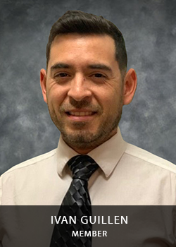December 2024

To the Honorable Governor Gavin Newsom and

RSA Commissioner Dante Allen

On behalf of the SRC, we are pleased to submit our 2023 – 24 Annual Report. The SRC engages with the Department of Rehabilitation (DOR) and the stakeholder community to evaluate services, programs, and policies. The partnership between the SRC and DOR helps ensure that services result in employment, independence, and equality for Californians with disabilities. Over the past term, the SRC’s priority areas included:

* Self-Employment: The SRC analyzed self-employment policies and opportunities available to DOR consumers to understand and improve support for individuals with disabilities pursuing entrepreneurial careers.
* Career Education: The SRC submitted feedback to ensure that the California Master Plan for Career Education includes individuals with disabilities and identifies access to career pathways, apprenticeships, college, and high-paying jobs.
* State Plan: The SRC monitored DOR’s progress in achieving the goals set in the 2020-2024 State Plan and collaborated with DOR on developing new priorities and goals for the 2024-2027 State Plan.
* Customer Service: The SRC engaged with DOR to review customer service policies, trainings, consumer satisfaction surveys, and initiatives to ensure that DOR consumers receive timely and effective services.

Individuals with disabilities have the right to pursue meaningful careers and enjoy full inclusion in society. DOR’s programs and services help individuals achieve competitive, integrated employment, and to maximize their independence. Employing individuals with disabilities is good for businesses and contributes to vibrant, innovative, and productive workforces. On behalf of the SRC, we extend our gratitude to DOR and the stakeholder community for their continued support and collaboration. I am honored to serve a second term as SRC Chair in 2024-25 and look forward to our continued work together.

Ivan Guillen, SRC Chair

# Message from the DOR Director

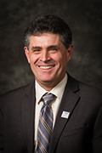December 2024

To the Honorable Governor Gavin Newsom and

RSA Commissioner Dante Allen

I am pleased to recognize the State Rehabilitation Council (SRC) for their commitment and accomplishments throughout October 2023 – September 2024.

Throughout this term, the SRC and the Department of Rehabilitation (DOR) partnership has continued to grow and strengthen. An example of this collaboration is the DOR and SRC jointly developing the goals and priorities for the 2024 – 2027 Vocational Rehabilitation (VR) Services Portion of California’s Unified State Plan. The SRC and DOR also engaged in timely and significant discussions on topics such as benefits planning, behavioral health programs and initiatives, and the the Master Plan for Career Education.

As I transition into retirement, I find myself reflecting on the SRC and DOR partnership. One of DOR’s core values is to ensure that our decisions and actions are informed by interested individuals and groups. The SRC helps DOR carry out this core value and we count on the SRC members to share the perspectives of their networks. The SRC is a critical partner as DOR actively modernizes, innovates, and continuously improves vocational rehabilitation services. I am grateful for the SRC’s partnership throughout my tenure as DOR Director.

DOR applauds the accomplishments of the SRC and looks forward to its ongoing collaboration with the SRC to advance the shared goal of employment, independence, and equality for Californians with disabilities.

Joe Xavier, DOR Director

# The Rehabilitation Act and the SRC

When new SRC members are appointed by the Governor, they learn about how - and why - the SRC exists in relation to the findings, purpose, and principles of the Rehabilitation Act of 1973 (as amended).

## Rehabilitation Act – Findings

In the Rehabilitation Act, Congress identified that individuals with disabilities have the right to: live independently, enjoy self-determination, make choices, contribute to society, pursue meaningful careers, and enjoy full inclusion and integration in society. In the Act, Congress also identified the need to support students with disabilities as they transition from school to postsecondary life.

## Rehabilitation Act – Purpose

Based upon these rights, the purpose of the Rehabilitation Act is to serve individuals with disabilities to maximize competitive integrated employment, economic self-sufficiency, and inclusion into society. The purpose of the Rehabilitation Act also includes:

* Ensuring youth with disabilities have opportunities for post-secondary success.
* Having vocational rehabilitation (VR) service providers and employers provide meaningful input, thereby increasing employment opportunities and outcomes for individuals with disabilities.
* Ensuring that federal and state governments support the employment of individuals with disabilities.
* Understanding that VR has a “dual customer approach” that addresses both the needs of VR consumers and the needs of businesses. Providing businesses with training and technical assistance increases competitive integrated employment outcomes for individuals with disabilities.

## The SRC and DOR Partnership

The SRC and the DOR partner together to maximize the employment and independence of people with disabilities. The partnership is a call to action to advocate and hear the voices of individuals served by VR in California. This ensures individuals with disabilities have resources and support to achieve their goals, while also ensuring the California VR program is effective and in compliance with federal regulations.

# California SRC Overview

Section 105 of the Rehabilitation Act of 1973 (as amended) requires consumers, advocates, and other representatives of individuals with disabilities to participate in the administration and oversight of a state’s VR program. The SRC fulfills this mandate in California and is required for DOR to be eligible for and maintain federal VR funds.

## SRC Vision Statement

The voice of DOR’s stakeholder community.

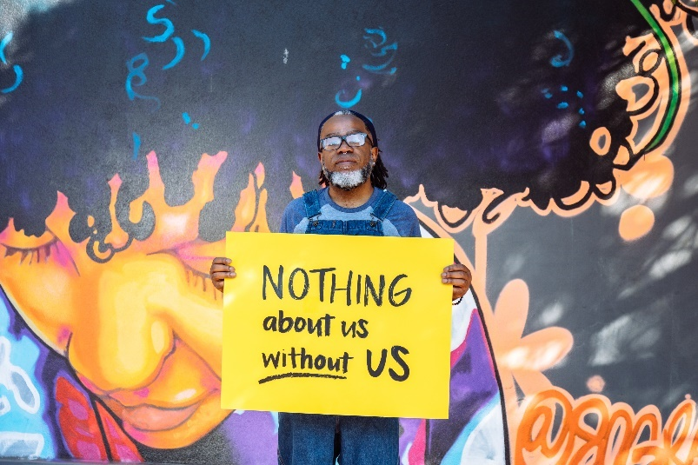

Photo Credit: Affect the Verb, Disabled and Here

## SRC Mission Statement

The SRC, in collaboration with the DOR and other community partners, reviews and analyzes policies, programs and services, and advises DOR on the quality and performance in meeting the Department’s mission.

## Membership and Meetings

The SRC consists of [16 members](https://www.dor.ca.gov/Home/SrcMembership) appointed by California’s Governor, representing a variety of perspectives from the VR program and disability community. Members can serve up to two consecutive three-year terms.

The SRC meets quarterly throughout the year. Members of the public are noticed of the meetings in accordance with the Bagley-Keene Open Meeting Act.

## Responsibilities and Activities

* Evaluation and Recommendations: The SRC reviews, analyzes, and evaluates DOR on the performance of California’s VR program. A particular focus is given to eligibility, service provision, and activities that impact employment outcomes. As a result of this process, the SRC adopts policy recommendations which are submitted to DOR for consideration.
* Comprehensive Statewide Needs Assessment (CSNA): To identify and assess the needs of Californians with disabilities, the SRC collaborates with DOR on the triennial CSNA. The current CSNA covers program years 2024 – 2027.
* State Plan: The SRC advises DOR on the development of California’s VR Services Portion of the Unified State Plan. The SRC and DOR partner to develop, agree to and review the plan’s priorities and goals.
* Assessing Consumer Satisfaction: The SRC partners with DOR to develop the annual Consumer Satisfaction Survey (CSS) and to evaluate the survey results.
* Coordination and Participation: The SRC actively engages with other councils and advisory bodies in California to enhance the number of individuals served. SRC members also participate in work groups, public meetings, and stakeholder forums.

## SRC Committee Structure

The SRC utilizes a committee structure to provide for greater discussion, analysis, and oversight of the SRC’s mandated responsibilities and to assist with carrying out the SRC’s administrative functions. Each SRC committee may prepare recommendations for the full Council’s consideration. The SRC examines the committee structure for efficiency and alignment with the council’s priorities. The SRC committees include:

* Monitoring and Evaluation: Partners with DOR on the CSS and the CSA, analyzes Office of Administrative Hearing decisions, and reviews DOR’s progress on federal and state performance measures.
* Unified State Plan: Partners with DOR on the CSA and the VR Services Portion of the Unified State Plan.
* Policy Committee: Researches policy questions and topics identified by the SRC and develops draft recommendations.
* Executive Planning: Comprised of the SRC Officers and Committee Chairs, this committee plans the quarterly meetings and addresses leadership issues topics.

# SRC Collaboration

## Collaboration between the SRC and DOR

Throughout the October 1, 2023 – September 30, 2024 term, the SRC collaborated with DOR to work towards the shared goals of increased employment, independence, and equality for Californians with disabilities. The SRC appreciates DOR providing SRC members the opportunity to learn about DOR’s programs and policies and to provide substantive feedback. Collaboration highlights include:

* DOR Directorate and SRC Partnership: Each SRC quarterly meeting includes an in-depth report from the DOR Directorate on federal, state and department issues of interest. SRC members engage with the Directorate to ask questions, provide input, discuss challenges, and identify opportunities. The SRC Chair and Vice-Chair have monthly informal conversations with the DOR Directorate to strengthen the SRC and DOR partnership.
* DOR Participation: DOR executives, managers, staff, and subject matter experts attend the SRC quarterly meetings to listen, provide updates, engage in interactive discussions, and gather feedback from the SRC members. The information they provide helps inform the SRC’s recommendation development process.
* SRC Executive Officer: DOR employs a Staff Services Manager I (Specialist) to serve as the SRC Executive Officer, providing fulltime support to the SRC. Regina Cademarti served in this position from June 2020 – April 2022. Kate Bjerke served in this position from May 2017 – April 2020, and from May 2022 – present.
* Adopt-a-District Program: Each SRC member meets quarterly with a DOR Regional Director (the manager responsible for overseeing DOR operations in a specific geographical area). Through these discussions, SRC members build connections and learn about issues and opportunities from the local perspective.

# SRC Quarterly Meetings

During the October 1, 2023 – September 30, 2024 term, the SRC met four times as a full council. During each meeting, the DOR Directorate provides an update on activities, policies, and issues occurring at the federal, state and department levels. Additionally, updates are provided at each quarterly meeting on the VR Services Portion of the Unified State Plan and the Consumer Satisfaction Survey. All SRC quarterly meeting agendas and meeting minutes are [posted online](https://dor.ca.gov/Home/SrcMeetingArchive).

## November 29 – 30, 2023 Quarterly Meeting Highlights

* Learned about the [Youth Leadership Forum](https://www.dor.ca.gov/home/ylf), a statewide program for high school students with disabilities to prepare them for transition after high school, build self-advocacy, connect them to resources and services and celebrate disability history, culture, and community.
* Received an update on legislation of interest to DOR.
* Learned about DOR’s behavioral health goals and initiatives taking place across California.
* Received a presentation on the [State Internship Program](https://www.dor.ca.gov/Home/SIP), an alternate eligibility process for people with intellectual and developmental disabilities to gain employment with the State of California.
* Engaged with DOR leadership to develop and provide feedback on the 2024 – 2027 State Plan priorities and goals.
* Welcomed new members Yuki Nagasawa, Candis Welch, and Hilary Lentini.

## March 6 – 7, 2024 Quarterly Meeting Highlights

* Learned about how DOR is making services available to individuals with disabilities in correctional settings as they prepare for release and transition back into the community.
* Reviewed DOR’s application for VR services and the new online application.
* Received an update on the [Older Individuals who are Blind Program](https://www.dor.ca.gov/Home/OIB) which assists Californians with living in their community of choice, functioning at maximum capacity, and feeling valued in society.
* Approved five new Administrative Law Judges to conduct fair hearings and mediations for DOR consumers.
* Analyzed consumer fair hearing and mediation statistics, the nature of issues and complaints, and legal decision summaries from October 1, 2022 – September 30, 2023.
* Received a report out from the [Client Assistance Program](https://www.disabilityrightsca.org/what-we-do/programs/client-assistance-program-cap) on advocacy efforts, trends, outreach, training and initiatives.

## July 17 – 18, 2024 Quarterly Meeting Highlights

* Received an update on legislation of interest to DOR.
* Learned about apprenticeship opportunities available to DOR consumers.
* Held an interactive discussion with DOR leadership about customer service and met the newly appointed DOR Ombudsperson.
* Received a presentation by the [California Interagency Council on Homelessness](https://bcsh.ca.gov/calich/) on the Homeless Action Plan. SRC members provided input and feedback.
* Received an update on the DOR Consumer Payment Card, designed to provide consumers with an efficient method to purchase authorized goods and services.
* Welcomed new SRC member, Brittany Comegna.

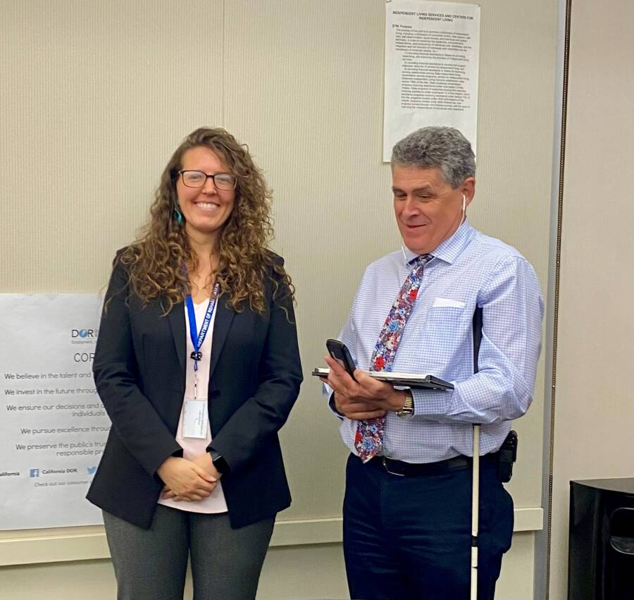

*Picture of DOR Director Joe Xavier with SRC member Brittany Comegna.*

## September 11 – 12, 2024 Quarterly Meeting Highlights

* Held an interactive discussion with DOR representatives regarding self-employment options for DOR consumers.
* Received a presentation on updates being made to the DOR Student and Consumer Information Handbook.
* Learned about DOR’s Integrating Employment in Recovery initiative, a pilot program that incorporates the full range of vocational rehabilitation services into behavioral health treatment delivery.
* Learned about DOR’s [Voice Options Program](https://www.dor.ca.gov/Home/VoiceOptions) which provides eligible Californians who are unable to speak, or who have difficulty speaking, with a free speech-generating device.
* Received a report out from the [State Independent Living Council](https://calsilc.ca.gov/).
* Elected the SRC Chair, Vice-Chair and Treasurer for the 2024 - 25 term.
* Welcomed new members Shannon Coe, Gregory Meza and Eli Gelardin.

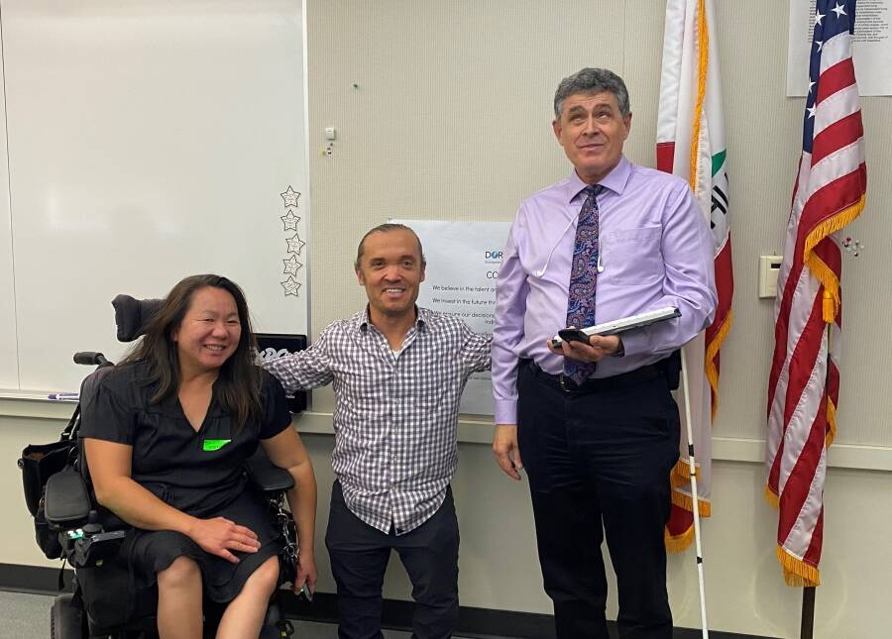

*Picture of SRC members Shannon Coe (left) and Eli Gelardin (middle) with DOR Director Joe Xavier (right).*

# SRC Recommendations

As a result of the many productive and interactive discussions between the SRC, DOR and other stakeholders, the SRC adopted the following recommendations for DOR’s consideration. These recommendations reflect the SRC’s efforts to review, analyze and advise DOR on the performance and effectiveness of California’s VR program. The SRC looks forward to working closely with DOR on these areas of interest.

## SRC Recommendation 2023.1 – Order of Selection

In June 2022, DOR began interactive discussions with the SRC regarding possible policy and fiscal matters that VR agencies may have to consider in the future related to order of selection, post-employment services, and employment retention. The SRC welcomed the opportunity to advise in accordance with 34 CFR § 361.17 on eligibility (including the order of selection); the extent, scope, effectiveness of services provided; and functions that affect or potentially affect the ability of individuals with disabilities in achieving employment outcomes. The SRC appreciated the informative presentations, data and discussions offered by DOR on these topics. As a result, the SRC adopted the following recommendation during the September 7, 2023, SRC quarterly meeting:

*Recommendation*: The SRC recommends that during an order of selection with closed categories that DOR support the provision of VR services to individuals who reapply and require services to maintain/retain employment even though the individual would otherwise be assigned to a waiting list.

*DOR Response*: The DOR appreciates the SRC’s thoughtful deliberation regarding this issue and agrees with the SRC’s recommendation. The DOR has a long-standing history of effectively managing resources and equitability serving eligible individuals with disabilities. Although not necessary at this time, should DOR need to implement an Order of Selection with closed categories in the future, DOR will re-engage with the SRC to discuss how to operationalize this recommendation.

## SRC Recommendation 2024.1 – Benefits Planning

*Recommendation:* The SRC supports the policy recommendations included in the [2024 Benefits Planning Report](https://publicaccessstorage.blob.core.usgovcloudapi.net/publicsitefiles/DOR%20Documents/Advisory%20Committees/CCEPD/2024/Benefits%20Planning%20in%20California%20Report%20-%20October%202024-final.pdf) developed by the California Committee on the Employment of People with Disabilities (CCEPD) workgroup of disability-related advisory bodies.

*Adopted on September 12, 2024*

## SRC Recommendation 2024.2 – VR Terminology

*Recommendation:* The SRC recommends that a glossary in plain language, within the vocational rehabilitation (VR) context, of VR terminology (example: disability, conservator, Community Rehabilitation Program, etc.) be made available to interested individuals, applicants and consumers on the DOR website and attached to the DOR application. A glossary may be a helpful reference when individuals apply for VR services without an advocate or DOR staff member present.

*Adopted on September 12, 2024*

## SRC Recommendation 2024.3 – CARF Accreditation

The SRC recommends that the DOR Community Resource Division (CRD) conduct a survey of Community Rehabilitation Programs (CRPs) currently providing services to DOR consumers to gather information on the following:

* CRP expenditures,
* Revenue from providing VR services,
* Cost of becoming Commission on Accreditation of Rehabilitation Facilities (CARF) accredited,
* Benefits to the CRP of having CARF accreditation, and,
* Barriers that CARF accreditation creates for the CRP.
* *Adopted on September 12, 2024*

The SRC looks forward to DOR’s responses to SRC recommendations 2024.1, 2024.2, and 2024.3, which will be released in early 2025.

# California Master Plan on Career Education



In August 2023, California Governor Gavin Newsom called for a [Master Plan for Career Education](https://careereducation.gov.ca.gov/master-plan-engage/), through [Executive Order N-11-23](https://www.gov.ca.gov/wp-content/uploads/2023/08/8.31.23-Career-Education-Executive-Order.pdf). This plan will increase equitable access to living wage jobs by creating and strengthening education and training pathways that are specific to 1) sectors, 2) regions, and 3) individuals’ skills and experience. These pathways will ensure that all Californians - whether youth just starting their first job search or experienced workers seeking a new career - can find opportunities that pay family-sustaining wages. By building these talent pipelines, California can power economic growth and create more resilient communities in priority sectors such as education, healthcare, and climate. The initial, primary concepts of the Master Plan are focused on the following:

1) Creating stronger coordination mechanisms,

2) Building skills-based pathways,

3) Expanding work-based learning, and

4) Increasing access to public benefits and career pathways.

In the final Master Plan, each of these concepts will include specific recommended actions and will be accompanied by proposed changes to statute, reallocation of funding streams, changes in agency responsibilities, and implementation suggestions for education, training, and social service providers. To inform the development of the Master Plan, regional meetings were held throughout California to gather information on the four core concepts. Stakeholders were also provided with the opportunity to submit written feedback. The SRC actively reviewed the core concepts and considered the following questions:

* *What are the barriers for individuals with disabilities to access career pathways, apprenticeships, college, and high-paying jobs?*
* *What would make the biggest difference in terms of removing these barriers?*

As a result of the SRC’s efforts, on July 18, 2024, the SRC submitted the following input for the Master Plan team’s consideration:

## Core Concept 1: Create state and regional coordinating bodies that make it easier to access information, funding, and support.

* SRC Input: To increase awareness and coordination, it would be beneficial to develop a standard referral policy and process that is consistent throughout the numerous agencies and departments that offer education and training programs.
* SRC Input: Existing Local Partnership Agreements (LPAs) could be leveraged, utilized, and expanded when creating regional coordinating bodies. Provide the regional coordinating bodies with guidance, a uniform set of goals, and define the membership composition to ensure diversity and representation. Identify facilitators to lead and manage the development of regional coordinating bodies. Increasing access to benefits planning for individuals with disabilities should be a priority action item for the regional coordinating bodies.
* SRC Input: Have the statewide entity that will be responsible for providing information on regional labor markets also provide details on 1) how local job markets have changed, 2) how to increase and access training for current, in-demand jobs, 3) encourage sector-based programs, and 4) identify funding opportunities to support schools and training programs that need to obtain accreditation and/or licensure.

## Core Concept 3: Create incentives and improve coordination to provide work-based learning opportunities for K12 students and adult learners.

* SRC Input: Ensure that employers offering work-based learning opportunities have the information and resources needed to provide reasonable accommodations. Increase access and awareness about reasonable accommodation and disability etiquette training that is available to employers.
* SRC Input: When designing work-based learning opportunities, encourage employers and agencies to look to model programs for best practices. These programs include DOR’s Demand Side Employment Initiative, the State of California’s State Internship Program, the Individual Placement and Support model, and apprenticeships

# Consumer Satisfaction Survey (CSS)



Photo Credit: Disability:IN

The Rehabilitation Act calls for the SRC to review and analyze the effectiveness of, and consumer satisfaction with, DOR’s delivery of VR services and the employment outcomes achieved by consumers. To carry out this responsibility, the SRC collaborates with DOR to conduct an annual CSS.

The SRC’s role in the survey includes developing and modifying the survey questions, advising on methodology, and developing policy recommendations based on the survey findings. The survey results are utilized by DOR to increase the effectiveness of the service delivery process, both internally and externally. The annual CSS cycle aligns with California’s State Fiscal Year (SFY) which runs from July 1st through the following June 30th.

The 2022/23 CSS was delivered to a statistically valid sample size of 7,648 randomly sampled consumers. Surveys were sent using electronic or surface mail and made available in five translated languages. The response rate from individuals receiving VR services was 15.5% and the response rate for individuals receiving pre-employment transition services (also known as “DOR Student Services”) was 4.9%.

The 2022/23 CSS was comprised of questions designed to assess consumer satisfaction with services from DOR and its providers. These questions cover six categories: overall DOR experience, DOR counselors, service providers, employment services, job satisfaction, and employment opportunities.

Highlights of the 2022/23 survey results are listed below.

* Survey respondents receiving VR services most frequently reported learning (23.2%), psychiatric (20.9%), and physical (20.9%) disabilities.
* Survey respondents receiving DOR Student Services most frequently reported learning (47.1%) and intellectual and developmental disabilities (25.0%).
* Survey respondents were asked to identify reasons or causes that contributed to their unemployment status. Respondents reported the top three reasons for being unemployed: still looking for employment (21.4%), currently being a student (20.4%), and needing additional help (13.6%).
* Survey respondents receiving VR services were asked to rate their satisfaction with their DOR experience, DOR counselors, service providers, employment services, job satisfaction for employed individuals, and employment opportunities for unemployed individuals. ***The combined weighted score for all satisfaction questions was 77.7%, which indicates that survey respondents receiving VR services were overall satisfied with the services they received from DOR and its providers.***
* Survey respondents receiving DOR Student Services were asked to rate the importance of the following Student Services: work experiences; counseling on job, school, or training options after high school; job and career exploration; self-advocacy training; and skills for work. They were then asked to identify and rate the Student Services they received.

***The overall satisfaction score reported for all survey respondents receiving DOR Student Services was 81.0%.***

The SRC and DOR are dedicated to measuring consumer satisfaction and exploring how well the needs and expectations of consumers are being met. In particular, the SRC and DOR is exploring strategies to enhance survey engagement and increase the response rate. The SRC looks forward to continued collaboration on the CSS and developing policy recommendations that will lead to increased consumer satisfaction.

# Vocational Rehabilitation Services Portion of the California Unified State Plan

The Workforce Innovation and Opportunity Act (WIOA) requires each state to submit a Unified or Combined State Plan that outlines a four-year strategy for the State’s workforce development system. For 2024 – 2027, California elected to submit a Unified State Plan, which includes six core programs: 1) Adult, 2) Dislocated Worker, 3) Youth, 4) Adult Education and Family Literacy Act, 5) Wagner-Peyser Services, and 6) Vocational Rehabilitation (VR). The [VR goals and priorities](https://www.dor.ca.gov/Home/StatePlan) were jointly developed by the SRC and DOR.



## 2024 – 2027 DOR State Plan Goals and Objectives

## Goal 1: Increase the unsubsidized employment rate of participants during the second and fourth quarter after exit from program.

Objective 1.1: The unsubsidized employment rate of participants during their second quarter after exit from program will increase from the 51.6% rate in Program Year (PY 2022) to no less than 55% by PY 2025.

Objective 1.2: The unsubsidized employment rate of participants during the fourth quarter after exit from program will increase from the 49.7% rate in PY 2022 to no less than 53% by PY 2025.

## Goal 2: Support increased work-based learning including intermediate employment, career technical education and training, and post-secondary education for all CDOR participants receiving VR services.

Objective 2.1: The Credential Attainment rate by DOR program participants will increase from the PY 2022 rate of 43.5% to no less than 48% by PY 2025.

Objective 2.2: DOR will increase the Measurable Skills Gain (MSG) rate for DOR participants from the PY 2022 rate of 28.6% to no less than 40% by PY 2025.

## Goal 3: Expand and improve VR services to those who have been underserved and underrepresented in the VR program.

Objective 3.1: Consumers with Behavioral Health (BH) disabilities who are Black or African American or Hispanic will have second quarter median earnings no less than $7,000 per quarter and be no less than the overall median earnings of all DOR consumers with BH disabilities by PY 2024 and will increase to no less than $7,200 and be no less than the overall median earnings of all DOR consumers with BH disabilities by PY 2025.

## Goal 4: Provide effective VR services with quality IPE developments consistent with in-demand workforce needs that lead to a career track offering sustainable living wages.

Objective 4.1: The percentage of consumer IPE goals for local/regional, high-wage, in-demand occupations will increase from the current 19% of all new IPE goals to at least 30% of all IPE goals for plans developed and approved during PY 2025.

## Goal 5: Support businesses in California to employ more individuals with disabilities.

Objective 5.1: For PY 2024 and PY 2025, develop, implement, and deliver services to at least 100 new, unduplicated businesses annually.

## Goal 6: Improve California state government employers’ parity rate for hiring and promotion of people with disabilities.

Objective 6.1: DOR will provide direct hiring services and supports to no less than 30 unduplicated State Departments, Offices, or Agencies by the end of PY 2025.

## Goal 7: Increase the number of students with disabilities, ages 16-21, who receive high quality Pre-Employment Transition Services, also known as CDOR Student Services.

Objective 7.1: DOR will increase the number of students with disabilities annually served by 35% from the 46,000 served in PY 2022 to no less than 62,100 in PY 2025.

## Goal 8: Increase the percentage of students with disabilities receiving CDOR Student Services who go on to receive VR services.

Objective 8.1: DOR will increase the percentage of students enrolled in CDOR Student Services who go on to receive an IPE for VR services from 19.5% in PY 2022 to no less than 35% during PY 2025.

# Comprehensive Statewide Needs Assessment

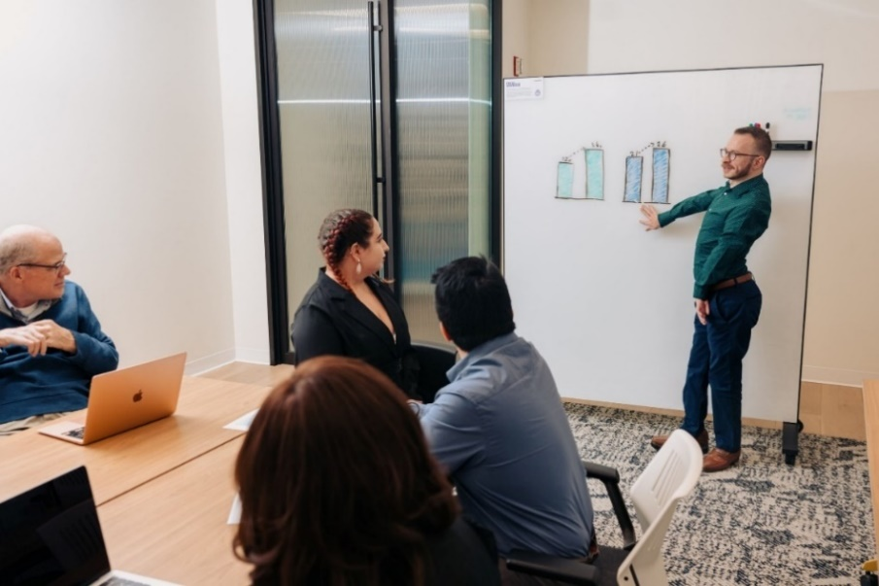

Photo Credit: Disability:IN

To inform the development of the State Plan goals and objectives, the DOR, in partnership with the SRC, conducts a triennial Comprehensive Statewide Needs Assessment (CSNA). The assessment includes five information goals and must describe the rehabilitation needs of individuals with disabilities residing within California.

The latest triennial CSNA covered years 2020 – 2023 and was submitted on January 5, 2024. Themes from the most recent CSNA are provided below.

## Information Goal 1: The needs of individuals with the most significant disabilities, including their need for supported employment services.

*The following themes were identified:*

* Individuals with Intellectual Disabilities/Developmental Disabilities (ID/DD) represent both the largest disability category of consumers and youth ages 14 to 24 with the most significant disabilities and receiving supported services, at application.
* For those indicating employment barriers, both individuals surveyed with the most significant disabilities and receiving supported employment cited the need for job skills and to learn how to use computer programs.
* Survey respondents reported college or university education as the most important type of training for the most significantly disabled consumers, whereas apprenticeship or on-the-job training is the most important type for consumers receiving supported employment.
* Survey results indicated that the consumers with the most significant disabilities and consumers receiving supported employment need to learn how to use computer programs such as Word and Excel more than other technological equipment or skills.
* Making a living wage was the most important job factor for consumers with the most significant disabilities and the third most important job factor for consumers receiving supported employment services. Job security is second most important to both.

## Information Goal 2: The needs of individuals with disabilities who are minorities and individuals with disabilities who have been unserved or underserved by the VR program.

*The following themes were identified:*

* Compared to American Community Survey (ACS) 5-year estimates, the population of Asians in Californians with disabilities ages 18 to 64 who speak English less than very well may seek DOR services in lower percentages than found in the population.
* Individuals with barriers of homelessness/unhoused, foster youth, justice-involved, and English learners may be underserved. Additionally, these were the top populations identified by key informants and survey respondents to focus attention on.
* Approximately 33% of DOR consumers have a behavioral health disability.
* Due to some consumers not disclosing their barrier(s) due to cultural stigma, DOR data may not reflect the actual percentages served.
* Black or African Americans are overrepresented among individuals experiencing homelessness/unhoused and those who are formerly justice involved.

## Information Goal 3: The needs of individuals with disabilities served through other components of the statewide workforce development system.

*The following themes were identified:*

* The rate of employment for working-aged persons with disabilities in California remains low at 23.2%.
* Individuals with disabilities are less likely to have earned a bachelor's degree or higher than individuals without a disability.
* Individuals with disabilities are more likely to earn a lower median wage than individuals without disabilities.
* Of DOR’s top five occupational placements, consumers in four of the occupations earn less than the estimated annual living wage of $44,179.

## Information Goal 4: The needs of youth with disabilities and students with disabilities, including, as appropriate, their need for pre-employment transition services or other transition services.

*The following themes were identified:*

* The rates for Hispanic or Latinx and Asian in the DOR Student Services population are lower than found in the California Department of Education population of special education students in grades nine through twelve.
* Youth and students with disabilities who identify as male applied for VR services and DOR Student Services at higher percentages than females.
* The provision of DOR Student Services to potentially eligible students with disabilities continues to increase annually.

## Information Goal 5: The need to establish, develop, or improve community rehabilitation programs (CRPs) within the State.

*The following themes were identified:*

* Both total VR consumers and individuals accessing CRP services have increased from program year 2020-21 to 2022-23.
* The phasing out of subminimum wage employment will likely increase the need to provide supported employment services to persons with the most significant disabilities, including through CRPs.
* Consumers in rural areas are limited in access to CRP locations and VR services.
* Counselors reported that the number and quality of CRPs across many areas of California are insufficient to meet demands.
* Survey results indicate that more CRPs offer a virtual or hybrid service delivery method as a result of the pandemic, however, a large number of individuals with disabilities are unable to access virtual services due to a lack of internet or broadband access, or technological skills and/or computer equipment.

| Current SRC Members **(as of December 2024)** |  |
| --- | --- |
| Ivan Guillen, SRC Chair Chair, Unified State Plan Committee  Client Assistance Program representative   * Senior Advocate Specialist, Client Assistance Program, Disability Rights California * Re-elected as SRC Chair on September 12, 2024. * Serving second, full SRC term   (September 2024 – September 2027) | Headshot of Ivan Guillen. |
| Chanel Brisbane, SRC Vice-Chair Chair, Policy Committee  Community Rehabilitation Program representative   * Director, Jobs and Transitions, Best Buddies International * Re-elected as SRC Vice-Chair on September 12, 2024. * Serving second, full SRC term   (September 2022 – September 2025) | Headshot of Chanel Brisbane |
| La Trena Robinson, SRC Treasurer Business, Industry and Labor representative   * Medical Social Worker, Kaiser Permanente * Re-elected as SRC Treasurer on September 12, 2024. * Serving second, full SRC term   (September 2024 – September 2027) | Headshot of La Trena Robinson |
| Theresa Comstock Disability Advocacy Group representative   * Executive Director, California Association of Local Behavioral Health Boards & Commissions * Serving second, full SRC term   (September 2022 – September 2025) | Headshot of Theresa Comstock |
| Yuki Nagasawa VR Counselor representative   * DOR Berkeley Branch Office * Serving first, full SRC term   (September 2024 – September 2027) | **Headshot of Yuki Nagasawa** |
| Hilary Lentini California Workforce Development Board representative   * Principal and Creative Director, Lentini Design and Marketing, Inc. * Serving first, full SRC term   (October 2023 – September 2025) | *Headshot of Hilary Lentini* |
| Brittany Comegna Disability Advocacy Group representative   * Founder & CEO, Deaf and Disability Mediation Services * Serving first, full SRC term   (September 2024 – September 2026) | Headshot of Brittany Comegna |
| Eli Gelardin Parent Training & Information Center representative   * Chief Executive Officer, Marin Center for Independent Living * Serving first, partial term   (September 2024 – September 2025) | Headshot of Eli Gelardin |
| Shannon Coe State Independent Living Council representative   * Community Parent, WarmLine Family Resource Center * Serving first, partial term   (September 2024 – September 2025) | *Headshot of Shannon Coe* |
| Gregory MezaBusiness, Industry and Labor representative  * Work-Based Learning Coordinator, Specialized Vocational Services, Napa Valley Unified School District * Serving first, full term   (September 2024 – September 2027) | *Not pictured* |
| Michelle BelloCalifornia Department of Education representative  * Education Programs Consultant, Special Education Division * Serving first, full term   (September 2024 – September 2026) | *Picture of Michelle Bello* |
| Joe XavierState Director RepresentativeEx-Officio Member  * Director, California Department of Rehabilitation * Serving fourth SRC term (September 2012 – September 2025) | Headshot of Joe Xavier |

| SRC Appointments Completed During the 2023-24 Term |  |
| --- | --- |
| Susan Henderson **Chair, Monitoring and Evaluation Committee**  Parent Training and Information Center representative   * Executive Director, Disability Rights Education and Defense Fund * Completed a second, full SRC term   (September 2022 – September 2025) | Headshot of Susan Henderson |
| Jonathan Hasak Business, Industry and Labor representative   * U.S. Public Sector Partnerships, Coursera * Served a second, partial SRC term   (September 2022 – September 2024) | Headshot of Jonathan Hasak |
| Elizabeth Lewis Business, Industry and Labor representative   * Senior Recruiter, Union Pacific * Completed a first, full SRC term   (March 2022 – September 2024) | Headshot of Elizabeth Lewis |
| Candis Welch Former VR Consumer representative   * Diversity, Equity, and Inclusion Coordinator,   Los Angeles Homeless Services Authority   * Served a first, partial SRC term   (September 2023 – September 2024) | Headshot of Candis Welch |

**Interested in Becoming an SRC Member?**

Would you like to advocate for the employment, independence, and equality for people with disabilities? If yes, then a position on the SRC may be for you! The SRC is always looking for new members to fill positions on the Council. If you are interested in serving on the SRC, please send your contact information to [SRC@dor.ca.gov](mailto:SRC@dor.ca.gov) or call (916) 558-5897. Thank you for considering the SRC!

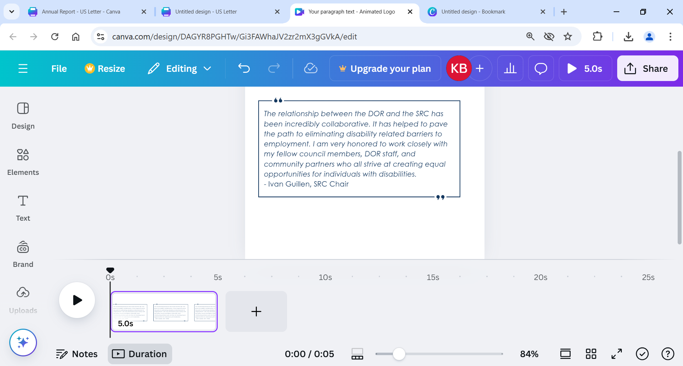

# About the Department of Rehabilitation (DOR)

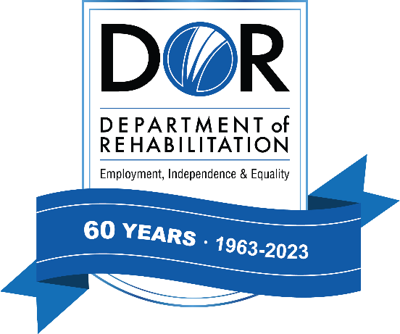

DOR administers the largest VR program in the country. DOR has a three-pronged mission to provide services and advocacy that assist people with disabilities to live independently, become employed and have equality in the communities in which they live and work. For additional information about DOR, visit [www.dor.ca.gov](http://www.dor.ca.gov)

DOR Vision Statement: Employment, independence, and equality for all Californians with disabilities.

DOR Mission Statement: The DOR works in partnership with consumers and other stakeholders to provide services and advocacy resulting in employment, independent living, and equality for individuals with disabilities.

DOR Core Values

* We believe in the talent and potential of individuals with disabilities.
* We invest in the future through creativity, ingenuity, and innovation.
* We ensure our decisions and actions are informed by interested individuals and groups.
* We pursue excellence through continuous improvement.
* We preserve the public's trust through compassionate and responsible provision of services.

DOR Guiding Principles

* Delivering effective VR services, and other programs and services in an efficient, caring, professional and prompt manner.
* Attracting, developing, and retaining a competent, creative, and highly motivated workforce.
* Maintaining public trust by being fiscally responsible and ensuring quality programs and services.
* Sustaining our role as a respected leader in the disability community; inspiring hope in those we serve.



California State Rehabilitation Council

721 Capitol Mall

Sacramento, CA 95814

(916) 558-5897 / [SRC@dor.ca.gov](mailto:SRC@dor.ca.gov)

[dor.ca.gov/Home/SRC](https://dor.ca.gov/Home/SRC)