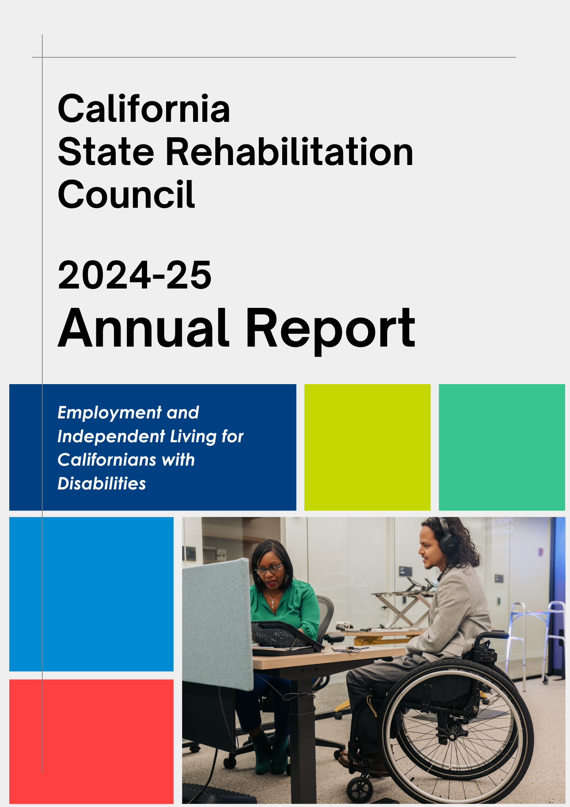

Table of Contents

Message from the SRC Chair 2
Message from the DOR Director 3
The Rehabilitation Act and the SRC 4
California SRC Overview 5
SRC Collaboration 7
SRC Quarterly Meetings 8
SRC Recommendations 12
Consumer Satisfaction Survey (CSS) 21
Vocational Rehabilitation Services Portion of the California Unified State Plan 21
Comprehensive Statewide Needs Assessment 23
Current SRC Members 24
SRC Appointments Completed During the 2024-25 Term 28
About the Department of Rehabilitation (DOR) 30

Cover page photo credit: Disability:IN

Message from the SRC Chair

Forthcoming

Message from the DOR Director

Forthcoming

The Rehabilitation Act and the SRC

When new SRC members are appointed by the Governor, they learn about how - and why - the SRC exists in relation to the findings, purpose, and principles of the Rehabilitation Act of 1973 (as amended).

Rehabilitation Act – Findings
In the Rehabilitation Act, Congress identified that individuals with disabilities have the right to: live independently, enjoy self-determination, make choices, contribute to society, pursue meaningful careers, and enjoy full integration in society. In the Act, Congress also identified the need to support students with disabilities as they transition from school to postsecondary life.

Rehabilitation Act – Purpose
Based upon these rights, the purpose of the Rehabilitation Act is to serve individuals with disabilities to maximize competitive integrated employment, economic self-sufficiency, and inclusion into society. The purpose of the Rehabilitation Act also includes:
- Ensuring youth with disabilities have opportunities for post-secondary success.
- Having vocational rehabilitation (VR) service providers and employers provide meaningful input, thereby increasing employment opportunities and outcomes for individuals with disabilities.
- Ensuring that federal and state governments support the employment of individuals with disabilities.
- Understanding that VR has a “dual customer approach” that addresses both the needs of VR consumers and the needs of businesses. Providing businesses with training and technical assistance increases competitive integrated employment outcomes for individuals with disabilities.

The SRC and DOR Partnership
The SRC and the DOR partner together to maximize the employment and independence of people with disabilities. The partnership is a call to action to advocate and hear the voices of individuals served by VR in California. This ensures individuals with disabilities have resources and support to achieve their goals, while also ensuring the California VR program is effective and in compliance with federal regulations.

California SRC Overview

Section 105 of the Rehabilitation Act of 1973 (as amended) requires consumers, advocates, and other representatives of individuals with disabilities to participate in the administration and oversight of a state’s VR program. The SRC fulfills this mandate in California and is required for DOR to be eligible for and maintain federal VR funds.

SRC Vision Statement
The voice of DOR’s stakeholder community.

SRC Mission Statement
The SRC, in collaboration with the DOR and other community partners, reviews and analyzes policies, programs and services, and advises DOR on the quality and performance in meeting the Department’s mission.

Membership and Meetings
The SRC consists of 16 members appointed by California’s Governor, representing a variety of perspectives from the VR program and disability community. Members can serve up to two consecutive three-year terms.
The SRC meets quarterly throughout the year. Members of the public are noticed of the meetings in accordance with the Bagley-Keene Open Meeting Act.

Responsibilities and Activities
- Evaluation and Recommendations: The SRC reviews, analyzes, and evaluates DOR on the performance of California’s VR program. A particular focus is given to eligibility, service provision, and activities that impact employment outcomes. As a result of this process, the SRC adopts policy recommendations which are submitted to DOR for consideration.

- Comprehensive Statewide Needs Assessment (CSNA): To identify and assess the needs of Californians with disabilities, the SRC collaborates with DOR on the triennial CSNA. The current CSNA covers program years 2024 – 2027.

- State Plan: The SRC advises DOR on the development of California’s VR Services Portion of the Unified State Plan. The SRC and DOR partner to develop, agree to and review the plan’s priorities and goals.

- Assessing Consumer Satisfaction: The SRC partners with DOR to develop the annual Consumer Satisfaction Survey (CSS) and to evaluate the survey results.

- Coordination and Participation: The SRC actively engages with other councils and advisory bodies in California to enhance the number of individuals served by the VR program. SRC members also participate in work groups, public meetings, and stakeholder forums.

SRC Committee Structure
The SRC utilizes a committee structure to provide for greater discussion, analysis, and oversight of the SRC’s mandated responsibilities and to assist with carrying out the SRC’s administrative functions. Each SRC committee may prepare recommendations for the full Council’s consideration. The SRC examines the committee structure for efficiency and alignment with the council’s priorities. The SRC committees include:

- Monitoring and Evaluation: Partners with DOR on the CSS and the CSNA, analyzes Office of Administrative Hearing decisions, and reviews DOR’s progress on federal and state performance measures.
- Unified State Plan: Partners with DOR on the CSNA and the VR Services Portion of the Unified State Plan.

- Policy Committee: Researches policy questions and topics identified by the SRC and develops draft recommendations.

- Executive Planning: Comprised of the SRC Officers and Committee Chairs, this committee plans the quarterly meetings and addresses leadership issues and topics.

SRC Collaboration

Collaboration between the SRC and DOR
Throughout the October 1, 2024 – September 30, 2025 term, the SRC collaborated with DOR to work towards the shared goals of increased employment and independence for Californians with disabilities. The SRC appreciates DOR providing SRC members the opportunity to learn about DOR’s programs and policies and to provide substantive feedback. Collaboration highlights include:

- DOR Directorate and SRC Partnership: Each SRC quarterly meeting includes an in-depth report from the DOR Directorate on federal, state and department issues of interest. SRC members engage with the Directorate to ask questions, provide input, discuss challenges, and identify opportunities. The SRC Chair and Vice-Chair have monthly informal conversations with the DOR Directorate to strengthen the SRC and DOR partnership.

- DOR Participation: DOR executives, managers, staff, and subject matter experts attend the SRC quarterly meetings to listen, provide updates, engage in interactive discussions, and gather feedback from the SRC members. The information they provide helps inform the SRC’s recommendation development process.

- SRC Executive Officer: DOR employs a Staff Services Manager I (Specialist) to serve as the SRC Executive Officer, providing fulltime support to the SRC. Regina Cademarti served in this position from June 2020 – April 2022. Kate Bjerke served in this position from May 2017 – April 2020, and from May 2022 – present.

- Adopt-a-Region Program: Each SRC member meets quarterly with a DOR Regional Director (the manager responsible for overseeing DOR operations in a specific geographical area). Through these discussions, SRC members build connections and learn about issues and opportunities from the local perspective.

SRC Quarterly Meetings

Between October 1, 2024 – September 30, 2025, the SRC convened four times as a full council. Each quarterly meeting included the following standing items:

- DOR Directorate Updates: DOR leaders joined the SRC to share information on key activities, policies, and issues at the federal, state, and department levels.

- Unified State Plan Collaboration: The SRC worked in partnership with DOR on the VR Services Portion of the Unified State Plan and received progress updates on DOR’s performance goals.

- Adopt-a-Region Reports: SRC members provided summaries of their recent Adopt-a-Region discussions.

- Network Updates: SRC members shared updates from their respective organizations, networks, and constituency groups.

- Debrief and Recommendations: Each meeting concluded with a debrief session, during which members discussed key takeaways and developed policy recommendations.

The SRC quarterly meeting agendas and minutes are posted online. Highlights from each quarterly of the meetings are provided below:

December 4 – 5, 2024 Quarterly Meeting Highlights
- Learned about the phase-out of subminimum wage in California, effective January 1, 2025, and the coordinated efforts to support individuals with disabilities in transitioning to competitive, integrated employment.
- Received an update on pre-employment transition services available to students with disabilities.
- Reviewed the DOR’s policies related to self-employment as a VR option for consumers.
- Learned about the 2025 Youth Leadership Forum and the opportunities it will offer to young leaders with disabilities.
- Received a presentation from the California Department of Education on current initiatives in special education programs.
- Welcomed new SRC member, Michelle Bello, and recognized outgoing SRC member, Chanel Brisbane, for her dedicated service.
- Reviewed and provided feedback on the draft 2025 Consumer Satisfaction Survey.

March 5 – 6, 2025 Quarterly Meeting Highlights
- Learned about DOR’s Mobility Evaluation Program, a high-tech driving assessment that identifies the adaptive equipment, vehicle modifications, and training needed to help consumers drive safely and independently in support of their vocational goals.
- Received an update from DOR’s Youth in Foster Care Workgroup, focused on improving services and outcomes for youth with disabilities in the foster care system.
- Analyzed consumer fair hearing and mediation data, including the nature of complaints, resolution trends, and legal decision summaries from October 1, 2023, through September 30, 2024.
- Received a report from the Client Assistance Program (CAP) on emerging trends, outreach efforts, and current initiatives.
- Reviewed DOR’s policies regarding the use of public and private institutional settings in the delivery of VR services.
- Elected Shannon Coe to serve as SRC Vice-Chair, filling the vacancy left by Chanel Brisbane.

June 11 – 12, 2025 Quarterly Meeting Highlights
- Received an update on proposed revisions to DOR’s maintenance regulations, which address allowable expenses for food, shelter, and clothing related to a consumer’s participation in VR services.
- Learned about DOR’s statewide workgroup dedicated to improving employment outcomes for individuals with intellectual and developmental disabilities.
- Discussed DOR’s ongoing efforts to modernize and streamline the certification process for new vendors, aimed at improving efficiency and expanding service options.
- Welcomed Danté Allen, DOR’s new Deputy Director of the Office of Legislation and Communications.
- Reviewed the finalized 2025 Consumer Satisfaction Survey, which will inform service improvements and consumer engagement strategies.
- Received an update on the Comprehensive Statewide Needs Assessment.

September 10 – 11, 2025 Quarterly Meeting Highlights
- Learned about DOR’s Ticket to Work program, which supports Social Security beneficiaries with disabilities in achieving their employment goals through access to vocational services and supports.
- Received an update from the California Department of Education on special education initiatives, programs, and legislation of interest.
- Welcomed LaCandice Ochoa, DOR’s new Deputy Director of the Independent Living and Community Access Division.
- Recognized Theresa Comstock for her dedicated service and contributions to the SRC.
- Learned about CalABLE, a savings and investment program that allows eligible individuals with disabilities and their families to save in tax-advantaged accounts without jeopardizing access to benefits.
- Elected the next SRC Officers for the 2025 – 2026 term.
- Learned about DOR’s Senior VR Counselor – Qualified Rehabilitation Professional Apprenticeship Program, set to launch in 2026.
- Drafted and approved policy recommendations for inclusion in the upcoming modification to the 2024 – 2027 VR Services Portion of the Unified State Plan.
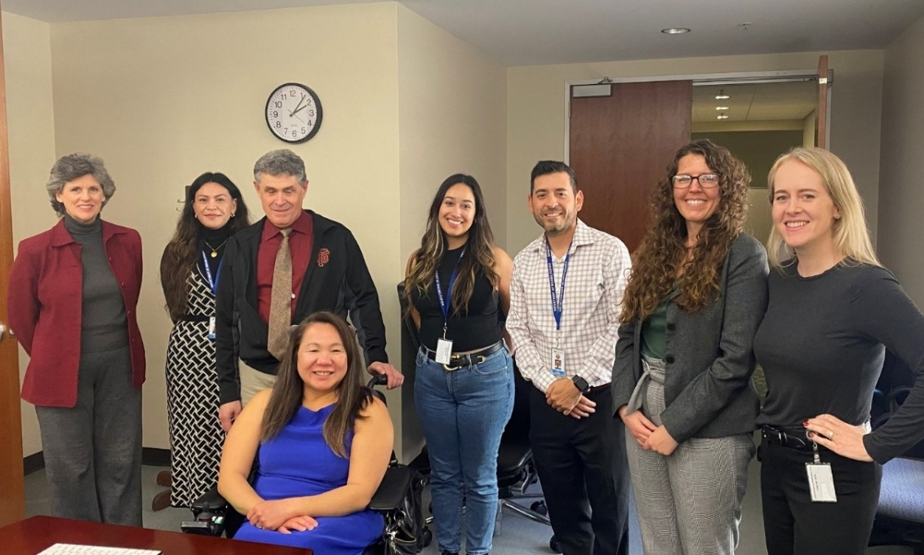
Photo of Theresa Comstock, Michelle Bello, Joe Xavier, Shannon Coe, Chanel Brisbane, Ivan Guillen, Brittany Comegna and Kate Bjerke at the December 5, 2024 SRC Quarterly Meeting.

SRC Policy Recommendations
As a result of the many productive and interactive discussions between the SRC, DOR and other stakeholders, the SRC adopted the following policy recommendation during the 2024/25 term. This recommendation reflects the SRC’s efforts to review, analyze and advise DOR on the performance and effectiveness of California’s VR program.

SRC Recommendation 2025.1 – DOR Staffing
Adopted on March 5, 2025
The SRC recommends that DOR work to understand and address barriers to attracting and retaining staff.

DOR Response to Recommendation 2025.1 – DOR Staffing
The DOR agrees with this recommendation and acknowledges the importance of attracting and retaining a qualified, dedicated workforce. DOR is prioritizing the quality of services delivered to consumers and ensuring that individuals exiting the VR program do so with meaningful, competitive employment outcomes. In support of this priority, DOR leadership is actively evaluating internal staffing practices, identifying recruitment and retention challenges, and exploring strategies to enhance staff engagement. DOR will continue to partner with stakeholders to strengthen our workforce and sustain high-quality service delivery across California.

SRC State Plan Modification Recommendations
In addition to adopting policy recommendations, the SRC has an advisory role in shaping the DOR’s upcoming modification to the 2024 – 27 VR Services Portion of the California Unified State Plan (State Plan). The SRC has a dedicated section in the State Plan that outlines the SRC’s membership composition and presents the SRC’s input and recommendations for strengthening the VR program.

To guide their development of meaningful input, the SRC State Plan Committee approved seven stakeholder engagement questions during its April 22, 2025 meeting. These questions were designed to solicit feedback from a broad range of stakeholders on the strengths, challenges, and opportunities within California’s VR service delivery system. These questions were distributed to the SRC stakeholder email listserv. SRC members also disseminated the questions through their own networks and engaged in discussions during their “Adopt-a-District” meetings with DOR Regional Directors and District Administrators.

During the September 10 – 11, 2025 quarterly meeting, the SRC reviewed the feedback submitted by the stakeholder community and developed and approved the following recommendations for inclusion in the 2026 State Plan modification:

SRC State Plan Modification Recommendation 1 – DOR Staffing
Adopted on September 11, 2025
On March 5, 2025, the SRC recommended that DOR work to identify and address barriers to attracting and retaining staff. The SRC appreciates DOR’s commitment to exploring staffing solutions and its ongoing engagement with the SRC Policy Committee throughout 2025, including updates on the DOR apprenticeship program, the streamlined Senior Vocational Rehabilitation Counselor–Qualified Rehabilitation Professional (SVRC-QRP) exam, and related workforce initiatives. The SRC recommends that DOR prioritize workforce development in the 2024–2027 State Plan Modification.

DOR Response to SRC State Plan Modification Recommendation 1 – DOR Staffing
DOR agrees that a strong workforce is essential to achieving quality outcomes for VR consumers. DOR will continue to implement strategies as outlined in Section (i) – Comprehensive System of Personnel Development (CSPD) of the State Plan to ensure an adequate supply of qualified rehabilitation professionals and to support the professional growth of current staff. Examples of recent initiatives to support and develop DOR’s workforce include the following:
- The Limited Examination and Appointment Program (LEAP) is a California state initiative that provides an alternative pathway to civil service employment for individuals with disabilities. Upon successful completion, candidates may receive a permanent appointment to their position. LEAP participants must meet the same job qualifications as other applicants and may request reasonable accommodations, as needed. DOR recently released a LEAP exam specific to the Senior Vocational Rehabilitation Counselor–Qualified Rehabilitation Professional (SVRC-QRP) classification and is including LEAP into the Department’s broader recruitment and retention strategies.
- In July 2025, DOR updated and streamlined the SVRC-QRP exam to make the hiring process more efficient and to attract a wider range of qualified candidates.
- The DOR is launching a Registered Apprenticeship Program to strengthen its pipeline of qualified SVRC-QRPs and to address workforce shortages. This two-year paid training program combines on-the-job experience with academic instruction. Graduates who complete the apprenticeship and hold a related bachelor’s degree will qualify for appointment as Vocational Rehabilitation Counselors.

DOR looks forward to ongoing collaboration with the SRC to monitor the effectiveness of these initiatives and to identify additional strategies to strengthen DOR’s workforce.

SRC State Plan Modification Recommendation 2 – Leveraging Partnerships
Adopted on September 11, 2025
The SRC recommends that DOR prioritize leveraging partnerships in the 2024 – 2027 State Plan Modification. By strengthening partnerships with community-based organizations, independent living centers, workforce boards, and other service providers, individuals with disabilities can continue to access needed supports, even if an Order of Selection is implemented.

DOR Response to SRC State Plan Modification Recommendation 2 – Leveraging Partnerships
The DOR agrees that coordinated partnerships are essential to enhancing service access and achieving successful employment outcomes for individuals with disabilities.

The DOR has, and continues, to engage in such initiatives, one of which is the Youth Employment Initiative, a three-year partnership launched in December 2023 between DOR and the Office of Youth and Community Restoration (OYCR). This initiative supports youth with disabilities involved in the justice system by providing vocational rehabilitation services that promote long-term employment and successful return to the community. Key features of the initiative include:
- Workforce Development Navigators employed by counties to identify eligible youth, coordinate services, and maintain engagement throughout the youth’s transition from secure facilities to the community.
- DOR Counselors who provide career counseling and planning, including in-facility engagement prior to release.
- Community-based organizations that deliver pre-employment transition services and coordinate paid work experiences both in facilities and in the community.

The DOR is also currently engaged in a strategic partnership with the California Employment Development Department (EDD) to implement a statewide initiative to expand services for individuals with disabilities through America’s Job Centers of California (AJCCs). The purpose of this initiative is to improve employment and training outcomes for individuals with disabilities served by California’s workforce development system. It aims to increase job quality and satisfaction for people with disabilities by promoting access to sustainable employment opportunities. A key component of the initiative is to expand co-enrollment across workforce programs, ensuring individuals receive coordinated services.

Additional examples of DOR’s partnerships are detailed in the following State Plan sections: Section (h) – Waiver of Statewideness, Section (k) – Coordination with Employers, and Section (l) – Interagency Cooperation with Other Agencies. These sections detail DOR’s efforts to engage the broader workforce development system and business community through outreach, relationship-building, and partnership development. They also detail DOR’s interagency coordination with educational agencies, regional centers, county programs, and community-based organizations to deliver coordinated services for youth and adults with disabilities.

The DOR is committed to providing regular updates to the SRC regarding the Department’s partnership initiatives.

SRC State Plan Modification Recommendation 3 – Vendor Development and Expansion
Adopted on September 11, 2025
The SRC recommends that DOR prioritize vendor development and expansion in the 2024 – 2027 State Plan Modification. Developing and expanding the pool of available vendors is critical in order to reduce service delays, ensure equitable access to services throughout California, improving consumer choice, and increasing competitive integrated employment outcomes for individuals with disabilities.

DOR Response to SRC State Plan Modification Recommendation 3 – Vendor Development and Expansion
DOR agrees with this recommendation and continues to evaluate and enhance its vendor management processes to promote quality in service delivery. Examples of how DOR is supporting the development and expansion of new vendors include the following:
- Courtesy Vendorization: Courtesy vendorization is utilized to quickly establish services when critical needs or service gaps exist. This may be extended across district lines, allowing existing vendors to provide approved services in multiple geographic areas without duplicative application processes. This practice reduces service delays and ensures consumers have timely access to needed services statewide.
- Online Vendor Application and Centralized Processing: An online vendor application system under development improves turnaround time, consistency, and communication. A dedicated vendorization team reviews and processes applications to ensure timely approvals and standardized procedures.
- Alternative and Electronic Service Delivery Models: Alternative and electronic service delivery models expand access, particularly in rural areas. These include virtual assessments, remote job coaching, and technology-based service options that enhance flexibility and consumer reach.
- Comprehensive Geographic Needs Assessments: Statewide and regional needs assessments identify vendor gaps by service type and location. Assessment data guide targeted outreach, recruitment, and capacity-building efforts in areas with limited service availability.
- Abbreviated Vendor Certification and Reference Tools: An abbreviated Quick Reference/Mini Guide outlines key certification steps, documentation requirements, and best practices for new vendors is under development. Technical assistance and training are also provided to support vendors in meeting certification and accreditation standards efficiently.
- Performance Monitoring and Continuous Improvement: Vendorization timelines, service coverage, and service quality measures tracking processes are being implemented to ensure accountability and guide continuous improvement. Feedback from vendors and DOR staff informs process enhancements to support efficient vendor growth and high-quality service delivery.

SRC State Plan Modification Recommendation 4 – Training
Adopted on September 11, 2025
The SRC recommends that DOR prioritize staff training and consistency in policy implementation in the 2024–2027 State Plan Modification, ensuring that individuals with disabilities receive fair, timely, and equitable services regardless of where they live or which DOR office serves them. Ensuring that staff across California apply regulations and policies consistently is essential for equity, efficiency, and accountability in DOR’s service delivery. Comprehensive staff training will help increase consumer employment outcomes.

DOR Response to SRC State Plan Modification Recommendation 4 – Training
DOR agrees that comprehensive staff training is critical to ensuring that individuals with disabilities receive quality services throughout California. Consistent application of policies and regulations promotes efficiency and positive outcomes for consumers. To meet current and emerging workforce training needs, DOR’s Staff Development Unit collaborates with other DOR divisions to develop and deliver targeted training and professional development opportunities for staff, as described in Section (i) – Comprehensive System of Personnel Development (CSPD) of the State Plan.

Examples of trainings recently provided to DOR staff include trainings on regulations related to student services, training services, public and private postsecondary schools, maintenance supports, and informed choice. Trainings currently in development will address key aspects of the vocational rehabilitation process, including regulations related to service applications, eligibility criteria, service prioritization, and other essential program components.

These coordinated training initiatives reinforce DOR’s commitment to staff excellence, policy consistency, and high-quality service delivery for Californians with disabilities.

SRC State Plan Modification Recommendation 5 – Order of Selection
Adopted on September 11, 2025
The SRC has closely monitored DOR’s workforce shortages, increased caseloads, resource and budget limitations. The Rehabilitation Act requires a state vocational rehabilitation agency to implement an Order of Selection (OOS) when it lacks sufficient staff or resources to serve all eligible individuals. An OOS prioritizes individuals with the most significant disabilities, ensuring that limited resources are directed to those with the greatest need. The SRC recognizes that an OOS is necessary in order for DOR to improve service quality, increase employment outcomes, and maintain the integrity of the VR program. Therefore, the SRC supports DOR’s decision to enter into an OOS for the modification to the 2024 – 2027 State Plan Modification.

DOR Response to SRC State Plan Modification Recommendation 5 – Order of Selection
Forthcoming

SRC State Plan Recommendation 6 – Expanding the Pool of American Sign Language (ASL) Interpreters
Adopted on September 11, 2025
The SRC recommends that DOR prioritize increasing the pool of ASL interpreters as part of the 2024–2027 State Plan Modification, ensuring that all consumers can fully participate in the VR process and achieve meaningful employment outcomes.

DOR Response to SRC State Plan Recommendation 6 – Expanding the Pool of American Sign Language (ASL) Interpreters
DOR agrees that access to qualified ASL interpreters is essential to ensuring that consumers who are Deaf and hard of hearing can fully participate in VR services and achieve successful employment outcomes. To increase interpreter availability and service quality, DOR’s Specialized Services Division is implementing the following strategies:
- Targeted recruitment of qualified ASL interpreters, including outreach to interpreter training programs and professional networks.
- Ongoing professional development opportunities to support interpreter skill-building and retention.
- Strategic partnerships with community-based organizations to expand access and coverage.

In addition, DOR is exploring innovative service delivery options, such as remote interpreting technology, to enhance accessibility and reduce service delays, particularly in regions with limited in-person interpreter availability. These solutions are intended to support consumers and ensure effective communication across all service settings. These efforts reflect DOR’s ongoing commitment to and effective communication for all consumers receiving VR services.

SRC State Plan Recommendation 7 – Expanding Outreach
Adopted on November 13, 2025
The SRC recommends that DOR expand outreach efforts to reach individuals and communities who may experience the most significant challenges with accessing VR services. This includes strengthening partnerships, improving communication about available resources, and using data and stakeholder feedback to identify areas where services are underutilized.

DOR Response to SRC State Plan Recommendation 7 – Expanding Outreach
Forthcoming

Consumer Satisfaction Survey (CSS)

Photo Credit: Disability:IN
The Rehabilitation Act calls for the SRC to reviewing and analyzing the effectiveness of, and consumer satisfaction with, DOR’s delivery of VR services and the employment outcomes achieved by consumers. To fulfill this responsibility, the SRC collaborates with DOR to conduct an annual Consumer Satisfaction Survey (CSS).

The CSS is a tool for ensuring the delivery of high-quality services to consumers. It provides a platform for consumers and community partners to share their experiences with the VR program, helping to identify strengths and areas for improvement. The survey also supports DOR’s efforts to enhance service effectiveness and employment outcomes.

The SRC plays an active role in the CSS process, including developing and refining survey questions, advising on methodology, and using the findings to inform policy recommendations. The survey results are used by DOR to improve service delivery, both internally and externally. The CSS is conducted on an annual basis and the sample size is comprised of consumers with an Individualized Plan for Employment (IPE) in the prior calendar year.

For the 2024 cycle, the CSS was distributed in May 2024 to 7,336 consumers in an “In-Plan” case status, meaning they had met all VR eligibility requirements, had an approved and signed IPE, and were actively receiving services during the period of January 1, 2023 through December 31, 2023. A total of 973 responses were received, resulting in a 13.3% response rate. Surveys were distributed via email and surface mail and were available in five translated languages to ensure accessibility.

Survey participants were asked to rate their satisfaction in several key areas, including their overall experience with DOR, interactions with counselors and service providers, employment services received, job satisfaction (for those employed), and employment opportunities (for those not yet employed).

The SRC reviewed the 2024 CSS results during its September 11–12, 2024 quarterly meeting. At the December 4–5, 2024 meeting, SRC members reviewed the draft 2025 CSS and offered feedback and suggestions. The final 2025 CSS was reviewed during the June 11–12, 2025 meeting. Notable improvements to the survey included the use of simplified language, a streamlined three-point scoring system (reduced from seven), and the introduction of skip logic to shorten the survey and improve the user experience.

The SRC and DOR remain committed to measuring consumer satisfaction and ensuring that the needs and expectations of individuals with disabilities are being met. The SRC looks forward to continued collaboration on the CSS and to using the results to shape policy recommendations that enhance service quality and consumer outcomes.

Vocational Rehabilitation Services Portion of the California Unified State Plan

The Workforce Innovation and Opportunity Act (WIOA) requires each state to submit a Unified or Combined State Plan that outlines a four-year strategy for the State’s workforce development system. For 2024 – 2027, California elected to submit a Unified State Plan, which includes six core programs: 1) Adult, 2) Dislocated Worker, 3) Youth, 4) Adult Education and Family Literacy Act, 5) Wagner-Peyser Services, and 6) Vocational Rehabilitation (VR).

The VR goals and priorities were jointly developed by the SRC and DOR and will be updated in 2026 in the State Plan modification.

Comprehensive Statewide Needs Assessment
To inform the development of the State Plan goals and objectives, the DOR, in partnership with the SRC, conducts a triennial Comprehensive Statewide Needs Assessment (CSNA). The assessment includes five information goals and must describe the rehabilitation needs of individuals with disabilities residing within California.

The latest triennial CSNA covered years 2020 – 2023 and was submitted on January 5, 2024. The DOR has started work on the 2024 – 2027 CSNA which is due for completion by December 31, 2026. The SRC looks forward to receiving an update from DOR on the 2024 – 2027 CSNA and welcomes the opportunity to collaborate.



Current SRC Members
(as of December 2025)

Shannon Coe, SRC Chair  State Independent Living Council representative  - Community Parent, WarmLine Family Resource Center  - Serving a second, full term (September 2025 – September 2028)  - Elected as SRC Chair on September 11, 2025 | 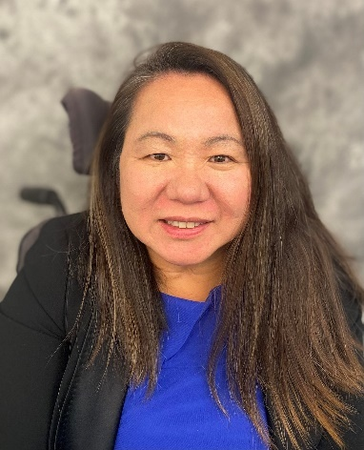
Yuki Nagasawa, SRC Vice-Chair and Policy Committee Chair  VR Counselor representative  Ex-Officio Member  - DOR Berkeley Branch Office  - Serving a second, full term (September 2024 – September 2027)  - Elected as SRC Vice-Chair on September 11, 2025 | 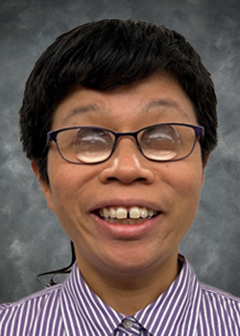
Hilary Lentini, SRC Treasurer  California Workforce Development Board representative  - Principal and Creative Director, Lentini Design and Marketing, Inc.  - Completed a first, full SRC term  (October 2023 – September 2025)  - Serving a second, full term (September 2024 – September 2027)  - Elected as SRC Treasurer on September 11, 2025 | 
Ivan Guillen, SRC Immediate Past Chair and State Plan Committee Chair  Client Assistance Program representative  - Senior Advocate Specialist, Client Assistance Program, Disability Rights California  - Served as SRC Chair from September 2023 – September 2025  - Serving second, full SRC term (September 2024 – September 2027) | 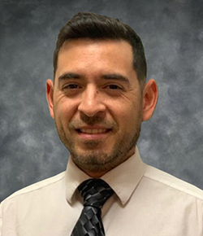
La Trena Robinson  Business, Industry and Labor representative  - Medical Social Worker, Kaiser Permanente  - Served as SRC Treasurer from September 2023 – September 2025.  - Serving second, full SRC term (September 2024 – September 2027) | 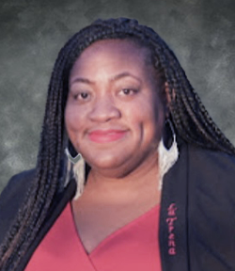
Gregory Meza  Business, Industry and Labor representative  - Work-Based Learning Coordinator, Specialized Vocational Services, Napa Valley Unified School District  - Serving first, full term (September 2024 – September 2027) | Not pictured
Michelle Bello  California Department of Education representative  - Education Programs Consultant, Special Education Division  - Serving first, partial term (November 2024 – September 2026) | 
Matthew Asner  Disability Advocacy Group representative  - President & CEO, The Ed Asner Family Center  - Serving first, full term (August 2025 – September 2028) | 
Michael Love  Current or Former DOR Consumer representative  - Outreach Coordinator, Student Services Professional II – Project Rebound, California State University, Sacramento  - Serving first, partial term (September 2025 – September 2026) | 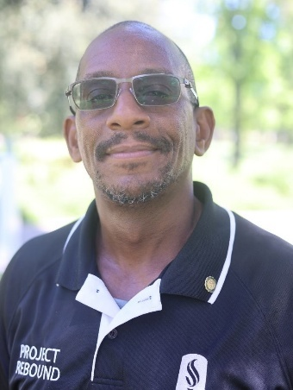
Shellena Heber  Community Rehabilitation Program representative  - Executive Director, Valley Center for the Blind – Madera, Fresno, Kings, Tulare, and Kern Counties  - Serving first, full term (September 2025 – September 2028) | 
Kim Rutledge  State Director representative  Ex-Officio Member  - Director, California Department of Rehabilitation  - Serving first, full term (September 2025 – September 2028) | 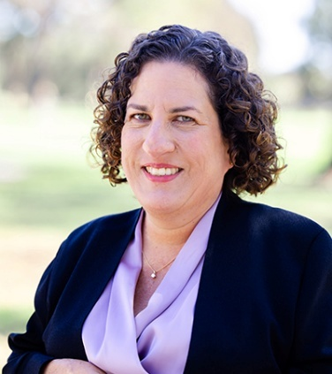

SRC Appointments Completed During the 2024-25 Term
Chanel Brisbane  Community Rehabilitation Program representative  - Director, Jobs and Transitions, Best Buddies International  - Served from September 2020 to January 2025 | 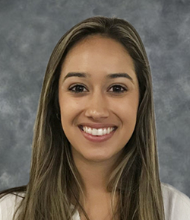
Theresa Comstock  Disability Advocacy Group representative  - Executive Director, California Association of Local Behavioral Health Boards and Commissions  - Served from August 2018 – September 2025 | 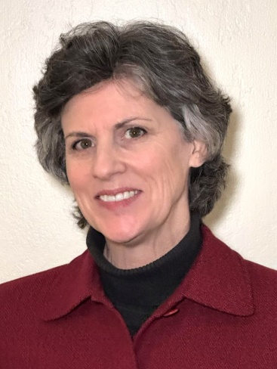
Joe Xavier  State Director representative  Ex-Officio Member  - Director, California Department of Rehabilitation  - Served from September 2012 – December 2024 | 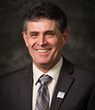
Brittany Comegna  Disability Advocacy Group representative  - Founder and CEO, Deaf and Disability Mediation Services  - Served from September 2024 – April 2025 | 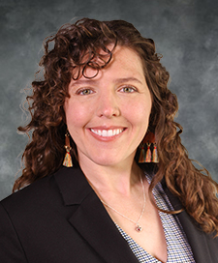
Eli Gelardin  Parent Training and Information Center representative  - Chief Executive Officer, Marin Center for Independent Living  - Served from September 2024 – January 2025 | 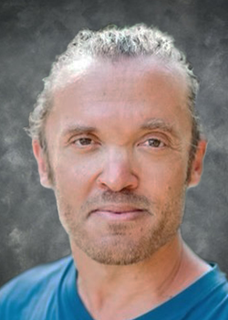

Interested in Becoming an SRC Member?
Would you like to advocate for the employment and independence for people with disabilities? If yes, then a position on the SRC may be for you! The SRC is always looking for new members to fill positions on the Council. If you are interested in serving on the SRC, please send your contact information to SRC@dor.ca.gov or call (916) 558-5897. Thank you for considering the SRC!

About the Department of Rehabilitation (DOR)
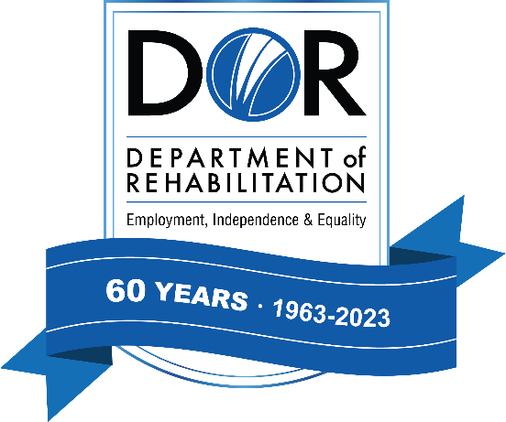
DOR administers the largest VR program in the country. DOR has a three-pronged mission to provide services and advocacy that assist people with disabilities to live independently, become employed and have equality in the communities in which they live and work. For additional information about DOR, visit www.dor.ca.gov

DOR Vision Statement: Employment, independence, and equality for all Californians with disabilities.

DOR Mission Statement: The DOR works in partnership with consumers and other stakeholders to provide services and advocacy resulting in employment, independent living, and equality for individuals with disabilities.

DOR Core Values
- We believe in the talent and potential of individuals with disabilities.
- We invest in the future through creativity, ingenuity, and innovation.
- We ensure our decisions and actions are informed by interested individuals and groups.
- We pursue excellence through continuous improvement.
- We preserve the public's trust through compassionate and responsible provision of services.

DOR Guiding Principles
- Delivering effective VR services, and other programs and services in an efficient, caring, professional and prompt manner.
- Attracting, developing, and retaining a competent, creative, and highly motivated workforce.
- Maintaining public trust by being fiscally responsible and ensuring quality programs and services.
- Sustaining our role as a respected leader in the disability community; inspiring hope in those we serve.



California State Rehabilitation Council
721 Capitol Mall
Sacramento, CA 95814
(916) 558-5897 / SRC@dor.ca.gov
dor.ca.gov/Home/SRC

