Annual Report
October 2022 – September 2023

The voice of the California Department of Rehabilitation stakeholder community

Table of Contents

Message from Ivan Guillen, SRC Chair 3
Message from the DOR Director 5
The Rehabilitation Act and the SRC 6
California SRC Overview 7
SRC Collaboration 10
SRC Quarterly Meetings 12
SRC Recommendations 14
Consumer Satisfaction Survey (CSS) 17
Vocational Rehabilitation Services Portion of the California Unified State Plan 20
Current SRC Members 22
SRC Appointments Completed During the 2022-23 Term 26
About the Department of Rehabilitation (DOR) 28

Message from Ivan Guillen, SRC Chair

December 2023

To the Honorable Governor Gavin Newsom and
RSA Commissioner Dante Allen

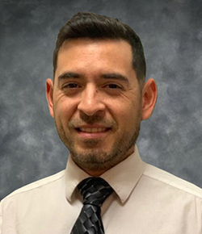
As the incoming Chair for the State Rehabilitation Council (SRC), I look forward to continued collaboration with our SRC members, DOR staff, and community stakeholders. I would like to thank our former Chair, Benjamin Aviles, for his passion and dedication in improving employment outcomes for Californians with disabilities. I am excited and grateful for the opportunity to serve as the new Chair, and I intend to bring the same passion and dedication in pushing forth the Council’s mission of assisting the DOR to provide effective services to its consumers. On behalf of the SRC, we are pleased to submit the 2023 Annual Report which highlights collaborations that led to the development and improvement of various DOR programs and policies.

The SRC engages with DOR and the stakeholder community to evaluate services, programs, and policies. The partnership between the SRC and DOR helps ensure that services result in employment, independence, and equality for Californians with disabilities. In the past year, the SRC’s priority areas of interest included:

• Behavioral Health: increasing and sustaining successful employment outcomes for individuals with behavioral health disabilities.
• Services for Students: expanding awareness of services offered by DOR to help students with disabilities explore and prepare for the workforce.
• Benefits Planning: expanding access to accurate information about working and impacts to disability benefits and health care coverage.
• Consumer Satisfaction: analyzing consumer satisfaction survey data and reviewing trends from administrative hearing decisions to identify opportunities for improvement.
• Diversity, Equity, and Inclusion: identifying inequities in DOR programs and services and strategies on how to reach underserved communities.

Individuals with disabilities have the right to pursue meaningful careers and enjoy full inclusion in society. DOR offers programs, services, and supports for individuals to obtain competitive, integrated employment. Hiring individuals with disabilities is good for businesses and contributes to vibrant, innovative, and productive workforces. Thank you for your support.

Ivan Guillen, SRC Chair
October 2023 – September 2024

Message from the DOR Director

To the Honorable Governor Gavin Newsom and
RSA Commissioner Dante Allen

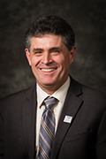
I am pleased to recognize the State Rehabilitation Council (SRC) for their commitment and accomplishments during Federal Fiscal Year October 2022 – September 2023.

Throughout this term, the SRC and the Department of Rehabilitation (DOR) partnership has continued to grow and strengthen. We engaged in timely and significant discussions on the partnership between DOR and local behavioral health agencies, student services, and benefits planning. The exploration of these topics and others resulted in the SRC adopting recommendations for the DOR’s consideration. DOR is grateful for the input offered by the SRC.

One of DOR’s core values is to ensure that our decisions and actions are informed by interested individuals and groups. The SRC helps DOR carry out this core value and we count on the SRC members to share the perspectives of their networks. The SRC is a critical partner as DOR actively modernizes, innovates, and continuously improves vocational rehabilitation services. As DOR updates the SRC on these efforts, SRC members are encouraged to share their insight, contributions, expertise, and connections. The SRC members have an important role in keeping their communities informed on DOR’s programs, services, and new initiatives.

DOR applauds the accomplishments of the SRC and looks forward to its ongoing collaboration with the SRC to advance the shared goal of employment, independence, and equality for Californians with disabilities.

Joe Xavier, DOR Director

The Rehabilitation Act and the SRC

When new SRC members are appointed by the Governor, they are provided with information on how and why the SRC exists in relation to findings, purpose, and principles of the Rehabilitation Act of 1973 (as amended). This foundational information provides context and helps to frame subsequent SRC discussions and activities.

Rehabilitation Act – Findings
In the Rehabilitation Act, Congress identified that individuals with disabilities have the right to: live independently, enjoy self-determination, make choices, contribute to society, pursue meaningful careers, and enjoy full inclusion and integration in society. In the Act, Congress also identified the need to support students with disabilities as they transition from school to postsecondary life.

Rehabilitation Act – Purpose
Based upon these rights, the purpose of the Rehabilitation Act is to serve individuals with disabilities to maximize competitive integrated employment, economic self-sufficiency, and inclusion into society. The purpose of the Rehabilitation Act also includes:
- Ensuring youth with disabilities have opportunities for post-secondary success.
- Having vocational rehabilitation (VR) service providers and employers provide meaningful input, thereby increasing employment opportunities and outcomes for individuals with disabilities.
- Ensuring the federal and state governments support the employment of individuals with disabilities.
- Understanding that VR has a “dual customer approach” that addresses both the needs of VR consumers and the needs of businesses. Providing businesses with training and technical assistance increases competitive integrated employment outcomes for individuals with disabilities.

The SRC and DOR Partnership
The SRC and the DOR partner together to carry out the Rehabilitation Act to maximize the employment and independence of people with disabilities. The partnership is a call to action to advocate and hear the voices of individuals served by VR in California. The partnership between the SRC and DOR ensures individuals with disabilities have resources and support to achieve their goals, while also ensuring the California VR program is effective and in compliance with federal regulations.

California SRC Overview

Section 105 of the Rehabilitation Act of 1973 (as amended) requires consumers, advocates, and other representatives of individuals with disabilities to participate in the administration and oversight of a state’s VR program. The SRC fulfills this mandate in California and is required for DOR to be eligible for and maintain federal VR funds.

Mission Statement
The SRC, in collaboration with the DOR and other community partners, reviews and analyzes policies, programs and services, and advises DOR on the quality and performance in meeting the Department’s mission.

Vision Statement
The voice of DOR’s stakeholder community.

Membership and Meetings
The SRC consists of 16 members appointed by California’s Governor, representing a variety of perspectives from the VR program and disability community. Members can serve up to two consecutive three-year terms.

The SRC meets quarterly throughout the year. Members of the public are noticed of the meetings in accordance with California’s Open Meeting Act.

Responsibilities and Activities
- Evaluation and Recommendations: The SRC reviews, analyzes, and evaluates DOR on the performance of California’s VR program. A particular focus is given to eligibility, service provision, and activities that impact employment outcomes. As a result of this process, the SRC adopts policy recommendations which are submitted to DOR for consideration.

- Comprehensive Statewide Needs Assessment (CSNA): To identify and assess the needs of Californians with disabilities, the SRC collaborates with DOR on the triennial CSNA. The current CSNA covers program years 2021 – 2023.

- State Plan: The SRC advises DOR on the development of California’s VR Services Portion of the Unified State Plan. The SRC and DOR partner to develop, agree to and review the plan’s priorities and goals.

- Assessing Consumer Satisfaction: The SRC partners with DOR to develop the annual Consumer Satisfaction Survey (CSS) and to evaluate the survey results.

- Coordination and Participation: The SRC actively engages with other councils and advisory bodies in California to enhance the number of individuals served. SRC members also participate in work groups, public meetings, and stakeholder forums.

SRC Committee Structure
The SRC utilizes a committee structure to provide for greater discussion, analysis, and oversight of the SRC’s mandated responsibilities and to assist with carrying out the SRC’s administrative functions. Each SRC committee may prepare recommendations for the full Council’s consideration. The SRC examines the committee structure for efficiency and alignment with the council’s priorities. The SRC current committees include:

- Monitoring and Evaluation: Partners with DOR on the CSS and the CSA, analyses Office of Administrative Hearing decisions, and reviews DOR’s progress on federal and state performance measures.
- Unified State Plan: Partners with DOR on the CSA and the VR Services Portion of the Unified State Plan.

- Policy Committee: Researches policy questions and topics identified by the SRC and develops draft recommendations.

- Executive Planning: Comprised of the SRC Officers and Committee Chairs, this committee plans the quarterly meetings and addresses leadership issues topics.

SRC Collaboration

Collaboration between the SRC and DOR
Throughout the October 1, 2022 – September 30, 2023 term, the SRC collaborated with DOR to work towards the shared goals of increased employment, independence, and equality for Californians with disabilities. The SRC appreciates DOR providing SRC members the opportunity to learn about DOR’s programs and policies and to provide substantive feedback. Collaboration highlights include:

- DOR Directorate and SRC Partnership: Each SRC quarterly meeting includes an in-depth report from the DOR Directorate on federal, state and department issues of interest. SRC members engage with the Directorate to ask questions, provide input, discuss challenges, and identify opportunities. The SRC Chair and Vice-Chair have monthly informal conversations with the DOR Directorate to strengthen the SRC and DOR partnership. Leadership topics and areas of shared interest and concern are discussed.

- DOR Participation: DOR executives, managers, staff, and subject matter experts attend the SRC quarterly meetings to listen, provide updates, engage in interactive discussions, and gather feedback from the SRC members. The information they provide helps inform the SRC’s recommendation development process.

- SRC Executive Officer: DOR employs a Staff Services Manager I (Specialist) to serve as the SRC Executive Officer, providing fulltime support to the SRC. Regina Cademarti served in this position from June 2020 – April 2022. Kate Bjerke served in this position from May 2017 – April 2020, and from May 2022 – present.

- Adopt-a-Region Program: Each SRC member meets quarterly with a DOR Regional Director (manager responsible for overseeing DOR operations in a specific geographical area). Through these discussions, SRC members build connections and learn about issues and opportunities from the local perspective. SRC members provide a report out from their Regional Director meetings at each SRC quarterly meeting.

SRC Quarterly Meetings

During October 1, 2022 – September 30, 2023, the SRC met four times as a full council. All SRC quarterly meeting agendas and approved meeting minutes are posted publicly at dor.ca.gov/Home/SrcMeetingArchive

November 30 – December 1, 2022 Quarterly Meeting Highlights
- Received a presentation from the UC Davis Violence Prevention Research Program.
- Heard about DOR’s Diversity, Equity, and Inclusion efforts.
- Received information on the services available through Community Rehabilitation Programs.
- Held an interactive discussion with DOR subject matter experts about DOR Student Services.
- Engaged with representatives from the California Committee on Employment of People with Disabilities regarding benefits planning and employment.

March 8 – 9, 2023 Quarterly Meeting Highlights
- Welcomed new SRC member, La Trena Robinson.
- Learned about DOR’s “Pathways to Success” and “Ready, Willing, and Able” career pathway programs.
- Heard about California’s State Digital Equity Plan.
- Analyzed consumer fair hearing and mediation decision summaries from April 2021 – September 2022.
- Received a comprehensive overview of the Client Assistance Program.
- Engaged with DOR representatives on the proposal to amend regulations pertaining to client owned vehicles and mileage rates for DOR consumers.
- Learned about DOR’s Workforce Development Section and the role of DOR Regional Business Specialists.
- Heard about current California Department of Education initiatives.

June 7 – 8, 2023 Quarterly Meeting Highlights
- Received a presentation on the CalDOR Consumer Payment Card.
- Heard about DOR’s Older Individuals who are Blind Program.
- Held an in-depth discussion with DOR representatives on questions related to Student Services.
- Learned about the numerous in-service trainings offered to DOR employees.
- Received an update on DOR’s client-owned vehicle use regulation package.
- Elected the 2023 Nominating Committee.
- Engaged in an interactive discussion with representatives from DOR’s executive team on the partnerships between DOR and behavioral health agencies.
- Received a report out from the SRC Policy Committee.

September 6 – 7, 2023 Quarterly Meeting Highlights
- Received an overview of DOR’s pilot to expand Work Incentives Planning services.
- Learned about how ASL interpreting services are provided to DOR staff and consumers.
- Heard about current California Department of Education initiatives.
- Recognized outgoing SRC members Benjamin Aviles, Nicolas Wavrin and Kecia Weller.
- Adopted policy recommendation 2023.1 regarding the Order of Selection.
- Elected the SRC Chair, Vice-Chair and Treasurer for the FFY 2023/24 term.

SRC Recommendations

As a result of the many productive and active discussions between the SRC, DOR and other stakeholders during the October 2022 – September 2023 term, the SRC adopted the following recommendations for DOR’s consideration. These recommendations reflect the SRC’s efforts to review, analyze and advise DOR on the performance and effectiveness of California’s VR program. The SRC looks forward to working closely with DOR on these areas of interest.

SRC Recommendation 2022.3 - Expanding Partnerships between Vocational Rehabilitation and Behavioral Health Agencies
Issue: Local behavioral health agencies could benefit from a state level partnership model like the Competitive Integrated Employment Blueprint. A formalized process (example: local partnership agreements) could help enhance services and increase opportunities for employment for individuals with behavioral health disabilities.

Recommendation: To increase and sustain successful employment outcomes for individuals with mental illness, the SRC recommends that DOR develop a blueprint that:
- Identifies barriers, challenges, and successful programs;
- Identifies the key stakeholders and leaders on the state and local level; and,
- Increases communication, resources and training for agencies and organizations.

DOR Response to SRC Recommendation 2022.3
DOR agrees with the SRC’s recommendation’s overarching goal “to increase and sustain successful employment outcomes for individuals with mental illness” and has already been developing a statewide, locally driven, initiative that includes a framework of strategies, collaborations, and efforts that is largely responsive to the three listed elements within the SRC’s recommendation above.

DOR’s behavioral health services initiative was developed with the understanding that broad reform efforts, led by Governor Newsom and supported by the California Health and Human Services Agency, are underway to align systems, increase coordination, and modernize and expand behavioral health services. DOR’s initiative was informed by the efforts of Governor Newsom’s Behavioral Health Task Force, which has provided DOR with the ability to identify and connect with key stakeholders including people living with behavioral health conditions, family members, advocates, providers, health plans, counties, and state agency leaders.

DOR’s initiative is founded on the understanding that employment serves to support behavioral health prevention, intervention, and recovery. The initiative’s efforts are centered on the DOR’s equity workforce impact goal which specifically focuses on behavioral health and employment. The goal is intended to improve the employment outcomes and earnings for people living with behavioral health conditions, with a focus on equity, with four specific targeted goals for individuals with behavioral health disabilities:

- Universally increase employment outcomes from 44% to 55%​.
- Universally increase quarterly median earnings for all to $7,000​.
- Ensure Black or African American participants also see an increase in quarterly median earnings to $7,000​.
- Ensure Hispanic participants also see an increase in quarterly median earnings to $7,000.

In support of this initiative and to achieve these equity workforce impact goals DOR’s Regional Directors have been actively connecting with key leaders at the local and regional level to increase partnerships with local behavioral health agencies and service providers.

DOR looks forward to sharing the Department’s framework, which addresses the three elements in this recommendation, for our equity workforce impact goal initiative with the SRC when these are finalized.

SRC Recommendation 2023.1 – Order of Selection
The SRC recommends that during an order of selection with closed categories that DOR support the provision of VR services to individuals who reapply and require services to maintain/retain employment even though the individual would otherwise be assigned to a waiting list.

CDOR Response to SRC Recommendation 2023.1
The DOR appreciates the SRC’s thoughtful deliberation regarding this issue and agrees with the SRC’s recommendation. The DOR has a long-standing history of effectively managing resources and equitability serving eligible individuals with disabilities. Although not necessary at this time, should DOR need to implement an Order of Selection with closed categories in the future, DOR will re-engage with the SRC to discuss how to operationalize this recommendation.

Consumer Satisfaction Survey (CSS)

The Rehabilitation Act calls for the SRC to review and analyze the effectiveness of, and consumer satisfaction with, DOR’s delivery of VR services and the employment outcomes achieved by consumers. To carry out this responsibility, the SRC collaborates with DOR to conduct an annual CSS. The SRC’s activities include developing and modifying the survey questions, advising on methodology, and developing policy recommendations based on the survey findings. The survey results are utilized by DOR to increase the effectiveness of the service delivery process, both internally and externally. The annual CSS cycle aligns with California’s State Fiscal Year (SFY) which runs from July 1st through the following June 30th. Throughout the term, the SRC Monitoring and Evaluation Committee actively met with DOR’s Planning Unit on the SFY 2021/22 CSS.

SFY 2021/22 CSS Highlights
- The 2021/22 CSS was delivered to a statistically valid sample size of 7,365 randomly sampled consumers. Surveys were sent using electronic or surface mail and made available in five translated languages.

- In the 2021-22 CSS, Vocational Rehabilitation (VR) and Potentially Eligible (PE) participants were categorized so that VR and PE survey data could be analyzed and reported separately. The VR response rate was 16.5% (825 responses) and PE was 5.1% (119 responses), for a total of 944 survey responses (a 13.7% response rate).

- The 2021-22 CSS was comprised of 19 questions designed to assess consumer satisfaction with services from DOR and its providers. These questions cover six categories: overall DOR experience, DOR counselors, service providers, employment services, job satisfaction, and employment opportunities.

- The most frequently reported disability types by VR participants were learning (24.3%), psychiatric (21.0%), and physical (20.1%) disabilities.
- Survey responses included ages from 98.8% of VR participants and their ages ranged from 17-88 years old. The average age of all survey participants was 39 years old.

- The most frequently reported employment barriers identified by unemployed survey participants were 1) being a student (23.6%), 2) still looking for employment (18.9%), or 3) needing additional help (13.2%).

- Survey participants were asked to rate their satisfaction with their DOR experience, DOR counselors, service providers, employment services, job satisfaction for employed individuals, and employment opportunities for unemployed individuals. The combined weighted score for all satisfaction questions was 78.6%, which indicates that survey participants were overall satisfied with the services they received from DOR and its providers.

After reviewing the 2021-22 CSS results, the SRC requested additional information and analysis from DOR on the findings below:

- Potentially eligible participants reporting “only somewhat satisfied with employment guidance (71.1% score) they received from their counselor.”

- Additional insight regarding the “lack of desired jobs” reported as a reason for unemployment.

- Data on the average amount of time from when a consumer enters VR to obtaining employment.

SFY 2022/23 CSS
The SRC continues to partner with the DOR Planning Unit on the CSS. In May 2023, the 2022/23 CSS was distributed. Changes to the 2022/23 CSS included the addition of race and ethnicity questions to better understand populations that may be unserved or underserved. In the 2022/23 CSS, the questions for potentially eligible participants were redesigned and the employment related questions were omitted. The CSS for potentially eligible participants now features three questions specifically towards student services. DOR will present the final results of the 2022/2023 CSS showing a three-year trend perspective with the SRC by summer 2024.

The SRC and DOR are dedicated to measuring consumer satisfaction and exploring how well the needs and expectations of consumers are being met. In particular, the SRC and DOR is exploring strategies to enhance survey engagement and increase the response rate. The SRC looks forward to continued collaboration on the CSS and developing policy recommendations that will lead to increased consumer satisfaction.

Vocational Rehabilitation Services Portion of the California Unified State Plan

The Workforce Innovation and Opportunity Act (WIOA) requires each state to submit a Unified or Combined State Plan that outlines a four-year strategy for the State’s workforce development system. For 2020 – 2023, California elected to submit a Unified State Plan, which includes six core programs: 1) Adult, 2) Dislocated Worker, 3) Youth, 4) Adult Education and Family Literacy Act, 5) Wagner-Peyser Services, and, 6) Vocational Rehabilitation (VR). The current California Unified State Plan covers July 1, 2020 – June 30, 2024 and the VR services portion is available online at https://www.dor.ca.gov/Home/StatePlan.

Throughout the October 2022 – September 2023 term, the SRC and DOR’s Planning Unit met during the quarterly meetings to review, discuss, and evaluate DOR’s progress in achieving the State Plan goals and priorities. These goals and priorities were jointly developed by the SRC and DOR.

2020 – 2023 DOR State Plan Priority and Goals
Priority 1: Increase the Quality and Quantity of Employment Outcomes
- Goal 1: Provide effective VR services with quality Individualized Plan for Employment developments consistent with workforce needs that lead to a career track with upward mobility offering sustainable living wages.
- Goal 2: Develop innovative approaches to support an increase in obtaining and sustaining employment for all consumers including those with the most significant barriers to employment.
- Goal 3: Improve systems alignment, coordination, and integration with partners to create a pathway toward successful employment outcomes for Californians with disabilities, including individuals with the most significant disabilities, with priorities focusing on individuals with behavioral health disabilities, students with disabilities, transition-age foster youth with disabilities, individuals with intellectual and developmental disabilities, and justice involved individuals with disabilities.

Priority 2: Services to Businesses
- Goal 1: Meet business talent needs by preparing consumers for in-demand jobs using local and regional labor market information.
- Goal 2: Build a direct pathway between employers and workers with disabilities including developing innovative ways to engage businesses.

Throughout the term, the SRC and DOR Planning Unit continued to develop and conduct the Comprehensive Statewide Needs Assessment (CSNA) together. In spring 2021, the SRC and DOR developed a plan for the 2021-2023 CSNA. In winter 2022, the SRC and DOR finalized the qualitative data collection instruments for the CSNA. In summer 2023, the SRC and DOR identified and developed findings for the CSNA. By January 2024, DOR will publish the final 2021-2023 CSNA report, including the findings and recommendations for DOR’s consideration. Moving forward to 2024, the SRC and DOR will jointly conduct the new triennial CSNA to determine the rehabilitation needs of individuals with disabilities in California.

Current SRC Members
(as of October 2023)

Ivan Guillen, SRC Chair
Chair, Unified State Plan Committee
Client Assistance Program representative
- Client Assistance Program Advocate at Disability Rights California
- Elected as SRC Chair on September 7, 2023 for a one-year term.
- Serving first full SRC term
(October 2021 – September 2024)

Chanel Brisbane, SRC Vice-Chair  Community Rehabilitation Program representative  - Director, Jobs and Transitions, Best Buddies International  - Elected as SRC Vice-Chair on September 7, 2023 for a one-year term.  - Serving second full SRC term  (September 2022 – September 2025) | 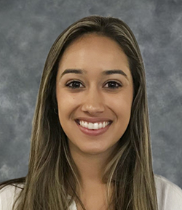
La Trena Robinson, SRC Treasurer  Business, Industry and Labor representative  - Medical Social Worker, Kaiser Permanente  - Elected as SRC Treasurer on September 7, 2023 for a one-year term.  - Serving first, partial full SRC term  (February 23 – September 2024) | 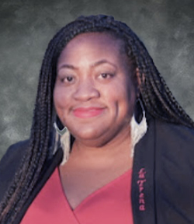
Susan Henderson  Chair, Monitoring and Evaluation Committee  Parent Training and Information Center representative  - Executive Director at the Disability Rights Education and Defense Fund  - Serving second full SRC term  (September 2022 – September 2025) | 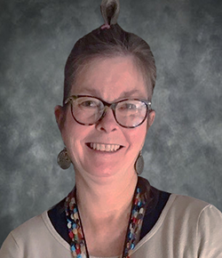
Theresa Comstock  Disability Advocacy Group representative  - Executive Director, California Association of Local Behavioral Health Boards & Commissions  - Serving second full SRC term  (September 2022 – September 2025) | 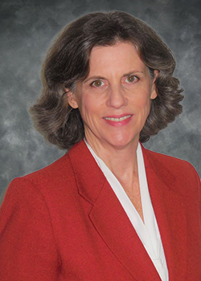
Jonathan Hasak  Business, Industry and Labor representative  - U.S. Public Sector Partnerships, Coursera  - Serving second full SRC term  (September 2022 – September 2025) | 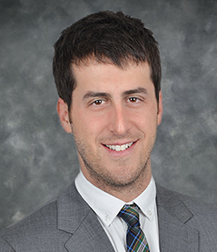
Elizabeth Lewis  Business, Industry and Labor representative  - Senior Recruiter, Union Pacific  - Serving first full SRC term  (March 2022 – September 2024) | 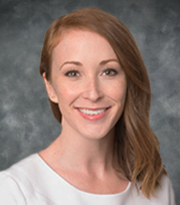
Yuki Nagasawa  VR Counselor Representative  - DOR Berkeley Branch Office  - Serving first partial SRC term  (September 2023 – September 2024) | 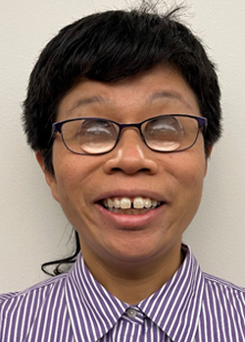
Candis Welch  Former VR Consumer Representative  - Diversity, Equity, and Inclusion Coordinator,  Los Angeles Homeless Services Authority  - Serving first full SRC term  (September 2023 – September 2026) | 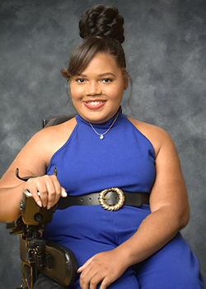

Hilary Lentini
California Workforce Development Board Representative
- Principal and Creative Director, Lentini Design and Marketing, Inc.
- Serving first full SRC term
(October 2023 – September 2025)

Joe Xavier

State Director Representative

Ex-Officio Member
- Director, California Department of Rehabilitation
- Serving fourth SRC term (September 2012 – September 2025)

SRC Appointments Completed During the 2022-23 Term
Benjamin Aviles  Current or Former DOR Consumer representative  - Financial Professional at World Financial Group/Revolution Financial Management  - Served as SRC Chair from September 1, 2022 to September 7, 2023.  - Completed two full SRC terms (August 2018 – September 2023) | 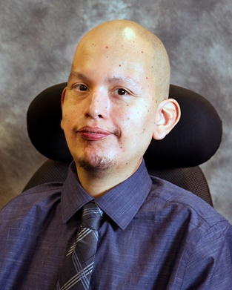
Kecia Weller, SRC Treasurer  Disability Advocacy Group representative  - National co-chair of the Peer Support Network at the National Adult Protective Services Association  - Served as SRC Treasurer from September 1, 2022 to September 7, 2023.  - Completed two, full SRC terms (October 2017 – September 2023) | 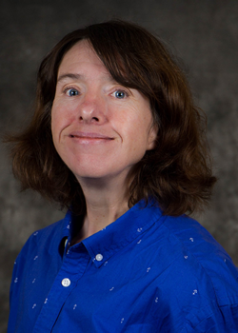

Nicolas Wavrin
California Department of Education (CDE) representative
- Educational Programs Consultant of the Programs and Partnerships Unit at CDE.
- Served as SRC Vice-Chair from September 2, 2021 – September 30, 2023.
- Completed two, full terms (June 2018 – September 2023)

Sara Abdrabou  VR Counselor representative  Ex-officio member  - Senior VR Counselor, Qualified Rehabilitation Professional, DOR Inland Empire District  - Served from March 2022 – February 2023. | 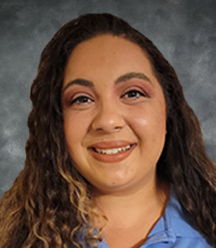

Lisa Hayes
State Independent Living Council representative
- Executive Director, Rolling Start, Inc.
- Served from September 2022 – September 2023

Interested in Becoming an SRC Member?
Would you like to advocate for the employment, independence, and equality for people with disabilities? If yes, then a position on the SRC may be for you! The SRC is always looking for new members to fill positions on the Council. If you are interested in serving on the SRC, please send your contact information to SRC@dor.ca.gov or call (916) 558-5897. Thank you for considering the SRC!

About the Department of Rehabilitation (DOR)
DOR administers the largest VR program in the country. DOR has a three-pronged mission to provide services and advocacy that assist people with disabilities to live independently, become employed and have equality in the communities in which they live and work. For additional information about DOR, visit www.dor.ca.gov

DOR Vision Statement: Employment, independence, and equality for all Californians with disabilities.

DOR Mission Statement: The DOR works in partnership with consumers and other stakeholders to provide services and advocacy resulting in employment, independent living, and equality for individuals with disabilities.

DOR Core Values
- We believe in the talent and potential of individuals with disabilities.
- We invest in the future through creativity, ingenuity, and innovation.
- We ensure our decisions and actions are informed by interested individuals and groups.
- We pursue excellence through continuous improvement.
- We preserve the public's trust through compassionate and responsible provision of services.

DOR Guiding Principles
- Delivering effective VR services, and other programs and services in an efficient, caring, professional and prompt manner.
- Attracting, developing, and retaining a competent, creative, and highly motivated workforce.
- Maintaining public trust by being fiscally responsible and ensuring quality programs and services.
- Sustaining our role as a respected leader in the disability community; inspiring hope in those we serve.

California State Rehabilitation Council
721 Capitol Mall
Sacramento, CA 95814
(916) 558-5897 / SRC@dor.ca.gov
dor.ca.gov/Home/SRC

