CALIFORNIA STATE REHABILITATION COUNCIL (SRC)
Quarterly Meeting Packet
November 30 – December 1, 2022

Table of Contents

Item 3 Detail Sheet: Approval of the August 31 – September 1, 2022 SRC Quarterly Meeting Minutes 3
Item 5 Detail Sheet: Violence Prevention Presentation and Discussion 57
Experiences of Violence in Daily Life Among Adults in California 57
Exposure to Violence, Firearm Involvement, and Socioemotional Consequences Among California Adults 57
California Public Opinion On Health Professionals Talking With Patients About Firearms 57
Firearm Ownership and Acquisition in California: Findings from the 2018 California Safety and Wellbeing Survey 57
New York Times Article: California Has America’s Toughest Gun Laws, and They Work 58
Item 8 Detail Sheet: Diversity, Equity, and Inclusion 61
SRC Recommendation 2020.4: Eliminating Racial and Ethnic Disparities 62
Item 13 Detail Sheet: DOR Independent Living and Community Access Division (ILCAD) 63
TBI California Community Health Needs Assessment 63
Item 14 Detail Sheet: Benefits Planning and Employment 64
SRC Recommendation 2021.4: Work Incentive Planning Information 65
CCEPD Integrated Benefits Planning Policy Recommendations 67
Item 15 Detail Sheet: Student Services 83
Questions from SRC Members about Student Services 83
Item 17 Detail Sheet: Debrief and Recommendations Discussion 85
DOR Waitlist and Post-Employment Services Data 88
Summary of SRC Recommendations from 2015 – 2022 94
Item 19 Detail Sheet: Adopt-a-Region Reports 116
Item 20 Detail Sheet: Future Agenda Items 117
Reference: SRC Membership Roster (as of 8/30/2022) 119
Reference: Glossary 120

Item 3 Detail Sheet: Approval of the August 31 – September 1, 2022 SRC Quarterly Meeting Minutes

Item Type: Action
The SRC members will review and vote to approve the minutes from the last SRC quarterly meeting.

Background:
The SRC met for their quarterly meeting on August 31 – September 1, 2022. The meeting minutes highlight the key issues discussed, motions proposed or voted on, and activities to be undertaken. The minutes also include the PowerPoint Presentations given during the meeting for reference.

Attachment:
Draft August 31 – September 1, 2022 SRC Quarterly Meeting Minutes (below)

California State Rehabilitation Council (SRC)
August 31 – September 1, 2022 Quarterly Meeting
9:00 a.m. – 4:00 p.m. each day
Department of Rehabilitation (DOR)
Meeting location: 721 Capitol Mall, Room 301, Sacramento, CA 95814
Virtual and telephone participation options offered via Zoom.

DRAFT MEETING MINUTES

Attendance
- SRC members (in person): Theresa Comstock, Chanel Brisbane, Susan Henderson, Benjamin Aviles, Nick Wavrin, Ivan Guillen, Joe Xavier.
- SRC members (by Zoom): Lisa Hayes, Sara Abdrabou, Elizabeth Lewis, Jonathan Hasak.
- SRC members absent: Kecia Weller.
- DOR staff (in person): Kate Bjerke, Priyanka Prasad, Jessica Grove, Mark Erlichman.
- DOR staff (by Zoom): Jeffrey McKey, Judy Gonzalez, Carol Asch, Trung Le, Lori Bruno, Sean Nunez, Gina Franklin, Phi Phi Phan, Kim Rutledge, Cynthia Butler, Rosa Gomez, Alicia Lucas, Ana Acton, Regina Cademarti, Megan Sampson, Rowena Okada, Emily Xongchao, Francesca Tayag, Nancy Wentling, Shanti Ezrine.
- Members of the public (in person): Tyler Szura, Adrianne Akers
- Members of the public (by Zoom): Tricia Robertson, Jacqueline Jackson,
La Trena Robinson, Danny Marquez, Nichole Kessel, Marion Rinkel, Rudy Acosta

Item 1: Welcome, Introductions and Membership Recognitions
Theresa Comstock, SRC Chair, called the meeting to order at 9:00 a.m. and welcomed SRC members and meeting attendees. The SRC members introduced themselves and a quorum was established. Kate Bjerke, SRC Executive Officer, recognized the following SRC reappointments announced by the Governor’s Office on August 24, 2022: Chanel Brisbane, Theresa Comstock, Jonathan Hasak, Lisa Hayes, Susan Henderson, and Joe Xavier.

Item 2: Public Comment
There were no public comments.

Item 3: Approval of the June 8 – 9, 2022 SRC Quarterly Meeting Minutes
Motion: It was moved/seconded (Wavrin, Guillen) to approve the June 8 – 9, 2022 SRC quarterly meeting minutes as presented. A roll call vote was taken (Yes – Comstock, Brisbane, Henderson, Hayes, Aviles, Wavrin, Guillen) (No – 0) (Abstain – 0) (Absent for vote – Hasak, Weller, Lewis). The motion carried and the approved minutes will be posted on the SRC webpage.

Item 4: Directorate Report
Joe Xavier, DOR Director, joined the SRC to provide a report out on national, state, and departmental topics of interest. Director Xavier began by congratulating the recently reappointed SRC members. Director Xavier highlighted the following commemorations taking place in September:
- Suicide Prevention Awareness Month (September)
- Labor Day (September 5th)
- Patriot Day (September 11th)
- National Rehabilitation Awareness Week (September 19 - 25, 2022)
- Deaf Awareness Week (September 19 - 25, 2022)
- California Memorial Project - commemorating those who died in state hospitals (September 19th)
- Native American Day (September 23rd)

Director Xavier recognized outgoing SRC Officers Theresa Comstock, Chair, Nick Wavrin, Vice-Chair, and Benjamin Aviles, Treasurer, and thanked them for their leadership and service. Kate Bjerke, SRC Executive Officer, presented certificates of appreciation to Comstock, Wavrin and Aviles.
National Updates
Director Xavier reported that the Council of State Administrators for Vocational Rehabilitation (CSAVR) and the National Coalition of State Rehabilitation Councils (NCSRC) conferences are taking place at the end of October 2022 in Texas. DOR staff and California SRC members are unable to attend these conferences as travel to Texas using public money is prohibited under AB 1887 (2016). DOR will be able to attend the Spring 2023 conferences in Maryland.

Regarding federal VR funding, 22 states relinquished $350 million, and $87 million was made available to the states as reallotment funding. The remaining federal VR reallotment funds were put into a Disability Innovation Fund. DOR requested and received $48 million in federal reallotment funding. DOR also requested $500,000 in reallotment funds for the Older Individuals who are Blind program; however, this funding was not available as states were able to spend their funding for this program.

State Updates
Director Xavier spoke about the three pillars that have, and continue, to drive the overall California Health and Human Services Agency (CalHHS) budget: 1) workforce development, 2) data exchange, and 3) improving infrastructure to better support service delivery. There is a focus on allocating funding to behavioral health services and person-centered approaches.

Department Updates
Director Xavier spoke about DOR Student Services and explained that there are approximately 150,000 students in California with an Individualized Education Program (IEP), and DOR is currently serving 30,000 of these students. DOR has established a new goal to increase the number of students served from 30,000 to 60,000 and a focus on ensuring that youth with disabilities leave high school with either 1) a family sustaining wage, or 2) enrolled in VR services. Updates were provided on department modernization efforts with information technology, licensing fees, electronic workflows, and DOR’s participation in Fi$Cal. An update on the CalDOR Payment Card was provided.

Director Xavier reported the following DOR senior leadership staffing updates:
- Sorath Hangse has been appointed as Regional Director for the San Jose District.
- Recruitment efforts are underway for the vacant Van Nuys District Regional Director position and the vacant DOR Chief Information Officer position.
- Applications are being reviewed for the vacant DOR Administrative Services, Assistant Deputy Director position.
- Efforts continue with the vacant Strategic Initiatives Officer and Chief Deputy Director positions.

Director Xavier provided the SRC with information on the difference between the roles of the DOR Regional Directors and District Administrators.
SRC members, Director Xavier and DOR staff then engaged in a discussion on the following topics:
- Reallotment funding, student services and utilization of Community Rehabilitation Programs (CRPs).
- Increasing marketing and awareness of DOR Student Services.
- Thinking of employment as a part of mental health treatment, and not waiting to engage with an individual about employment until after they have stabilized.
- The need to provide students with transportation for paid work experience.
- The true cost of being disabled and stigma that deters individuals from pursuing VR services. A barrier is that benefit systems are designed based on the concept that one must “fail to in order to benefit.”

Public comment: Jacqueline Jackson suggested convening a summit of school superintendents and other stakeholders to share information on DOR Student Services.

Item 5: Updated Individualized Plan for Employment (IPE)
Carol Asch, Assistant Deputy Director, DOR Vocational Rehabilitation (VR) Employment Division, began by providing background information on the IPE, which is developed in collaboration between the VR Counselor and DOR consumer to establish career goals and the steps and services to reach that goal. The IPE helps the consumer move forward, documents the career exploration that took place, and identifies how informed choice was incorporated. Asch identified the need to make the IPE form more user friendly and person-centered. In response, a workgroup was formed and reviewed each component of the IPE form to better reflect the consumer’s journey. Before the updates were finalized, focus groups with DOR staff and consumers were held. Training was provided to all VR Counselors and DOR Team Managers last spring on this new person-centered approached, and a second training was provided in August 2022. Asch spoke about the philosophy and practice of person-centered planning. Asch shared a PowerPoint Presentation that identified the new seven person-centered questions/statements on the updated IPE, compared with the prior versions of the questions (Reference – Attachment 1). Then, Asch reviewed the prior and updated versions of the DR 215 Individualized Plan for Employment for and attachments. The following feedback was offered: Acknowledgment that the process of emailing the IPE to consumers and the electronic signature process has been beneficial.

Item 6: Expedited Enrollment Update
Trung Le, Assistant Deputy Director, DOR VR Employment Division, provided an update on the implementation of DOR’s expedited enrollment. Through this initiative, VR Counselors use their expertise and observation to determine if an applicant is eligible for VR services. Data has shown that 98% of DOR applicants who apply for services will be eligible, and that many applicants are already working with other entities and agencies. Evaluations can still be performed if needed. Through the expedited enrollment process, VR Counselors have a skilled, in-depth interview with interested applicants, and over 85% of applicants can be determined eligible between one to five days. Data shows that the quicker an individual is determined eligible and moved into an IPE, the percentage of success is higher. DOR will be sharing information with other states on the expedited enrollment process. SRC members shared the following feedback/questions:
- The independent living program does not require medical documentation for eligibility; rather, an individual just needs to self-identify as having a disability.
- Often times consumers encounter many systems and agencies, and its overly burdensome to ask individuals to continuously verify their disability.
- Can consumers apply online for VR services?

Public comment: Danny Marquez thanked the SRC for including this item on the agenda and recognized the benefits of expedited enrollment for consumers.

Item 7: Consumer Reimbursement of Goods and Services Process and CalDOR Payment Card Program Overview
Lori Bruno, Chief, Gina Franklin, Accounting Administrator I, Supervisor, and Phi Phi Phan, Associate Governmental Program Analyst from DOR’s Accounting Services, along with Sean Nunez, Staff Services Manager I, DOR Napa Branch, presented on the consumer reimbursement process and the CalDOR Payment Card Program.

A category identified in DOR fair hearing complaints has included reimbursement requests for goods and services which were not previously authorized by DOR. Bruno began by providing background information on the consumer reimbursement process and the steps involved, which include: a consumer needs to first discuss the request with their VR Counselor; the VR Counselor considers the request and determines if the items/services are needed for the employment plan and are eligible for reimbursement; the VR Counselor enters a case note documenting the approval; the consumer is notified they can use their own funds to purchase the item; and then the consumer submits their receipt for review by the VR Counselor (or their delegate). After these steps are completed, DOR issues an authorization and reimbursement check to the consumer. The most common challenge related to denied consumer reimbursement requests is that the consumer did not first contact their VR Counselor before purchasing the items, as required by federal regulations. Another issue that can arise is when the consumer does not submit a receipt, or the receipt is not itemized. A discussion was held on if, and how, DOR assists consumers when follow up with a receipt is needed.

Then, SRC members received a presentation (reference – Attachment B) on the CalDOR Payment Card Program, which provides consumers with a quick and easy way to purchase approved goods and services directly from businesses and vendors. Bruno provided background information on the history and need for an electronic payment card, which will be transformational for consumers and the Department. Consumers will be able to purchase approved goods and services quickly, conveniently, and confidentially. The program will also include a web-based portal where consumers can view their personalized payment account, check their authorized balance, receive notifications and upload receipts. The CalDOR Payment Card is a Mastercard and will be accepted by most online or point-of-sale register merchants. This portal went live on August 30, 2022, and the DOR Napa Branch is conducting the initial testing with consumers, which will inform future developments, trainings, and instructional materials. Four DOR Districts will pilot the CalDOR Payment Card, and by the end of 2022, the program will rollout statewide. Franklin provided additional background information and spoke about the benefits of the CalDOR Payment Card for both consumers and staff. Nunez spoke about the experience for the consumer, which will include same day services, increased privacy, and a reduction in the need for consumer reimbursements. Discussion highlights with the SRC members included:
- Question if Community Rehabilitation Programs (CRPs) will receive training on the CalDOR Payment Card.
- Clarification that the administrative portal went live on August 30, 2022. The CalDOR Payment Card webpage will launch in the near future.
- Information on how VR Counselors will authorize funds for an item that is needed right away.
- Educating consumers about the importance of informing DOR staff in a timely manner when items are needed.
- Discussion regarding the DOR logo on the CalDOR Payment Card and privacy.

Item 8: DOR Social Media
Kim Rutledge, Deputy Director, and Cynthia Butler, Public Information Officer II, from DOR’s Office of Legislation and Communications joined the SRC to discuss how DOR engages with consumers and stakeholders through social media. Rutledge reviewed the roles and functions of the DOR Office of Legislation and Communications, which includes tracking bills that would impact DOR and/or people with disabilities, partnering with other departments, proposed legislation, and interacting with legislative staff and stakeholders. Rutledge offered to attend a future SRC meeting to provide additional information on DOR’s legislative activities. Regarding communications, Rutledge’s office provides an array of services including overseeing the DOR website, developing collateral materials, event planning, and managing DOR’s social media platforms. Butler provided an overview of DOR’s presence on Facebook, Twitter and LinkedIn and the goals for these platforms (reference – Attachment C). Questions and discussion highlights included the following:
- Audience engagement, analytics, partnering with other agencies, and post promotion.
- Suggestion to post success stories on social media. Discussion about the DOR’s Notice Abilities blog.
- Suggestion to identify which platforms are most effective for different audiences such as parents and students.
- Challenges related to the lack of awareness about DOR.
- Concept that “youth attract youth”, and to have suggestion to have youth interns who can assist with social media.
- Branding concept that DOR is the “door” that brings people into community life.
- Suggestion to encourage engagement between consumers through social media.
- Question about the possibility of DOR working with a marketing firm on rebranding.

Item 9: Diversity, Equity, and Inclusion
Rosa Gomez, DOR Chief Equity Officer, provided the SRC with information on DOR’s diversity, equity, and inclusion (DEI) strategies from a national, state, and departmental level. DOR participates on the national CSAVR group working to bring DEI efforts across all state VR agencies to gain an understanding of the various challenges that historically marginalized groups experience, including people with disabilities. Through this effort, an online repository of DEI materials (videos, training materials, articles, etc.) will be made available for VR departments to access. Gomez spoke about DEI efforts at the state level, which include DOR’s participation on the CalHHS Justice, Equity, Diversity, and Inclusion (JEDI) committee to help implement budgetary changes, such as language policy and resources, developing a training program to identify and eliminate barriers, and developing an equity dashboard across major health and human services programs to identify data gaps by race ethnicity, sexual orientation and gender identity. Gomez spoke about her participation in the Capitol Collaborative on Race and Equity, a community of California state government teams working together to advance racial equity. At the Department level, DOR is considering the development of a racial equity plan. Gomez spoke about the various DOR affinity groups and provided an update on DOR’s Disability Advisory Committee.

Kate Bjerke, SRC Executive Officer, reviewed the policy question posed to the SRC by Joe Xavier, DOR Director: how can inequities in DOR’s programs and services be identified, and what methodologies can be used to address these equity gaps? Bjerke highlighted themes and findings from the 2020 Comprehensive Statewide Assessment, specifically section three, “Individuals with disabilities who are minorities and those who have been unserved or underserved by DOR” (reference – Attachment D). Bjerke noted that she reached out to the Strategic Growth Council to gather information about the equity action plan development process. Questions and discussion highlights with the SRC included the following:
- Suggestion to consult with other State entities that have engaged in this type of work and data analysis. For example, data from the Department of Developmental Services (DDS) shows notable differences in service access among racial/ethnic and language communities.
- DOR could inform proposed legislation that includes equity hiring goals to ensure disability is included (example: SB 485).
- Keep DEI as a standing SRC agenda item.
- Comment regarding digital literacy and access to online training programs.
- Collecting characteristics at application for potentially eligible caseloads would provide additional insight and data.
- The RSA reporting requirements can present limitations as it relates to DEI data collection. Bjerke provided an example about gender identity categories.
- Older adults who want to work is an underserved population.
- There is a need for increased services for individuals who are deaf-blind.
- Ensure that DOR’s affinity groups inform the development of the Department’s equity action plan.
- Provide cultural explanations when presenting data.

Item 10: Adopt-a-Region Reports
SRC members reported out from their recent Adopt-a-Region discussions:
- Redwood Empire District: Theresa Comstock, SRC Chair, connected with David Wayte, Regional Director. District collaborations include the Breaking Barriers grant and partnership with the America’s Job Center of California Job Link program, both of which focus on serving individuals experiencing homelessness. Wayte is increasing collaboration with the county Continuum of Care Committees to strengthen the employment component provided in wrap around services. Efforts are taking place in the district to reach out to superintendents and school leaders to promote DOR Student Services. Work experience opportunities are being established for both adults and students. District successes include participating in the State Internship Program and implementation of the expedited enrollment process. Challenges include staff vacancies due to rural areas and the high cost of living.
- Santa Barbara District: Comstock connected with Brian Winic, Regional Director, and Justin Winic, District Administrator. Reported challenges include DOR’s name and branding. Challenges also include staff vacancies due to the high cost of living and the loss of farming jobs in the area due to water shortages. A success is that the Santa Barbara District met their 2021/22 goals.
- Greater Los Angeles District: Nick Wavrin, SRC Vice Chair, was informed by Maria Turrubiartes, Regional Director, that there are no District updates, but she did mention an upcoming initiative with the Inland Empire District.
- Inland Empire District: Benjamin Aviles, SRC Treasurer, connected with Robert Loeun, Regional Director. For the last fiscal year, Inland Empire led the state with the most successful employment placements. The district has a strong relationship with local education agencies and is working on partnering with behavioral health agencies. Challenges include finding competitive integrated employment opportunities for the intellectual and developmental disabilities (I/DD) population, and lack of American Sign Language (ASL) interpreters. Aviles noted that the Inland Empire management team meetings begin with success stories. Upcoming opportunities for the district include increasing support for the I/DD population, increasing the number of self-employment opportunities, working with youth wrap around services, and an apprenticeship program focused on the medical sector. As of April 2022, the District provided services to over 4,000 students.
- Orange/San Gabriel District: Chanel Brisbane, SRC Member, connected with Sherri Han-Lam, Regional Director, who spoke about her experience with the VR program and her new role. The district has a health services sector-based program and continues to research the impact of COVID-19 and needs of consumers.
- Greater East Bay District: Susan Henderson, Chair, SRC Monitoring and Evaluation Committee, connected with Della Randolph, Regional Director, who reported that the district is participating in more in-person events and school visits. Greater East Bay has embraced expedited enrollment, staff completed the updated IPE training, and efforts are taking place to expand work experiences for students. The district will launch an adult work experience in the near future. The district held a Windmills training with staff and are planning National Disability Employment Awareness Month (NDEAM) events.
- San Diego District: Ivan Guillen, Chair, SRC Unified State Plan Committee, met with Peter Blanco, Regional Director, and Jeffrey Noyes, District Administrator. The district is expediting most applications (85%) within three days and is experiencing increases in applications and referrals of consumers to the career pathways program. New projects include working with foster youth and providing wrap around services with a focus on union jobs for re-entry populations in partnership with a community college. A challenge has been the culture shift as it relates to expedited enrollment and offering advanced training options to consumers. Guillen spoke about a Disability Rights California (DRC) presentation given to DOR that focused on trends and patterns of denied requests for advanced training. It was noted that perhaps DRC can be a resource as DOR develops its equity action plan.
- Northern Sierra District: Elizabeth Lewis, SRC member, connected with Vivian Hernandez-Obaldia, Regional Director, who reported that a strength is the Northern Sierra District staff and their partners who continue to serve the communities and carry out the DOR mission. A challenge is staff vacancies, particularly for VR Counselors. An upcoming opportunity is partnering with a nonprofit organization to provide services to underserved communities, and the district plans to expand their participation in the Paid Internship Program and the State Internship Program. The district works with youth and students with disabilities and has several Transition Partnership Programs, We Can Work contracts, and summer training and work experience opportunities.
- San Joaquin Valley District: Lisa Hayes, SRC member, connected with Shayn Anderson, Regional Director. The district serves fourteen counties and has six offices, and their greatest challenge is staff vacancies. A successful program is “Foundations for Employment”, offered during the first and third weeks of the month to help consumers with resume writing and filling out applications.
- San Jose District: Jonathan Hasak, SRC member, reported that Sorath Hangse was recently appointed as Regional Director. Hangse wants the district to be more inclusive and enhance partnerships. The district is working on a new strategic plan and vision that focuses on career opportunities and pathways. The district offers adult work experience, which will launch in September 2022. The district is also hosting virtual job fairs. It was noted that staff vacancies are a challenge for the district.
- Blind Field Services District: Sara Abdrabou, SRC member, reported that Peter Dawson, Regional Director, was not available to meet.

Recess
The SRC quarterly meeting recessed until 9:00 a.m. on Thursday, September 1, 2022

Item 11: Reconvene, Welcome, and Introductions
Theresa Comstock, SRC Chair, welcomed SRC members and attendees back for day two of the quarterly SRC meeting. A quorum was established.

Item 12: Public Comment
There were no public comments.

Item 13: DOR Independent Living & Community Access Division (ILCAD)
Ana Acton, Deputy Director, DOR ILCAD, joined the SRC to continue the discussion from the June 8 – 9, 2022 quarterly meeting on identifying program coordination opportunities to increase access and outcomes for individuals with disabilities. Acton reported on ILCAD’s state fiscal year 2022/23 investments, which include a $10 million Community Living Fund that builds off the Master Plan on Aging, the Aging and Disability Resource Connection Initiative, and the No Wrong Door Initiative. The Community Living Fund will provide transition or diversion services to support community-based living. This will enable older adults and people with disabilities to access funding to move from an institutional setting to the community, or to support individuals who are at risk of going into an institution to remain in their community. Acton introduced Regina Cademarti, who joined the ILCAD management team to assist with the Community Living Fund and other ILCAD initiatives. Comstock noted that she has met individuals in adult residential facilities who are employed as they receive transition services.
Acton reviewed the sections within ILCAD: Independent Living and Assistive Technology, the Assistive Technology Program, the Traumatic Brain Injury (TBI) Program, the Disability Access Section, and the California Committee on Employment of People with Disabilities.

Acton spoke about the Aging and Disability Resource Connection, which will serve individuals of all disabilities and ages. Community providers will link individuals, through enhanced information and referrals and person-centered counseling, to specific services needed and will help individuals navigate the disability and aging services infrastructure. The initiative will also support individuals experiencing urgent needs and transitional situations. There is an opportunity to incorporate vocational rehabilitation and employment supports into the No Wrong Door initiative. Discussion highlights included:
- In addition to programs agreeing to work together, providers need to be paid for their services, particularly small providers who may not have the capacity to wait for reimbursements.
- Employment is critical for an individual’s success, from a financial, quality of life, and community participation perspective.
- Discussion if a master service agreement could assist with program coordination.

Megan Sampson, Chief of DOR ILATS, spoke about the TBI California Community Health Needs Assessment which 1) analyzed hospital data, 2) conducted a TBI needs assessment, and 3) surveyed individuals in California with and without TBI. Sampson reviewed highlights and findings from the needs assessment, including the percentage of the population that has experienced a TBI, the physical and mental impacts TBI can have on an individual, demographics, and unmet needs including employment services. Sampson spoke about the need to support the employment of individuals who have TBI and who want to work, particularly through accommodations. It was asked if the medical community uses the same definition and medical code for TBI as used in the needs assessment.

From a policy recommendation perspective, it was suggested that TBI needs to be included more openly in discussions, and TBI stigma needs to be reduced. TBI symptoms are discussed but not the systemic issue itself. TBI prevention, the importance of early identification, early services and support, and the ripple effect of TBIs increasing risk of homelessness and incarceration, needs to be discussed as well. Increasing TBI education and person-centered training internally within DOR and in community-based organizations could help.

Item 14: Money Follows the Person, California Community Transitions Project
Department of Health Care Services (DHCS) representatives Nichole Kessel, Marion Rinkel, and Rudy Acosta provided an overview of the Money Follows the Person, California Community Transition (CCT) program that assists individuals on Medi-Cal to transition from institutional settings to community living (reference – Attachment E). Questions and discussion highlights included the following
- Question on CCT funding and if the number of agencies that provide services will increase. Kessel provided background information on CCT funding and noted there is a goal having approximately 24 agencies throughout California.
- The timeline and process for an agency to become a CCT service provider, which can range from three to twelve months.
- Challenges that independent living centers experience with having to front the money to provide services and then wait between three to twelve months to be reimbursed from Medicaid.
- How to integrate VR services. When individuals visit an independent living center for transition services, a detailed transition plan is developed. The focus is transitioning the individual back into the community, and a DOR referral is provided. The intersection of employment and the CCT program could be identified in these transition plans. This could be a significant opportunity for the CCT program and the DHCS team is open to discussing this further.
- How do individuals in skilled nursing facilities become aware of CCT services? Kessel spoke about statewide marketing campaigns, contact lists, relationships that are developed locally, and the need for continuous education and reeducation.
- The CCT is a bridge program from the institution to where the individual will live permanently. CCT helps to get an individual into community living, but then success is dependent on other providers supporting the individual (example: Medicaid, employment, rehabilitation services, etc.).
- CCT is a statewide program, but its reach is limited by the number of providers available.

Item 15: Overview of the DOR Budget Building Process and Program Funding
Rowena Okada, Chief, DOR Budget Fiscal Forecasting and Research (BFFR) and Emily Xongchao, Manager, BFFR, presented information on DOR’s budget building process and provided an overview of DOR program funding.
(reference – Attachment F). Kate Bjerke, SRC Executive Officer, explained that this information can assist the SRC as they consider the following policy question often asked by Joe Xavier, DOR Director: If DOR was going to make a budget ask, what should that ask be, and why? Bjerke explained that additionally, the information from the BFFR team will also inform the next agenda item regarding the intersection of retention plans and the order of selection. Questions and discussion highlights included:
- Question regarding the state general funding that DOR receives. Federal VR regulations require that states incur a portion of expenditures from non-federal funds to meet the state’s cost sharing requirements. The federal share is 78.7% and the state share is 21.3%.
- How is DOR impacted if the state provides a match of over 21.3%? If the state matches above and beyond what’s required, DOR’s “maintenance of effort” will increase for future years, i.e., DOR would have to provide that level match moving forward.
- How can budget change proposals (BCPs) be used as a tool to increase collaborations between agencies?
- What happens to federal funds that DOR receives but does not have authority to spend? In this case, DOR could submit a BCP to the Department of Finance requesting to increase spending authority.
- Are BCPs always granted? It depends on the proposal and whether or not new federal dollars coming into California require a state match. A priority of the administration is to pursue federal funding for California and bring federal dollars into the State.
- How is VR funding divided between CRP and direct VR service providers and does DOR spend all of its funding? Yes, DOR does spend all its VR funding, included awarded reallotment funds. There is no set formula for how funding is divided.
- BCP recommendations and concepts need to be submitted to DOR between January – March 2023 for consideration in the next budget cycle.

Item 16: Future Policy Considerations – Intersection of Retention Plans and Order of Selection
Francesca Tayag, Analyst, DOR BFFR, provided information on the VR Order of Selection (OOS) waitlist, which goes into effect when there are not enough resources to serve everyone who is eligible for VR services. Individuals with the most significant disabilities are given priority over those with less significant disabilities, which is the order of selection process. Priority categories are based on how much impact an individual’s disability has on their ability to find competitive integrated employment. DOR utilizes three priority categories and has been in an OOS since 1995. Consumers on the waitlist receive referrals to other providers. Currently, DOR serves all three priority categories. Youth and students receiving pre-employment transition services are not impacted by the OOS and are not subject to a waitlist.

Nancy Wentling, Chief, and Shanti Ezrine, Manager, from the DOR Program Policy Implementation Section, presented additional information on the OOS, priority category determination, the updated policy that clarifies when post-employment services are provided, and the importance of DOR supporting individuals with retaining employment (reference – Attachment G). The following policy question was posed for the SRC’s consideration: If DOR implements an OOS with closed categories, would DOR support the provision of VR services to individuals who reapply and require services to maintain/retain employment even though the individual would otherwise be assigned to a waitlist? Questions and discussion highlights included:
- If policies are going to be changed, will the California Code of Regulations (CCRs) need to be updated? It was noted that even though the federal regulations provide a provision, it would still be important to update the CCRs and state level policies to lessen confusion and delays.
- Some consumers identify their career goal quickly and their process can be expedited, and some consumers are unsure of their career goal and need more time. Both circumstances are fine, and the focus is on serving the individual with no undue delay.
- It would be helpful for the SRC to receive data on the cost, trends and patterns of what individuals request when returning to DOR for post-employment services.
- DOR does not currently have a position on this policy question. The Department wanted to bring the policy question forward to advisory groups first for consideration.
- Could DOR provide enhanced information and referrals for consumers on the waitlist?

Item 17: Debrief and Recommendations Discussion
Kate Bjerke, SRC Executive Officer, reviewed numerous highlights, questions and areas of interest identified by the SRC members over the past two days. Bjerke also reviewed the SRC’s list of policy questions for consideration and the running list of future agenda items. Theresa Comstock, SRC Chair, identified five areas of interest: 1) a barrier for students is transportation and clothing; 2) revisiting a prior SRC recommendation on DEI and determining if updates are needed; 3) the need for disability to be part of DEI legislative and advocacy efforts; 4) reviewing the TBI needs assessment and developing recommendations; and 5) considering the DOR’s policy question on the order of selection and retention services. Comstock asked the SRC members to share their initial thoughts regarding the prioritization of retention services and the order of selection. Many SRC members supported the prioritization of retention services to help individuals maintain their employment; however, it was identified that more information and data is needed before a formal recommendation is adopted. Bjerke will summarize the feedback, questions, and future agenda items for review and prioritization during the October 5, 2022 SRC Executive Planning Committee meeting.

Item 18: SRC Officers, Members, and Executive Officer Reports
- Theresa Comstock, SRC Chair: Comstock expressed her appreciation to the SRC and noted that it has been an honor to serve as Chair.
- Nick Wavrin, SRC Vice-Chair: Wavrin provided updates from the California Department of Education (CDE) and noted that the Alternative Pathway to a High School Diploma program will launch this year. The CDE will issue guidance on program roll out and data reporting requirements to teachers, students, and families. The Individualized Education Program (IPE) workgroup will reconvene and continue working on developing a standardized IPE template that is student centered and mapped backwards from employment. The Family Empowerment Centers have expanded from 13 to 36 across California with the goal of having a total of 41.
- Benjamin Aviles, SRC Treasurer: Aviles thanked the SRC officers and members. He noted that the SRC’s budget is still experiencing a cost savings and has spent approximately 60% of its current budget.
- Ivan Guillen, Chair, SRC Unified State Plan Committee: Guillen stated there are no updates at this time regarding the Unified State Plan. Disability Rights California has hired two new Client Assistance Program advocates in the Los Angeles area.
- Susan Henderson, Chair, SRC Monitoring and Evaluation Committee: Henderson anticipates there will be a preliminary review of the Consumer Satisfaction Survey data available in November 2022. Henderson noted that the start of the school year is a busy time for the Parent Training and Information Centers.
- Chanel Brisbane, SRC Member: Brisbane stated that her organization, Best Buddies, is hiring.
- Jonathan Hasak, SRC Member: Hasak noted that his organization, Coursera, has a partnership with the California State Library, and individuals can visit the library and access free upscaling opportunities.
- Lisa Hayes, SRC Member: Hayes reported that the State Independent Living Council is beginning work on the 2023 – 2026 State Plan for Independent Living. A priority issue is home and community-based services and trying to find solutions to the shortage of available in-home support services workers.
- Elizabeth Lewis, SRC Member: Lewis noted that her organization, Union Pacific, is hiring.
- Sara Abdrabou, SRC Member: Abdrabou reported that her DOR District, Inland Empire, will host a regional youth leadership forum in October.

Item 19: Annual Election of the SRC Officers
Kate Bjerke, SRC Executive Officer, reviewed the process for the annual election of the SRC officers. Before announcement of the slate of candidates, the floor was opened for additional nominations. There were no additional nominations, and the slate of candidates was announced. It was then moved/approved (Brisbane/Henderson) to elect the following slate of candidates recommended by the SRC Nominating Committee on August 17, 2022:
- Chair – Benjamin Aviles
- Vice-Chair – Ivan Guillen
- Treasurer – Kecia Weller.
A roll call vote was taken (Yes – Comstock, Brisbane, Hasak, Henderson, Hayes, Aviles, Wavrin, Guillen, Lewis) (No – 0) (Abstain – 0) (Absent for vote –Weller). The motion carried and the slate of candidates was elected to serve as SRC officers for the October 1, 2022 – September 30, 2023 term.

Item 20: Identification of Future Agenda Items
Kate Bjerke, SRC Executive Officer, reviewed the SRC’s list of future agenda items. This list, updated with the SRC’s feedback from the August 31 – September 1, 2022 quarterly meeting, is available for reference online. Additional suggestions included: learning about the new IEP and 504 plans and the intersection with VR services and how DOR might prepare for an anticipated influx of individuals seeking services due to long COVID-19

Public comment: La Trena Robinson offered the following suggestion via Zoom chat – “I also see a potential collaboration between the new California mental
health court laws and the Department of Rehabilitation. The DOR referrals for job services and training after clients are psychiatrically stable.”

Adjourn
Theresa Comstock, SRC Chair, adjourned the August 31 – September 1, 2022 SRC quarterly meeting.

Attachment A – Item 5 PowerPoint Presentation
Updated and Prior IPE Plan Questions/Statements

Slide 1
1. Why did we choose this employment goal?
Previously
1a) What are the reason for choosing the employment goal?
1b) Please explain how this choice of employment goal will lead to a job (address the labor market information).

Slide 2:
2. These are the steps I need to accomplish to reach my employment goal.
Previously: What steps, stages, or phases are needed to reach the employment goal? For a youth with disabilities (ages 14 – 24) or a student with disabilities (ages 16 – 21), identify the steps, stages, or phases toward employment including, collaboration with secondary schools, and/or other community partners, planning coordination and/or delivery of specific transition services, such as supports needed to achieve the employment outcome or project post school employment outcome and “pre-employment transition services” (PreETS) for students with disabilities.

3. These are the services we agreed are necessary to reach my employment goal.
Previously: What specific services are needed to reach the employment goal? (if the employment goal is in a supported employment setting, identify the necessary extended services. Describe the source, or anticipated source, of the extended services.

4. How did we choose or arrange these services?
Previously: How were the services arrnaged or chosben? (For example: researched schools, met with school counselors, talked with the DOR counselor, and selected the most suitable training program.

5. How and when will progress toward my employment goal be evaluated?
Previously:
5a) How will progress toward the employment goal be evaluated? (for example, school grade reports, work or training reports discussion between counselor and consumer?)
5b) How often will progress be reviewed (must be reviewed at least annually).

6. These are my responsibilities toward the cost of my Plan.
Previously: Describe the consumer’s responsibilities towards the cost of the plan and securing comparable benefits.

7. What additional services will I need after I reach my employment goal, if any?
Previously: What is the project need for post-employment services?

Attachment B – Item 7 PowerPoint Presentation
CalDOR Payment Card

Slide 1

Slide 2
Slide 3

Slide 4

Slide 5

Slide 6

Attachment C – Item 8 PowerPoint Presentation
DOR Social Media Platforms

Slide 1
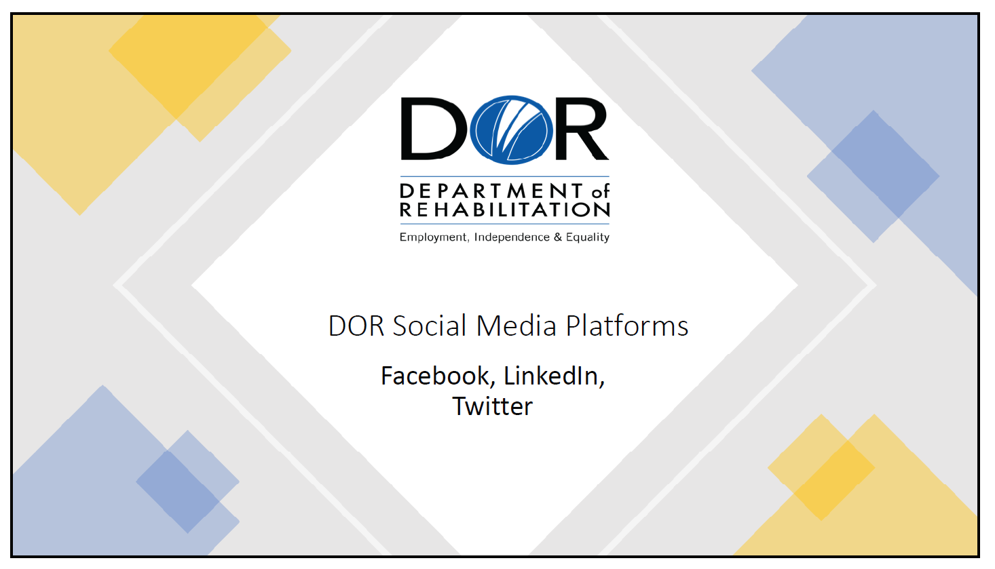

Slide 2
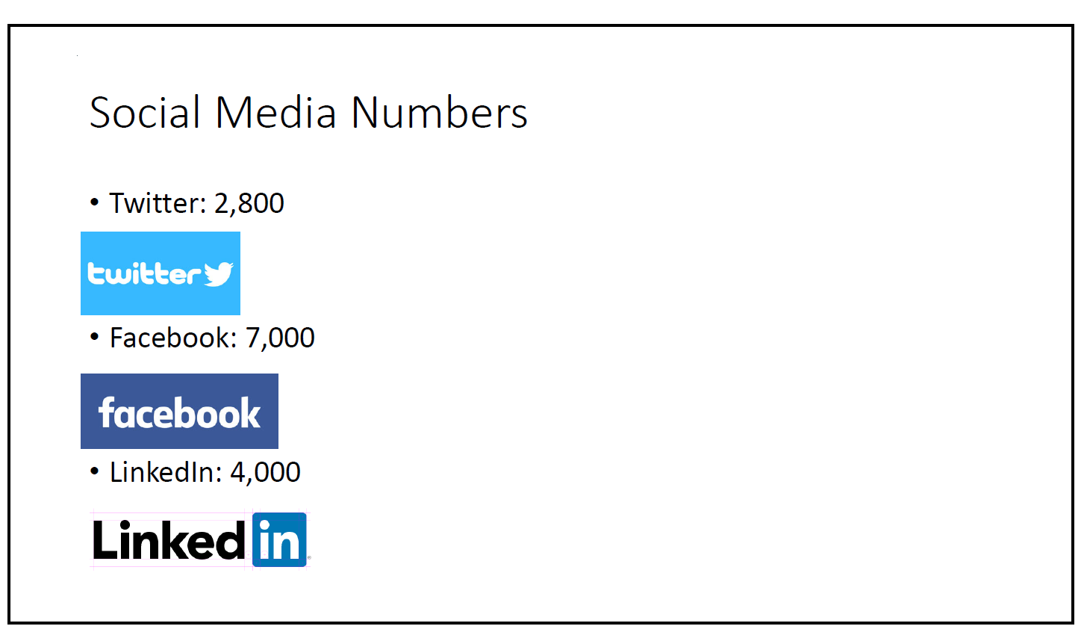

Slide 3
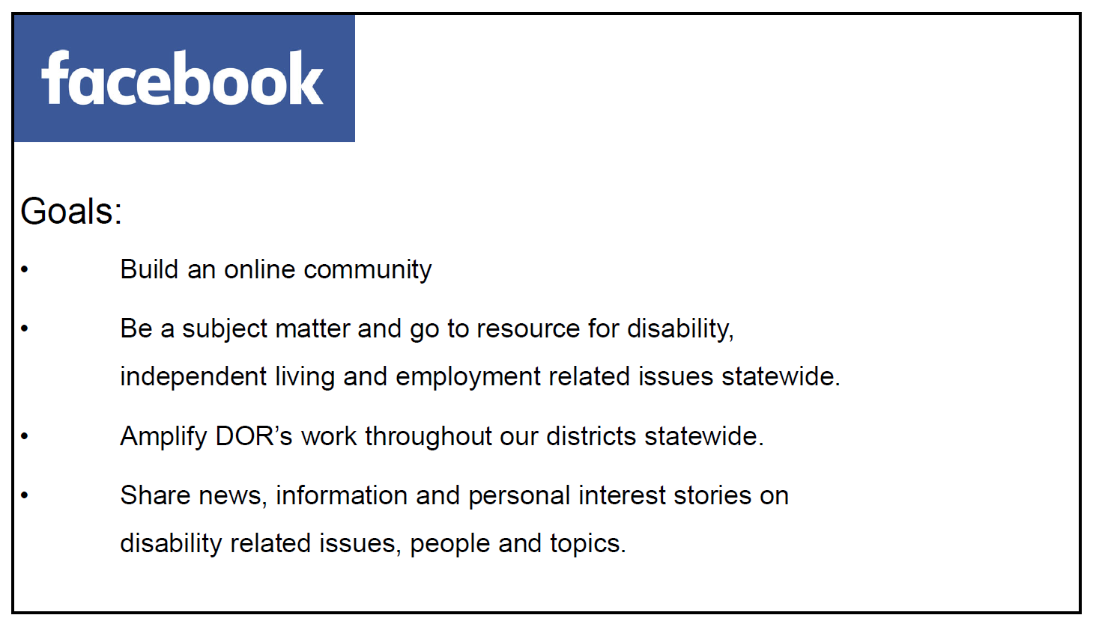

Slide 4
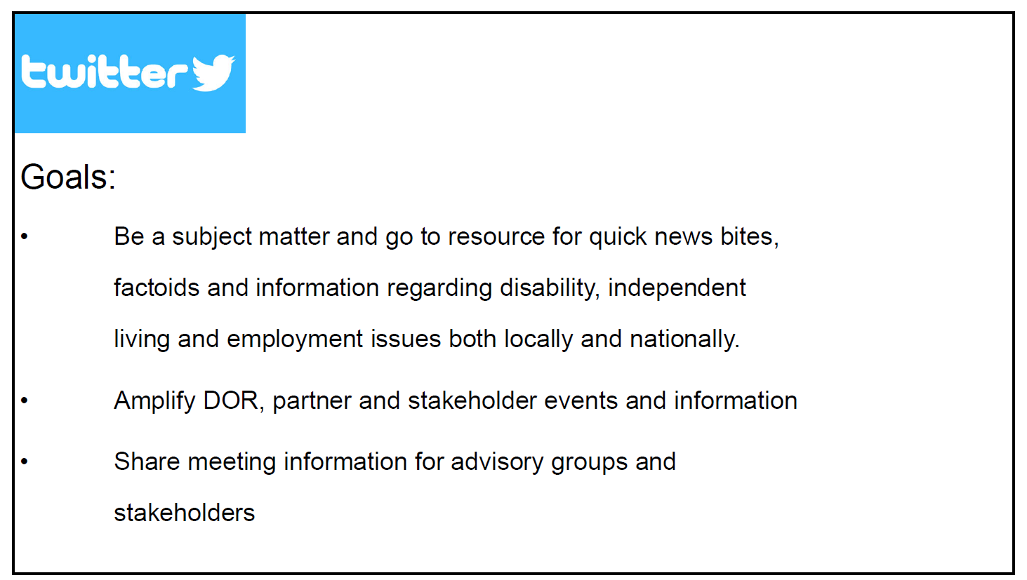

Slide 5
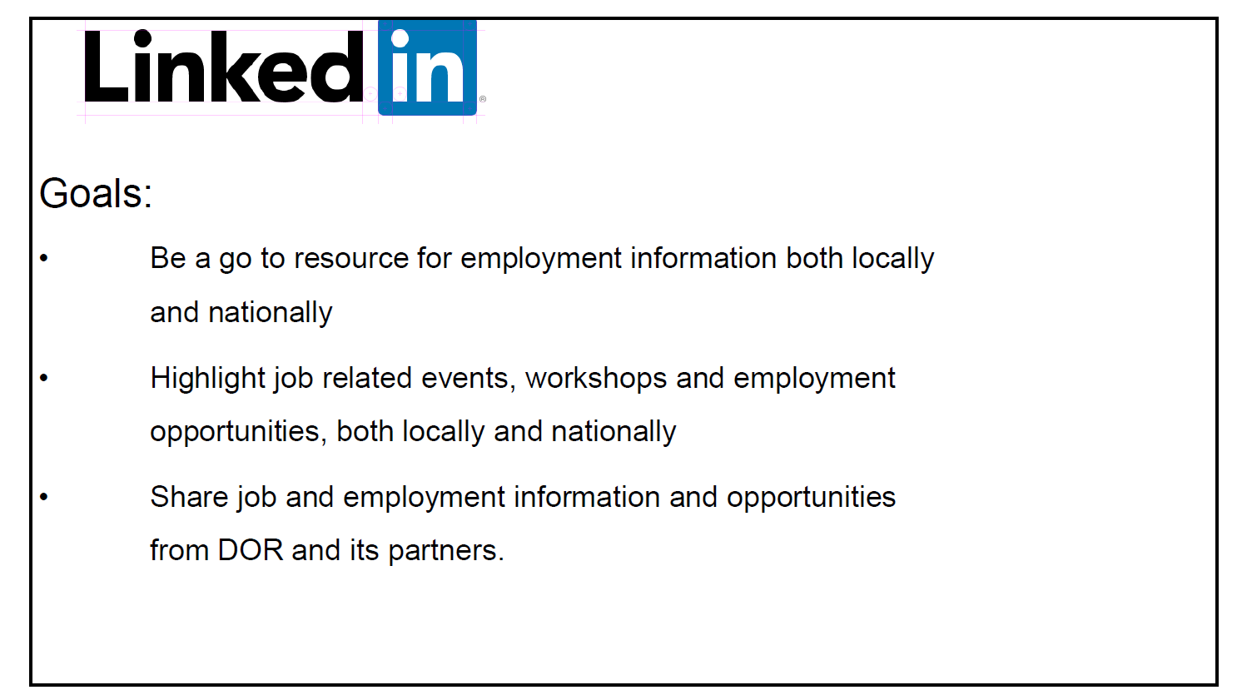

Attachment D – Item 9 PowerPoint Presentation
2020 Comprehensive Statewide Assessment, Review of Section III: Themes and Findings

Slide 1
DOR Logo
- 2020 Comprehensive Statewide Assessment (CSA)
- Program Years 2018-2020
- Review of Section III: Themes and Findings

Slide 2 – Introduction
The Comprehensive Statewide Assessment (CSA) is:
- Mandated by the federal Rehabilitation Act of 1973, as amended by the Workforce Innovation and Opportunity Act (WIOA).
- The study of the Vocational Rehabilitation (VR) needs of individuals with disabilities in California.
- Developed by DOR in partnership with the SRC.
- Research that informs DOR’s understanding of its consumers and their service needs and contributes to the goals and priorities of DOR’s State Plan.

Slide 3 – Five Areas of Focus
The CSA is an assessment of the general VR needs of individuals with disabilities statewide, with a focus on five required areas:
- Individuals with most significant disabilities, including their need for supported employment services.
- Individuals with disabilities served by other components of the State workforce development system.
- Individuals with disabilities who are minorities and those who have been unserved or underserved by DOR.
- Youth and students with disabilities, including their need for pre-employment transition services.
- An assessment of the need to establish, develop, or improve community rehabilitation programs.

Slide 4 – Section III: Caseload Themes and Findings
Minorities and unserved or underserved populations:
- The lowest percentage of DOR consumers served was Pacific Islander.
- Individuals who identify as Asian were identified as underserved.
- Individuals who identify as African American, Native American, and those identifying multiple race/ethnicities had lower successful rehabilitation rates.
- Latinx individuals had a 3.0% lower rate of successful case closures when compared to all DOR consumers.
- Asian consumers were represented with the lowest percentages for both physical and psychiatric disabilities.
- African American consumers were represented with a low percentage for deaf and hard of hearing disabilities.

Slide 5 – Section III: Key Informant Interview Themes and Findings
The following groups were expressed by key informants as being unserved or underserved by DOR’s programs and services:
- Homeless individuals with disabilities.
- Individuals with a dual diagnosis of substance abuse and a behavioral health disability.
- Individuals with behavioral health disabilities.
- Individuals with ID/DD, including those with the most significant disabilities who may need personal care assistance while on the job.
- Non-English-speaking individuals with disabilities.

- Youth ages 16-25, in particular those with dual diagnoses of substance abuse and a behavioral health disability.
- Formerly incarcerated individuals with disabilities, in particular individuals who are African American.
- Justice-involved individuals with behavioral health disabilities

Attachment E – Item 14 PowerPoint Presentation
California Community Transitions (CCT)
Slide 1

Slide 2
Slide 3

Slide 4

Slide 5

Slide 6

Slide 7

Slide 8

Slide 9

Slide 10

Slide 11

Slide 12

Slide 13

Slide 14

Slide 15

Slide 16

Slide 17

Slide 18

Slide 19

Slide 20

Attachment F – Item 15 PowerPoint Presentation
Overview of the DOR Budget Building Process and Program Funding

Slide 1

Slide 2

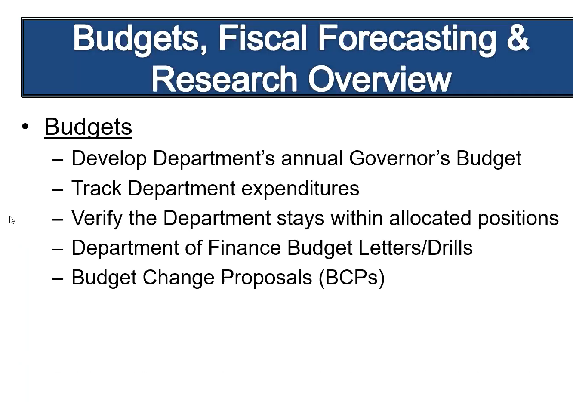

Slide 3

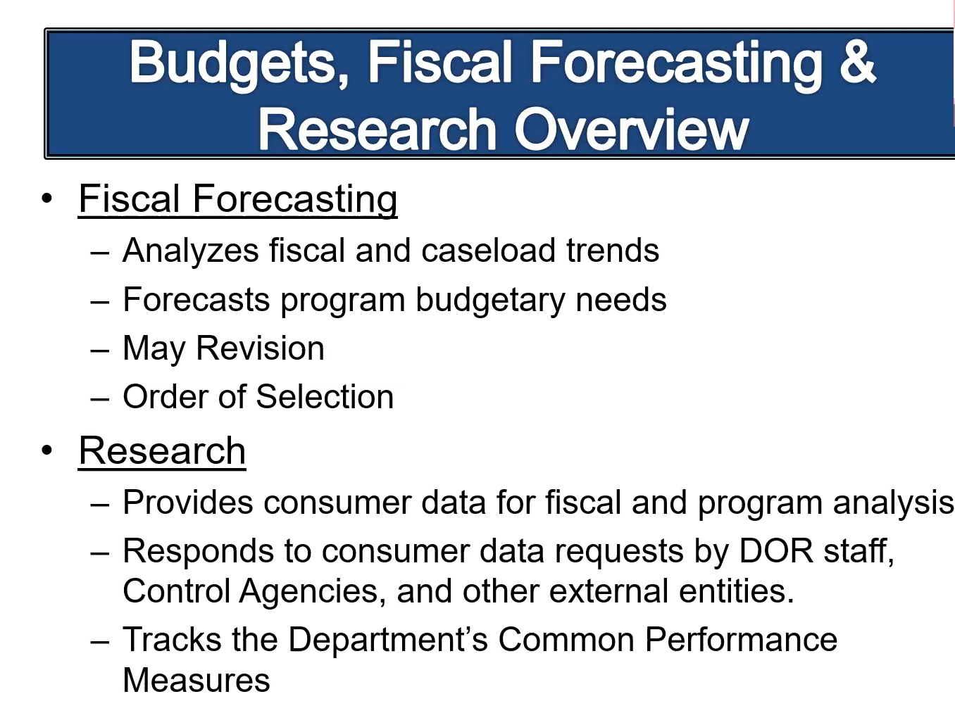

Slide 4

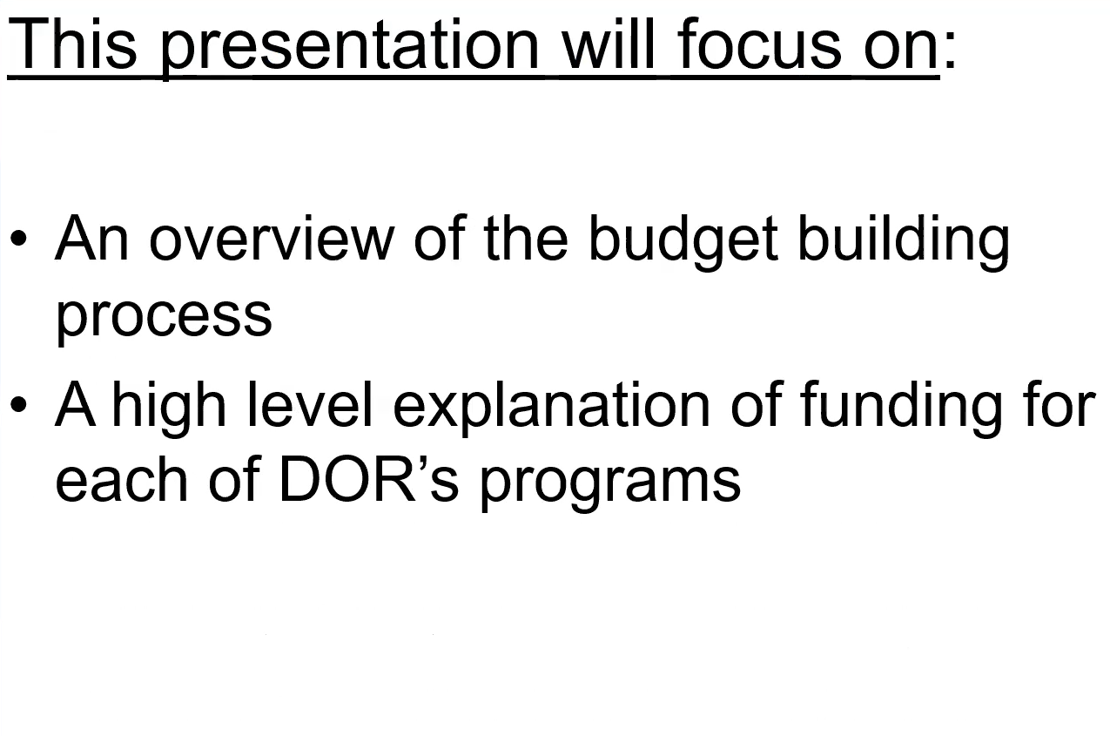

Slide 5

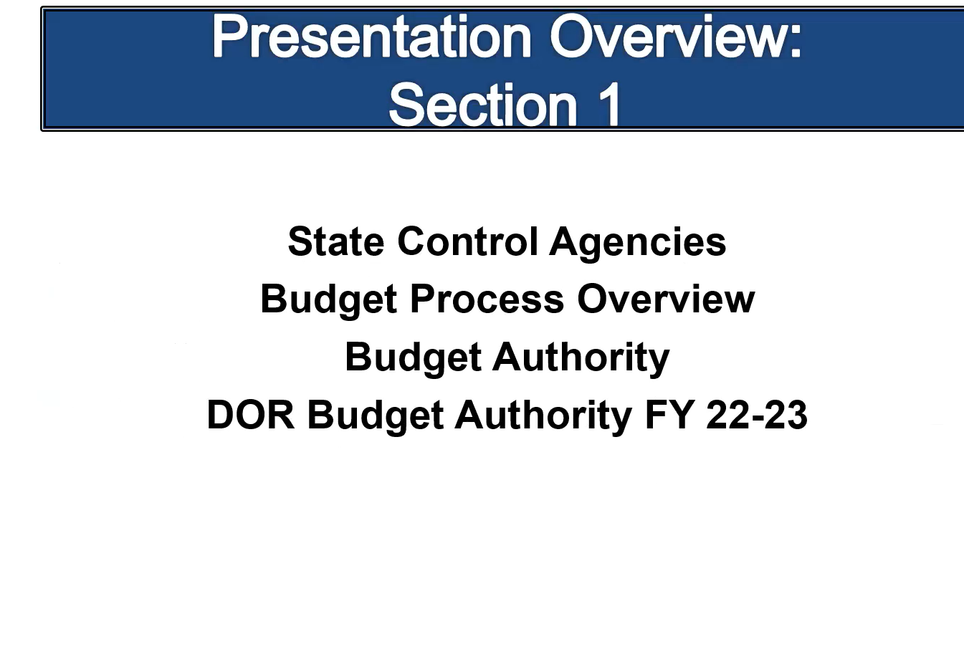

Slide 6

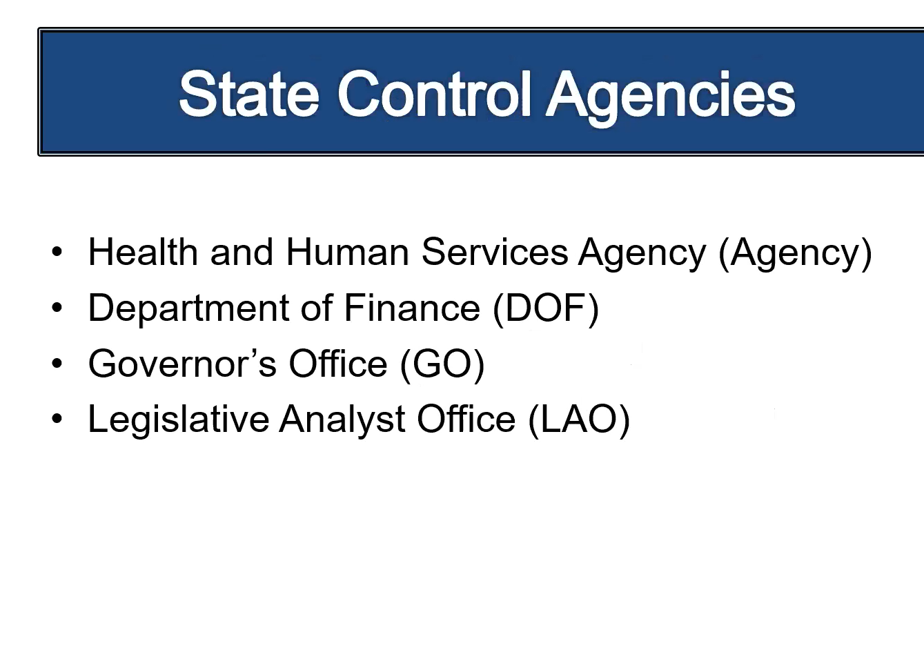
Slide 7

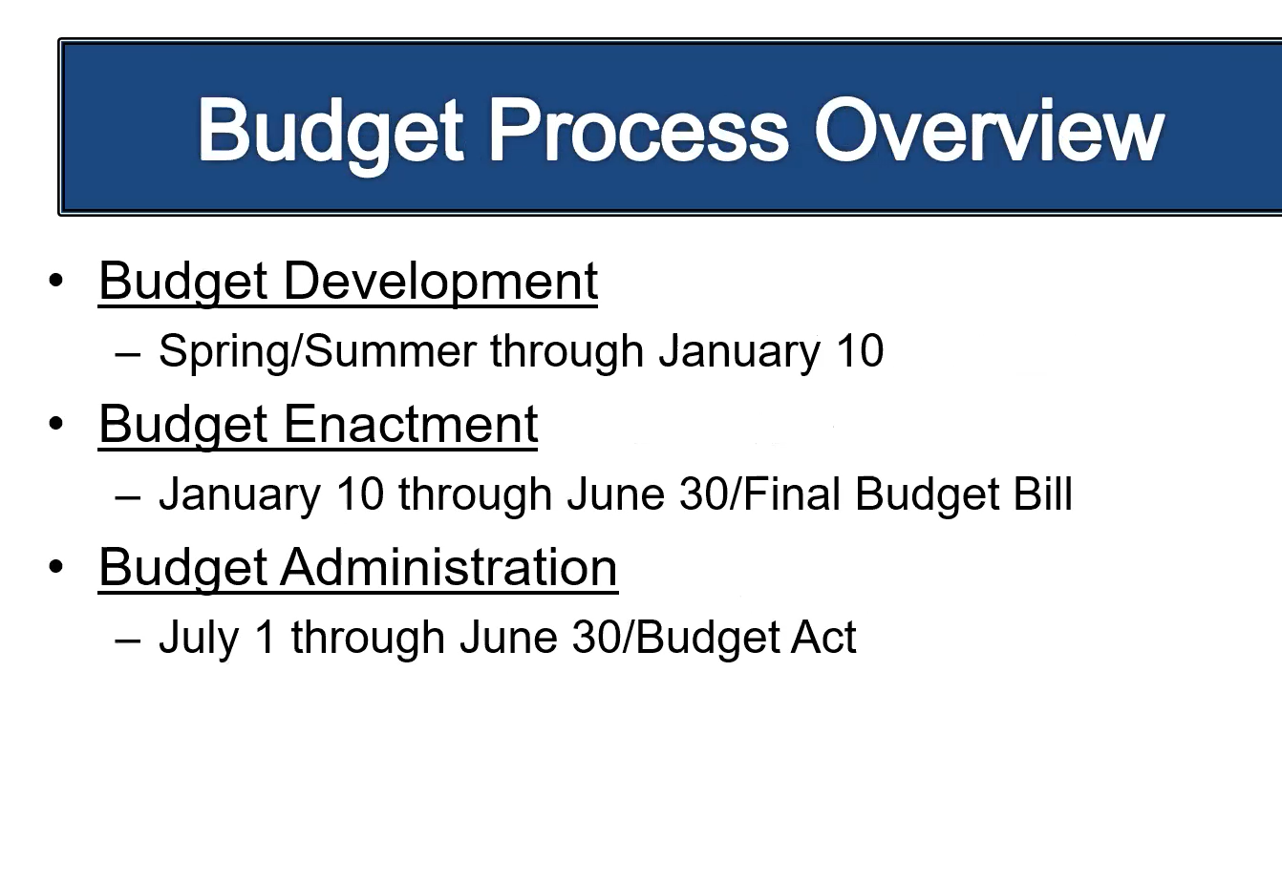

Slide 8

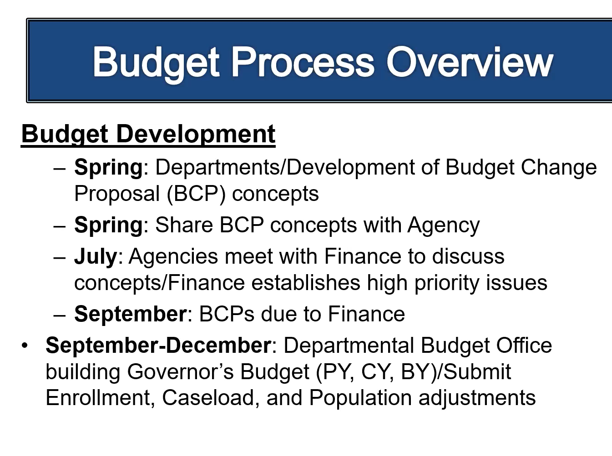
Slide 9

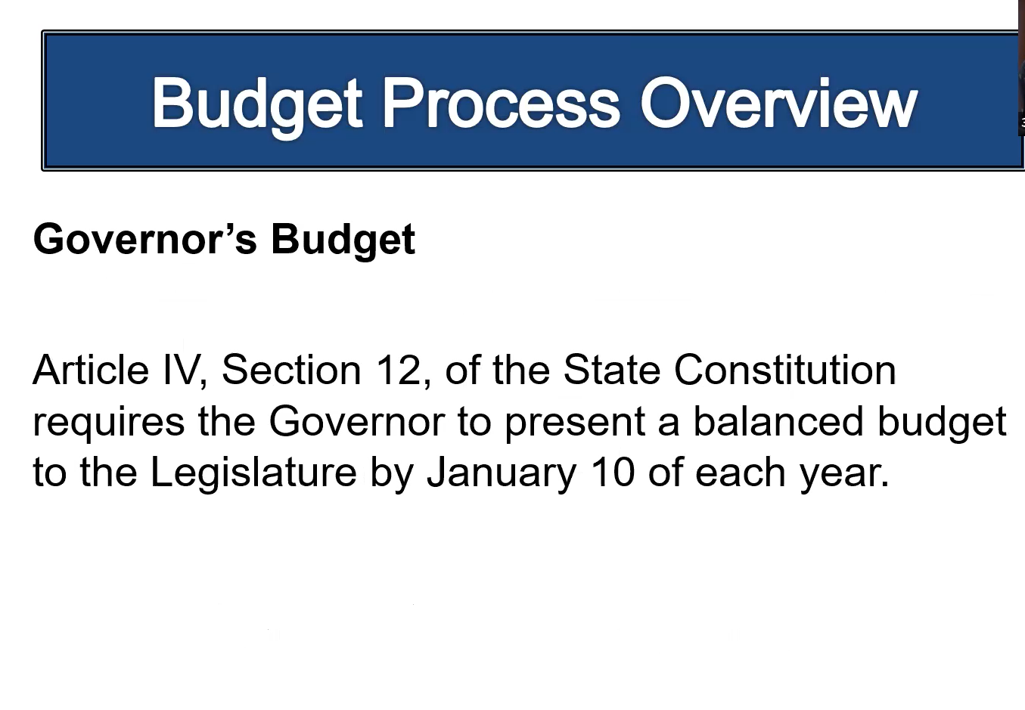

Slide 10

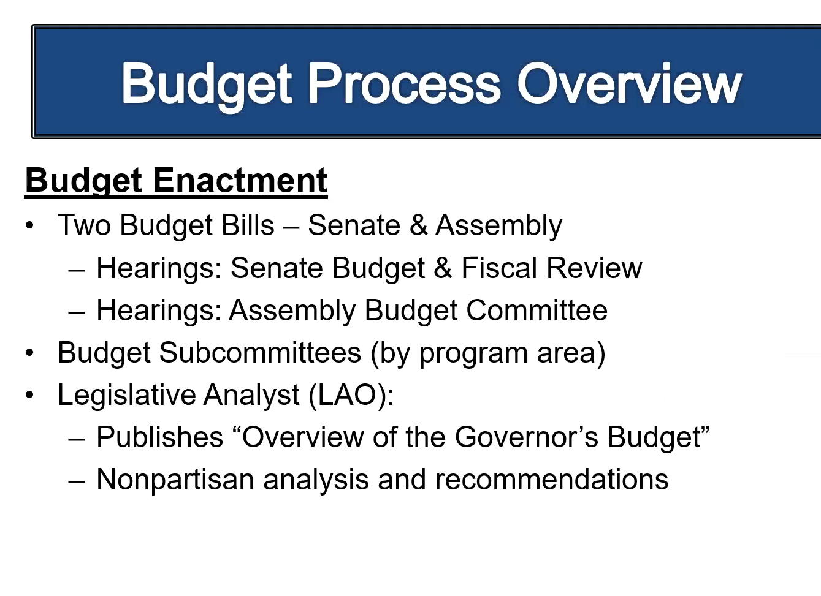

Slide 11

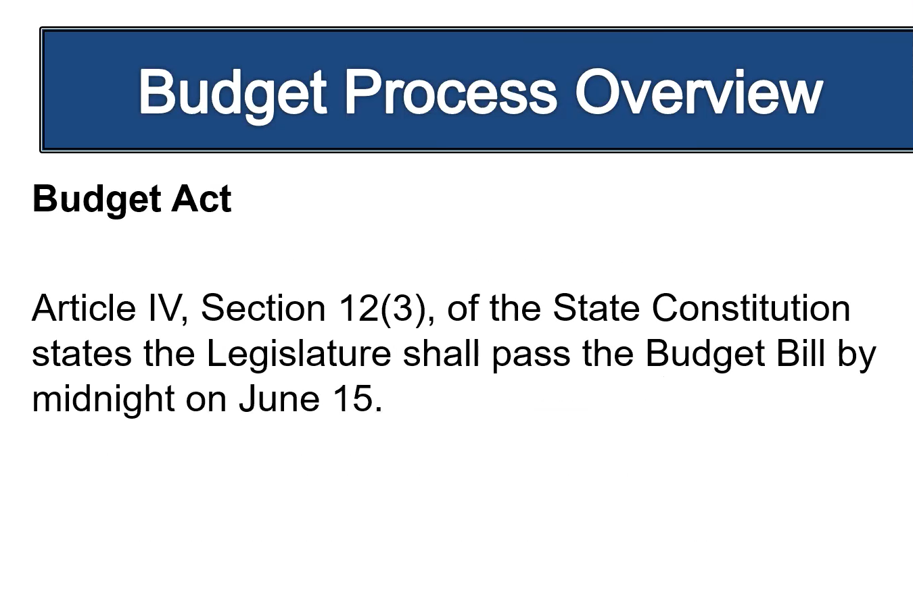

Slide 12

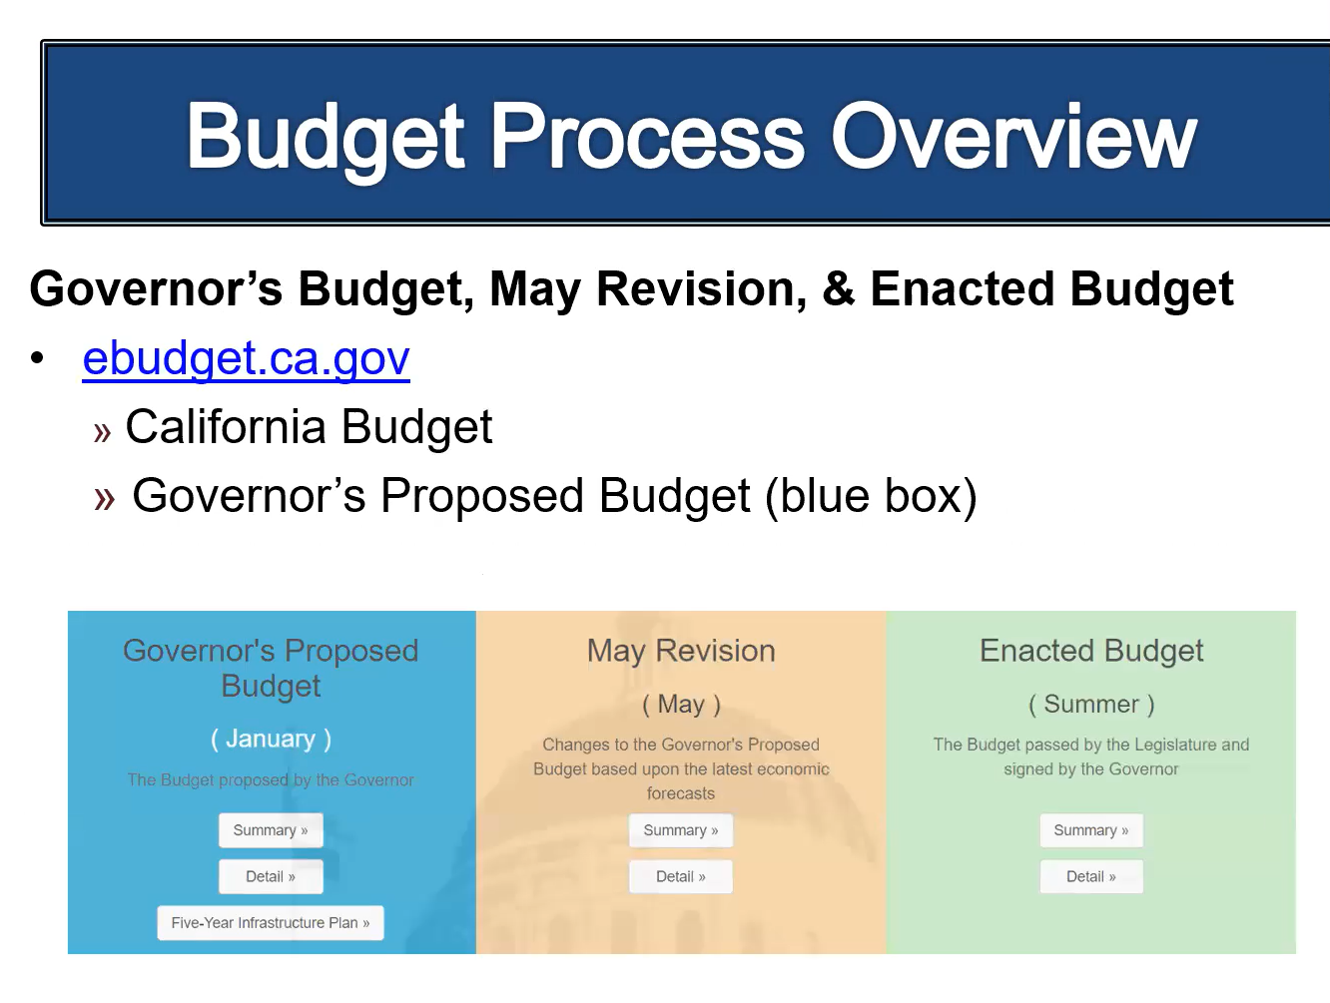
Slide 13

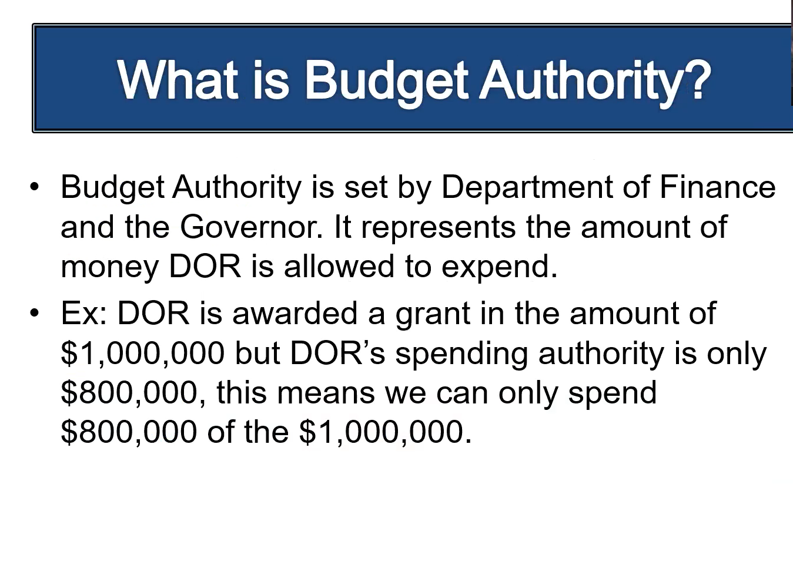

Slide 14

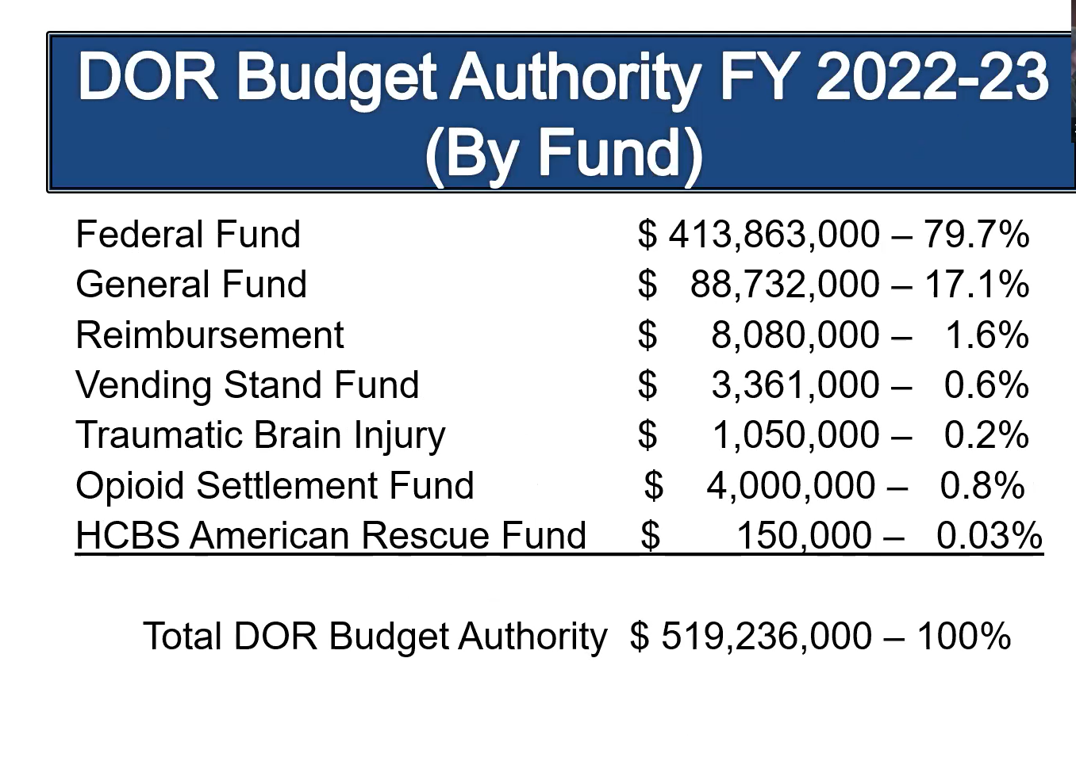

Slide 15

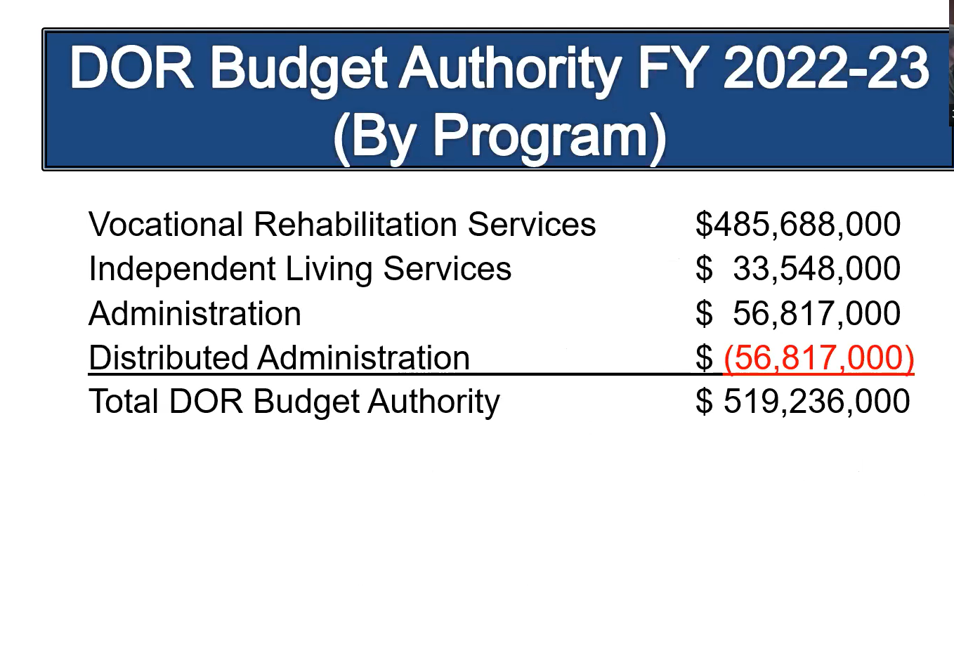

Slide 16

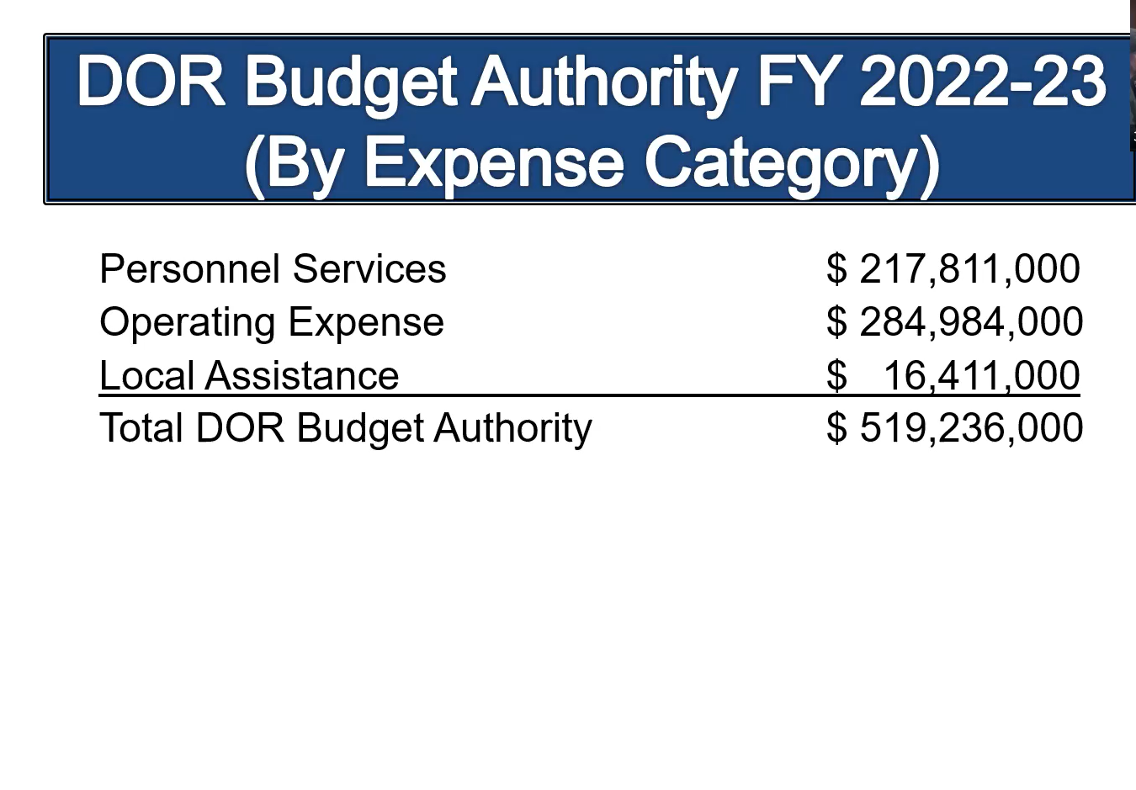
Slide 17

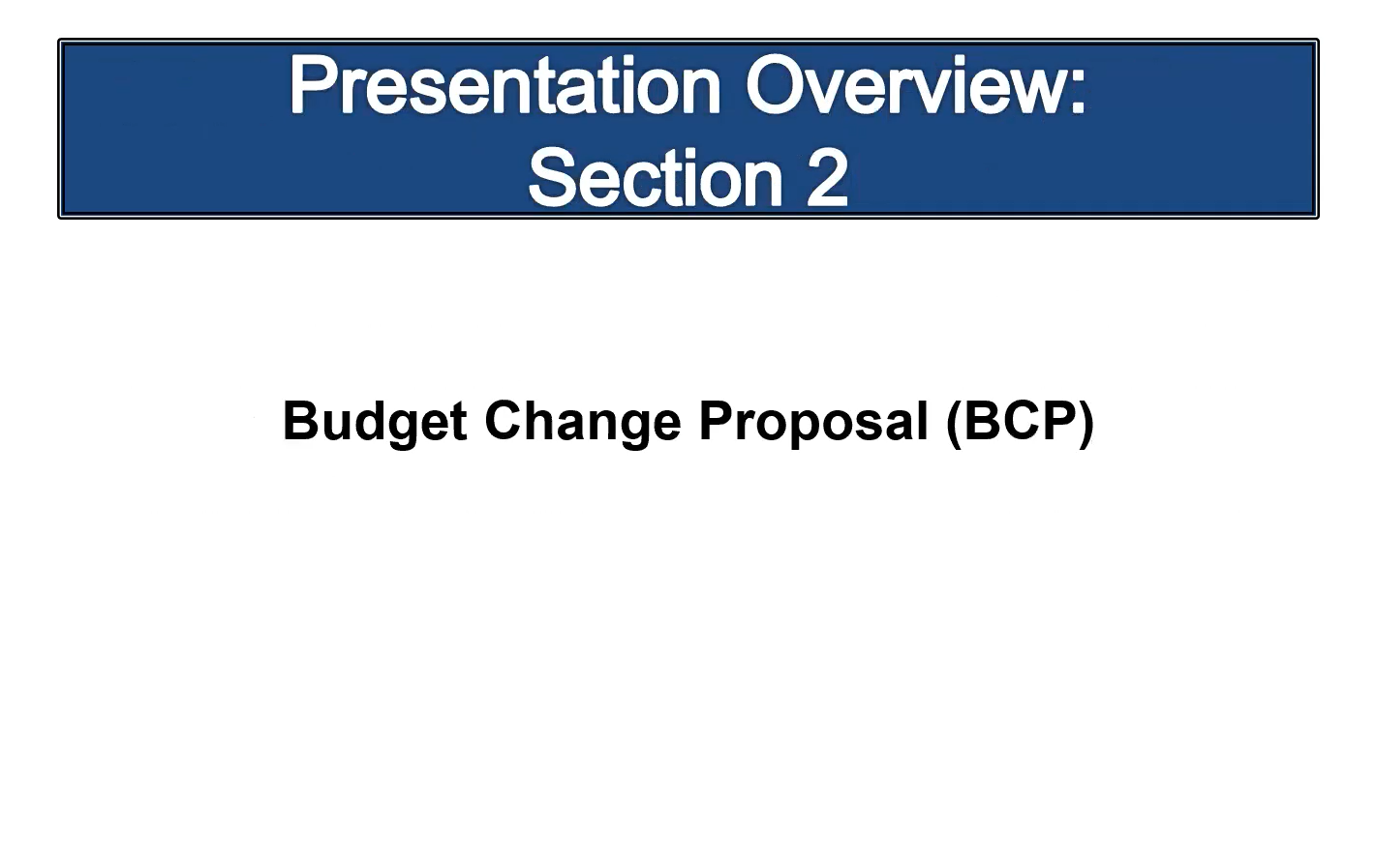

Slide 18

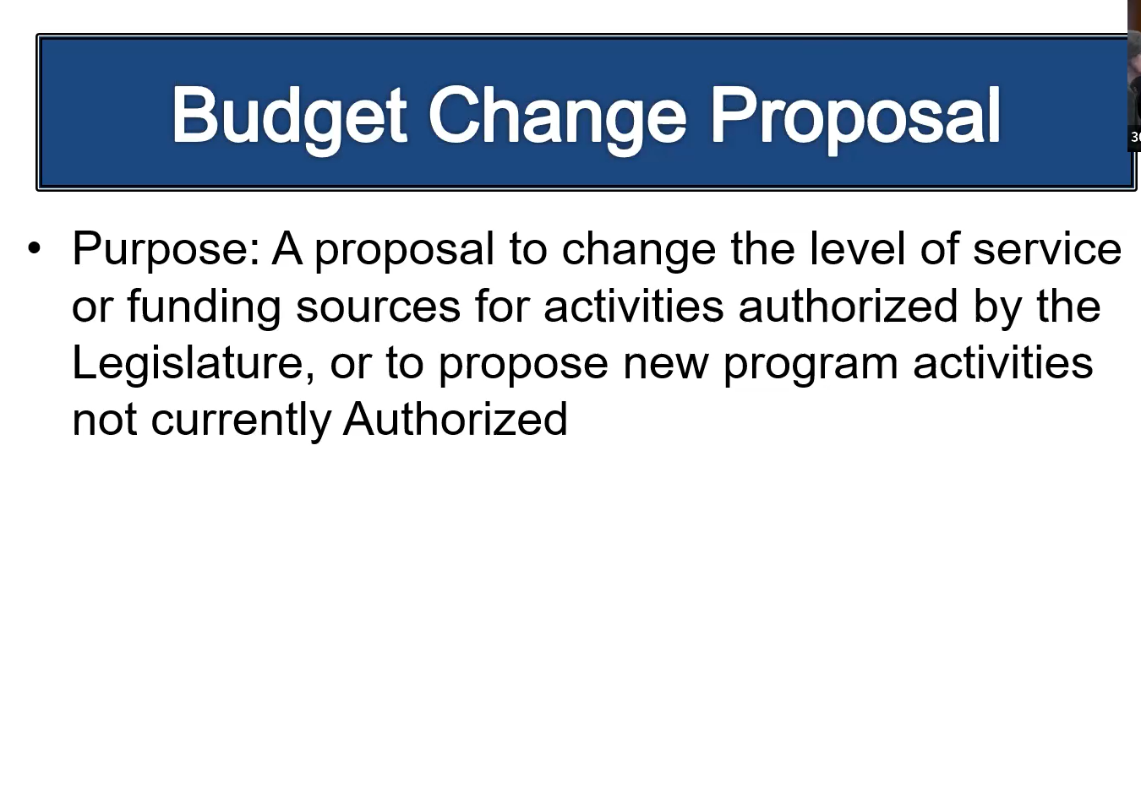

Slide 19

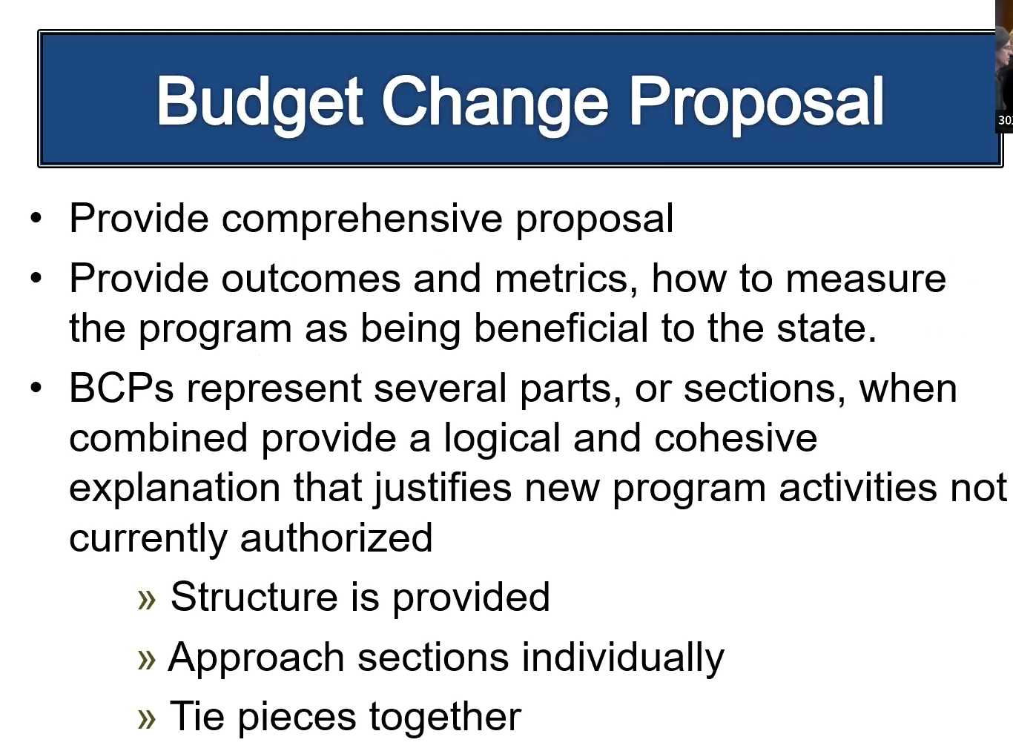

Slide 20

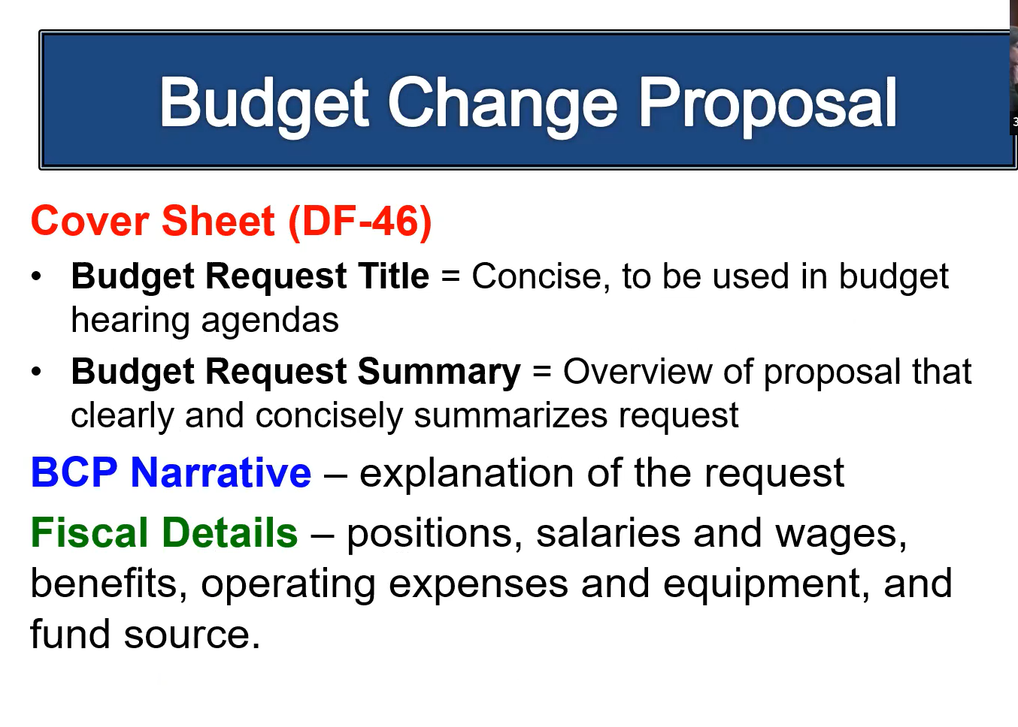
Slide 21

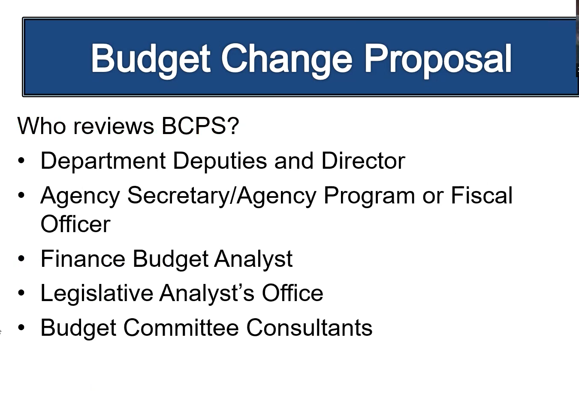

Slide 22

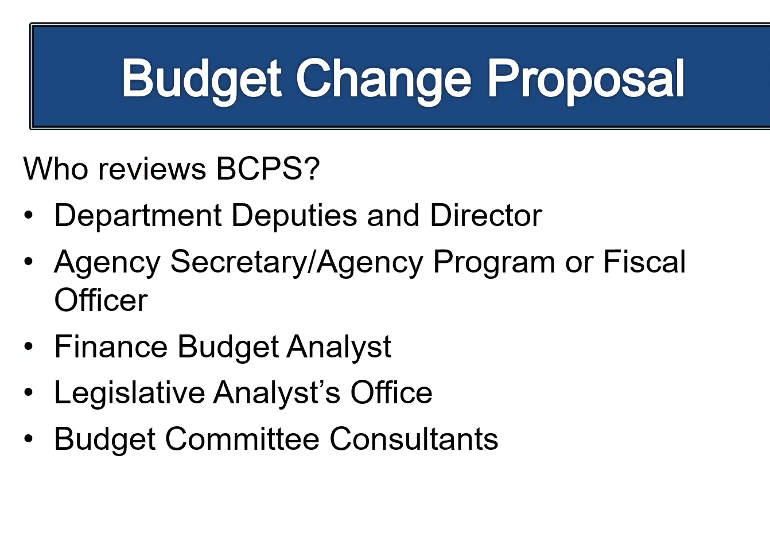

Attachment G – Item 16 PowerPoint Presentation
Intersection of Retention Plans and Order of Selection

Slide 1

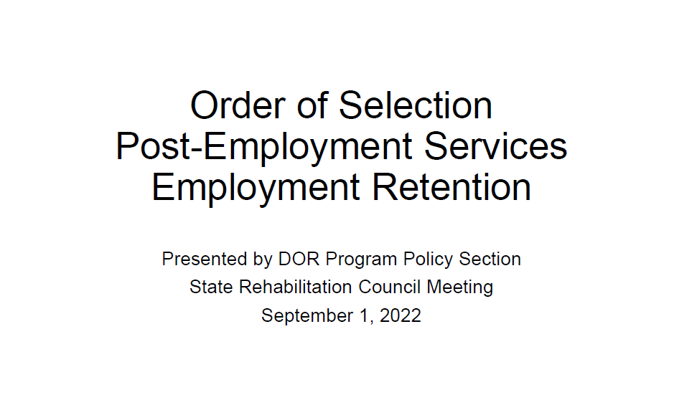

Slide 2

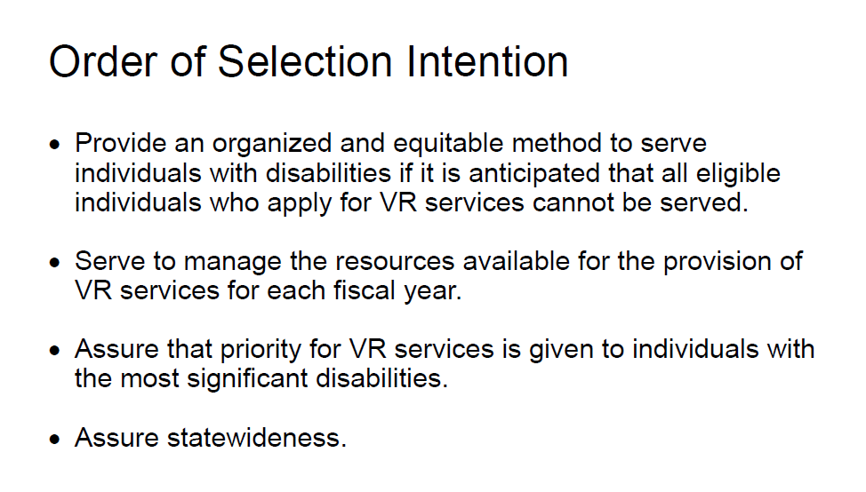

Slide 3

Slide 4

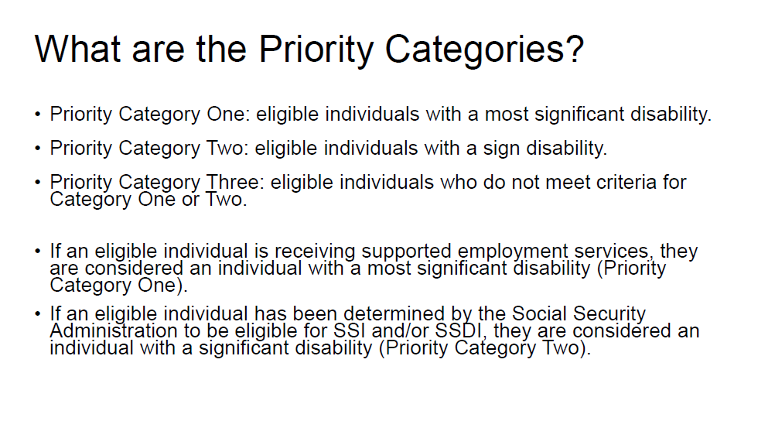

Slide 5

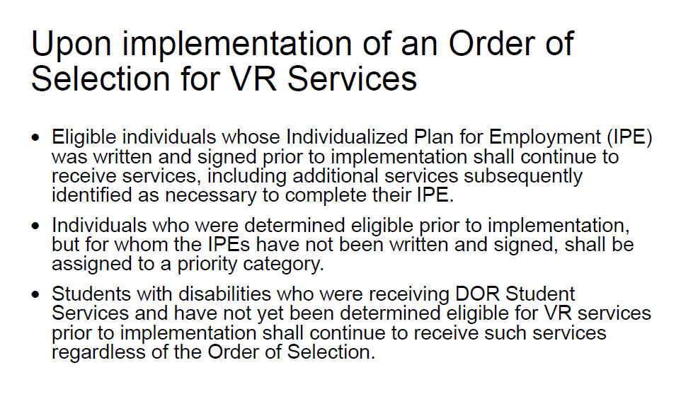

Slide 6

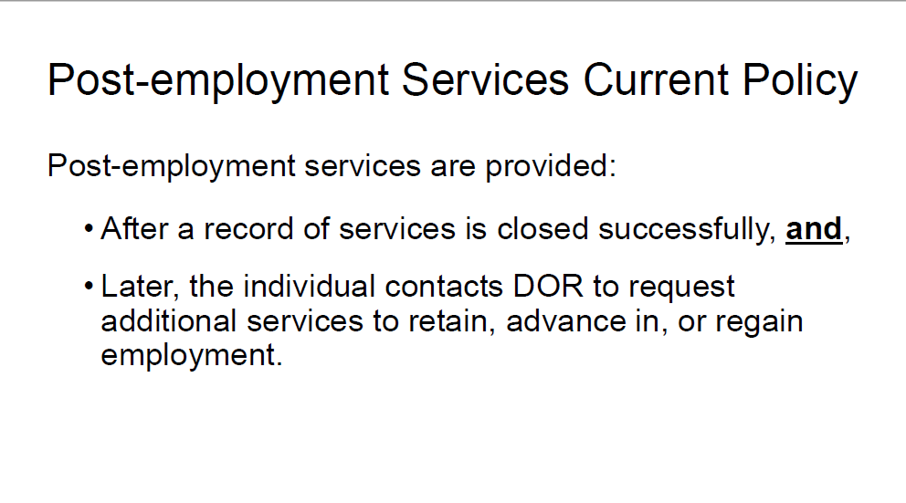

Slide 7

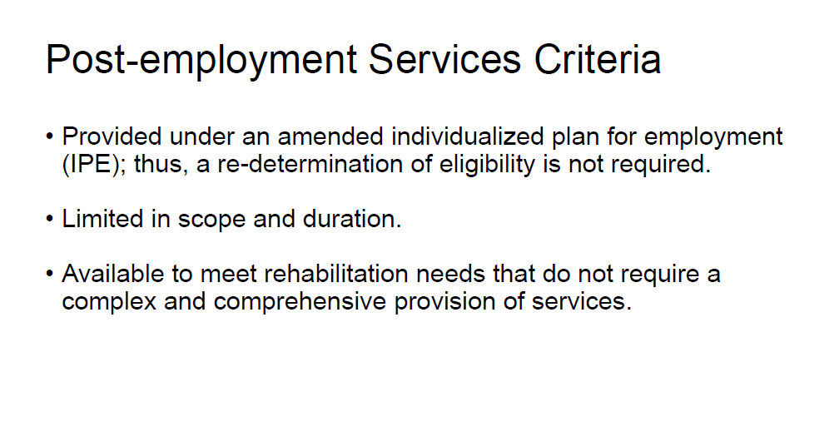

Slide 8

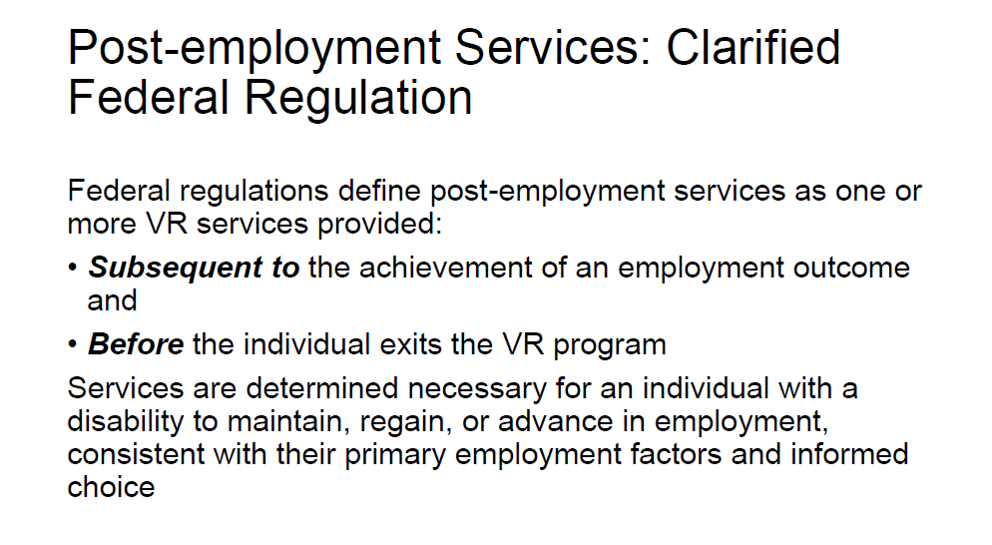

Slide 9

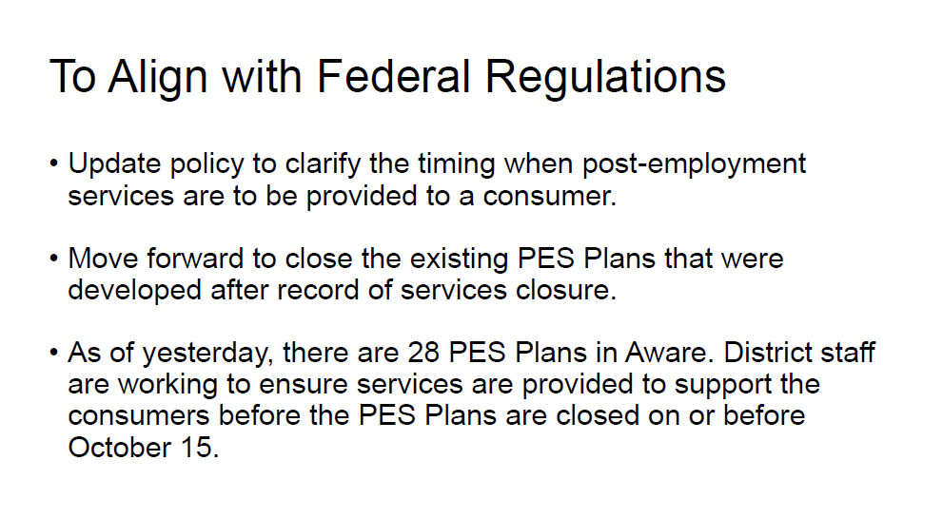

Slide 10

Slide 11

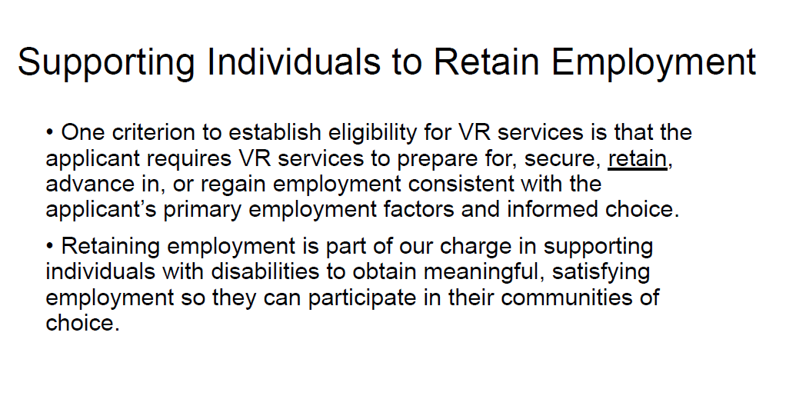

Slide 12

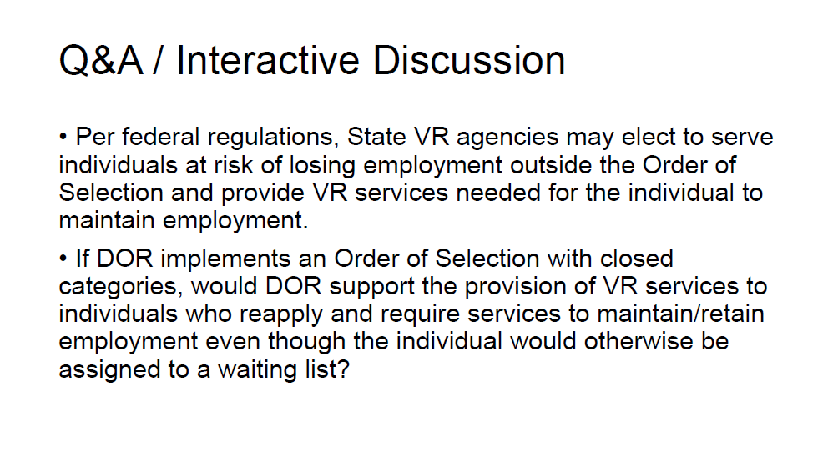

Item 5 Detail Sheet: Violence Prevention Presentation and Discussion

Item Type: Information and Discussion

Background and Policy Questions:
At the June 8 – 9, 2022 SRC quarterly meeting, the following policy questions were posed to the SRC for consideration:

The California Health and Human Services Agency is calling upon Departments, including DOR, to recognize gun violence as a public health and public safety crisis.
- How can DOR contribute to the strategies and actions that address this crisis?
- What are examples of those strategies?

During the November 30, 2022 SRC quarterly meeting, Vicka Chaplin, Director of Education and Outreach, UC Davis Violence Prevention Research Program, will present on the impacts that firearm violence has in the daily lives of Californians and will share information on the “Swiss cheese model” of prevention. Following the presentation, SRC members will discuss how DOR’s employment and independent living programs/services can add to layers of intervention. The presentation and discussion will inform the SRC as they consider the California Health and Human Services Agency’s call to action for Departments to recognize gun violence as a public health and safety crisis.

References: California Safety and Wellbeing Survey factsheets:

Experiences of Violence in Daily Life Among Adults in California

Exposure to Violence, Firearm Involvement, and Socioemotional Consequences Among California Adults

California Public Opinion On Health Professionals Talking With Patients About Firearms

Firearm Ownership and Acquisition in California: Findings from the 2018 California Safety and Wellbeing Survey

Attachment:
New York Times Article: California Has America’s Toughest Gun Laws, and They Work (below)

New York Times Article: California Has America’s Toughest Gun Laws, and They Work
As in the “Swiss cheese model” of Covid prevention, a lot of small measures add up.

By Shawn Hubler
May 31, 2022

The grotesque toll of gun violence is again being debated in Congress. As Luis Ferré-Sadurní and I reported over the long weekend, states are not holding their breath.

Particularly this state: In ways that have tended to be underreported, California has significantly lowered gun deaths, Dr. Garen J. Wintemute, an emergency room doctor and longtime firearm violence researcher, told me this week.

“For the last 20, maybe even 25 years — except for the two years of the pandemic, which have increased homicides and suicides across the country — our rates of firearm violence have trended downward,” said Dr. Wintemute, who directs the Violence Prevention Research Program at the University of California, Davis, Medical Center in Sacramento. “And this has been at a time when most of the rates in the rest of the country have gone up.”

California’s rate of firearm mortality is among the nation’s lowest, with 8.5 gun deaths per 100,000 people in 2020, compared with 13.7 per 100,000 nationally and 14.2 per 100,000 in Texas, the Centers for Disease Control and Prevention has reported. And Californians are about 25 percent less likely to die in mass shootings, compared with residents of other states, according to a recent Public Policy Institute of California analysis.

I asked Dr. Wintemute how California is different. Here’s a lightly edited excerpt from our conversation, which took place on Memorial Day after his emergency room shift:

Just a couple of weeks ago, California had a mass shooting. By what measures are our policies a success?
You have to look at it on a population basis. We do have more mass shootings in California, but we’re also by far the largest state. I looked a while ago at the rates of firearm violence across the 21st century — homicide and suicide together — and the rest of the country was up, but California’s rates were so far down that the average was flat.
We always hear that nothing works, that even California’s strict gun laws are ineffective.
That’s because we evaluate policies one at a time, in isolation. The results for one policy might be mixed or even negative. But what California has done over a number of decades has been to enact a whole bundle of policies that I think work in synergy, to measurable effect.

It sounds like the “Swiss cheese model” public health experts have used to address Covid.
Yes. The idea is to prevent the holes in the policies from lining up. But if we rank the states, California’s rate of firearm violence ranks 29th out of 50 states for homicides and 44th for suicides.

Can you share some examples?
California has done a lot to prevent high-risk people from purchasing firearms. We’ve broadened the criteria for keeping guns out of the hands of people who pose a danger to themselves or others due to mental illness. If you’re convicted of a violent misdemeanor in California, you can’t have a gun for the next 10 years; that offense has to be a felony in most states.

We require background checks, and not just from licensed retailers; in most states, purchases from private parties require no background checks or record keeping of any kind. We have a system, that we’re evaluating now, for getting guns back from “prohibited persons” — people who have been convicted of violent crimes or who are facing domestic violence restraining orders. And we enforce these policies, unlike a lot of other states.

What else?
In the early 1990s, cheap handguns — “Saturday Night Specials” — were almost entirely manufactured around Los Angeles. It was a few companies making upward of 800,000 cheap handguns a year. So the state imposed standards for design and safety. One of the companies has since gone to Nevada. The rest went belly-up and no one else has come in to fill the gap.

What about gaps?
Every time California sets a new standard, the gun industry tries to outwit it. Unregulated ghost guns have become immensely popular here, precisely because we’re such a tightly regulated market. And the state program to recover guns from prohibited people has never had the level of funding it needs to do the whole job — there are only about 40 trained agents for the whole state and a backlog of at least 10,000 people whose guns need to be taken.
Overall, what could the rest of the country learn from California?
The lower the prevalence of ownership, the lower the rate of firearm violence — that’s been one of the most robust research findings for decades. Rates of gun ownership are lower here, in part because of this bundle of state measures. In the United States overall, something like 25 percent to 30 percent of individuals own guns. In California, it’s about 15 percent to 18 percent.

Item 8 Detail Sheet: Diversity, Equity, and Inclusion

Item Type: Information and Discussion

Background and Policy Questions:
During the June 8 – 9, 2022 SRC quarterly meeting, the following information and policy questions were presented to the SRC for consideration:

The California Health and Human Services Agency is leading many initiatives to improve diversity, equity, and inclusion (DEI) and as a result, DOR will likely be asked to develop an equity action plan.
- How can inequities in DOR’s programs and services be identified, and what methodologies can be used to address these equity gaps,
- What communities are unserved and underserved, and how can DOR effectively reach them, and,
- What methods and models should DOR look to and consider to address these inequities?

During the August 31 – September 1, 2022 SRC quarterly meeting, Rosa Gomez, DOR Diversity and Inclusion Officer, provided information on DOR’s DEI efforts at the national, state and department level. Kate Bjerke, SRC Executive Officer, highlighted themes and findings from the 2020 Comprehensive Statewide Assessment, specifically section three, “Individuals with disabilities who are minorities and those who have been unserved or underserved by DOR.” The SRC provided initial feedback, suggestions, and questions for consideration.

As a follow up, during the November 30 – December 1, 2022 SRC quarterly meeting, the SRC will continue discussions in an effort to respond to the DEI policy questions. Gomez will facilitate an interactive discussion with the SRC members focused on the following: How can inequities and disparities in DOR’s programs and services be identified, and what strategies can be used to address these equity gaps? Then, SRC members may consider reviewing SRC Recommendation 2020.4-Eliminating Racial and Ethnic Disparities to determine if updates are needed.

Attachment: SRC Recommendation 2020.4 (below)

SRC Recommendation 2020.4: Eliminating Racial and Ethnic Disparities
The SRC recommends DOR integrate on-going mechanisms throughout its operations to eliminate racial, ethnic, and cultural disparities (to include identification, data analysis, stakeholder review, training, and performance of services).

DOR Response to SRC Recommendation 2020.4
The DOR appreciates this recommendation and is addressing racial, ethnic, and cultural disparities. Looking inward, the DOR established the Diversity, Equity, and Inclusion (DEI) team to develop DOR’s DEI vision, goals, and objectives for state year 2020-21. This team will work to build DOR’s internal capacity to support long term DEI efforts and develop an initial set of DEI strategies to be implemented by the DOR. DOR has supported managers’ participation in implicit bias and cultural competency trainings. Employees have united through the work of the African American and Asian Pacific Islander taskforces and established the Latinx taskforce.

The majority of DOR Community Rehabilitation Programs (CRPs) are accredited by the Commission on Accreditation of Rehabilitation Facilities (CARF). CARF is committed to diversity and cultural competence in all CARF activities and associations and has an eight-module webinar available to its members to support ongoing development.

The DOR is collecting, analyzing, and sharing data on consumer demographics to learn more about the consumers served or who are potentially unserved or underserved. The DOR conducts a triennial comprehensive statewide needs assessment to identify unserved or underserved communities and strategies to serve them. DOR has entered into demographic data sharing agreements with the Employment Development Department and nationally with VR agencies. The DOR is contracting with San Diego State University to analyze consumer demographic data and employment outcomes. The DOR’s support of these data endeavors and diversity, equity, and inclusion efforts will further the department’s commitment to the pursuit of employment, independence, and social equity.

Item 13 Detail Sheet: DOR Independent Living and Community Access Division (ILCAD)

Item Type: Information and Discussion

Background:
DOR’s Independent Living and Community Access Division has a standing item on the SRC quarterly meeting agenda for program overviews, updates, and opportunities for collaboration. This aligns with the SRC’s requirement to coordinate efforts with the State Independent Living Council (SILC).

During the November 30 – December 1, 2022 SRC quarterly meeting, Ana Acton, Deputy Director, and Megan Sampson, Chief, will provide the SRC with ILCAD program updates and will have an interactive discussion with SRC members regarding potential opportunities for program collaboration and coordination. Policy questions for the SRC’s consideration include the following:

- How can DOR provide coordinated “no wrong door” services to address the whole person whether they enter the systems through the VR or independent living programs?
- How can DOR improve employment services and outcomes for individuals with traumatic brain injuries (TBIs)?
- How can TBI be more openly included discussions, both at DOR and with community-based organizations?
- How can TBI stigma be reduced?

Reference:

TBI California Community Health Needs Assessment

Item 14 Detail Sheet: Benefits Planning and Employment

Item Type: Information and Discussion

Background and Policy Questions:
An existing barrier that needs to be addressed is regarding the true cost of living with a disability. Concerns regarding losing benefits might deter individuals from pursuing VR services. Individuals with disabilities need more education on benefits. The current design of the benefit system is that it’s built on the concept of “fail to benefit.” In response to these barriers and concerns, the SRC will consider the following policy questions:

- How can DOR increase awareness for consumers about available benefits?
- There is a need to include vocational rehabilitation and the benefits of employment when community supports are being discussed. Where and when does employment fit into the conversation?

During the November 30 – December 1, 2022 SRC quarterly meeting, California Committee on the Employment of People with Disabilities (CCEPD) Executive representatives Maria Aliferis-Gjerde, Executive Officer, Taylor Winchell, Vice Chair, and Jennifer Fischer, State Coordination Subcommittee Chair, will present on the CCEPD Integrated Benefits Planning Policy Recommendations adopted in May 2022. SRC Chair Benjamin Aviles will review SRC recommendation 2021.4 to expand consumers’ access to Work Incentive Planning information and services. The SRC members and CCEPD representatives will identify potential opportunities for collaboration and support.

Attachments:
SRC Recommendation 2021.4 – Work Incentive Planning Information
May 2022 CCEPD Integrated Benefits Planning – Policy Recommendations

SRC Recommendation 2021.4: Work Incentive Planning Information

Work Incentive Planning Information
The SRC recommends DOR expand consumers’ access to Work Incentive Planning (WIP) information and services by providing WIP information and services so the consumer can make an informed choice. WIP services should be consistent throughout California in the following ways:
- Before, during and after the consumer’s individualized plan for employment is written
- Virtually through on-line materials and a recorded video that provides an overview of work incentive information and explanation of DOR WIP services. (Materials and video must meet website accessibility requirements)
- Provide WIP information to family members of consumers (who may be impacted)

DOR Response to SRC Recommendation 2021.4
The DOR appreciates the SRC’s recommendations to expand consumers’ access to DOR’s WIP information and services. Currently, DOR Districts provide this service to Potentially Eligible (PE) and Vocational Rehabilitation (VR) consumers receiving Supplemental Security Income and/or Social Security Disability Insurance. PE consumers receive DOR WIP services either in a group setting to learn financial literacy skills or on an individual basis if they are planning for or participating in paid work experience as part of their DOR Student Services. VR consumers receive DOR WIP services either in Service-J status, Employed status or Service status or in their final quarter or semester of training. Some benefits planning services may also be provided during other stages of the VR process through the Work Incentive Planning and Assistance Programs sponsored by Social Security.

DOR staff will examine currently provided WIP services and assess whether resources, including staff resources, are available, can be identified, obtained or redirected to expand WIP services, including providing these services earlier in the consumer’s case. Following this examination, the DOR commits to working with the SRC regarding the development or implementation of possible changes to the provision of this important VR service.

Regarding the SRC’s recommendation on providing WIP information to family members, currently, at any meeting with DOR staff, including meetings with Work Incentive Planners, all PE and VR consumers have the right to include family members, other representatives, or advocates. The DOR will ensure that WIPs and other DOR staff know and inform participants and their families and representatives that family members can be and are encouraged to participate.

With respect to online resources, DOR will review currently available online information regarding WIP services and access to and availability of that information to participants. DOR will ensure that online information is in plain-language and consumer-focused, that WIP website materials are accessible to consumers, family members, representatives, stakeholders, and partners, and provides an accurate explanation of DOR WIP services. DOR would appreciate the SRC’s sharing of resources or examples that are representative of what the SRC recommends as potential on-line materials and recorded videos that they feel provide a good overview of and delivers effective work incentive information.

DOR looks forward to future conversations with the SRC on this recommendation and sharing the results of the analysis, steps that have been or will be taken, and potential next steps the DOR will take in support of the delivery of effective and timely WIP services.

CCEPD Integrated Benefits Planning Policy Recommendations
August 2022

Introduction to Policy Recommendations
The California Committee on Employment of People with Disabilities (CCEPD) is proposing a set of policy recommendations to create strategies for effective integrated benefits planning approaches among the various programs serving people with disabilities. The CCEPD submitted a similar policy recommendation in late 2019, however a few months later the global pandemic struck, and further discussions were deferred. The CCEPD has identified a gap in service delivery systems including a lack of consistent cross-system approaches to the provision of benefits planning services, limited access to benefits planners, and underutilization of the Disability Benefits (DB) 101 tool in workforce programs. People with disabilities are served through multiple programs not just the Vocational Rehabilitation program, including workforce and other human service programs.

Although previously submitted, the CCEPD believes that additional strategies are needed to fully integrate DB101 into programs and develop sustaining cross-system approaches to benefits planning. Currently, benefits planning is not integrated into each program for employment, education and training and services for people with disabilities from the beginning. The systems offering benefits planning only offer benefits counseling for their clients, and oftentimes, there are not enough Work Incentives Planners (WIP), navigators, or counselors to serve the entire population of people with disabilities within the system. Therefore, the web-based tool DB101 can assist providers and people with disabilities with a better understanding of how to manage benefits and employment. With current labor shortages and staff turnover, DB101 provides information to clients and offers providers with updated information on the various benefits without additional formal training for staff. It is a tool that can help clients make decisions about their livelihood without the need for an experienced WIP to be involved with each question or scenario. This allows WIPs to prioritize more complicated questions or cases, while allowing other service providers to support clients newly exploring how working will impact their benefits, thus keeping them engaged in employment and training activities.

Considering the continued high unemployment rates and low labor market participation rates for people with disabilities, effective, state-level strategies to coordinate benefits planning services are needed to assist with dispelling myths and incorporating the message that people with disabilities can manage benefits and work. If people with disabilities do not manage their benefits, they risk losing access to health care or long-term services and supports and are at risk of overpayments. Overpayments of benefits must be refunded to the Social Security Administration. Both are tragedies and effectively create long-term financial hardship to people with disabilities. Without the power of information, people with disabilities live in fear and poverty because benefits have been designed to not incorporate employment as essential to a person’s well-being, both economically and as a social determinant of health for themselves and their families.

DB101 has been funded by the State of California in the past and is considered the sole source of information to existing professionals in the State of California. Because this existing web-based tool has been updated and used by professionals, the CCEPD believes that it should be fully supported and integrated into programs serving people with disabilities in a more consistent basis. Due to the unique nature and being the only web-based tool used by professionals in California, CCEPD believes the State of California should continue funding the web-based tool. Other states, Hawaii and Washington, have developed online benefit planning tools. Virginia Commonwealth University’s WorkWORLD decision support software performs benefits calculations based on work scenarios. But DB101 is unique in providing comprehensive, user-friendly benefits information alongside online tools for service providers and beneficiaries, within an integrated multistate technical infrastructure. To work with another vendor and recreate content would not be an efficient use of public funds.

Although California is the first in the nation to develop this toolkit, DB101, the state of California has never fully integrated DB101 into all programs and services for people with disabilities. The CCEPD believes more integration of the tool will bring a better understanding of how to manage benefits and employment, education, and training for people with disabilities. If California can integrate the use of DB 101 throughout all programs with an employment element or focus, it can empower people with disabilities with the knowledge and tools they need to make sound employment and financial decisions throughout their careers. In addition, the number of users will increase, helping to demonstrate a return of investment.

CCEPD also believes a state department needs to lead efforts to coordinate and leverage existing resources for benefits planning, oversee DB101 and develop strategies to integrate DB101 into all programs and services. There is no entity that provides oversight for DB101 or strategizes with the various programs to expand the information or assist in leveraging resources for benefits counseling.

The CCEPD recommends the following:

Funding
- Collaboration to fund the web-based tool Disability Benefits (DB)101 among the two agencies. Multiple providers and frontline staff in the following systems: workforce areas, vocational rehabilitation, independent living centers, behavioral health, social services, and regional centers may use the web-based tool. At the state level, six state departments are impacted using DB101, either by having information of their programs for clients or frontline staff or providers using the DB101 to help people with disabilities become employed. Each Department can use DB101 as part of other services and integrated service delivery.
- Recommend having a lead Department that coordinates an integrated approach to benefits planning among multiple systems. The Department can have existing staff provide technical assistance or specific staff that coordinate strategies at state level.

Service Delivery/Capacity Building
- Provide DB101 information to all clients, regardless of whether they are brand-new into the labor market, reentering or switching careers. This information will benefit all people with disabilities in various points of their employment efforts.
- Recommend Departments coordinate ongoing training efforts for frontline staff and providers on use of DB101 and general benefits planning understanding. Several training models can be used such as a “train the trainer” model, use of a learning management system or ongoing virtual training.
- Recommend that benefits planning questions are included as part of the intake process or when requesting services and develop informational sessions to include benefits planning as part of the intake process in all programs.
- Recommend Departments that have transition-age youth or youth programs incorporate usage of DB101 to educate families and youth about community resources and managing benefits. Departments should collaborate with Parent Training Information Centers to provide benefits counseling information to parents and DB101 information.
- Recommend Departments that work with Local Education Agencies, community colleges and higher education to advocate and educate incorporating DB101 in community resources for youth with disabilities.

Individual Departmental Strategies
- Request Employment Development Department and California Workforce Development Board work with the America’s Job Centers of California to relay DB101 information to clients receiving services as they are enrolling into employment services and training programs.
- Request DB101 usage for employment efforts within the Department of Developmental Services, as part of the elimination of sub-minimum wage discussions and other employment discussions. Regional Centers should incorporate DB101 knowledge among staff and incorporate benefits planning strategies as part of the elimination of subminimum wage.
- Request Department of Rehabilitation relay DB101 information to clients receiving services as they are enrolling into the vocational rehabilitation program and developing an Individualized Plan for Employment.
- Request Department of Health Care Services incorporate DB101 into behavioral health efforts.
- Request Mental Health Services Oversight and Accountability Commission to incorporate DB101 in employment and recovery efforts for people with behavioral health.
- Request Departments that work with CalABLE to incorporate DB101 for information to families.
- Request Department of Social Services (DSS) coordinate with DSS employment program administrators, service providers, and additional stakeholder communities to share DB101 resource information. Utilization of DB101 can be pivotal in achieving employment goals for people with disabilities. This resource provides access to information that can encourage engagement by demonstrating the impact potential on an individual’s disability benefit levels, which has historically been a source of apprehension for potential participants.

Website/Data Collection
- Information on benefits planning and access to DB101 should be placed on state websites.
- Request Departments with programs that do not collect data on benefits planning, both in number of WIPs providing benefits planning services and number of clients who are provided with these services.

Need for Benefits Planning
Benefits planning helps individuals determine how their cash benefits (including SSI and SSDI) and healthcare benefits (such as Medi-Cal, Medicare, and In-Home Supportive Services) or housing benefits may be impacted by earnings from employment. Clear, timely, and accurate benefits planning supports people with disabilities to choose employment over benefits, and plan for their future. The CCEPD believes that benefits planning is just as critical as inclusive employment strategies and educational opportunities. Supporting integrated benefits planning strategies and consistent use helps increase the employment rate of people with disabilities. All in line with the work of the Workforce Innovation and Accountability Act (WIOA) and the goals, objectives, and strategies of WIOA Modified State Plan.

According to the Social Security Administration (SSA), as of 2020 there are 1.9 million Californians receiving SSI and SSDI benefits. Of those, 1,192,888 Californians receive SSI based on disability, blindness, and age, and 709,336 Californians receive SSDI, based on disability. Although SSI and SSDI provide a safety net, income derived solely from benefits assures a life of poverty.

It is difficult to determine the number of clients in all systems receiving benefits planning services because some programs do not collect that data. Although benefits planning is considered an evidence-based practice, it is not considered a core service for some programs, and therefore, data is not collected. Based on the number of sessions on DB101, there were about 647,583 users in 2021. Based on that figure, an assumption can be made that less than half of all people receiving SSI/SSDI in California can benefit from benefits planning.

There are credentialed WIPs within the Department of Rehabilitation and other entities, and credentialed Community Work Incentives Coordinators in workforce or community-based organizations. However, for some programs service providers or frontline, staff may not be credentialed. Therefore, DB101 provides case managers in multiple programs the support to discuss benefits planning with clients without needing further expertise.

As noted in the WIOA Modified State Plan, the labor force participation rate, an indicator of people not institutionalized who are employed or looking for work, is 21.2% for people with disabilities and continues to remain low when comparing other populations. This rate has remained flat for people with disabilities despite a recovered economy. Labor force participation is one metric that demonstrates the continued, low employment of people with disabilities.

Although benefits planning is mentioned as support services in WIOA Modified State Plan, there is not coordinated state-level strategies to assist with ongoing efforts to integrate the knowledge of benefits planning among frontline staff in multiple systems. From an equity standpoint, benefits planning is an essential service for people with disabilities. Inconsistent and unreliable information can cause hardship for people with disabilities from loosing health care or long- term care services and supports to paying overpayments to Social Security Administration. By implementing long-term strategies and considering benefits planning an essential service, the State of California will further encourage the independence and increase the employment rate of people with disabilities.

Use of Benefits Planning
Currently, only three systems (independent living, vocational rehabilitation, and workforce) have expertise in providing people with disabilities benefits planning to assist both in employment efforts and with a social safety net. Other systems, such as mental health or developmental services, do not offer benefits planning in a consistent manner. Each system uses the expertise differently for the populations it serves. At the local level, there may be systems overlap. However, at the state-level, there is no interaction of state policy across all three systems that can be determined by the CCEPD. The CCEPD believes that more cross-system collaboration can occur to further the training for all professionals collaborating with people with disabilities to educate them on benefits planning and employment. Educating professionals about managing benefits is a needed strategy to help dispel the myths about employment for people with disabilities.

Independent Living Centers (ILCs) are community-driven and offer a variety of services to people with disabilities of any age based on the community needs of the local area. Although the supportive services that ILCs offer can be different, most offer benefits planning. ILCs provide expertise to wrap services around people with disabilities, stabilizing a social safety net with benefits. This creates access to employment when people with disabilities understand their benefits and their interaction with paid work.

Data is not collected from the Department of Rehabilitation (DOR) on how many of the ILCs have staff with benefits planning expertise or how many people receive benefits planning services from the ILCs. In this system, benefits planning is not a core service, so there is no data collection. In collaboration with the DOR, a survey was sent to the ILCs to ask about staff with benefits planning expertise, tracking of clients who request benefits planning and if ILCs work with other entities. There were 27 ILC responses.

From the survey, there are seventy staff that have benefits planning as part of their duties and two in training. CCEPD believes that this staff understand the types of services needed and may not be credentialed. At least, 3 ILCs have credentialed staff as WIP and 1 ILC is part of the Work Incentives Planning and Assistance (WIPA) program, administrated by the Social Security Administration.

In terms of the number of clients served, the survey did not provide definitive information on the number of clients receiving these services from ILCs. ILCs did work with other entities, depending on the need of the client, and may refer them to DOR for WIP services, or other community-based organizations with expertise, contracted WIP or local WIPA programs in the area. A few ILCs indicated there is no access to WIPA in their regions.

DOR’s Vocational Rehabilitation program, provides WIP Services, including information and counseling on benefits planning for SSI/SSDI participants who are in the job-ready and employed statuses of their Individualized Plan for Employment and for students with disabilities, between the ages of 16 and 21 and in a secondary, postsecondary, or other recognized education program. The DOR also receives funds from the Social Security Administration’s Cost Reimbursement program for SSI/SSDI consumers who have gained employment.

DOR offers WIP services for students in the Potentially Eligible (PE) and Vocational Rehabilitation (VR) Case Types, offering benefits planning services to students planning for and participating in a paid work experience who receive SSI or Title II disability benefits (SSDI or Childhood Disability Benefits). DOR Student WIP Services are designed to empower students planning for and participating in a paid work experience to explore competitive integrated employment by mitigating fears about impacts to disability benefits. Services include educating students and their families about benefits planning and financial literacy, explanation of the student’s benefits, review of a benefits summary, calculation, and information through the DB101 website, and an overview of how to report earnings.

Since Fiscal Year (FY) 2015/2016, DOR has collected data on the number of clients who have been in the job-ready status. Since Fiscal Year 2015/2016, DOR has provided intensive WIP Services to over 16,000 clients, with an average of 5,240 clients served each year. As of July 2022, there are 33 credentialled WIPs who provide WIP Services throughout California’s vocational rehabilitation program. DOR provided WIP Services to 4,703 clients during FY 2021/2022.

In California, 8 Local Workforce Development Areas (LWDAs) are Employment Networks, offering Ticket to Work Programs that include connections to benefits planners. Employment Networks are recognized by the Social Security Administration as providers who can assist people with disabilities pursue, enter, and maintain employment. LWDA Ticket to Work Programs are funded on a milestone/outcome basis, only receiving funds for clients who gain and keep employment. These LWDAs have access to benefits planning either through staffing benefits planners or by navigating services within their partnership and referral networks. They have built capacity to assist people with disabilities with employment services, including benefits planning and supportive services through grant programs such as the Disability Employment Initiative (DEI) and Disability Employment Accelerator (DEA). Unlike ILCs and DOR, LWDAs serve the public who are seeking job services, and do not have additional eligibility criteria based on the severity of a disability.

The CCEPD, in collaboration with workforce partners, sent a survey to local workforce areas. The CCEPD believed LWDAs that are Employment Networks would have staff with certification and training for work incentives planning. The survey also included information on referrals, knowledge of DB101 and whether LWDAs would use this tool.

There were twenty-seven responses. Many of the LWDAs did not answer all the questions, so therefore, the information offers a lens and is not conclusive. From the information received, a few LWDAs responded that staff are credentialed WIPs and have from one to three staff with expertise. Others indicated that they referred clients to DOR or had a contract in place for WIP services and referred clients to that organization. Information received indicated that some LWDAs had less than 10 to hundreds of clients that they are assisting with benefits planning. Lastly, staff use DB101 to give general overviews of managing benefits to clients and use the estimators on the web tool. A few LWDAs did not know about DB101, but others used it as part of their processes to either have clients use estimators and provide overviews of how to manage benefits and employment to clients.

There are 21 Regional Centers state-wide offering employment services. Although some of the Regional Centers may offer benefits counseling, it is unknown how consistent the counseling is throughout the system. If Regional Center clients participate in employment efforts and works with DOR, then that individual will receive benefits planning counseling in the job-ready status.

The CCEPD emailed a survey to Employment Specialists to gain a better understanding of the expertise, referrals, use of DB101, and number of clients served. There were 7 responses, which offers a lens and information is not conclusive. Four of the 7 Regional Centers did not have staff with expertise and 3 had a basic working knowledge of benefits planning. Of the responses received, 4 Regional Centers know about DB101 and use it as a resource, provide a link to service providers or work with client to demonstrate tool’s feature. The Regional Centers that responded stated that clients are referred to DOR, a WIPA at local workforce area, or a service provider with WIP services.

The surveys to various systems offered a lens into benefits planning and provided the following insights.
- When staff know about DB101, they use it to provide clients with a general understanding of managing benefits and employment and use DB101 for estimator features.
- It is difficult to determine the level of expertise or credentials of staff without data collection from statewide programs. Some have received credentials and are WIPs or CWICs. Others have a working knowledge through their work with people with disabilities.
- Except for DOR, it is difficult to determine the number of clients served for benefits planning collectively among the programs. LWDAs and a few ILCs keep track of the clients receiving benefits planning because they are part of the Ticket to Work programs. Others offer it as part of the overall services and do not collect data because it is not a core service.
- It is difficult to determine if there are formal agreements to refer clients to experts in each system. In some cases, many local entities have developed partnerships and refer clients to DOR, service providers and LWDA.

Since the1990s, federal law has instituted WIP that assists people with disabilities to gain employment while managing their benefits. The WIPA program, created by the Social Security Administration, was developed to promote employment for people with disabilities. According to the federal government, the goal of the program is to allow people with disabilities to have financial stability and have gainful employment. There are currently seven WIPA projects in California. These federal law changes have allowed states to have benefits planning for people with disabilities and receive funding when people with disabilities receive employment. If people with disabilities gain employment, the entities (i.e., DOR, ILCs and LWDAs) receive funds from Social Security Administration. Accompanying funding enabled states to expand their work incentives planning programs and allowed nonprofit organizations to receive funds to develop benefits planning programs.

DB101 Website Background
The DB101 website is maintained by the World Institute of Disability (WID). The website offers information on SSI and SSDI, Medi-Cal, In Home Supportive Services, Medicare, work preparation and education, asset building information, and benefits planning/work incentive planning calculators.

In California, the DB101 website offers users the information in English or Spanish. In the last five years, the following chart provides the number of users.

Year | English Site | Spanish Site | Percentage Increase | Total Users
2017 | 506,093 | 43,607 | 28.7% | 549,700
2018 | 609,841 | 48,724 | 20.5% | 658,565
2019 | 792,893 | 55,038 | 30.0% | 847,931
2020 | 745,865 | 67,416 | -6% | 813,281
2021 | 611,123 | 36,460 | -17.9% | 647,583
5-Year Total | 3,265,815 | 251,245 |  | 3,517,060
Sessions are the number of times an individual uses the website. WID assumes that those using the website are benefits planning specialists and service providers with knowledge of the online tool, people with disabilities or their families or support network who know of the online tool due to the service providers.

DB101 was first created in California to combat the misinformation and fear among people with disabilities to be employed and manage their benefits. At that time, conversations centered on the need for an online portal that could be accessed by both customers and their families or support network and practitioners working with people with disabilities. A needs assessment was developed to determine usability needs of the online portal.

Launched in 2004, the creation of the online portal has been a public-private creation between the WID, grants from the California Endowment, start-up and research and design grants from the DOR, and funds from the Disability Employment Initiative from the EDD. In 2005, the Social Security Administration awarded a grant to finish designs and launch online calculators for California disability beneficiaries.

In 2020, after securing foundational grants, the WID redesigned the website to streamline the navigation of the tool and make it fully mobile responsive. Although WID continues to maintain the tool, the State of California currently does not pay for the ongoing maintenance and operation costs. The CCEPD has provided examples of how other states have funded DB101 as well as how other have integrated the usage of DB101 in multiple systems.

WID provides updates and has quality assurance measures embedded to ensure DB101 is accurate. Lastly, WID also receives feedback from users, on issues with website and works to resolve those.

In 2020, as part of understanding how customers are experiencing the site and what the site is used for, WID embedded a survey feature into the site. People with disabilities, their families or caregivers and professionals are using DB101. Of the service professionals, the majority users are service providers, employment specialists and community resource specialists. Many are using DB101 to support their job and clients with information on employment and community resources. As a result of using DB101, many will use community resources to improve their life, take the job offer, look for work and go back to school.

DB101 Financial Needs
The CCEPD requested information from WID on what type of resources are needed to update the DB101 toolkit annually. The CCEPD have estimated costs based on a three-year period with the information provided by WID.

Funds for this initiative would include Departments represented on the CCEPD. The following Departments within Labor and Workforce Development Agency would include California Workforce Development Board, EDD and other state and federal workforce programs within Labor and Development Agency. The following Departments within Health and Human Services Agency would be DOR, Department of Developmental Services, Department of Health Care Services, and Department of Social Services which have workforce programs or programs that provides state and federal social safety net programs.

The CCEPD is also requesting a Department becomes the lead to manage the contract with WID and provide oversight on contractual obligations. The lead Department can also collaborate with other identified Departments to provide subject matter expertise on programs, identify training needs, and receive technical assistance for both fiscal and program knowledge to ensure strategies are targeted and implemented.

CCEPD believes that there will be staffing costs for the lead Department.
- It can be an Associate Governmental Program Analyst (Analyst) at .25 Quarter Personnel Year (PY) level to just manage contractual obligations, costing $32,274.
- Or staffing costs can be up to .5 PY at analyst level that will include the development of a workgroup to develop strategies with WID and other Departments to implement training and outreach strategies. In collaboration with WID, staff will oversee a user group to ensure DB101 is accurate, and users can understand the choices. This group will be with external partners, WID and departmental staff. This would cost $64,548.
The lead Department would have to determine if existing staff can undertake this work or request a Budget Change Proposal for staff.

Funding for this change is needed to ensure that people with disabilities are provided an equitable chance in entering, reentering, or retaining jobs with a better understanding of managing benefits and employment. Benefits planning is a specialized service that people with disabilities need to have ongoing access to not create undue financial hardships.

Maintenance and Operations are $113,463, which includes:
- Updates to existing benefits based on any legislative or policy changes. This funds a team that works with subject matter experts to understand changes and makes changes to DB101.
- Annually, staff review links and information is accurate.
- Conduct ongoing security and accessibility checks to the website. This occurs monthly.
- Conduct quality assurance checks and resolve any user issues on and ongoing basis.
- Virtual Technical assistance includes ongoing coordination meetings at the cadence of the state; implementation strategies, training support; assistance with infrastructure and funding efforts; coalition building guidance; and future development recommendations.

One-Time Costs are $45,200, which includes:
- DB101 has partial Spanish translation for some articles and partial translation on others. $26,897 would be to translate the following articles fully on DB101:
  - Know Your Rights and Responsibilities
  - Start Planning Now
  - Benefits for Young People
  - Finding a Job
  - Employer-Sponsored Coverage
  - Buying Individual Coverage on Covered CA
  - Programs that Support Work
- Part of the $26,897 would also translate articles that are partially translated into Spanish:
  - SSDI
  - CalWORKs
  - Medicare
  - IHSS

The rest of the funding would be to enhance the Medi-Cal by changing the article from a comprehensive article into easier to understand articles, such as Medical for Low-Income, Medicaid for People with Disabilities, and Medicaid Buy-In. This change would better assist people with disabilities and enhance the understanding of health care benefits. The changes would also include Spanish translation.

Potential Ongoing Trainings:
There are several different ways to approach training: in-person, virtual or train the trainer model. If the State picks the train the trainer method, there will be one-time costs. Otherwise, there could be ongoing costs for virtual or in-person training. Costs for the various training methods are as follows:
- Virtual training can cost up to $2500 for a three-hour training.
- In-Person training can cost up to $4800, including travel costs.
- Virtual train-the-trainer can cost $5000.
Departments can also use existing training budgets to fund the trainings.

CCEPD assumes that training would be once a year, not multiple times a year. However, Departmental staff can determine if more than once a year is needed for training in all programs. Depending on the method of training, final total costs can change.

Fiscal Year (FY) | Maintenance and Operations (Ongoing Costs) | Staffing | Ongoing Training | One-Time Costs | Total
FY 2023/2024 | $113,463 | $32,274 or $64,548 | $2500-$5000 | $26,897 for Spanish translation and $18,303 to improve Medi-Cal articles | $195, 937 or  $223,211
FY 2024/2025 | $117,486 | $32,274 or $64,548 | $2500-$5000 |  | $150,260 or $187,034
FY 2025/2026 | $117,486 | $32,274 or $64,548 | $2500-$5000 |  | $150,260 or $187,034

First year costs will include one- time costs. However, costs will be reduced in following two years due to the one-time costs disappearing.

Depending on what type of staffing is chosen, the total costs could be:
- With a quarter PY at the analyst level and rounded to $5000 for training, the total for the three years would be:
  - FY 23/24 -- $195,937
  - FY 24/25 -- $150,260
  - FY 25/26 -- $150,260
- With a half PY at the analyst level and rounded to $5000 for training, the total for the three years would be:
  - FY 23/24 -- $223,211
  - FY 24/25 -- $187,034
  - FY 25/26 -- $187,034

Funding options for the recommendations can be as follows:
- Develop through an Interagency Agreement that each state Department agrees and identifies the existing revenue streams. Funding streams should include both federal and state revenues.
- Request a Budget Change Proposal to receive funding from the General Fund. If there is a lead Department chosen, that lead Department can develop it and work with CCEPD to support efforts. This will include the costs above and based on decisions made as outlined.

Other State’s DB 101 Usage
DB101 is now available in ten states, including Alaska, Arizona, California, Colorado, Kentucky, Michigan, Minnesota, Missouri, New Jersey, and Ohio. In 2022, DB101 is launching in Illinois. California, Arizona, Colorado, and New Jersey have a bilingual website and so will Illinois.

Each state can additional specific information to the tool. For instance, the State of Minnesota has included information on energy, childcare, housing, and food assistance that California does not include. Additionally, Arizona has included information on home ownership and how to start a business. The State of Michigan provides veterans information on its web-based online tool. The State of California can also include other information not currently included on the toolkit.

Not only are states including several types of information to assist people with disabilities, but States have also integrated DB101 into the service delivery of multiple systems. The following are three examples of how States integrated DB101 into their systems to assist people with disabilities navigate and manage benefits and employment.
Arizona (AZ) has integrated AZ DB101 into every service provider system within the state. Though the site is funded solely by Vocational Rehabilitation dollars, systems like Medicaid have mandated use of and competencies in AZ DB101 for all employment specialist receiving Medicaid reimbursement. The mental health system has also created policy that mandated AZ DB101 usage. AZ DB101 has been incorporated into Development Disability trainings as has the Department of Education. Each agency has looked at how AZ DB101 can improve the effectiveness of the services they provide to promote and support employment.
Michigan (MI) has united MI DB101 with their benefit planner tiered-approach system. Michigan has included a professional path to their vault that allows for benefit planner to coordinate services and communicate with their beneficiaries. They have also included videos as a diverse way to communicate benefit complexity. Michigan also has tutorial video to support users – both individuals with disabilities and service providers.
Minnesota (MN) has created an integrated system that partners with local Center of Independence to provide a HUB, where trained professionals are available to provide information and referral to people with disabilities. MN DB101 is at the center of the HUB information. Minnesota Department of Human Services has partnered with Vocational Rehabilitation to access MN Vault activities through the HUB.

Funding Streams Used in Other States
In the State of Alaska, the Department of Health and Social Services, Division of Senior and Disability pays for monthly maintenance services. The State of Arizona funds DB101 by the Department of Economic Security, Division of Employment and Rehabilitation, and pay for direct training services, change requests and monthly maintenance. The States of Kentucky and Ohio fund DB101 through developmental services departments in respective states (Kentucky Commonwealth Council on Developmental Disabilities and Ohio Department of Developmental Services, Policy, and Strategy Division). The State of Kentucky pays for monthly maintenance and the State of Ohio pays for both monthly maintenance and change requests. The State of Michigan pays for DB101 through the Department of Technology, Management and Budget and pays for monthly maintenance. No information on how State of New Jersey funds DB 101 was provided.

Only two states, Minnesota, and Missouri, seem to have braided funding for the DB101 website. The Department of Human Services, Disability Services Division and Housing and Supportive Services Division paid for monthly maintenance, change requests and real-time search tools for DB 101. Braiding funds also occurred in the State of Missouri. The Department of Mental Health, Division of Behavioral Health and Office of Adult Learning and Rehabilitation Services and the Developmental Disabilities paid for DB 101 for both monthly maintenance and change requests.

Item 15 Detail Sheet: Student Services

Item Type: Information and Discussion

Background and Policy Question:
There are 150,000 students in California eligible for an Individualized Education Program (IEP). DOR is currently serving ~30,000 students. As reported during the August 31, 2022 SRC meeting, DOR’s goal is to increase the number of students served to 60,000. Policy questions for the SRC’s consideration include:

- What strategies could help DOR double the number of students receiving DOR Student Services?
- How is DOR going to ensure that youth with disabilities leave high school with either 1) a family sustaining wage, or 2) enrolled in VR services?

During the November 30 – December 1, 2022 SRC quarterly meeting, DOR’s Program Policy Implementation (PPI) Unit will present an overview of DOR Student Services program. Following the presentation, Nancy Wentling, PPI Chief, Carol Asch, DOR VR Employment Division Assistant Deputy Director, and the SRC members will have an interactive discussion on questions related to DOR Student Services.

Reference:

Questions from SRC Members about Student Services
- Transportation and Clothing: How does DOR provide transportation or clothing for a student’s paid work experience?

- Individualized Education Program (IEP) and 504 Plans: IEPs are provided to a student when they qualify for special education. A 504 plan is provided to a student when accommodations and removing barriers to learning are needed.
  - How do IEP and 504 Plans intersect with DOR Student Services, We Can Work contracts, Transition Partnership Programs, and the Workability programs?
  - What strategies can be utilized to increase understanding at schools about these various DOR programs?

- Case Management: How can potentially eligible case type students be transitioned to a vocational rehabilitation case type? What demographics are collected for DOR’s potentially eligible case type?

- Outreach: Many students are not aware of DOR Student Services and more outreach is needed. One VR Counselor per DOR office designated to attend IEP meetings and provide student services, etc. is not enough.
  - Can additional funds be dedicated to this program?
  - Are all DOR staff aware that students can receive both Student Services and VR services at the same time? If not, how are DOR staff being trained on how to implement Student Services?
  - Do DOR staff encourage dual enrollment?

- Language Skills: VR Counselors with language skills, including American Sign Language, is greatly needed because VR Counselors must communicate with parents/families who may be monolingual Spanish speakers, or speak other languages.

- Rural Areas: Rural areas are especially challenging because there are few resources. How does DOR provide Student Services to those in rural areas or without internet service?

Item 17 Detail Sheet: Debrief and Recommendations Discussion

Item Type: Information, Discussion and Possible Action

Background:
The SRC’s policy recommendations reflect the Council’s efforts to review, analyze and advise DOR on the performance and effectiveness of California’s VR program, a function of the SRC required by federal law. The SRC’s current list of policy questions under consideration are summarized below:

Intersection of Retention Plans and Order of Selection: Per federal regulations, State VR agencies may elect to serve individuals at risk of losing employment outside the order of selection and provide VR services needed for the individual to maintain employment.
- If DOR implements an Order of Selection with closed categories, would DOR support the provision of VR services to individuals who reapply and require services to maintain/retain employment even though the individual would otherwise be assigned to a waiting list?

SRC Recommendation Review: Which SRC recommendations from the past five years should the SRC revisit and request updates on?

Gun Violence: The California Health and Human Services Agency is calling upon Departments, including DOR, to recognize gun violence as a public health and public safety crisis, and for Departments to do more to act on this issue.
- How can DOR contribute to the strategies and actions that address this crisis?
- What are examples of those strategies?

Diversity, Equity, and Inclusion (DEI): The California Health and Human Services Agency is leading many initiatives to improve DEI and as a result, DOR will likely be asked to develop an equity action plan.
- How can inequities in DOR’s programs and services be identified, and what methodologies can be used to address these equity gaps,
- What communities are unserved and underserved, and how can DOR effectively reach them, and,
- What methods and models should DOR look to and consider to address these inequities?

Independent Living and Traumatic Brain Injury Programs:
- How can DOR provide coordinated “no wrong door” services to address the whole person whether they enter the systems through the VR or independent living programs?
- How can DOR improve employment services and outcomes for individuals with traumatic brain injuries (TBIs)?
- How can TBI be more openly included in discussions, both at DOR and with community-based organizations?
- How can TBI stigma be reduced?

Benefits Planning and Employment:
- How can DOR increase awareness for consumers about available benefits?
- There is a need to include vocational rehabilitation and the benefits of employment when community supports are being discussed. Where and when does employment fit into the conversation?

Student Services:
- What strategies could help DOR double the number of students receiving DOR Student Services?
- How is DOR going to ensure that youth with disabilities leave high school with either 1) a family sustaining wage, or 2) enrolled in VR services?

Budget Change Proposal (BCP) Concepts
- If DOR was going to make a budget ask, what should that ask be, and why? Requests should be new initiatives, not a request to do more of the same. The DEI analysis requirements in Executive Order N-16-22 should be considered when developing BCP concepts.

Legislative Policy Change: If DOR had an opportunity to make a legislative policy change, what would that change be, and why should DOR ask for that change?

Data Analysis: What can the data and trends from the Consumer Satisfaction Survey, administrative hearings and Comprehensive Statewide Assessment tell us about the impact of DOR’s programs and the opportunity to improve service delivery?

Program Development
- Before developing a new initiative or program what are the core, guiding principles that need to be identified and established?
- What are some of the core principles that should guide efforts to integrate health and human services programs?
- What systems and policies are outdated and need to be modernized? Or instead, do we need to let go of them?

Attachments
- DOR Waitlist and Post-Employment Services Data
- Summary of SRC Recommendations from 2015 – 2022

DOR Waitlist and Post-Employment Services Data

DOR Waitlist Summary
Source: DOR Caseload Dashboards as of November 14, 2022

End of State Fiscal Year (SFY) | Number of DOR Consumers on the Waitlist
SFY 2018 – 19 | 38
SFY 2019 – 20 | 22
SFY 2020 - 21 | 0

DOR Post-Employment Services Data
Source: DOR Report #AH22-057, received November 9, 2022

- As of October 1, 2022, the number of consumers currently receiving post-employment services:

- There are only 17 consumers in PES status and receiving services as of October 1, 2022.
- As of November 9, 2022, there is only 1 consumer who is currently PES status and receiving services.

- Historical data on the number of DOR consumers receiving post-employment services, by year from 2021 – 2017:

State Fiscal Year (SFY) Authorization Begin Date | Number of Consumers Receiving Post-Employment Services
SFY 2017-2018 | 228
SFY 2018-2019 | 189
SFY 2019-2020 | 182
SFY 2020-2021 | 138
SFY 2021-2022 | 140

- Average cost of post-employment services by year from 2021 – 2017:

State Fiscal Year (SFY) Authorization Begin Date | Average Total
SFY 2017-2018 | $443.50
SFY 2018-2019 | $483.55
SFY 2019-2020 | $398.74
SFY 2020-2021 | $394.93
SFY 2021-2022 | $501.08

- Average length of time it takes consumers to receive post-employment services by year from 2021 – 2017:

State Fiscal Year (SFY) Authorization Begin Date | Average Number of Days to Receive Post-Employment Services
SFY 2017-2018 | 159.3
SFY 2018-2019 | 256.7
SFY 2019-2020 | 187.9
SFY 2020-2021 | 263.8
SFY 2021-2022 | 184.2
Calculation: Authorization begin date to post-employment services start date

- Trend analysis: what are the top reasons why consumers who are employed come back to DOR to seek post-employment services?

State Fiscal Year (SFY) Post-Employment Services Closure Date | Advance Employment | Maintain Employment | Regain Employment
SFY 2017-2018 | 18 | 235 | 37
SFY 2018-2019 | 13 | 185 | 20
SFY 2019-2020 | 14 | 169 | 22
SFY 2020-2021 | 9 | 121 | 13
SFY 2021-2022 | 14 | 157 | 12

- Trend analysis: what are the most frequently requested post-employment services?

Service Category | SFY 2017-18 | SFY 2018-19 | SFY 2019-20 | SFY 2020-21 | SFY 2021-22
Assistive Technology Assessments/Evaluations | 9 | 4 | 2 | 3 | 6
Assistive Technology Devices | 26 | 22 | 26 | 33 | 20
Assistive Technology Training | 27 | 15 | 8 | 11 | 23
Books and School Supplies | 0 | 9 | 2 | 6 | 6
Business / Professional Service Fees | 13 | 19 | 14 | 11 | 11
Business Based Service | 2 | 0 | 0 | 0 | 0
Clothing | 42 | 22 | 21 | 26 | 16
Concur Travel | 0 | 0 | 0 | 1 | 2
Cooperative Contract Services | 0 | 0 | 23 | 59 | 27
Cooperative Employment Services | 37 | 17 | 0 | 0 | 0
Dental | 0 | 0 | 1 | 0 | 0
Durable Medical Equipment | 0 | 2 | 0 | 0 | 0
Employment Services | 17 | 30 | 31 | 17 | 10
General Medical | 12 | 5 | 8 | 4 | 6
Group Job Coaching for Client | 0 | 1 | 0 | 0 | 0
Hearing and Speech | 22 | 10 | 12 | 11 | 10
Interpreter and Notetaking Services | 10 | 15 | 6 | 1 | 8
Job Coaching - Individual | 17 | 10 | 4 | 7 | 1
Maintenance | 4 | 0 | 1 | 2 | 0
Maintenance Fees/Services | 0 | 5 | 2 | 3 | 4
Occupational Skills Training | 0 | 1 | 1 | 0 | 0
On-the-Job Training / Apprenticeship | 0 | 0 | 0 | 0 | 2
Orientation and Mobility Services | 7 | 2 | 6 | 4 | 3
Orthotics and Prosthetics | 2 | 2 | 0 | 0 | 1
Other Goods and Services Not Coded Elsewhere | 8 | 0 | 0 | 0 | 1
Personal Computers - General/Hardware/Software | 26 | 22 | 22 | 28 | 22
Placement Equipment | 19 | 3 | 10 | 9 | 16
Pre-ETS 1: Job Exploration Counseling | 0 | 0 | 0 | 0 | 2
Pre-ETS 2: Work-Based Learning Experiences | 0 | 0 | 0 | 0 | 1
Pre-ETS 3: Postsecondary Counseling | 0 | 0 | 0 | 0 | 1
Pre-ETS 4: Workplace Readiness Training | 0 | 0 | 0 | 0 | 2
Pre-ETS 5: Self Advocacy Training | 0 | 0 | 0 | 0 | 5
Psychological | 1 | 0 | 1 | 0 | 0
Rehabilitation Technology Services | 1 | 1 | 0 | 2 | 0
Short Term Supports | 18 | 17 | 15 | 14 | 18
TPP Administrative Costs | 0 | 0 | 0 | 0 | 5
Training - Barrier Removal | 4 | 3 | 13 | 10 | 5
Training - Business and Vocational | 9 | 12 | 11 | 5 | 7
Training - College/University | 12 | 9 | 8 | 5 | 6
Training - Other | 3 | 0 | 0 | 1 | 2
Training Equipment | 3 | 1 | 2 | 4 | 3
Transportation Services | 59 | 36 | 49 | 15 | 15
Travel | 11 | 6 | 3 | 0 | 16
Travel - Fee Based | 0 | 0 | 0 | 0 | 1
Tutors | 1 | 0 | 0 | 0 | 0
Vehicle - Other | 4 | 0 | 3 | 0 | 0
Vehicle Modification | 0 | 1 | 1 | 0 | 0
Vehicle Operation Fees | 0 | 1 | 1 | 0 | 1
Vision | 26 | 23 | 24 | 23 | 26

Summary of SRC Recommendations from 2015 – 2022

Year and Number | SRC Recommendation | DOR Response
2015.1 | Provide SRC information on how many consumers attended soft skills training and how many districts participated and developed an integrated approach to provide soft skills program. | DOR provided soft skills training to 123 consumers in all 14 districts. DOR will provide soft skills training as part of VR services, and as appropriate based on need, as identified in each consumer’s Individualized Plan for Employment (IPE).
2015.2 | Expand engagement with businesses and ensure business engagement is disseminated throughout DOR. | DOR welcomed continued opportunities to collaborate with business on their employment needs. As DOR builds partnerships with businesses they will provide training and resources to management and staff.
2015.3 | Develop partnership agenda at District Offices to engage in regional planning and local service delivery efforts with the Workforce Boards. | DOR is developing a partnership with the State Board at the state level to be replicated at the regional and local levels.
2015.4 | Include students with 504 Plans in engagement efforts to provide services. | Students with or eligible for 504 plans will be included in outreach efforts.
2015.5 | Inform staff and consumers of the importance of Assistive Technology. | The DOR will continue to pursue innovation(s) and advanced technology to educate and inform consumers on Assistive Technology and determine how to increase user competency.
2015.6 | SRC will further evaluate the Consumer Satisfaction Survey results. | The DOR continues to make efforts to address consumer concerns and welcomes SRC recommendations to enhance and improve services for DOR consumers.
2016.1 | Improve orientation process to provide consistent and accessible information of the VR process and informed choice. | DOR will engage in the following activities (1) A formal review and discussion of current district/office consumer orientation delivery protocols (2) A “Consumer Orientation Workgroup” comprised of central office and field staff will be established to develop and implement specific actions to improve the consumer orientation process statewide.
2016.2 | Provide work incentive planning services during the development of the IPE. | DOR has initially provided work incentive planning services to individuals who are in the job search process, as this support is critical to an individual at this time. DOR will explore additional ways field staff can provide work incentive planning services to consumers earlier in the rehabilitation process.
2016.3 | Notify field staff, CRPs, and CAPs when Consumer Satisfactory Survey is distributed. | When the consumer satisfaction survey is being conducted, the Vocational Rehabilitation Employment Division and the Specialized Services Division receive an email notification that contains instructions for our staff in the field offices to encourage and remind their consumers to complete the consumer satisfaction survey. For the upcoming survey distribution cycle, the memo notification will also be issued to Community Rehabilitation Program partners and the Client Assistance Program to have them as available resources to support this activity.
2016.4 | Provide local labor market data to consumers during plan development and implementation. | DOR has provided Labor Market Information (LMI) training to service delivery team staff, including employment coordinators. All team staff is provided information and access to the following resources, which provide current and on-demand LMI. This LMI is shared with consumers throughout the plan development and subsequent job search process.  DOR's Workforce Development Services and Staff Development are developing online training for DOR field staff on "How to Find and Use LMI."
2016.5 | Establish networking opportunities for consumers, former consumers, and DOR staff with individuals with disabilities who are successfully employed. | DOR Employment Division staff, including Workforce Development Services, will collaborate with DOR Independent Living and Community Access Division staff to develop a joint-divisional workgroup to analyze the feasibility of and workload requirements necessary to develop a statewide consumer formal networking protocol.  At upcoming statewide district administrator meetings, the topic of “networking opportunities” will be an agenda item for the purpose of identifying current practices and encouraging and supporting local districts to work with local businesses, local Independent Living Centers, and successfully employed current and prior consumers to provide networking opportunities for DOR consumers.
2016.6 | Provide training to DOR staff on procurement methods that allow consumers to make informed choices on their Assistive Technology (AT) and training providers. | Training was provided twice in 2016 to buyers and other DOR staff on approved procurement methods to allow consumers to make informed choices about AT and services. The staff were trained on the need to also include considerations of consumer preferences, especially if they are based on consumers’ personal experiences or reliable information when selecting a vendor.
2016.7 | Create formal mechanism to ensure contact is maintained between DOR and consumer in their first 90 days on job. | DOR will review current district practices related to contact with consumers during their first 90 days of employment and investigate the potential to leverage VR Team staff (i.e. employment or service coordinators) to make monthly contacts to assess consumer progress and need for additional services.
2016.8 | Provide materials and training in brand marketing to CRPs and other stakeholders as part of business engagement efforts. | DOR's Workforce Development Section (WDS) will be working with External Affairs staff on a long-term branding strategy in support of business engagement that, per SRC's recommendation, will include specific strategies with Community Rehabilitation Programs, cooperative programs, and other stakeholders and partners.
2016.9 | Develop a plan to address the Reasonable Accommodation (RA) needs of youth being served under Pre-ETS. | The DOR intends to address the RA needs of students with disabilities being served under Pre-ETS through the following clearly defined plan:  - Policy guidance to DOR field staff on the provision of Pre-ETS services, including considerations for RA such as interpreters, accessible materials, and readers as allowed by RSA for potentially eligible individuals and additional accommodations and supports as an individualized VR service for eligible individuals.  - Explore ways DOR might “fast track” the eligibility determination and plan development of students with disabilities who need reasonable accommodations to participate in Pre-ETS.  - Staff technical training on the provision of Pre-ETS services, including considerations for RA.  - Review with California Department of Education (CDE), the responsibility of Special Education in providing RAs that cannot be charged as Pre-ETS.
2016.10 | Consider adopting a customer experience strategy to guide the provision of services to consumers. | DOR’s Customer Service Unit (CSU) annually provides Team Managers and District Administrators with data and trends regarding consumer complaints/concerns and customer service strategies. All districts were provided a comprehensive Customer Service Training curriculum and have provided training to district staff. The DOR’s CSU, in collaboration with DOR’s Staff Development Section, will develop a customer service training component for all staff training academies.
2017.1 | Continue to improve the consumer orientation process. | DOR will review the orientation process for improvements consistent with the Core Values of ‘investing in the future through creativity, ingenuity and innovation’, and ‘continuous improvement’. We will identify improvements to better make information available to individuals who want to attend a workshop yet find it difficult to attend when offered, and to increase the opportunities to participate in a workshop.
2017.2 | Make work incentive planning services available to consumers at intake and throughout the VR process. | DOR will explore additional ways field staff can provide work incentive planning services to consumers earlier in the rehabilitation process.
2017.3 | Include all case service staff for training on LMI. | DOR is making the online training modules available to all DOR staff members and will emphasize the module on the utilization LMI as a tool for team staff members, including the rehabilitation counselors for purposes of plan development.
2017.4 | Establish formal mentoring opportunities between consumers and former consumers who are successfully employed. | DOR welcomes the opportunity to discuss, with the SRC, any model of a formal mentoring program that the SRC suggests being considered. Among many of the discussion items are: How DOR should identify mentors; how to address privacy and safety concerns; how to involve our stakeholders in exploring a formal peer mentoring program.
2017.5 | Establish communication protocol for first 90 days of consumer’s employment. | DOR Districts currently utilize the Vocational Rehabilitation Services Delivery Team Business Specialists to contact employed consumers during their first 90 days of employment. In addition, Community Rehabilitation Providers also contact employed consumers, as appropriate.  A protocol exists in the Business Specialist Guide, entitled “Job Retention.” District Administrators or their delegate will review the section to identify improvements in communication that may be made to assist the consumer in addressing any unmet accommodation needs with their employer and provide support as needed.
2017.6 | Provide ongoing disability etiquette and inclusion training to all DOR staff. | We agree that ‘disability etiquette’ is important. The DOR web page has a number of resources for our staff including a document regarding ‘disability etiquette’ and we address concerns as they come to our attention to raise awareness of perception around words and terms that may not be known to employees who do not have disabilities.  The DOR Office of Civil Rights is conducting statewide training on a variety of issues entitled “Awareness, Empathy and Respect.” This training includes knowledge and sensitivity. The Disability Inclusion Advisory Committee is also developing a training module and will be recommending statewide training to begin this Spring.
2017.7 | Refocus the duty statements and section assignments of the Business Specialists to DOR’s Workforce Development Section. | The Business Specialists are a vital component of the local VRSD Teams that provide direct services to both DOR’s job seekers and local business customers. By working closely with the local staff, we believe that the Specialists are most effective. WDS will continue to provide the Specialists with assistance and resources on regional, state, and national employment information, monthly meetings to discuss challenges and opportunities and roles.
2018.1 | Post the Rehabilitation Administrative Manual to DOR external website. | In early 2019, DOR is launching a redesigned website. We will post RAM chapters 0, 1, 7, 9, 11, 12, 15, 29, 30, 31, and 34 in the “Public Information” section on the redesigned DOR website.
2018.2 | Prioritize efforts to leverage partner programs and resources to improve consumer services and outcomes. | To further advance DOR’s priority of building and leveraging partnerships, DOR is developing a team to map both existing and potential partner programs and resources. Ultimately, these efforts will assist DOR and our partners with achieving the policy objective identified in California’s Unified State Plan of “aligning, coordinating, and integrating programs and services to economize limited resources while also providing the right services to clients, based on each client’s particular and potentially unique needs so as to facilitate skills-attainment.”
2018.3 | Utilize the Comprehensive Statewide Assessment (CSA) to gather information on consumers regarding effective methods to elicit feedback about their DOR experience. | DOR is currently developing the 2018-2020 CSA. Through this effort, DOR will reach out to consumers through interviews, focus groups, surveys, etc. about providing feedback on their DOR experience.
2018.4 | Ensure each consumer understands LMI. | Available to all DOR staff are online training modules that contain current information on how to utilize LMI to provide important information to consumers about their employment goal. DOR staff, including the Business Specialists, regularly receive opportunities for training on businesses’ needs and hiring practices either during monthly calls or at district and unit meetings. Additionally, DOR will launch a redesigned DOR website that will include user-friendly, current and accessible LMI available to all job seekers.
2018.5 | Rebrand individuals who receive DOR services from consumers to students, jobseekers, or workers. | Prior to moving forward with such a significant change, conducting a policy and impact study (which could be informed by focus groups) would be critical. Based on the results of the study, DOR would need to develop a communication and change management plan to ensure successful implementation. The DOR welcomes the opportunity to collaborate and have further discussions with the SRC regarding this recommendation.
2018.6 | Provide the SRC with all State Price Schedule for Assistive Technology policy documentation for review and feedback before implementing the alternative purchasing mechanism. | Due to the limited timeframe between issuance of the SRC’s recommendation and launch of the statewide Cal-ATSD on January 1st, a comprehensive review by the full SRC of all policy documentation was not feasible.
2019.1 | Display Client Assistance Program (CAP) materials in local DOR Offices. | The SRC Executive Officer will coordinate with CAP and DOR VR Employment Division representatives on next steps for distributing and displaying the materials. DOR encourages CAP to also provide materials in alternative formats.
2019.2 | Remind DOR field staff that a consumer’s case expenditures are not discussed with consumers or be considered in the provision of goods and services. | Per federal and state regulations, DOR is required to provide information related to cost of services to assist an applicant or consumer with exercising informed choice. Additionally, the DOR is required to ensure that the IPE is developed and implemented in a manner that provides the individual with the opportunity to exercise informed choice in selecting services, service providers, and methods for procuring services.
2020.1 | Work to understand causes and explore solutions related to the recruitment and retention of VR Counselors. | The challenges to the recruitment and retention efforts of VR Counselors listed in the State Leadership Accountability Act report were due to high-cost geographical locations of the VR Counselor positions, low pay differentials, and the lack of a robust candidate pool. Further, the DOR Workforce Strategic Plan used qualitative analysis and evidence from the VR Counselors’ employee exit surveys to identify low pay as the primary cause, besides retirement, why VR Counselors leave their position. VR Counselors have higher salary opportunities for comparable job duties available statewide at the U.S. Department of Veterans Affairs, at universities, or within the private sector.  To help attract and retain VR Counselors, DOR offers internships, student positions, generous benefits, telework, flexible work schedules, and career advancement opportunities. DOR has improved and increased workplace engagement by holding virtual all-staff meetings and added Microsoft Teams for team-based chats, collaborating, and remote meeting. DOR publishes recruitment tools on the intranet and encourages workforce planning as a standing agenda item for district management team meetings. DOR understands recruitment and retention require strategic thought and planning and will continue to monitor these efforts.
2020.2 | Consider the impact of Assembly Bill 5 (Gonzalez, Statutes of 2019, Chapter 296) Worker Status: Employees and independent contractors as it develops the 2021/22 budget. | As with all service delivery decisions, the DOR will develop a fiscal analysis of proposed approaches to ensure effective fiscal planning.
2020.3 | Increase knowledge and engagement of DOR services through collaborative communication efforts with other state agencies and organizations. | Collaboration of messages and website content with like-minded agencies and organizations continues to be a large part of DOR’s communication strategy. In 2020, DOR extended its social media’s audience reach by 30% and more than 100% in post engagements (the number of times people liked, reacted, commented, or shared DOR’s social media posts). DOR collaborated with the Employment Development Department, the California Department of Aging, Listos California, the California Foundation for Independent Living Centers, the State Independent Living Council, and The Arc of California on joint social media campaigns such as the Americans with Disabilities Act 30th anniversary, National Disability Employment Awareness Month, and ongoing emergency response communication efforts. Further collaboration is planned with other entities such as the State Council on Developmental Disabilities and the California Transition Alliance.  To help drive interested individuals to the DOR website, education institutions, workforce development boards, and partners provide links from their website to the DOR website. These partners include school districts, offices of education, community colleges, universities, The Anaheim Workforce Connection, Disability Benefits 101, County of Marin Health and Human Services, San Mateo County Health, Vision Aware and Choice Adaptive. Future work includes plans for DOR to increase its outreach to foster care youth and justice-involved individuals.
2020.4 | Integrate on-going mechanisms to eliminate racial, ethnic, and cultural disparities. | DOR established the Diversity, Equity, and Inclusion (DEI) team to develop DOR’s DEI vision, goals, and objectives for state year 2020-21. This team will work to build DOR’s internal capacity to support long term DEI efforts and develop an initial set of DEI strategies to be implemented by the DOR. DOR has supported managers’ participation in implicit bias and cultural competency trainings. Employees have united through the work of the African American and Asian Pacific Islander taskforces and established the Latinx taskforce.  The majority of DOR CRPs are accredited by the Commission on Accreditation of Rehabilitation Facilities (CARF). CARF is committed to diversity and cultural competence in all CARF activities and associations and has an eight-module webinar available to its members to support ongoing development.  The DOR is collecting, analyzing, and sharing data on consumer demographics to learn more about the consumers served or who are potentially unserved or underserved. The DOR conducts a triennial comprehensive statewide needs assessment to identify unserved or underserved communities and strategies to serve them. DOR has entered into demographic data sharing agreements with the Employment Development Department and nationally with VR agencies. The DOR is contracting with San Diego State University to analyze consumer demographic data and employment outcomes. The DOR’s support of these data endeavors and diversity, equity, and inclusion efforts will further the department’s commitment to the pursuit of employment, independence, and social equity.
2021.1 | Recommends DOR materials (informational handouts to consumers, website content, staff resources and training) related to financial participation and loaned property regulations are developed with plain language | The DOR agrees with this recommendation. The DOR is required by Government Code §6219 to write each document it produces in plain, straight forward language, avoiding technical terms as much as possible, and using a coherent and easily readable style. The DOR will develop consumer informational handouts, website content, resources, and training materials related to financial participation and loaned property regulations, when approved, consistent with the requirements of Government Code §6219. The intent of the information is to ensure consumers, staff, and interested stakeholders understand how the regulations are applied, are given examples, and know who to contact for questions or concerns. The DOR will keep the SRC involved as an active partner to provide input as these products are developed.
2021.2 | The SRC recommends DOR assess the Virtual Delivery Services Project and Student Assistant & Peer Mentorship Project in terms of:  - Analyzing performance outcomes of these projects  - Consideration for statewide implementation in all DOR Districts | The DOR appreciates the recommendation of the SRC and agrees that an evaluation to determine the efficacy of these programs is important to support the possible broad implementation of the two programs. The DOR sees the value and innovation that the two service delivery projects, Virtual Delivery Services and the Student Services and Peer Mentorship Project, have brought to the DOR Inland Empire District. Both projects ensured continuing vocational rehabilitation services and DOR Student Services to consumers and students, respectively, during the COVID-19 pandemic.  Both projects are tracking utilization and impact through established performance measures including cost, goals, and outcomes. This information will help DOR analyze the extent to which the projects are achieving the intended results to inform DOR’s consideration for statewide implementation of both projects to all DOR districts. The DOR plans to evaluate and start making decisions on changes, including expansion during and through State Fiscal Year 2021-2022.
2021.3 | The SRC recommends that the VR Connections Project staff:  - Provide meaningful opportunity for stakeholder input (including vendors, consumers, and DOR staff);  - Respond to stakeholder input to ensure that VR Connections provides an effective and efficient platform for all users; and  - Ensure that the VR Connections Project meets Americans with Disabilities Act (ADA) accessibility requirements. | The DOR concurs with this SRC recommendation and has initiated actions to facilitate stakeholder input throughout the VR Connections Project and deliver an effective and efficient platform for all users that meets all accessibility requirements.  In May 2021, the VR Connections Project team administered a survey to vendors, consumers, and staff to assess overall satisfaction and gather feedback on how current features can be improved. Survey results indicate overall VR Connections satisfaction was rated from 1 to 5, with “1” being least satisfied and “5” most satisfied. Initial survey results revealed a vendor satisfaction rating of 3.9 out of 5, consumer satisfaction rating was 4.2 out of 5, and staff satisfaction rating was 3.5 out of 5. In July 2021, a second set of surveys were sent to vendors, consumers, and staff to collect information for future VR Connections development including a solicitation for stakeholder participation in upcoming design sessions, with additional surveys planned throughout the life of VR Connections. As noted, in combination with the ongoing stakeholder surveys, and to inform future VR Connections features prior to final design and implementation, DOR is incorporating stakeholder feedback including through vendor and consumer participation in design sessions.  Accessibility is a requirement and philosophy of DOR, including for the VR Connections Project. The VR Connections Project team ensures accessibility standards are met by adhering to California Government Code Sections 7405 and 11135, and Web Content Accessibility Guidelines. The VR Connections Project team includes the input of assistive technology (AT) users throughout the development and testing of features to confirm accessibility for all AT users.  The VR Connections Project team will ensure accessibility standards continue to be met and will engage, listen, and respond to stakeholders through surveys, design review sessions, and the VRConnections@dor.ca.gov inbox.
2021.4 | Work Incentive Planning Information  The SRC recommends DOR expand consumers’ access to Work Incentive Planning (WIP) information and services by providing WIP information and services so the consumer can make an informed choice. WIP services should be consistent throughout California in the following ways:  - Before, during and after the consumer’s individualized plan for employment is written  - Virtually through on-line materials and a recorded video that provides an overview of work incentive information and explanation of DOR WIP services. (Materials and video must meet website accessibility requirements)  - Provide WIP information to family members of consumers (who may be impacted) | The DOR appreciates the SRC’s recommendations to expand consumers’ access to DOR’s WIP information and services. Currently, DOR Districts provide this service to Potentially Eligible (PE) and Vocational Rehabilitation (VR) consumers receiving Supplemental Security Income and/or Social Security Disability Insurance. PE consumers receive DOR WIP services either in a group setting to learn financial literacy skills or on an individual basis if they are planning for or participating in paid work experience as part of their DOR Student Services. VR consumers receive DOR WIP services either in Service-J status, Employed status or Service status or in their final quarter or semester of training. Some benefits planning services may also be provided during other stages of the VR process through the Work Incentive Planning and Assistance Programs sponsored by Social Security.  DOR staff will examine currently provided WIP services and assess whether resources, including staff resources, are available, can be identified, obtained or redirected to expand WIP services, including providing these services earlier in the consumer’s case. Following this examination, the DOR commits to working with the SRC regarding the development or implementation of possible changes to the provision of this important VR service.  Regarding the SRC’s recommendation on providing WIP information to family members, currently, at any meeting with DOR staff, including meetings with Work Incentive Planners, all PE and VR consumers have the right to include family members, other representatives, or advocates. The DOR will ensure that WIPs and other DOR staff know and inform participants and their families and representatives that family members can be and are encouraged to participate.  With respect to online resources, DOR will review currently available online information regarding WIP services and access to and availability of that information to participants. DOR will ensure that online information is in plain-language and consumer-focused, that WIP website materials are accessible to consumers, family members, representatives, stakeholders, and partners, and provides an accurate explanation of DOR WIP services. DOR would appreciate the SRC’s sharing of resources or examples that are representative of what the SRC recommends as potential on-line materials and recorded videos that they feel provide a good overview of and delivers effective work incentive information.  DOR looks forward to future conversations with the SRC on this recommendation and sharing the results of the analysis, steps that have been or will be taken, and potential next steps the DOR will take in support of the delivery of effective and timely WIP services.
2022.1 | Transportation Regulations  To address consumers’ transportation challenges, DOR should review their transportation regulations to determine what areas should be retained, modified, or removed. Areas for consideration include:  - Increasing the consumer-owned vehicle usage paid amount of fifteen cents ($0.15) per mile, or at twenty cents ($0.20) for adapted vans  - Ensuring consumers can financially assume the cost of transportation before closing their record of service  - Adding ridesharing methods such as Uber or Lyft as a form of reimbursable transportation | The DOR thanks the SRC for the recommendation to review the transportation regulations in respect to the consumer-owned vehicle usage paid amount, consumer’s responsibility of financially assuming costs of transportation, and adding alternative modes of transportation such as ridesharing. DOR staff will analyze the feasibility and requirements necessary to update these regulations and discuss if, where, and how to implement changes, and the potential impact to consumers and DOR. DOR welcomes future discussions with the SRC about this recommendation, to include updates on the analysis and any actions the DOR will be considering or pursuing regarding regulatory and or policy changes related to participant transportation. DOR appreciates the SRC’s partnership and is looking forward to these future conversations.
2022.2 | Working with Local Education Agencies to Increase Awareness of DOR Services  Issue  Information on DOR services to students with disabilities should be shared with all teachers, not only teachers in Special Education. There are students with disabilities that may not qualify for Special Education, such as those with 504 plans, that could potentially utilize DOR services.  Recommendation  To increase awareness that all students with disabilities, including those without an Individualized Education Program, are eligible for vocational services, the DOR should partner with local education agencies to increase awareness and information to teachers, administration, counselors, parents, and students.  Strategy  Including additional details about DOR Student Services in secondary transition planning handbooks and resources may be an effective strategy to increase awareness. Examples of these resources include the California Transition Alliance Handbook, the Individualized Education Program template, the universal referral form, and the California Department of Education website. | Forthcoming
2022.3 | Expanding Partnerships between Vocational Rehabilitation and Behavioral Health Agencies  Issue  Local behavioral health agencies could benefit from a state level partnership model like the Competitive Integrated Employment Blueprint. A formalized process (example: local partnership agreements) could help enhance services and increase opportunities for employment for individuals with behavioral health disabilities.  Recommendation  To increase and sustain successful employment outcomes for individuals with mental illness, the SRC recommends that DOR develop a blueprint that:  - Identifies barriers, challenges, and successful programs;  - Identifies the key stakeholders and leaders on the state and local level; and,  - Increases communication, resources and training for agencies and organizations. | Forthcoming

Item 19 Detail Sheet: Adopt-a-Region Reports

Item Type: Information
During this agenda item, SRC members will report out from their recent Adopt-a-Region discussions.

Background:
Through the SRC’s “Adopt-a-Region” program, each SRC member is paired up with a DOR Regional Director (assignments listed in the table below). The goal is for SRC members and Regional Directors to meet once a quarter to build connections and to learn about local issues, activities, and opportunities.

Adopt-a-Region SRC Member Assignments (updated on 9/13/22)

DOR District/Region | DOR Regional Director | Assigned SRC Member
Northern Sierra | Vivian Hernandez-Obaldia | Elizabeth Lewis
Greater East Bay | Della Randolph | Susan Henderson
San Jose | Sorath Hangse | Jonathan Hasak
Santa Barbara | Brian Winic | Theresa Comstock
Inland Empire | Robert Loeun | Benjamin Aviles
Van Nuys/Foothill | Maureen McIntyre | Kecia Weller
Greater Los Angeles | Maria Turrubiartes | Nicolas Wavrin
Los Angeles South Bay | Susan Senior | Benjamin Aviles
Redwood Empire | David Wayte | Theresa Comstock
San Joaquin Valley | Shayn Anderson | Lisa Hayes
San Francisco | Theresa Woo | Jonathan Hasak
San Diego | Peter Blanco | Ivan Guillen
Orange/San Gabriel | Sherri Han-Lam | Chanel Brisbane
Blind Field Services | Peter Dawson | Sara Abdrabou

Item 20 Detail Sheet: Future Agenda Items

Item Type: Information and Discussion
The SRC members will provide input on future agenda items.

Background:
In addition to the policy questions and discussion topics listed in the Item 17 Detail Sheet, below is a summary of requested agenda items.

Items Requested by the Public
COVID-19: How can DOR prepare for an anticipated influx of individuals seeking services due to disabilities resulting from long COVID-19?

Items Requested by DOR Staff
Unified State Plan Committee: The DOR Planning Unit will provide the SRC Unified State Plan Committee with quarterly updates on the progress of the State Plan goals and objectives.

Monitoring and Evaluation Committee: The DOR Planning Unit will provide the Monitoring and Evaluation Committee with the results of the most recent Consumer Satisfaction Survey.

Items Requested by SRC Members
Standing Item: Updates and coordination discussions with the DOR Independent Living and Community Access Division.

Standing Item: Biannual updates on California Department of Education initiatives-
- Alternative Pathway to a High School Diploma program
- Standardized Individualized Education Program template (IPE)
- Learning about the new IEP and 504 plans and the intersection with VR services.

California Community Transitions (CCT) Project
Follow up discussion with program staff at the Department of Health Care Services Regarding the CCT project on questions such as:
- How could DOR become an information and referral partner?
- How can VR services and employment be incorporated into the CCT transition plans?
- Contractor Requirements – It would be helpful to understand how VR services could offered, perhaps within "habilitation" services?
- Reporting Requirements – Could it be possible to update reporting requirements to include the provision of VR services and/or a warm hand-off for VR services (when desired)?

Updates on DOR Initiatives
- Integrating Employment in Recovery (IER) initiative supported by opioid funding. How can success be defined and measured for individuals participating in the Integrating Employment in Recovery initiative at opioid treatment centers?
- Demand Side Employment Initiative
- VR Connections
- Labor Market Sector Specialty Teams

Fair Hearing and Mediation Statistics and Overview of Hearing Summaries
SRC members will learn about the fair hearing and mediation statistics and receive an overview of hearing summaries. The last update was received in January 2022. Report out on issues and trends the Client Assistance Program has provided support to DOR consumers with over the past three years.
(March 2023 specific)

State Hearing Division: Members will receive an update on DOR’s transition to utilizing the California Department of Social Services, State Hearings Division to conduct fair hearings for DOR consumers. SRC members are interested in learning if this transition has resulted in positive changes, increased engagement and neutrality, and if it is more user friendly for DOR consumers.

Individual Service Providers (ISP): Members will receive an update on DOR’s use of ISPs. ISPs are independent contractors who assist individuals with disabilities to participate in vocational rehabilitation services and to achieve and maintain an employment outcome. DOR did not discontinue authorizations for ISPs and their services by September 1, 2021, as previously communicated.

Adult Work Experience
Members will receive an update on the availability of Adult Work Experiences for DOR consumers. Work experiences are intended to be temporary placements to gain experience in the workplace.

Reference: SRC Membership Roster (as of 8/30/2022)

 | Member Name | Currently serving | Appointment Date | End  Date | Representing
1 | Benjamin Aviles | Second full term | Sept 8, 2020 | Sept 7, 2023 | Applicant or Recipient of VR Services
2 | Nicholas Wavrin | Second full term | Sept 8, 2020 | Sept 7, 2023 | State Education Agency
3 | Kecia Weller | Second full term | Sept 8, 2020 | Sept 7, 2023 | Disability Advocacy Group
4 | Ivan Guillen | First  full term | Oct 11, 2021 | Sept 7, 2024 | Client Assistant Program  (no term limits)
5 | Sara Abdrabou | First  full term | Mar 30, 2022 | Sep 7. 2024 | VR Counselor  (non-voting)
6 | Elizabeth Lewis | First  full term | Mar 30, 2022 | Sep. 7, 2024 | Business, Industry, and Labor
7 | Theresa Comstock | Second full term | Sept 8, 2022 | Sept 7, 2025 | Disability Advocacy Group
8 | Chanel Brisbane | Second full term | Sept 8, 2022 | Sept 7, 2025 | Community Rehabilitation Programs
9 | Jonathan Hasak | Second full term | Sept 8, 2022 | Sept 7, 2025 | Business, Industry, and Labor
10 | Susan Henderson | Second full term | Sept 8, 2022 | Sept 7, 2025 | Parent Training and Information Centers
11 | Lisa Hayes | First full term | Sept 8, 2022 | Sept 7, 2025 | State Independent Living Council
12 | Joe Xavier | Fourth full term | Sept 8, 2022 | Sept 7, 2025 | State VR Director  (non-voting)
13 | Vacant (1 of 2) |  |  |  | Business, Industry and Labor
14 | Vacant (2 of 2) |  |  |  | Business Industry and Labor
15 | Vacant |  |  |  | Tribal VR Programs
16 | Vacant |  |  |  | California Workforce Development Board

Reference: Glossary

Acronym | Term
ACE | Achieving Competitive Employment
ACSED | Association of California State Employees with Disabilities
ADA | Americans with Disabilities Act
ADRC | Aging and Disability Resource Connection
AFN | Access and Functional Needs
AJCC | America's Job Center of California
ALJ | Administrative Law Judge
APSEA | Asian Pacific State Employees Association
ASL | American Sign Language
AT | Assistive Technology
ATAC | Assistive Technology Advisory Committee
AWARE | Accessible Web-based Activity Reporting Environment
BAC | Blind Advisory Committee
BFFR | DOR Budgets, Fiscal Forecasting and Research Section
BFS | DOR Blind Field Services
CalAIM | ​California Advancing and​ Innovating Medi-Cal
CalATSD | CA Assistive Technologies, Services, and Devices Supplier Directory
CalHHS | California Health and Human Services Agency
CalPIA | California Prison Industry Authority
CalWORKS | CA Work Opportunity and Responsibility to Kids
CAP | Client Assistance Program
CaPROMISE | Promoting the Readiness of Minors in Supplemental Security Income
CARF | Commission on Accreditation of Rehabilitation Facilities
CASRA | CA Association of Social Rehabilitation Agencies
CCEPD | California Committee on the Employment of People with Disabilities
CCIR | Career Counseling and Information and Referral Services
CCORE | Capitol Collaborative on Race and Equity
CCR | California Code of Regulations
CCT | California Community Transitions Project
CDE | California Department of Education
CDOR | CA Department of Rehabilitation
CFR | Code of Federal Regulations
CHHS | California Health and Human Services Agency
CIE | Competitive Integrated Employment
COOP | Cooperative Program
CPEHN | California Pan-Ethnic Health Network
CRP | Community Rehabilitation Program
CSA | California State Auditor
CSA | Comprehensive Statewide Assessment
CSAVR | Council of State Administrators of Vocational Rehabilitation
CSA | Comprehensive Statewide Assessment
CSS | Consumer Satisfaction Survey
CSU | DOR Customer Service Unit
CWDB | California Workforce Development Board
DA | DOR District Administrator
DAC | Disability Advisory Committee
DDS | California Department of Developmental Services
DHCS | California Department of Health Care Services
DHH | Deaf and Hard of Hearing
DEI | Diversity, Equity, and Inclusion
DGS | California Department of General Services
DRC | Disability Rights California
DOF | CA Department of Finance
DOL | US Department of Labor
DOR | Department of Rehabilitation
DSEI | Demand Side Employment Initiative
DVBE | Veteran Business Enterprise
ED | US Education Department
EDD | California Employment Development Department
EPC | SRC Executive Planning Committee
FAST | Functional Assessment Service Team
FCCC | Foundation for California Community Colleges
FFY | Federal Fiscal Year
FPL | Federal Poverty Level
GAO | U.S. Government Accountability Office
GIS | Geographical Information System
GSM | Grant Solicitation Manual
HHS | US Department of Health and Human Services
IA | Interagency Agreement
IDEA | Individuals with Disabilities Education Act
IER | Integrated Employment in Recovery Program
IEOCC | CA Improving Educational Outcomes of Children in Care
IEP | Individualized Education Plan
IL | Independent Living
IL/ILC | Independent Living/Independent Living Center
ILCAD | DOR Independent Living and Community Access Division
IPE | Individualized Plan for Employment
IPS | Individual Placement and Support
ISP | Individual Service Providers
JEDI | Justice, Equity, Diversity and Inclusion
LEA | Local Education Agency
LEAP | Limited Examination and Appointment Program
LGBTQ | Lesbian, Gay, Bisexual, Transgender, and Queer
LGP | Loan Guarantee Program
LMI | Labor Market Information
LMS | Learning Management System
LPA | Leveraged Purchase Agreement
LWDB | Local Workforce Development Board
MH | Mental Health
MHSA | Mental Health Services Act
MOE | Maintenance of Effort
NCSAB | National Council of State Agencies for the Blind
NCSRC | National Coalition of State Rehabilitation Councils
NDEAM | National Disability Employment Awareness Month
OAH | Office of Administrative Hearings
OAL | Office of Administrative Law
OIB | DOR Older Individuals who are Blind
OIB | Older Individuals who are Blind
OJT | On the Job Training
OOS | Order of Selection
OSDS | Office of Small Business and Disabled Veteran Business Enterprise Services
OSF | Opioid Settlements Fund
Pre-ETS | Pre-Employment Transition Services
Project E3 | Educate, Empower, Employ Targeted Communities Project
PTIC | Parent Training and Information Center
Q&A | Questions and Answers
RA | Reasonable Accommodation
RAM | DOR Rehabilitation Administrative Manual
RFAs | Request for Applications
RFI | Request for Interest
RFP | Requests for Proposal
ROI | Return on Investment
RSA | Rehabilitation Services Administration
RSA 911 | federal Case Service Report for the State VR and Supported Employment Programs
SB | CA Certified Small Business
SCM | State Contracting Manual
SE | Supported Employment
SED | Supported Employment Demonstration
SELPA | Special Education Local Plan Area
SFY | State Fiscal Year
SILC | State Independent Living Council
SIO | DOR Strategic Initiatives Office
SLAA | State Leadership Accountability Act
SPS-AT | State Price Schedule for Assistive Technology
SRC | State Rehabilitation Council
SSDI | Social Security Disability Insurance
SSI | Supplemental Security Income
SSP | State Supplemental Program
STEPS | Summer Training and Employment Program for Students
SIP | State Internship Program
SUD | Substance Use Disorders
SVRC-QRP | Senior Vocational Rehabilitation Counselor - Qualified Rehabilitation Professional
TA | Technical Assistance
TANF | Temporary Assistance for Needy Families
TAP | Talent Acquisition Portal
TBI | Traumatic Brain Injury
TPP | Transitional Partnership Program
VR | Vocational Rehabilitation
VRED | DOR Vocational Rehabilitation Employment Division
VRPRD | DOR Vocational Rehabilitation Policy and Resources Division
VRSD | Vocational Rehabilitation Services Delivery Team
WDS | DOR Workforce Development Section
WIOA | Workforce Innovation and Opportunities Act
WIP | Work Incentives Planning
YLF | Youth Leadership Forum

