State Fiscal Year 2020-21
Consumer Satisfaction Survey
Executive Summary
TABLE OF CONTENTS
Introduction 3
I. The Department of Rehabilitation’s Mission 3
II. Consumer Satisfaction Survey 3
III. SFY 2020-21 Consumer Satisfcation Survey 3
A. Revisions to Survey Methodology, Questions, and Analysis 3
B. Overview of CSS Results 4
Methodology 5
I. Survey Design 5
A. Population Size 5
B. Survey Delivery 5
C. Survey Languages 6
II. Survey Participant Demographics 6
III. Satisfaction Ratings 6
IV. Employment Barriers 7
V. Additional Feedback 7
Consumer Satisfaction Survey Results 7
I. Survey Engagement 7
II. Consumer Satisfaction 9
A. DOR Experience 9
B. DOR Counselors 10
C. Service Providers 11
D. Employment Services 13
E. Current Employment 14
F. Improved Employment Opportunities 15
III. Survey Results by Consumer DOR District 16
A. Survey Responses by Consumer DOR District 16
B. Satisfaction by Consumer DOR District 18
IV. Survey Results by Consumer Disability Type 20
A. Survey Responses by Consumer Disability Type 20
B. Satisfaction by Consumer Disability Type 21
V. Survey Results by Consumer Age Range 22
A. Survey Responses by Consumer Age Range 22
B. Satisfaction by Consumer Age Range 24
VI. Survey Results by Consumer Location 24
A. Survey Responses by Consumer Location 24
B. Satisfaction by Consumer Location 25
VII. Employment Barriers and Consumer Satisfaction 26
A. Survey Responses by Consumer Unemployment Reasons 26
B. Satisfaction by Consumer Unemployment Reasons 28
VIII. Additional Feedback 28
Conclusion 30

Consumer Satisfaction Survey
Executive Summary

Introduction
- The Department of Rehabilitation’s Mission
The mission of the Department of Rehabilitation (DOR) is to work in partnership with consumers and other stakeholders to provide services and advocacy resulting in employment, independent living, and equality for individuals with disabilities.
- Consumer Satisfaction Survey
The DOR Vocational Rehabilitation program provides direct services to eligible individuals with significant disabilities to prepare for, find, and retain a job. In furtherance of its mission, DOR recognizes the value of consumer input to evaluate services, processes, and improve results. In accordance with 34 Code of Federal Regulation §361.17 (h)(4), DOR, in collaboration with the State Rehabilitation Council (SRC), conducts an annual Consumer Satisfaction Survey (CSS) as an effort to ensure that DOR is meeting its vocational rehabilitation program responsibilities to its consumers by providing high-quality, effective services that ultimately result in employment outcomes.
The CSS gathers anonymous feedback from individuals who received services from DOR in the previous State Fiscal Year (SFY). The survey results inform the Department and the SRC and are utilized to increase effectiveness and efficiency in the service delivery process, both internally and externally. This report is shared with DOR staff, consumers, and the public. It is published on DOR’s intranet and internet domains. Additionally, the data is available as an interactive dashboard through the Planning Unit on DOR’s intranet domain.
The SRC is a federally mandated policy advisory body composed of individuals appointed by the Governor. The DOR and SRC work jointly to determine the goals and priorities for the State’s effort on behalf of its vocational rehabilitation consumers.
- SFY 2020-21 Consumer Satisfcation Survey
- Revisions to Survey Methodology, Questions, and Analysis
In lieu of conducting the CSS in SFY 2019-20, DOR and the SRC collaborated to update and revise the survey. The goal for making modifications was to better capture the voice of consumers, identify their DOR experiences, and improve survey methodology.
Revisions were incorporated into the SFY 2020-21 CSS. These revisions included a reduced sample size to minimize oversampling while maintaining statistical confidence levels in the results. To identify trends and subtle variations, the satisfaction rating scale was increased to a seven-point Likert scale. To identify additional barriers that may impact services or employment, demographic questions were added to collect data on consumers’ location and age. To reduce cognitive load, survey questions were categorized into groups, simplified, and included additional context.
- Overview of CSS Results
For SFY 2020-21, the CSS survey population was limited to individuals who received services from DOR between July 1, 2019, through June 30, 2020 (SFY 2019-20). The CSS had a 16.6% response rate, which was based on the 849 responses received from the 5,123 survey invitations sent. These responses are equivalent to 0.8% of the survey population.
Survey respondents most frequently reported physical (22.0%) and psychiatric (21.8%) disabilities. The ages reported by survey participants ranged from 16 to 93 years old with an average age of 39 years old. Based on the locations reported by survey participants, 47.3% live in a city with a DOR office. The most frequently reported employment barriers identified by unemployed survey participants were being a student (22.7%), still looking (18.4%), or needing additional help (12.2%).
Survey participants were asked to rate their satisfaction with their DOR experience, DOR counselors, service providers, employment services, job satisfaction for employed individuals, and employment opportunities for unemployed individuals. The combined weighted score for all satisfaction questions was 78.6%, which indicates that survey participants were overall satisfied with the services they have received from DOR and its providers (Table 1). This level of satisfaction is echoed in the positive comments received from 141 survey participants which praise DOR and its service providers.
- Overall Satisfaction Scores for CSS Question Categories
Categories | Satisfaction Score
DOR Experience | 79.4%
DOR Counselors | 80.0%
Service Providers | 80.3%
Employment Services | 77.4%
Employment | 75.7%
Employment Opportunities | 72.0%
Overall | 78.6%

Methodology
- Survey Design
- Population Size
The survey population size is calculated as the total number of individuals served by DOR for the previous SFY. There were 109,845 individuals who received services from DOR in SFY 2019-20 and their satisfaction was measured in the SFY 2020-21 CSS.
The survey sample size refers to the total number of individuals invited from the population size to participate in the CSS. The sample size for the SFY 2020-21 CSS was set to 5,731 individuals which was calculated using the population size, estimated response rate (18%), and desired confidence level (99% with a ±4% margin of error).
Individuals were sent survey invitations based on their DOR district. For each DOR district, the percent of total invitations sent was equivalent (less than one percent difference) to the percent of DOR’s total population it served (Figure 8 and Table 11). The ACE Team District represented less than 1% of all DOR cases, and as a result, no surveys were sent to individuals from that district.
- Survey Delivery
The CSS was sent to DOR consumers using either electronic or surface mail based on their case file contact information. Surveys were completed either using Survey Monkey (electronic delivery) or using the provided paid postage return envelope (surface delivery). Individuals were sent at least one reminder to complete the CSS.
For the SFY 2020-21 CSS, a total of 5,123 surveys were sent out to DOR consumers (excluding surveys returned due to invalid surface or electronic addresses) (Table 2). Of the total surveys sent in SFY 2020-21, 95.2% were sent using electronic mail and 4.8% were sent using surface mail, which is consistent (<1% variation) with the delivery methods of previous iterations of the CSS. Surveys sent via surface mail were completed at a higher response rate (21.4%) compared to those sent electronically (16.3%).

- Comparison of CSS Delivery Methods
CSS Delivery Method | Sent¹  (Count) | Sent¹  (Percent of Total) | Responses  (Count) | Responses  (Percent of Total) | Response Rate²
Electronic Mail | 4,875 | 95.2% | 796 | 93.8% | 16.3%
Surface Mail | 248 | 4.8% | 53 | 6.2% | 21.34%
Total | 5,123 | 100% | 849 | 849 | 16.6%
- Excludes surveys returned due to invalid email or street addresses.
- Response rate is calculated as the percent of responses compared to surveys sent.
- Survey Languages
The CSS was translated from English into seven languages (Armenian, Farsi, Chinese, Korean, Spanish, Tagalog, and Vietnamese) consistent with their prevalence in DOR’s total consumer population. There were no changes to language prevalence compared to the previous years, including DOR’s biennial languages (Armenian, Spanish, and Tagalog). Participants were also notified that they could contact DOR to request the survey in Braille. English and Spanish surveys were available electronically and via surface mail, whereas all other languages were only sent using surface mail.
- Survey Participant Demographics
Demographic information for the CSS is self-reported by survey participants and includes their disability type(s), age, and location (city). Additionally, DOR consumer demographic information was not used as a factor for sending survey invitations, only DOR district size. As result, the survey demographic information may not align with DOR’s total population.
- Satisfaction Ratings
After revisions, the SFY 2020-21 CSS was comprised of 19 individual questions designed to assess consumer satisfaction with services from DOR and its providers. These questions cover six categories: overall DOR experience, DOR counselors, service providers, employment services, job satisfaction (employed individuals) or employment opportunities (unemployed individuals). Participants were asked to rate their satisfaction for each question using a seven-point Likert scale from one (not at all satisfied) to seven (extremely satisfied) (Table 3). Median and weighted satisfaction scores were used to determine the overall satisfaction level of survey participants. The weighted satisfaction score is calculated as the score (sum of all ratings) represented as a percent of the potential score (number of responses multiplied by the highest rating (seven points) (Table 3).
- Satisfaction Levels for Ratings and Scores
Rating | Scores | Satisfaction Level
1 | (0.0% - 14.3%) | Not at all Satisfied
2 | (14.4% - 28.6%) | Dissatisfied
3 | (28.7% - 42.9%) | Somewhat Dissatisfied
4 | (43.0% - 57.1%) | Neutral
5 | (57.2% - 71.4%) | Somewhat Satisfied
6 | (71.5% - 85.7%) | Satisfied
7 | (85.8% - 100.0%) | Extremely Satisfied
- Employment Barriers
Unemployed survey participants were asked to identify reasons or causes for their unemployment from a given list of potential barriers. Unemployment reasons included: Needs Additional Help, Retain SSI/SSDI Benefits, Prevented by their Disability, Family Issues, Transportation Issues, Lack of Assistance from DOR, Lack of Desirable Jobs, or Lack of Jobs Aligned with their Employment Goals. Additionally, Currently a Student and Still Looking were added to the list when the CSS was revised in SFY 2020-21.
- Additional Feedback
Survey participants were able to give additional feedback and suggestions for improvements. Feedback received was sent to the participant’s corresponding DOR District on a weekly basis for review. These comments were analyzed for common topics and themes by reviewing their content, context, and key words. In total there were 14 common topics identified which were classified into four general themes: General DOR Feedback, Interacting with DOR Counselors or Service Providers, Employment Services, and Additional Assistance. A single comment could contain multiple themes. This information was used to support satisfaction ratings and provide a narrative of the survey results.

Consumer Satisfaction Survey Results
- Survey Engagement
The CSS serves as a mechanism for measuring the satisfaction and opinions of DOR’s consumer population. The accuracy of the survey results depends on the number of responses received compared to the size of the population. By comparing response rates, the number of responses received to the number of surveys sent, survey engagement can be determined (Figure 1, Table 4). For the CSS, response rates were consistent between SFY 2016-17 and SFY 2017-18 (23.3% and 23.4%, respectively). However, in subsequent years, response rates for the CSS have declined to 18.7% in SFY 2018-19 and 16.6% in SFY 2020-21.
To elucidate the underlying cause(s) of the observed decline in CSS response rates, several factors associated with survey administration were compared. Over time, the total number of individuals served by DOR has increased from SFY 2016-17 to SFY 2020-21. However, in SFY 2020-21, the number of individuals sent the CSS was reduced by 72% compared to previous years. The purpose of sending the CSS to fewer individuals was to decrease the sampling of the population while still maintaining accurate results, which would not impact consumer response rates. Additionally, the delivery methods (95% sent electronically) were consistent with those of previous years (less than one percent variation). Yet, there was a 1.7% increase in the number of undeliverable surveys, due to invalid consumer contact information, when compared to SFY 2018-19. While there were modifications made to the administration of the CSS in SFY 2020-21, these changes do not explain the decreased response rate observed in previous year(s).
- CSS Response Rates Over Time
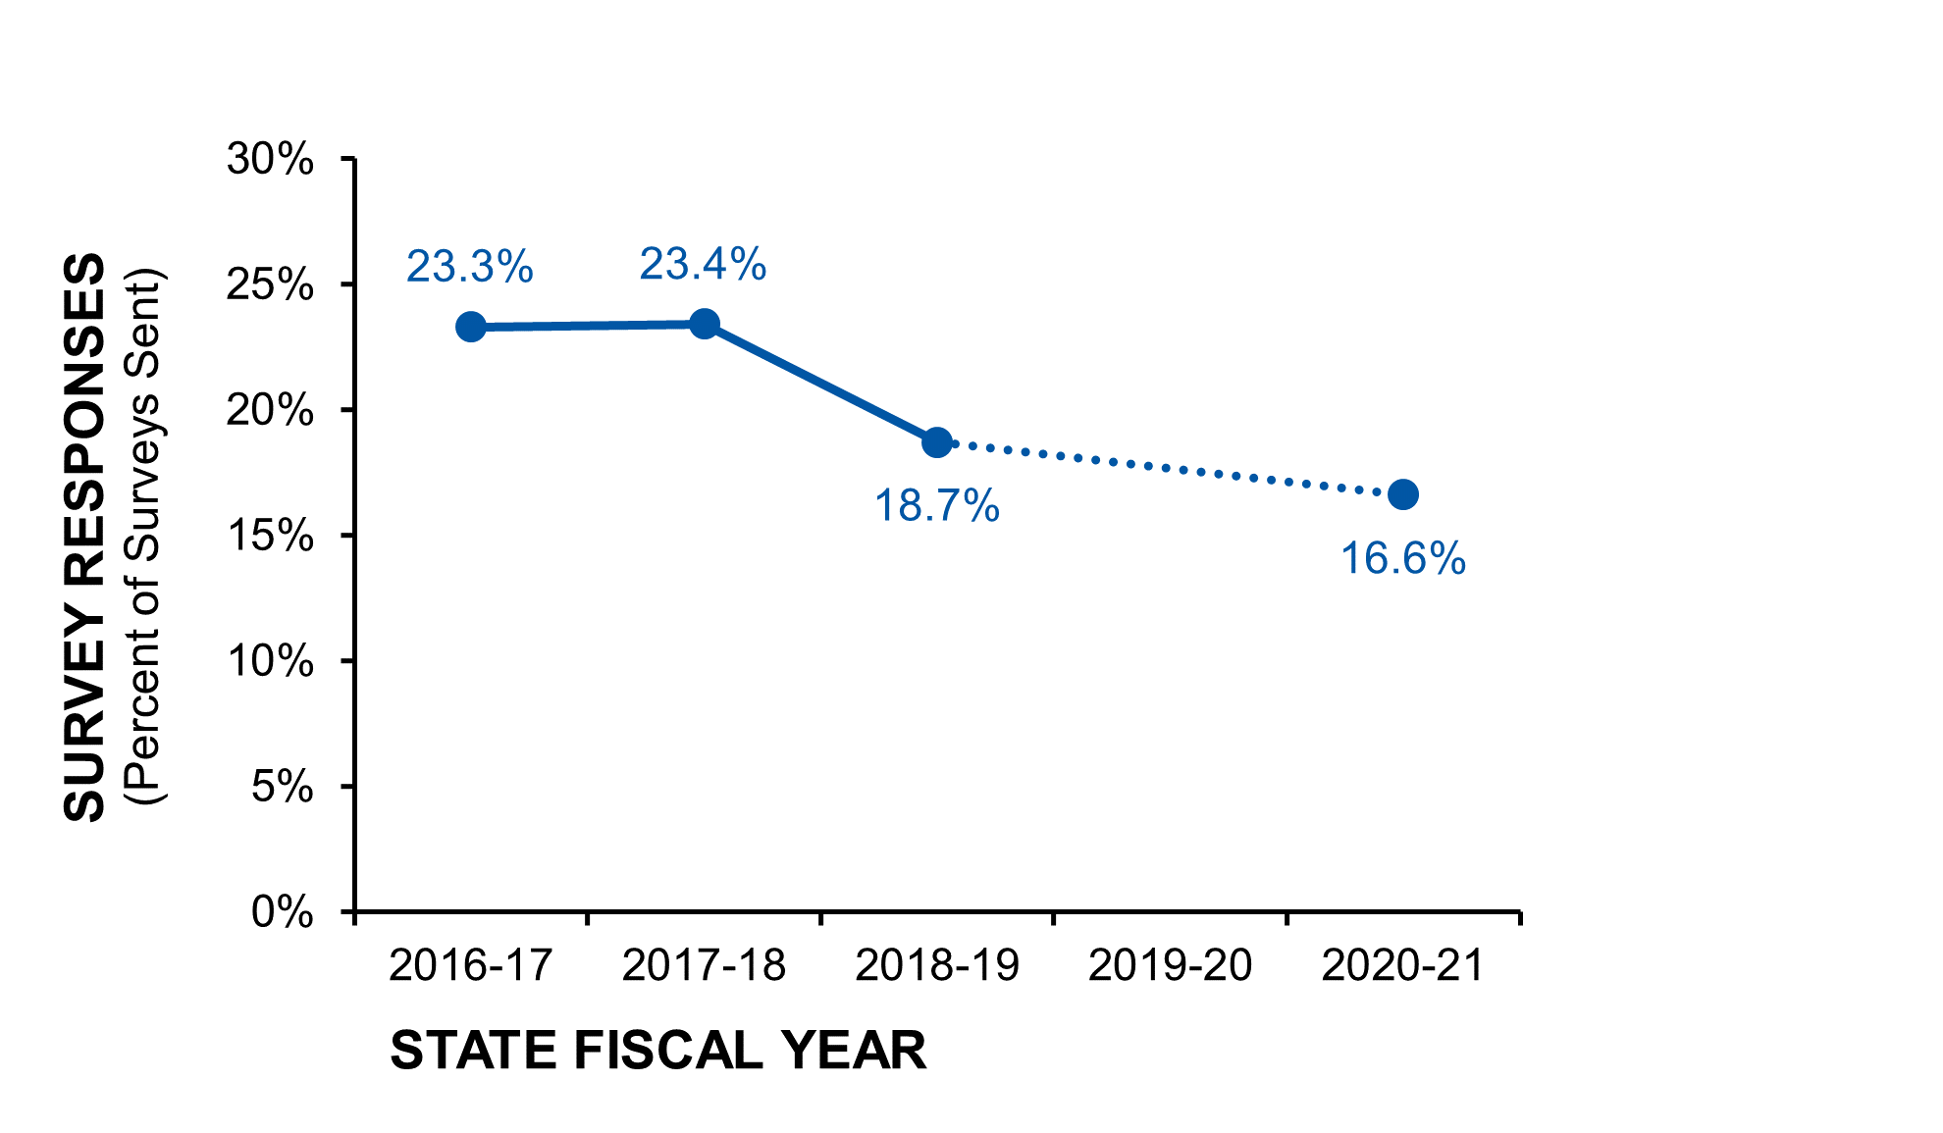
- The line graph represents the CSS response rates (y-axis) over time (x-axis). The CSS was not conducted in SFY 2019-20 and is represented as a dashed line. Figure data is listed in table format below (Table 4).

- Comparison of CSS Population Sizes, Surveys Sent, and Responses Received Over Time
Survey Design | 2016-17 | 2017-18 | 2018-19 | 2019-20¹ | 2020-21
Population Size² | 98,332 | 100,442 | 101,750 | 108,916 | 109,845
Survey Sample Size | 20,400 | 20,400 | 20,400 | N/A | 5,731
Population Survey Rate³ | 20.7% | 20.3% | 20.0% | N/A | 5.2%
Total Sent⁴ | 18,676 | 18,561 | 18,666 | N/A | 5,123
Deliverable Rate⁵ | 91.5% | 91.0% | 91.5% | N/A | 89.8%
Responses Received | 4,344 | 4,351 | 3,483 | N/A | 849
Responses Rate⁶ | 23.3% | 23.4% | 18.7% | N/A | 16.6%
- CSS was not conducted in SFY 2019-20.
- Population size refers to the total population served by DOR in the previous state fiscal year.
- Population survey rate is the percent of individuals selected for the survey, referred to as the survey sample size, compared to total population size.
- Total number of surveys sent excludes any undeliverable surveys due to invalid consumer contact information.
- Deliverable rate is the percent of total surveys sent, excluding undeliverable surveys, compared to survey sample size.
- Response rate is the percent of survey responses received compared to the total number of surveys sent, excluding undeliverable surveys.
- Consumer Satisfaction
- DOR Experience
Survey participants were asked to rate their satisfaction with their overall experience at DOR. There were 828 total responses received, which represents 97.5% of the survey participants. The number of responses received per rating are displayed in Figure 2 and listed in Table 5 below.
Of the ratings received, 78.4% of participants were satisfied (ratings 5-7), 16.8% were dissatisfied (ratings 1-3), and 4.8% were neutral (rating 4) with their overall DOR experience. The combined weighted satisfaction score for DOR experience was 79.4% which is considered satisfied. This category rating is consistent with the combined overall satisfaction score of the CSS, which was also satisfied.
- Satisfaction Ratings for Overall DOR Experience

- Frequency of satisfaction ratings for overall experience at DOR are illustrated as a diverging bar chart. Ratings were considered satisfied (5-7, blues), neutral (4, light gray), and not satisfied (1-3, dark grays). Figure data are listed in table format below (Table 5).
- Satisfaction Ratings for Overall DOR Experience
Overall DOR Experience  Ratings (Count) | 1 | 2 | 3 | 4 | 5 | 6 | 7 | Total | Score
Overall DOR Experience | 68 | 38 | 33 | 40 | 95 | 154 | 400 | 828 | 79.4%
- DOR Counselors
The DOR counselors serve as the initial point of contact for DOR’s consumers, providing them with support and guidance to help them achieve their employment goals. The CSS included five questions to assess consumer satisfaction with their DOR counselors. These questions included: understanding consumer needs, providing guidance on skills and abilities, providing guidance on employment goals, treating consumers with respect, and communicating in a timely manner. Ratings and satisfaction scores for each question are listed below in Figure 3 and Table 6.
The DOR counselors received an overall satisfaction score of 80.0%, which is considered satisfied. Participants were extremely satisfied with the respect they have received from their counselors, with a satisfaction score of 88.7%. This was the highest rated question of the entire survey. Participants were satisfied with the ability of their counselors to understand their needs (81.3% score), respond in a timely manner (79.4% score), provide guidance on their disability and skills (76.7%, score), and provide employment guidance (73.7% score).
- Satisfaction Ratings for DOR Counselors

- Satisfaction ratings of CSS questions related to DOR counselors are illustrated as a diverging bar chart. Ratings were considered satisfied (5-7, blues), neutral (4, light gray), and not satisfied (1-3, dark grays). Figure data are listed below in table format (Table 6).
- Satisfaction Ratings for DOR Counselors
DOR Counselor Ratings (Count) | 1 | 2 | 3 | 4 | 5 | 6 | 7 | Total | Score
Understands Needs | 68 | 28 | 34 | 28 | 86 | 131 | 442 | 817 | 81.3%
Disability Guidance | 88 | 26 | 42 | 57 | 80 | 141 | 362 | 796 | 76.7%
Employment Guidance | 98 | 28 | 41 | 47 | 81 | 109 | 305 | 709 | 73.7%
Respectful | 38 | 14 | 18 | 27 | 38 | 86 | 551 | 772 | 88.7%
Timely Responses | 75 | 30 | 34 | 39 | 85 | 111 | 412 | 786 | 79.4%
Total | 367 | 126 | 169 | 198 | 370 | 578 | 2,072 | 3,880 | 80.0%
- Service Providers
Service providers support DOR consumers and include job coaches, community rehabilitation programs, schools, etc. The CSS asked survey participants to rate their satisfaction with service providers via four questions: overall satisfaction, understanding their needs, treating consumers with respect, and communicating in a timely manner. Ratings received and satisfaction scores for service providers are listed below in Figure 4 and Table 7.
Service providers were given an overall satisfaction score of 80.3% which is considered satisfied. In fact, participants rated this the highest rated category for the entire CSS. Along the same lines, survey participants were extremely satisfied with the level of respect from their service providers (satisfaction score 87.7%), which was the second highest rated question of the entire survey. Additionally, participants were satisfied with their service providers’ timely responses (81.1% score), understanding of their disability (80.3%), and overall experience (73.0% score).
- Satisfaction Ratings for Service Providers

- Satisfaction ratings of CSS questions related to service providers are illustrated as a diverging bar chart. Ratings were considered satisfied (5-7, blues), neutral (4, light gray), and not satisfied (1-3, dark grays). Figure data are listed below in table format (Table 7).
- Satisfaction Ratings for Service Providers
Service Provider Ratings (Count) | 1 | 2 | 3 | 4 | 5 | 6 | 7 | Total | Score
Overall Satisfaction | 66 | 24 | 38 | 69 | 149 | 351 | 109 | 806 | 73.0%
Understands Disability | 52 | 22 | 38 | 39 | 82 | 126 | 354 | 713 | 80.3%
Respectful | 30 | 12 | 23 | 18 | 58 | 107 | 460 | 708 | 87.7%
Timely Responses | 55 | 20 | 28 | 48 | 81 | 132 | 378 | 742 | 81.1%
Total | 203 | 78 | 127 | 174 | 370 | 716 | 1,301 | 2,969 | 80.3%
- Employment Services
Survey participants were asked to rate their satisfaction with their employment services and goals which are related to their Individualized Plan for Employment (IPE). The CSS had four questions regarding employment services: setting employment goals, making the right connections to other agencies and service providers, employment goal disagreements, and DOR’s appeal process. Ratings for each question are listed below (Figure 5, Table 8).
Employment services had an overall satisfaction score of 77.4%, which means survey participants were satisfied with this category. For this category, survey participants rated the connections made by their DOR team highest (80.6%, satisfied), followed by employment goal setting (77.3%, satisfied), DOR appeal process (75.9%, satisfied), and employment goal disagreements (75.8%). These positive results are consistent with the high ratings participants also gave their DOR counselors and service providers.
- Satisfaction Ratings for Employment Services

- Satisfaction ratings of CSS questions related to employment services are illustrated as a diverging bar chart. Ratings were considered satisfied (5-7, blues), neutral (4, light gray), and not satisfied (1-3, dark grays). Figure data are listed below in table format (Table 8).
- Satisfaction Ratings for Employment Services
Employment Services  Ratings (Count) | 1 | 2 | 3 | 4 | 5 | 6 | 7 | Total | Score
Setting Goals | 78 | 26 | 34 | 45 | 92 | 131 | 338 | 744 | 77.3%
Agency/Prov. Connections | 97 | 28 | 31 | 39 | 78 | 113 | 341 | 727 | 75.8%
Goal Disagreements | 58 | 21 | 22 | 51 | 76 | 132 | 360 | 720 | 80.6%
DOR Appeal Process | 72 | 32 | 25 | 60 | 63 | 111 | 294 | 657 | 75.9%
Total | 305 | 107 | 112 | 195 | 309 | 487 | 1,333 | 2,848 | 77.4%
- Current Employment
Employed survey participants were asked to rate their satisfaction with various aspects of their current job (Figure 6 and Table 9). Specifically, they rated their satisfaction with the type of work they do, their wages and benefits, how well their job aligns with their DOR employment goals, and if their life is more independent after becoming employed with the help of DOR services. Please note that some survey participants responded to employment satisfaction questions for currently employed and currently unemployed consumers.
Overall, participants were satisfied with their current employment satisfaction (75.7% score). In fact, 73.6% of all responses received for this category were positive (ratings five or higher). Based on satisfaction score, participants rated their type of work highest (77.1%), followed by increased independence (76.2%), IPE alignment (76.0%), and wages/benefits (73.5%). Additionally, 46.0% (254) of respondents (552) said they were extremely satisfied (rating seven) with their increased independence after receiving DOR services.
- Satisfaction Ratings for Current Employment from Employed Participants

- Satisfaction ratings for CSS questions related to current employment are illustrated as a diverging bar chart. Ratings were considered satisfied (5-7, blues), neutral (4, light gray), and not satisfied (1-3, dark grays). Figure data are listed below in table format (Table 9).
- Satisfaction Ratings for Current Employment from Employed Participants
Current Employment Ratings (Count) | 1 | 2 | 3 | 4 | 5 | 6 | 7 | Total | Score
Type of Work | 52 | 12 | 7 | 22 | 38 | 47 | 189 | 367 | 77.1%
Wages and Benefits | 54 | 16 | 13 | 25 | 48 | 53 | 157 | 366 | 73.5%
Alignment with IPE | 51 | 12 | 9 | 21 | 48 | 55 | 171 | 367 | 76.0%
Increased Independence | 68 | 23 | 23 | 28 | 65 | 91 | 254 | 552 | 76.2%
Total | 225 | 63 | 52 | 96 | 199 | 246 | 771 | 1,652 | 75.7%
- Improved Employment Opportunities
Unemployed survey participants were asked to rate their satisfaction with their employment opportunities after receiving DOR services (Figure 7, Table 10). Overall, there were 545 responses, which is equivalent to 64.2% of all survey participants (849). While 24.2% of individuals gave dissatisfied ratings (1-3), 40.4% of all respondents were extremely satisfied (rating seven). Collectively, survey participants rated their improved employment chances as satisfied (72.0% satisfaction score).
Compared to all other categories assessed in the CSS, improved employment chances had the lowest satisfaction score. Interestingly, identifying employment opportunities was discussed in 17% of all comments received, which was the third most common theme in survey feedback.
- Satisfaction Ratings for Employment Opportunities from Unemployed Participants

- Satisfaction ratings for employment opportunities for unemployed participants are illustrated as a diverging bar chart. Ratings were considered satisfied (5-7), neutral (4), and not satisfied (1-3). Figure data are listed below in table format (Table 10).
- Satisfaction Ratings for Employment Opportunities from Unemployed Survey Participants
Employment Opportunities  Ratings (Count) | 1 | 2 | 3 | 4 | 5 | 6 | 7 | Total Ratings | Score
Improved Employment Opportunities | 95 | 18 | 19 | 31 | 76 | 86 | 220 | 545 | 72.0%
- Survey Results by Consumer DOR District
- Survey Responses by Consumer DOR District
Invitations for the CSS were sent to DOR consumers based on their DOR district. For each DOR district, the percent of total invitations sent was equivalent (±1%) to the percent of DOR’s total population it served (Figure 8 and Table 11).
There were 849 responses received for the SFY 2020-21 CSS, which is equivalent to 0.8% of the total population served by DOR in SFY 2019-20. While the total number of responses was lower than anticipated, the responses are still reflective of DOR’s total consumer population with a statistical confidence level of 99% (±4.411%).
Responses from DOR districts Santa Barbara, San Diego, and Blind Field Services were higher than expected (by at least one percent) compared to the proportion of individuals served by DOR. Conversely, responses from DOR districts Inland Empire and LA South Bay were lower than expected (by at least one percent) compared to the proportion of individuals sent the survey. For the remaining ten DOR districts, the percent of survey responses received were consistent with the percent of DOR’s total population served (±1.0%).
- Comparison of CSS Population Size, Surveys Sent, and Responses Received by DOR District
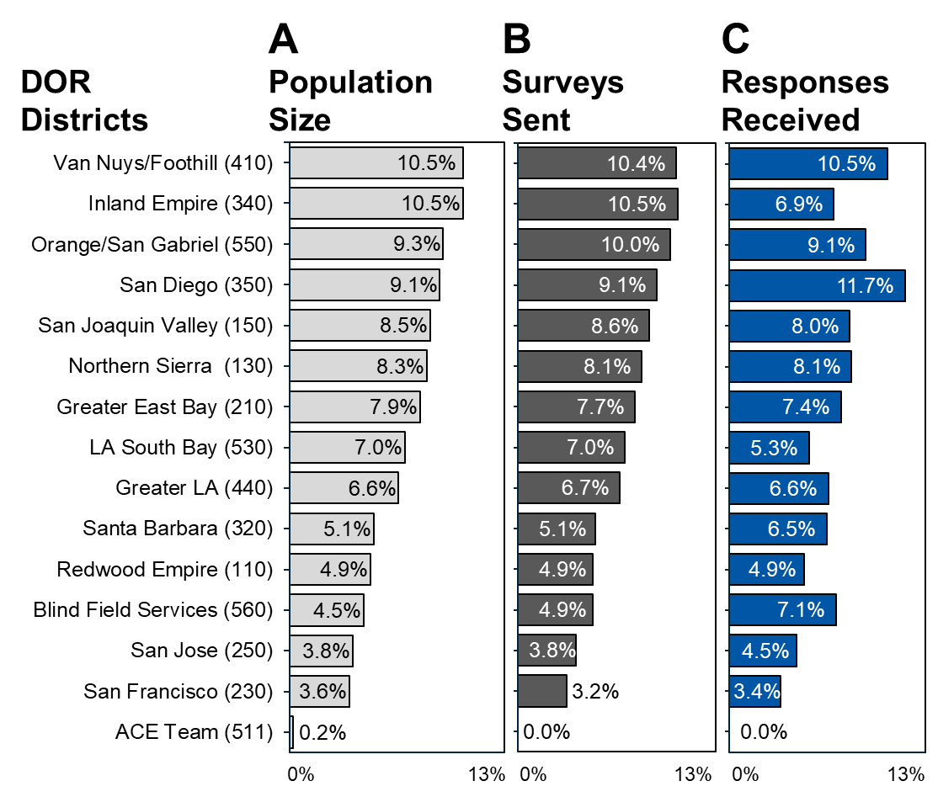
- The percent of total DOR Population Size (A, light gray), surveys sent (B, dark gray), and CSS responses received (C, blue) for each DOR district (by name and code) are illustrated using bar charts. Figure data are listed in table format below (Table 11).

- Comparison of Consumer Satisfaction Survey and DOR District Sizes
DOR District  (Name and Code) | Population  (Percent of Total) | Sent  (Percent of Total) | Responses  (Percent of Total)
Van Nuys/Foothill (410) | 10.5% | 10.4% | 10.5%
Inland Empire (340) | 10.5% | 10.5% | 6.9%
Orange/San Gabriel (550) | 9.3% | 10.0% | 9.1%
San Diego (350) | 9.1% | 9.1% | 11.7%
San Joaquin Valley (150) | 8.5% | 8.6% | 8.0%
Northern Sierra (130) | 8.3% | 8.1% | 8.1%
Greater East Bay (210) | 7.9% | 7.7% | 7.4%
LA South Bay (530) | 7.0% | 7.0% | 5.3%
Greater LA (440) | 6.6% | 6.7% | 6.6%
Santa Barbara (320) | 5.1% | 5.1% | 6.5%
Redwood Empire (110) | 4.9% | 4.9% | 4.9%
Blind Field Services (560) | 4.5% | 4.9% | 7.1%
San Jose (250) | 3.8% | 3.8% | 4.5%
San Francisco (230) | 3.6% | 3.2% | 3.4%
ACE Team (511) | 0.2% | 0.0% | 0.0%
Total Number | 109,845 | 5,731 | 849
- Satisfaction by Consumer DOR District
To determine if satisfaction was influenced by the consumer’s DOR district, satisfaction scores were compared for each DOR district (Table 12). Based on their overall satisfaction scores, all participants were considered satisfied regardless of their DOR district. The highest overall satisfaction score was 85.6%, which was given by participants from the Redwood Empire District. The lowest overall satisfaction score was 73.9%, which was given by participants from the Greater East Bay District.
General experience at DOR, DOR counselors, and service providers categories were rated as satisfied by participants from all DOR districts, with the exception of participants from the Redwood Empire District who rated these categories as extremely satisfied. All participants rated their employment services as satisfied. Current employment was rated as somewhat satisfied by employed participants from the San Francisco District, Northern Sierra District, or the Greater East Bay District, whereas employed participants from the remaining districts were satisfied with their current employment. Unemployed participants were satisfied with the improvements to their employment opportunities if they received services from Redwood Empire, Orange/San Gabriel, San Joaquin Valley, San Francisco, San Diego, or Los Angeles South Bay DOR districts. Whereas participants from the remaining DOR districts rated their satisfaction with improved employment opportunities as only somewhat satisfied.
Taken together, these data suggest that while satisfaction levels may vary slightly for different categories, a participant’s DOR district does not influence their overall satisfaction level.
- Satisfaction Scores by Participant DOR Districts
DOR District  (Name and Code) | DOR Exp.  (Score) | DOR Couns.  (Score) | Service Providers  (Score) | Employ. Services  (Score) | Current Employ.  (Score) | Employ. Opport.  (Score) | Overall  (Score)
Redwood Empire (110) | 87.5% | 86.9% | 87.9% | 85.4% | 81.5% | 76.0% | 85.6%
San Jose  (250) | 84.1% | 84.2% | 80.8% | 81.7% | 82.8% | 87.6% | 82.8%
Orange/ San Gabriel (550) | 82.4% | 82.5% | 82.2% | 78.9% | 81.2% | 79.1% | 81.3%
San Joaquin Valley (150) | 83.5% | 80.5% | 83.0% | 79.6% | 76.3% | 78.9% | 80.5%
Santa Barbara (320) | 79.4% | 83.0% | 82.3% | 77.1% | 79.0% | 70.1% | 80.2%
Blind Field Services (560) | 79.8% | 79.6% | 81.3% | 76.6% | 83.1% | 66.5% | 79.4%
San Francisco (230) | 80.3% | 85.1% | 78.9% | 76.5% | 68.9% | 73.7% | 78.9%
Van Nuys/ Foothill (410) | 78.4% | 79.8% | 79.4% | 78.7% | 78.0% | 71.0% | 78.7%
San Diego  (350) | 80.3% | 79.5% | 81.1% | 77.9% | 73.7% | 73.1% | 78.6%
Los Angeles South Bay (530) | 80.4% | 79.0% | 82.4% | 77.0% | 74.3% | 71.9% | 78.4%
Inland Empire (340) | 77.1% | 79.6% | 76.8% | 78.1% | 72.9% | 64.3% | 76.8%
Greater Los Angeles (440) | 72.0% | 76.6% | 77.0% | 73.0% | 72.5% | 66.4% | 74.6%
Northern Sierra (130) | 73.7% | 75.8% | 78.2% | 73.3% | 65.0% | 67.3% | 74.0%
Greater East Bay (210) | 76.7% | 74.9% | 75.1% | 73.3% | 69.9% | 69.8% | 73.9%
- Survey Results by Consumer Disability Type
- Survey Responses by Consumer Disability Type
Survey participants reported their disability type(s) by either selecting option(s) from a given list or other (please specify) which was then reviewed and categorized. For the SFY 2020-21 CSS, 97.8% of survey participants responded and reported a total of 1,195 disability types (Figure 9, Table 13). The total number of disability types exceeds the total number of survey participants because individuals were able to report more than one disability type when applicable. The most frequently reported disability types by CSS participants were Physical (22.0%), Psychiatric (21.8%), and Learning (19.9%) Disabilities. The distribution of disability types reported by survey participants does not exactly align with that of DOR’s total population, which is due to how individuals were selected for the CSS and how CSS demographic information was collected. For example, 24.5% of DOR’s total consumer population did not report a disability but the CSS only had 1.6% of participants who did not report a disability type. Please note that potentially eligible consumers, or PE case type, do not report a disability type in their DOR case file which is why there is a high percent of the population without disability type.
- Comparison of Consumer Satisfaction Survey Population Size and Responses by Disability Type
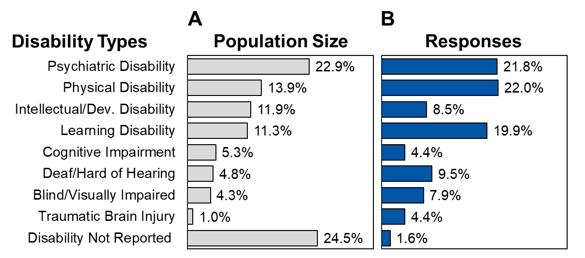
- Comparison of the percent of the total DOR population size (A, gray) and CSS responses (B, blue) by Disability Type are illustrated using bar charts. The total DOR population size for SFY 2019-20 was 109,845 and the total disabilities reported for the SFY 2020-21 CSS was 1,195. Figure data are listed in table format below (Table 5).
- Comparison of Consumer Satisfaction Survey Population Size and Responses by Disability Type
Disability Types | Population¹  (Percent of Total) | Responses²  (Percent of Total)
Psychiatric Disability | 22.9% | 21.8%
Physical Disability | 13.9% | 22.0%
Intellectual/Developmental Disability | 11.9% | 8.5%
Learning Disability | 11.3% | 19.9%
Cognitive Impairment | 5.3% | 4.4%
Deaf/Hard of Hearing | 4.8% | 9.5%
Blind/Visually Impaired | 4.3% | 7.9%
Traumatic Brain Injury | 1.0% | 4.4%
Not Reported | 24.5% | 1.6%
Total (count) | 109,845 | 1,195
- Satisfaction by Consumer Disability Type
Based on the overall satisfaction score, all participants were considered satisfied regardless of the disability type reported. The highest overall satisfaction score was 80.5%, which was from participants who identified as deaf or hard of hearing. The lowest overall satisfaction score was 72.5%, which was reported by participants who identified as having a traumatic brain injury. Survey participants most frequently reported a psychiatric disability, and their overall satisfaction score was 78.7%.
Survey participants, regardless of their disability types, were satisfied with all categories assessed in the CSS, except for the following ratings. Individuals who reported a physical disability, intellectual or developmental disability, or a traumatic brain injury were only somewhat satisfied with their current employment and employment opportunities. Additionally, individuals who reported deaf or hard of hearing and cognitive impairments were only somewhat satisfied with their employment opportunities. Individuals who did not report a disability type in the survey were extremely satisfied with their current employment, but only somewhat satisfied with their general experience at DOR and their employment opportunities. Collectively, these findings suggest that disability type has minimal influence on overall consumer satisfaction.

- Satisfaction Scores by Participant-reported Disability Types
Disability  Type | DOR Exp.  (Score) | DOR Counselor  (Score) | Service Providers  (Score) | Employ. Services  (Score) | Current Employ.  (Score) | Employ. Opport.  (Score) | Overall  (Score)
Deaf/ Hard of Hearing | 80.3% | 82.1% | 83.4% | 78.8% | 77.9% | 71.2% | 80.5%
Learning Disability | 81.3% | 81.7% | 80.7% | 79.5% | 73.7% | 74.3% | 79.5%
Blind/ Visually Impaired | 80.3% | 79.3% | 79.8% | 77.2% | 81.5% | 74.3% | 79.1%
Psychiatric Disability | 80.1% | 79.6% | 80.8% | 76.9% | 75.4% | 77.1% | 78.7%
Cognitive Impairment | 78.3% | 79.9% | 79.6% | 77.3% | 72.7% | 68.3% | 77.8%
Disability Not Reported | 68.6% | 74.9% | 80.1% | 77.1% | 86.1% | 67.1% | 77.7%
Physical Disability | 77.7% | 77.2% | 76.9% | 76.5% | 70.2% | 70.7% | 75.9%
Intellectual/ Dev. Disability | 78.5% | 78.0% | 79.6% | 72.5% | 69.2% | 68.7% | 75.6%
Traumatic Brain Injury | 74.4% | 74.1% | 72.9% | 72.1% | 70.1% | 64.9% | 72.5%
- Survey Results by Consumer Age Range
- Survey Responses by Consumer Age Range
The CSS asked participants to report their ages. The percent of DOR consumers served is compared to the percent of CSS responses received based on consumer ages below (Figure 10, Table 15).
The survey received ages from 98.8% of participants and their ages ranged from 16-93 years old. The average age of all survey participants was 39 years old. Interestingly, 23.9% of participants are considered youths (ages 16-24 years old).
Survey invitations were sent to consumers based on their DOR district and did not account for age. This explains why the age distribution of survey responses do not align with that of DOR’s total population.
- Comparison of Consumer Satisfaction Survey Population Size and Responses Age
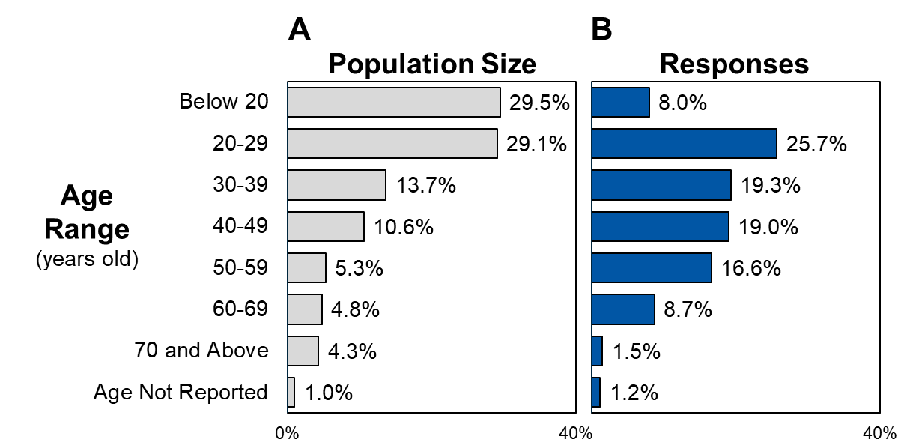
- The percent of total DOR population (109,845 consumers, Panel A) and the percent of total CSS responses received (849 responses, Panel B) by age range are illustrated using bar charts. Figure data are listed in table format below (Table 15).
- Comparison of Consumer Satisfaction Survey Population Size and Responses by Age
Age Range  (Years Old) | Population  (Percent of Total) | Responses  (Percent of Total)
Below 20 | 29.5% | 8.0%
20-29 | 29.1% | 25.7%
30-39 | 13.7% | 19.3%
40-49 | 10.6% | 19.0%
50-59 | 11.0% | 16.6%
60-69 | 5.3% | 8.7%
70 and Above | 0.7% | 1.5%
Age Not Reported | 0.002% | 1.2%
Total (Count) | 109,845 | 849
- Satisfaction by Consumer Age Range
Satisfaction scores of participants were compared by age ranges below (Table 16).
Overall satisfaction scores varied slightly between age groups while remaining within the satisfied range. Survey participants between the ages of 20-29 years old reported a satisfaction score of 83.1%, which was the highest score for all age ranges. The lowest satisfaction score was 75.3% which was reported by survey participants under the age of 20 years old.
In general, all participants were satisfied with the individual categories assessed in the survey with a few exceptions. Participants above the age of 70 years old were extremely satisfied with their current employment (88.0% score), but neutral about their improved employment opportunities (57.1% score). Additionally, unemployed participants below the age of 20 years old, 30-39 years old, and 50-59 years old were only somewhat satisfied with the improvement of their employment opportunities.
- Satisfaction Scores by Participant Age Range
Participant  Age Range | DOR Exper.  (Score) | DOR Counselor  (Score) | Service Providers  (Score) | Employ. Services  (Score) | Current Employ.  (Score) | Employ. Opport.  (Score) | Overall  (Score)
Below 20 | 78.0% | 76.9% | 77.2% | 74.6% | 71.6% | 66.8% | 75.3%
20-29 | 84.4% | 84.9% | 85.2% | 80.7% | 80.8% | 77.6% | 83.1%
30-39 | 78.1% | 77.4% | 79.4% | 76.1% | 76.7% | 71.0% | 77.3%
40-49 | 77.4% | 79.1% | 80.6% | 77.8% | 72.7% | 72.6% | 77.9%
50-59 | 76.3% | 77.7% | 76.9% | 74.1% | 72.8% | 67.2% | 75.5%
60-69 | 80.0% | 80.7% | 75.4% | 78.9% | 73.4% | 71.8% | 77.8%
70 and Above | 80.2% | 83.3% | 82.7% | 83.3% | 88.0% | 57.1% | 83.0%
Not Reported | 73.0% | 82.5% | 80.2% | 70.0% | 75.3% | 79.4% | 77.2%
- Survey Results by Consumer Location
- Survey Responses by Consumer Location
Survey participants were asked to report their location. This information was compared with the locations of DOR offices to determine which participants have a local DOR office, and which must travel to a different city to visit a DOR office. The distribution of DOR offices and CSS participants throughout the state of California are compared below (Figure 11, Table 17).
In California, DOR has 83 offices spanning 77 cities. For the CSS, 839 participants reported their locations which included 288 different cities. When compared to DOR offices, 47.7% of participants shared a city with a DOR office, 50.5% of participants did not share a city with a DOR office, and 2.1% of participants did not report their city.
- Distribution of Consumer Satisfaction Survey Participants by Location and overlap with DOR District Offices
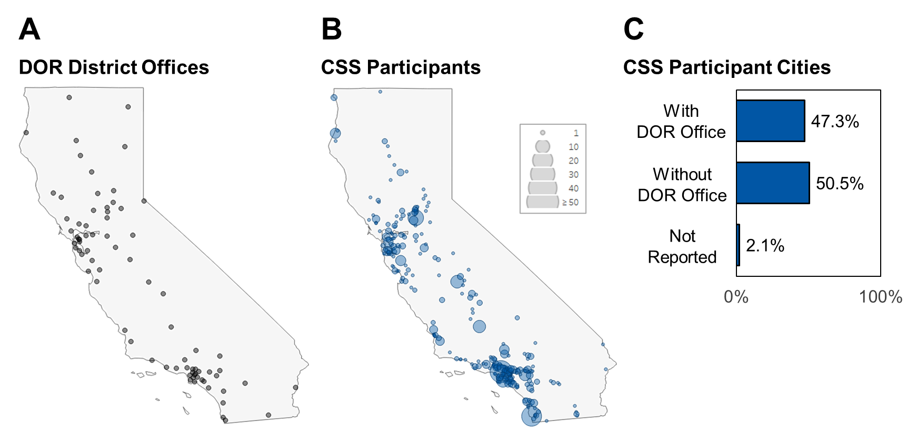
- Location (city) of DOR district offices (A, gray) and CSS participants (B, blue) were plotted on a map of California (generated with Tableau). The percent of survey participants who reported a city with or without a DOR office are illustrated using a bar chart (C). Figure data are listed below in table format (Table 17).
- Distribution of Consumer Satisfaction Survey Participants by Location and overlap with DOR District Offices
Participant Location¹ | Participants (Count) | Participants  (Percent of Total)
City with DOR Office | 402 | 47.3%
City without DOR Office | 429 | 50.5%
City Not Reported | 18 | 2.1%
Total | 849 | 100.0%
- Participant reported locations were compared to the locations of the DOR district offices at the city level.
- Satisfaction by Consumer Location
Satisfaction scores were compared for survey participants based on their reported location below (Table 18). In general, there was less than a one percent difference in satisfaction scores for Overall DOR Experience, Service Providers, Employment Services, Current Employment, and Employment Opportunities categories between participants who do or do not live a city with a DOR office. Participants with a local DOR office rated their DOR counselors 1.1% lower than participants who do not have a DOR office in their city. The overall satisfaction scores varied less than one percent between survey participants who did or did not have a local DOR office, which suggests that proximity to a DOR office has minimal influence on a consumer’s overall satisfaction.
- Comparison of Satisfaction Score for Participants based on their Location relative to DOR offices
CSS Satisfaction  Categories | Participant City with DOR Office  (Satisfaction Score) | Participant City without DOR Office  (Satisfaction Score) | Difference¹
DOR Experience | 79.7% | 79.5% | 0.2%
DOR Counselors | 79.7% | 80.8% | -1.1%
Service Providers | 80.1% | 80.9% | 0.8%
Employment Services | 78.0% | 77.3% | 0.7%
Current Employment | 76.3% | 76.1% | 0.2%
Employment Opportunities | 72.3% | 72.4% | -0.1%
Overall | 78.6% | 79.0% | -0.4%
- Difference is calculated as the satisfaction score of individuals whose city does have a DOR office minus the satisfaction score of individuals whose city does not have a DOR office.
- Employment Barriers and Consumer Satisfaction
- Survey Responses by Consumer Unemployment Reasons
Survey participants were asked to identify reasons or causes that contributed to their unemployment status. The frequency employment barriers were reported by survey participants are listed below (Figure 12, Table 19).
Of the 849 survey participants, 76.1% (646) identified a total of 1,385 employment barriers. On average, each respondent reported two reasons for being unemployed. Currently a Student (22.7%, 314), Still Looking for Employment (18.4%, 255), and Needs Additional Assistance (12.2%, 169) were the most commonly reported unemployment reasons.
- Unemployment Reasons Reported

- The percent of total unemployment reasons reported (1,385) by participants is illustrated using a bar chart. Figure data are listed in table format below (Table 19).
- Unemployment Reasons Reported
Unemployment Reasons | Responses  (Count) | Responses  (Percent of Total)
Currently a Student | 314 | 22.7%
Still Looking for Employment | 255 | 18.4%
Need Additional Help | 169 | 12.2%
Lack of DOR Assistance | 121 | 8.7%
Prevented by Disability | 112 | 8.1%
Not Ready for Employment | 98 | 7.1%
Prevented by Transportation Issues | 83 | 6.0%
Lack of Desired Jobs Available | 81 | 5.8%
Lack of IPE-consistent Jobs Available | 68 | 4.9%
Retaining SSI/SSDI Benefits | 43 | 3.1%
Prevented by Family Issues | 41 | 3.0%
Total | 1,385 | 100%
- Satisfaction by Consumer Unemployment Reasons
To determine if the presence of an employment barrier influenced a consumer’s overall satisfaction with DOR, the satisfaction scores were compared between participants who did or did not report unemployment reasons (Table 20).
The overall satisfaction score from participants who reported at least one unemployment reason was 9.5% lower than that of participants who did not report any unemployment reasons. In fact, all categories were rated lower by participants with employment barriers, with the largest discrepancy for satisfaction with employment and improved employment opportunities, which were rated significantly lower (-16.2% and -15.5%, respectively) compared to participants who did not report unemployment reasons.
- Comparison of Satisfaction Scores from Survey Participants who did or did not Report Unemployment Reasons
Category | Reported Unemployment Reasons  (Satisfaction Score) | Did Not Report Unemployment Reasons  (Satisfaction Score) | Difference¹
DOR Experience | 77.3% | 86.0% | -8.7%
DOR Counselors | 78.1% | 86.8% | -8.7%
Service Providers | 78.7% | 86.2% | -7.5%
Employment Services | 75.4% | 84.1% | -8.7%
Current Employment | 69.9% | 86.1% | -16.2%
Employment Opportunities | 71.0% | 86.5% | -15.5%
Overall | 76.3% | 85.9% | -9.5%
- Difference is calculated as the satisfaction score of individuals who reported at least one unemployment reason minus the satisfaction score of individuals who did not report any unemployment reasons.
- Additional Feedback
Survey participants were able to submit additional feedback and suggestions for improvements. There were 348 comments received from participants which discussed 14 common topics regards four common themes (Table 21).
Consumers wrote comments about their overall experience at DOR which included thanking DOR, requesting additional information, being impacted by the coronavirus pandemic, and discussing general topics. Consistent with their overall DOR satisfaction, consumers praised DOR and counselors in their feedback, representing 35.1% and 6.0% of all comments received, respectively. The onset of the coronavirus pandemic in early 2020 may have impacted the experiences of consumers who were surveyed for the SFY 2020-21 CSS. At this time, we are unable to determine the effects of the pandemic on consumer satisfaction ratings. However, 12.6% of comments received from survey participants discussed issues related to the coronavirus pandemic including health risks, virtual communication, shutdowns, and school closures.
Comments about DOR counselors mentioned a need for timely and consistent communication most frequently (18.4%), followed by management of consumer’s record of service (9.5%), their ability to understand consumer needs (7.8%), praise (6.0%), and respect (3.7%). Additional feedback regarding employment services consisted of identifying employment opportunities and accessing employment services, these topics represented 17.0% and 13.5% of all comments received, respectively. Consumers also wrote about needing additional support from DOR, which included student services (12.1%), transportation needs (3.7%), and financial support (4.3%).
- Themes Identified in the Feedback from Consumer Satisfaction Survey Participants
CSS Feedback Themes and Topics | Comments²  (Percent of Total)
Theme: Overall DOR Experience
Praise for DOR | 35.1%
Providing Information about DOR Applications | 3.4%
Impacts of the Coronavirus Pandemic | 12.6%
Other General Feedback | 3.7%
Theme: Interacting with DOR Counselors
Praise for DOR Counselors and Staff | 6.0%
Timely and Consistent Communication | 18.4%
Respectful Communication | 3.7%
Managing Records of Service | 9.5%
Understanding Consumer Needs | 7.8%
Theme: Utilizing Employment Services
Identifying Employment Opportunities | 17.0%
Utilizing Employment Services | 13.5%
Theme: Accessing Additional Support
Providing Services for Students | 12.1%
Assisting with Transportation Needs | 3.7%
Providing Additional Financial Support | 4.3%
Total (Count) | 348

Conclusion
The SFY 2020-21 CSS collected feedback from DOR consumers who received services in SFY 2019-20. While there were fewer surveys completed in SFY 2020-21 compared to previous years, the feedback received was still insightful, informative, and representative of DOR’s total consumer population.
Based on their overwhelmingly positive reviews, DOR consumers were satisfied with the services they have received from DOR and its providers. Moreover, consumers were extremely satisfied with the respect they have received from their DOR counselors and service providers. This high level of satisfaction with DOR was reiterated in the 122 comments received that were praising DOR. On the other hand, satisfaction with increased employment opportunities was rated the lowest by unemployed consumers but still considered within the satisfied score range. Interestingly, comparing satisfaction ratings by consumer demographics, such as district, age, disability type, or location did reveal some variations in satisfaction with different categories. However, consumer demographics did not alter overall satisfaction scores.
Another goal of the CSS was to identify potential barriers that may impact a consumer’s accessibility and satisfaction with DOR services. Most frequently, DOR consumers reported being a student, still looking for employment, or needing additional assistance as the cause for their unemployment. Additionally, survey participants who reported at least one unemployment reason were also more likely to have lower satisfaction scores overall and for each category.
To further explore the satisfaction results by the DOR district, consumer disability type, location, or age please refer to the Consumer Satisfaction Survey Dashboard. This interactive dashboard will be available through the DOR’s intranet domain via the Planning Unit.

