California State Rehabilitation Council (SRC)
August 31 – September 1, 2022 Quarterly Meeting
9:00 a.m. – 4:00 p.m. each day
Department of Rehabilitation (DOR)
Meeting location: 721 Capitol Mall, Room 301, Sacramento, CA 95814
Virtual and telephone participation options offered via Zoom.

Meeting Minutes
Approved on November 30, 2022

Attendance
- SRC members (in person): Theresa Comstock, Chanel Brisbane, Susan Henderson, Benjamin Aviles, Nick Wavrin, Ivan Guillen, Joe Xavier.
- SRC members (by Zoom): Lisa Hayes, Sara Abdrabou, Elizabeth Lewis, Jonathan Hasak.
- SRC members absent: Kecia Weller.
- DOR staff (in person): Kate Bjerke, Priyanka Prasad, Jessica Grove, Mark Erlichman.
- DOR staff (by Zoom): Jeffrey McKey, Judy Gonzalez, Carol Asch, Trung Le, Lori Bruno, Sean Nunez, Gina Franklin, Phi Phi Phan, Kim Rutledge, Cynthia Butler, Rosa Gomez, Alicia Lucas, Ana Acton, Regina Cademarti, Megan Sampson, Rowena Okada, Emily Xongchao, Francesca Tayag, Nancy Wentling, Shanti Ezrine.
- Members of the public (in person): Tyler Szura, Adrianne Akers
- Members of the public (by Zoom): Tricia Robertson, Jacqueline Jackson,
La Trena Robinson, Danny Marquez, Nichole Kessel, Marion Rinkel, Rudy Acosta

Item 1: Welcome, Introductions and Membership Recognitions
Theresa Comstock, SRC Chair, called the meeting to order at 9:00 a.m. and welcomed SRC members and meeting attendees. The SRC members introduced themselves and a quorum was established. Kate Bjerke, SRC Executive Officer, recognized the following SRC reappointments announced by the Governor’s Office on August 24, 2022: Chanel Brisbane, Theresa Comstock, Jonathan Hasak, Lisa Hayes, Susan Henderson, and Joe Xavier.

Item 2: Public Comment
There were no public comments.

Item 3: Approval of the June 8 – 9, 2022 SRC Quarterly Meeting Minutes
Motion: It was moved/seconded (Wavrin, Guillen) to approve the June 8 – 9, 2022 SRC quarterly meeting minutes as presented. A roll call vote was taken (Yes – Comstock, Brisbane, Henderson, Hayes, Aviles, Wavrin, Guillen) (No – 0) (Abstain – 0) (Absent for vote – Hasak, Weller, Lewis). The motion carried and the approved minutes will be posted on the SRC webpage.

Item 4: Directorate Report
Joe Xavier, DOR Director, joined the SRC to provide a report out on national, state, and departmental topics of interest. Director Xavier began by congratulating the recently reappointed SRC members. Director Xavier highlighted the following commemorations taking place in September:
- Suicide Prevention Awareness Month (September)
- Labor Day (September 5th)
- Patriot Day (September 11th)
- National Rehabilitation Awareness Week (September 19 - 25, 2022)
- Deaf Awareness Week (September 19 - 25, 2022)
- California Memorial Project - commemorating those who died in state hospitals (September 19th)
- Native American Day (September 23rd)

Director Xavier recognized outgoing SRC Officers Theresa Comstock, Chair, Nick Wavrin, Vice-Chair, and Benjamin Aviles, Treasurer, and thanked them for their leadership and service. Kate Bjerke, SRC Executive Officer, presented certificates of appreciation to Comstock, Wavrin and Aviles.
National Updates
Director Xavier reported that the Council of State Administrators for Vocational Rehabilitation (CSAVR) and the National Coalition of State Rehabilitation Councils (NCSRC) conferences are taking place at the end of October 2022 in Texas. DOR staff and California SRC members are unable to attend these conferences as travel to Texas using public money is prohibited under AB 1887 (2016). DOR will be able to attend the Spring 2023 conferences in Maryland.

Regarding federal VR funding, 22 states relinquished $350 million, and $87 million was made available to the states as reallotment funding. The remaining federal VR reallotment funds were put into a Disability Innovation Fund. DOR requested and received $48 million in federal reallotment funding. DOR also requested $500,000 in reallotment funds for the Older Individuals who are Blind program; however, this funding was not available as states were able to spend their funding for this program.

State Updates
Director Xavier spoke about the three pillars that have, and continue, to drive the overall California Health and Human Services Agency (CalHHS) budget: 1) workforce development, 2) data exchange, and 3) improving infrastructure to better support service delivery. There is a focus on allocating funding to behavioral health services and person-centered approaches.

Department Updates
Director Xavier spoke about DOR Student Services and explained that there are approximately 150,000 students in California with an Individualized Education Program (IEP), and DOR is currently serving 30,000 of these students. DOR has established a new goal to increase the number of students served from 30,000 to 60,000 and a focus on ensuring that youth with disabilities leave high school with either 1) a family sustaining wage, or 2) enrolled in VR services. Updates were provided on department modernization efforts with information technology, licensing fees, electronic workflows, and DOR’s participation in Fi$Cal. An update on the CalDOR Payment Card was provided.

Director Xavier reported the following DOR senior leadership staffing updates:
- Sorath Hangse has been appointed as Regional Director for the San Jose District.
- Recruitment efforts are underway for the vacant Van Nuys District Regional Director position and the vacant DOR Chief Information Officer position.
- Applications are being reviewed for the vacant DOR Administrative Services, Assistant Deputy Director position.
- Efforts continue with the vacant Strategic Initiatives Officer and Chief Deputy Director positions.

Director Xavier provided the SRC with information on the difference between the roles of the DOR Regional Directors and District Administrators.
SRC members, Director Xavier and DOR staff then engaged in a discussion on the following topics:
- Reallotment funding, student services and utilization of Community Rehabilitation Programs (CRPs).
- Increasing marketing and awareness of DOR Student Services.
- Thinking of employment as a part of mental health treatment, and not waiting to engage with an individual about employment until after they have stabilized.
- The need to provide students with transportation for paid work experience.
- The true cost of being disabled and stigma that deters individuals from pursuing VR services. A barrier is that benefit systems are designed based on the concept that one must “fail to in order to benefit.”

Public comment: Jacqueline Jackson suggested convening a summit of school superintendents and other stakeholders to share information on DOR Student Services.

Item 5: Updated Individualized Plan for Employment (IPE)
Carol Asch, Assistant Deputy Director, DOR Vocational Rehabilitation (VR) Employment Division, began by providing background information on the IPE, which is developed in collaboration between the VR Counselor and DOR consumer to establish career goals and the steps and services to reach that goal. The IPE helps the consumer move forward, documents the career exploration that took place, and identifies how informed choice was incorporated. Asch identified the need to make the IPE form more user friendly and person-centered. In response, a workgroup was formed and reviewed each component of the IPE form to better reflect the consumer’s journey. Before the updates were finalized, focus groups with DOR staff and consumers were held. Training was provided to all VR Counselors and DOR Team Managers last spring on this new person-centered approached, and a second training was provided in August 2022. Asch spoke about the philosophy and practice of person-centered planning. Asch shared a PowerPoint Presentation that identified the new seven person-centered questions/statements on the updated IPE, compared with the prior versions of the questions (Reference – Attachment 1). Then, Asch reviewed the prior and updated versions of the DR 215 Individualized Plan for Employment for and attachments. The following feedback was offered: Acknowledgment that the process of emailing the IPE to consumers and the electronic signature process has been beneficial.

Item 6: Expedited Enrollment Update
Trung Le, Assistant Deputy Director, DOR VR Employment Division, provided an update on the implementation of DOR’s expedited enrollment. Through this initiative, VR Counselors use their expertise and observation to determine if an applicant is eligible for VR services. Data has shown that 98% of DOR applicants who apply for services will be eligible, and that many applicants are already working with other entities and agencies. Evaluations can still be performed if needed. Through the expedited enrollment process, VR Counselors have a skilled, in-depth interview with interested applicants, and over 85% of applicants can be determined eligible between one to five days. Data shows that the quicker an individual is determined eligible and moved into an IPE, the percentage of success is higher. DOR will be sharing information with other states on the expedited enrollment process. SRC members shared the following feedback/questions:
- The independent living program does not require medical documentation for eligibility; rather, an individual just needs to self-identify as having a disability.
- Often times consumers encounter many systems and agencies, and its overly burdensome to ask individuals to continuously verify their disability.
- Can consumers apply online for VR services?

Public comment: Danny Marquez thanked the SRC for including this item on the agenda and recognized the benefits of expedited enrollment for consumers.

Item 7: Consumer Reimbursement of Goods and Services Process and CalDOR Payment Card Program Overview
Lori Bruno, Chief, Gina Franklin, Accounting Administrator I, Supervisor, and Phi Phi Phan, Associate Governmental Program Analyst from DOR’s Accounting Services, along with Sean Nunez, Staff Services Manager I, DOR Napa Branch, presented on the consumer reimbursement process and the CalDOR Payment Card Program.

A category identified in DOR fair hearing complaints has included reimbursement requests for goods and services which were not previously authorized by DOR. Bruno began by providing background information on the consumer reimbursement process and the steps involved, which include: a consumer needs to first discuss the request with their VR Counselor; the VR Counselor considers the request and determines if the items/services are needed for the employment plan and are eligible for reimbursement; the VR Counselor enters a case note documenting the approval; the consumer is notified they can use their own funds to purchase the item; and then the consumer submits their receipt for review by the VR Counselor (or their delegate). After these steps are completed, DOR issues an authorization and reimbursement check to the consumer. The most common challenge related to denied consumer reimbursement requests is that the consumer did not first contact their VR Counselor before purchasing the items, as required by federal regulations. Another issue that can arise is when the consumer does not submit a receipt, or the receipt is not itemized. A discussion was held on if, and how, DOR assists consumers when follow up with a receipt is needed.

Then, SRC members received a presentation (reference – Attachment B) on the CalDOR Payment Card Program, which provides consumers with a quick and easy way to purchase approved goods and services directly from businesses and vendors. Bruno provided background information on the history and need for an electronic payment card, which will be transformational for consumers and the Department. Consumers will be able to purchase approved goods and services quickly, conveniently, and confidentially. The program will also include a web-based portal where consumers can view their personalized payment account, check their authorized balance, receive notifications and upload receipts. The CalDOR Payment Card is a Mastercard and will be accepted by most online or point-of-sale register merchants. This portal went live on August 30, 2022, and the DOR Napa Branch is conducting the initial testing with consumers, which will inform future developments, trainings, and instructional materials. Four DOR Districts will pilot the CalDOR Payment Card, and by the end of 2022, the program will rollout statewide. Franklin provided additional background information and spoke about the benefits of the CalDOR Payment Card for both consumers and staff. Nunez spoke about the experience for the consumer, which will include same day services, increased privacy, and a reduction in the need for consumer reimbursements. Discussion highlights with the SRC members included:
- Question if Community Rehabilitation Programs (CRPs) will receive training on the CalDOR Payment Card.
- Clarification that the administrative portal went live on August 30, 2022. The CalDOR Payment Card webpage will launch in the near future.
- Information on how VR Counselors will authorize funds for an item that is needed right away.
- Educating consumers about the importance of informing DOR staff in a timely manner when items are needed.
- Discussion regarding the DOR logo on the CalDOR Payment Card and privacy.

Item 8: DOR Social Media
Kim Rutledge, Deputy Director, and Cynthia Butler, Public Information Officer II, from DOR’s Office of Legislation and Communications joined the SRC to discuss how DOR engages with consumers and stakeholders through social media. Rutledge reviewed the roles and functions of the DOR Office of Legislation and Communications, which includes tracking bills that would impact DOR and/or people with disabilities, partnering with other departments, proposed legislation, and interacting with legislative staff and stakeholders. Rutledge offered to attend a future SRC meeting to provide additional information on DOR’s legislative activities. Regarding communications, Rutledge’s office provides an array of services including overseeing the DOR website, developing collateral materials, event planning, and managing DOR’s social media platforms. Butler provided an overview of DOR’s presence on Facebook, Twitter and LinkedIn and the goals for these platforms (reference – Attachment C). Questions and discussion highlights included the following:
- Audience engagement, analytics, partnering with other agencies, and post promotion.
- Suggestion to post success stories on social media. Discussion about the DOR’s Notice Abilities blog.
- Suggestion to identify which platforms are most effective for different audiences such as parents and students.
- Challenges related to the lack of awareness about DOR.
- Concept that “youth attract youth”, and to have suggestion to have youth interns who can assist with social media.
- Branding concept that DOR is the “door” that brings people into community life.
- Suggestion to encourage engagement between consumers through social media.
- Question about the possibility of DOR working with a marketing firm on rebranding.

Item 9: Diversity, Equity, and Inclusion
Rosa Gomez, DOR Chief Equity Officer, provided the SRC with information on DOR’s diversity, equity, and inclusion (DEI) strategies from a national, state, and departmental level. DOR participates on the national CSAVR group working to bring DEI efforts across all state VR agencies to gain an understanding of the various challenges that historically marginalized groups experience, including people with disabilities. Through this effort, an online repository of DEI materials (videos, training materials, articles, etc.) will be made available for VR departments to access. Gomez spoke about DEI efforts at the state level, which include DOR’s participation on the CalHHS Justice, Equity, Diversity, and Inclusion (JEDI) committee to help implement budgetary changes, such as language policy and resources, developing a training program to identify and eliminate barriers, and developing an equity dashboard across major health and human services programs to identify data gaps by race ethnicity, sexual orientation and gender identity. Gomez spoke about her participation in the Capitol Collaborative on Race and Equity, a community of California state government teams working together to advance racial equity. At the Department level, DOR is considering the development of a racial equity plan. Gomez spoke about the various DOR affinity groups and provided an update on DOR’s Disability Advisory Committee.

Kate Bjerke, SRC Executive Officer, reviewed the policy question posed to the SRC by Joe Xavier, DOR Director: how can inequities in DOR’s programs and services be identified, and what methodologies can be used to address these equity gaps? Bjerke highlighted themes and findings from the 2020 Comprehensive Statewide Assessment, specifically section three, “Individuals with disabilities who are minorities and those who have been unserved or underserved by DOR” (reference – Attachment D). Bjerke noted that she reached out to the Strategic Growth Council to gather information about the equity action plan development process. Questions and discussion highlights with the SRC included the following:
- Suggestion to consult with other State entities that have engaged in this type of work and data analysis. For example, data from the Department of Developmental Services (DDS) shows notable differences in service access among racial/ethnic and language communities.
- DOR could inform proposed legislation that includes equity hiring goals to ensure disability is included (example: SB 485).
- Keep DEI as a standing SRC agenda item.
- Comment regarding digital literacy and access to online training programs.
- Collecting characteristics at application for potentially eligible caseloads would provide additional insight and data.
- The RSA reporting requirements can present limitations as it relates to DEI data collection. Bjerke provided an example about gender identity categories.
- Older adults who want to work is an underserved population.
- There is a need for increased services for individuals who are deaf-blind.
- Ensure that DOR’s affinity groups inform the development of the Department’s equity action plan.
- Provide cultural explanations when presenting data.

Item 10: Adopt-a-Region Reports
SRC members reported out from their recent Adopt-a-Region discussions:
- Redwood Empire District: Theresa Comstock, SRC Chair, connected with David Wayte, Regional Director. District collaborations include the Breaking Barriers grant and partnership with the America’s Job Center of California Job Link program, both of which focus on serving individuals experiencing homelessness. Wayte is increasing collaboration with the county Continuum of Care Committees to strengthen the employment component provided in wrap around services. Efforts are taking place in the district to reach out to superintendents and school leaders to promote DOR Student Services. Work experience opportunities are being established for both adults and students. District successes include participating in the State Internship Program and implementation of the expedited enrollment process. Challenges include staff vacancies due to rural areas and the high cost of living.
- Santa Barbara District: Comstock connected with Brian Winic, Regional Director, and Justin Winic, District Administrator. Reported challenges include DOR’s name and branding. Challenges also include staff vacancies due to the high cost of living and the loss of farming jobs in the area due to water shortages. A success is that the Santa Barbara District met their 2021/22 goals.
- Greater Los Angeles District: Nick Wavrin, SRC Vice Chair, was informed by Maria Turrubiartes, Regional Director, that there are no District updates, but she did mention an upcoming initiative with the Inland Empire District.
- Inland Empire District: Benjamin Aviles, SRC Treasurer, connected with Robert Loeun, Regional Director. For the last fiscal year, Inland Empire led the state with the most successful employment placements. The district has a strong relationship with local education agencies and is working on partnering with behavioral health agencies. Challenges include finding competitive integrated employment opportunities for the intellectual and developmental disabilities (I/DD) population, and lack of American Sign Language (ASL) interpreters. Aviles noted that the Inland Empire management team meetings begin with success stories. Upcoming opportunities for the district include increasing support for the I/DD population, increasing the number of self-employment opportunities, working with youth wrap around services, and an apprenticeship program focused on the medical sector. As of April 2022, the District provided services to over 4,000 students.
- Orange/San Gabriel District: Chanel Brisbane, SRC Member, connected with Sherri Han-Lam, Regional Director, who spoke about her experience with the VR program and her new role. The district has a health services sector-based program and continues to research the impact of COVID-19 and needs of consumers.
- Greater East Bay District: Susan Henderson, Chair, SRC Monitoring and Evaluation Committee, connected with Della Randolph, Regional Director, who reported that the district is participating in more in-person events and school visits. Greater East Bay has embraced expedited enrollment, staff completed the updated IPE training, and efforts are taking place to expand work experiences for students. The district will launch an adult work experience in the near future. The district held a Windmills training with staff and are planning National Disability Employment Awareness Month (NDEAM) events.
- San Diego District: Ivan Guillen, Chair, SRC Unified State Plan Committee, met with Peter Blanco, Regional Director, and Jeffrey Noyes, District Administrator. The district is expediting most applications (85%) within three days and is experiencing increases in applications and referrals of consumers to the career pathways program. New projects include working with foster youth and providing wrap around services with a focus on union jobs for re-entry populations in partnership with a community college. A challenge has been the culture shift as it relates to expedited enrollment and offering advanced training options to consumers. Guillen spoke about a Disability Rights California (DRC) presentation given to DOR that focused on trends and patterns of denied requests for advanced training. It was noted that perhaps DRC can be a resource as DOR develops its equity action plan.
- Northern Sierra District: Elizabeth Lewis, SRC member, connected with Vivian Hernandez-Obaldia, Regional Director, who reported that a strength is the Northern Sierra District staff and their partners who continue to serve the communities and carry out the DOR mission. A challenge is staff vacancies, particularly for VR Counselors. An upcoming opportunity is partnering with a nonprofit organization to provide services to underserved communities, and the district plans to expand their participation in the Paid Internship Program and the State Internship Program. The district works with youth and students with disabilities and has several Transition Partnership Programs, We Can Work contracts, and summer training and work experience opportunities.
- San Joaquin Valley District: Lisa Hayes, SRC member, connected with Shayn Anderson, Regional Director. The district serves fourteen counties and has six offices, and their greatest challenge is staff vacancies. A successful program is “Foundations for Employment”, offered during the first and third weeks of the month to help consumers with resume writing and filling out applications.
- San Jose District: Jonathan Hasak, SRC member, reported that Sorath Hangse was recently appointed as Regional Director. Hangse wants the district to be more inclusive and enhance partnerships. The district is working on a new strategic plan and vision that focuses on career opportunities and pathways. The district offers adult work experience, which will launch in September 2022. The district is also hosting virtual job fairs. It was noted that staff vacancies are a challenge for the district.
- Blind Field Services District: Sara Abdrabou, SRC member, reported that Peter Dawson, Regional Director, was not available to meet.

Recess
The SRC quarterly meeting recessed until 9:00 a.m. on Thursday, September 1, 2022

Item 11: Reconvene, Welcome, and Introductions
Theresa Comstock, SRC Chair, welcomed SRC members and attendees back for day two of the quarterly SRC meeting. A quorum was established.

Item 12: Public Comment
There were no public comments.

Item 13: DOR Independent Living & Community Access Division (ILCAD)
Ana Acton, Deputy Director, DOR ILCAD, joined the SRC to continue the discussion from the June 8 – 9, 2022 quarterly meeting on identifying program coordination opportunities to increase access and outcomes for individuals with disabilities. Acton reported on ILCAD’s state fiscal year 2022/23 investments, which include a $10 million Community Living Fund that builds off the Master Plan on Aging, the Aging and Disability Resource Connection Initiative, and the No Wrong Door Initiative. The Community Living Fund will provide transition or diversion services to support community-based living. This will enable older adults and people with disabilities to access funding to move from an institutional setting to the community, or to support individuals who are at risk of going into an institution to remain in their community. Acton introduced Regina Cademarti, who joined the ILCAD management team to assist with the Community Living Fund and other ILCAD initiatives. Comstock noted that she has met individuals in adult residential facilities who are employed as they receive transition services.
Acton reviewed the sections within ILCAD: Independent Living and Assistive Technology, the Assistive Technology Program, the Traumatic Brain Injury (TBI) Program, the Disability Access Section, and the California Committee on Employment of People with Disabilities.

Acton spoke about the Aging and Disability Resource Connection, which will serve individuals of all disabilities and ages. Community providers will link individuals, through enhanced information and referrals and person-centered counseling, to specific services needed and will help individuals navigate the disability and aging services infrastructure. The initiative will also support individuals experiencing urgent needs and transitional situations. There is an opportunity to incorporate vocational rehabilitation and employment supports into the No Wrong Door initiative. Discussion highlights included:
- In addition to programs agreeing to work together, providers need to be paid for their services, particularly small providers who may not have the capacity to wait for reimbursements.
- Employment is critical for an individual’s success, from a financial, quality of life, and community participation perspective.
- Discussion if a master service agreement could assist with program coordination.

Megan Sampson, Chief of DOR ILATS, spoke about the TBI California Community Health Needs Assessment which 1) analyzed hospital data, 2) conducted a TBI needs assessment, and 3) surveyed individuals in California with and without TBI. Sampson reviewed highlights and findings from the needs assessment, including the percentage of the population that has experienced a TBI, the physical and mental impacts TBI can have on an individual, demographics, and unmet needs including employment services. Sampson spoke about the need to support the employment of individuals who have TBI and who want to work, particularly through accommodations. It was asked if the medical community uses the same definition and medical code for TBI as used in the needs assessment.

From a policy recommendation perspective, it was suggested that TBI needs to be included more openly in discussions, and TBI stigma needs to be reduced. TBI symptoms are discussed but not the systemic issue itself. TBI prevention, the importance of early identification, early services and support, and the ripple effect of TBIs increasing risk of homelessness and incarceration, needs to be discussed as well. Increasing TBI education and person-centered training internally within DOR and in community-based organizations could help.

Item 14: Money Follows the Person, California Community Transitions Project
Department of Health Care Services (DHCS) representatives Nichole Kessel, Marion Rinkel, and Rudy Acosta provided an overview of the Money Follows the Person, California Community Transition (CCT) program that assists individuals on Medi-Cal to transition from institutional settings to community living (reference – Attachment E). Questions and discussion highlights included the following
- Question on CCT funding and if the number of agencies that provide services will increase. Kessel provided background information on CCT funding and noted there is a goal having approximately 24 agencies throughout California.
- The timeline and process for an agency to become a CCT service provider, which can range from three to twelve months.
- Challenges that independent living centers experience with having to front the money to provide services and then wait between three to twelve months to be reimbursed from Medicaid.
- How to integrate VR services. When individuals visit an independent living center for transition services, a detailed transition plan is developed. The focus is transitioning the individual back into the community, and a DOR referral is provided. The intersection of employment and the CCT program could be identified in these transition plans. This could be a significant opportunity for the CCT program and the DHCS team is open to discussing this further.
- How do individuals in skilled nursing facilities become aware of CCT services? Kessel spoke about statewide marketing campaigns, contact lists, relationships that are developed locally, and the need for continuous education and reeducation.
- The CCT is a bridge program from the institution to where the individual will live permanently. CCT helps to get an individual into community living, but then success is dependent on other providers supporting the individual (example: Medicaid, employment, rehabilitation services, etc.).
- CCT is a statewide program, but its reach is limited by the number of providers available.

Item 15: Overview of the DOR Budget Building Process and Program Funding
Rowena Okada, Chief, DOR Budget Fiscal Forecasting and Research (BFFR) and Emily Xongchao, Manager, BFFR, presented information on DOR’s budget building process and provided an overview of DOR program funding.
(reference – Attachment F). Kate Bjerke, SRC Executive Officer, explained that this information can assist the SRC as they consider the following policy question often asked by Joe Xavier, DOR Director: If DOR was going to make a budget ask, what should that ask be, and why? Bjerke explained that additionally, the information from the BFFR team will also inform the next agenda item regarding the intersection of retention plans and the order of selection. Questions and discussion highlights included:
- Question regarding the state general funding that DOR receives. Federal VR regulations require that states incur a portion of expenditures from non-federal funds to meet the state’s cost sharing requirements. The federal share is 78.7% and the state share is 21.3%.
- How is DOR impacted if the state provides a match of over 21.3%? If the state matches above and beyond what’s required, DOR’s “maintenance of effort” will increase for future years, i.e., DOR would have to provide that level match moving forward.
- How can budget change proposals (BCPs) be used as a tool to increase collaborations between agencies?
- What happens to federal funds that DOR receives but does not have authority to spend? In this case, DOR could submit a BCP to the Department of Finance requesting to increase spending authority.
- Are BCPs always granted? It depends on the proposal and whether or not new federal dollars coming into California require a state match. A priority of the administration is to pursue federal funding for California and bring federal dollars into the State.
- How is VR funding divided between CRP and direct VR service providers and does DOR spend all of its funding? Yes, DOR does spend all its VR funding, included awarded reallotment funds. There is no set formula for how funding is divided.
- BCP recommendations and concepts need to be submitted to DOR between January – March 2023 for consideration in the next budget cycle.

Item 16: Future Policy Considerations – Intersection of Retention Plans and Order of Selection
Francesca Tayag, Analyst, DOR BFFR, provided information on the VR Order of Selection (OOS) waitlist, which goes into effect when there are not enough resources to serve everyone who is eligible for VR services. Individuals with the most significant disabilities are given priority over those with less significant disabilities, which is the order of selection process. Priority categories are based on how much impact an individual’s disability has on their ability to find competitive integrated employment. DOR utilizes three priority categories and has been in an OOS since 1995. Consumers on the waitlist receive referrals to other providers. Currently, DOR serves all three priority categories. Youth and students receiving pre-employment transition services are not impacted by the OOS and are not subject to a waitlist.

Nancy Wentling, Chief, and Shanti Ezrine, Manager, from the DOR Program Policy Implementation Section, presented additional information on the OOS, priority category determination, the updated policy that clarifies when post-employment services are provided, and the importance of DOR supporting individuals with retaining employment (reference – Attachment G). The following policy question was posed for the SRC’s consideration: If DOR implements an OOS with closed categories, would DOR support the provision of VR services to individuals who reapply and require services to maintain/retain employment even though the individual would otherwise be assigned to a waitlist? Questions and discussion highlights included:
- If policies are going to be changed, will the California Code of Regulations (CCRs) need to be updated? It was noted that even though the federal regulations provide a provision, it would still be important to update the CCRs and state level policies to lessen confusion and delays.
- Some consumers identify their career goal quickly and their process can be expedited, and some consumers are unsure of their career goal and need more time. Both circumstances are fine, and the focus is on serving the individual with no undue delay.
- It would be helpful for the SRC to receive data on the cost, trends and patterns of what individuals request when returning to DOR for post-employment services.
- DOR does not currently have a position on this policy question. The Department wanted to bring the policy question forward to advisory groups first for consideration.
- Could DOR provide enhanced information and referrals for consumers on the waitlist?

Item 17: Debrief and Recommendations Discussion
Kate Bjerke, SRC Executive Officer, reviewed numerous highlights, questions and areas of interest identified by the SRC members over the past two days. Bjerke also reviewed the SRC’s list of policy questions for consideration and the running list of future agenda items. Theresa Comstock, SRC Chair, identified five areas of interest: 1) a barrier for students is transportation and clothing; 2) revisiting a prior SRC recommendation on DEI and determining if updates are needed; 3) the need for disability to be part of DEI legislative and advocacy efforts; 4) reviewing the TBI needs assessment and developing recommendations; and 5) considering the DOR’s policy question on the order of selection and retention services. Comstock asked the SRC members to share their initial thoughts regarding the prioritization of retention services and the order of selection. Many SRC members supported the prioritization of retention services to help individuals maintain their employment; however, it was identified that more information and data is needed before a formal recommendation is adopted. Bjerke will summarize the feedback, questions, and future agenda items for review and prioritization during the October 5, 2022 SRC Executive Planning Committee meeting.

Item 18: SRC Officers, Members, and Executive Officer Reports
- Theresa Comstock, SRC Chair: Comstock expressed her appreciation to the SRC and noted that it has been an honor to serve as Chair.
- Nick Wavrin, SRC Vice-Chair: Wavrin provided updates from the California Department of Education (CDE) and noted that the Alternative Pathway to a High School Diploma program will launch this year. The CDE will issue guidance on program roll out and data reporting requirements to teachers, students, and families. The Individualized Education Program (IPE) workgroup will reconvene and continue working on developing a standardized IPE template that is student centered and mapped backwards from employment. The Family Empowerment Centers have expanded from 13 to 36 across California with the goal of having a total of 41.
- Benjamin Aviles, SRC Treasurer: Aviles thanked the SRC officers and members. He noted that the SRC’s budget is still experiencing a cost savings and has spent approximately 60% of its current budget.
- Ivan Guillen, Chair, SRC Unified State Plan Committee: Guillen stated there are no updates at this time regarding the Unified State Plan. Disability Rights California has hired two new Client Assistance Program advocates in the Los Angeles area.
- Susan Henderson, Chair, SRC Monitoring and Evaluation Committee: Henderson anticipates there will be a preliminary review of the Consumer Satisfaction Survey data available in November 2022. Henderson noted that the start of the school year is a busy time for the Parent Training and Information Centers.
- Chanel Brisbane, SRC Member: Brisbane stated that her organization, Best Buddies, is hiring.
- Jonathan Hasak, SRC Member: Hasak noted that his organization, Coursera, has a partnership with the California State Library, and individuals can visit the library and access free upscaling opportunities.
- Lisa Hayes, SRC Member: Hayes reported that the State Independent Living Council is beginning work on the 2023 – 2026 State Plan for Independent Living. A priority issue is home and community-based services and trying to find solutions to the shortage of available in-home support services workers.
- Elizabeth Lewis, SRC Member: Lewis noted that her organization, Union Pacific, is hiring.
- Sara Abdrabou, SRC Member: Abdrabou reported that her DOR District, Inland Empire, will host a regional youth leadership forum in October.

Item 19: Annual Election of the SRC Officers
Kate Bjerke, SRC Executive Officer, reviewed the process for the annual election of the SRC officers. Before announcement of the slate of candidates, the floor was opened for additional nominations. There were no additional nominations, and the slate of candidates was announced. It was then moved/approved (Brisbane/Henderson) to elect the following slate of candidates recommended by the SRC Nominating Committee on August 17, 2022:
- Chair – Benjamin Aviles
- Vice-Chair – Ivan Guillen
- Treasurer – Kecia Weller.
A roll call vote was taken (Yes – Comstock, Brisbane, Hasak, Henderson, Hayes, Aviles, Wavrin, Guillen, Lewis) (No – 0) (Abstain – 0) (Absent for vote –Weller). The motion carried and the slate of candidates was elected to serve as SRC officers for the October 1, 2022 – September 30, 2023 term.

Item 20: Identification of Future Agenda Items
Kate Bjerke, SRC Executive Officer, reviewed the SRC’s list of future agenda items. This list, updated with the SRC’s feedback from the August 31 – September 1, 2022 quarterly meeting, is available for reference online. Additional suggestions included: learning about the new IEP and 504 plans and the intersection with VR services and how DOR might prepare for an anticipated influx of individuals seeking services due to long COVID-19

Public comment: La Trena Robinson offered the following suggestion via Zoom chat – “I also see a potential collaboration between the new California mental
health court laws and the Department of Rehabilitation. The DOR referrals for job services and training after clients are psychiatrically stable.”

Adjourn
Theresa Comstock, SRC Chair, adjourned the August 31 – September 1, 2022 SRC quarterly meeting.

Attachment A – Item 5 PowerPoint Presentation
Updated and Prior IPE Plan Questions/Statements

Slide 1
1. Why did we choose this employment goal?
Previously
1a) What are the reason for choosing the employment goal?
1b) Please explain how this choice of employment goal will lead to a job (address the labor market information).

Slide 2:
2. These are the steps I need to accomplish to reach my employment goal.
Previously: What steps, stages, or phases are needed to reach the employment goal? For a youth with disabilities (ages 14 – 24) or a student with disabilities (ages 16 – 21), identify the steps, stages, or phases toward employment including, collaboration with secondary schools, and/or other community partners, planning coordination and/or delivery of specific transition services, such as supports needed to achieve the employment outcome or project post school employment outcome and “pre-employment transition services” (PreETS) for students with disabilities.

3. These are the services we agreed are necessary to reach my employment goal.
Previously: What specific services are needed to reach the employment goal? (if the employment goal is in a supported employment setting, identify the necessary extended services. Describe the source, or anticipated source, of the extended services.

4. How did we choose or arrange these services?
Previously: How were the services arrnaged or chosben? (For example: researched schools, met with school counselors, talked with the DOR counselor, and selected the most suitable training program.

5. How and when will progress toward my employment goal be evaluated?
Previously:
5a) How will progress toward the employment goal be evaluated? (for example, school grade reports, work or training reports discussion between counselor and consumer?)
5b) How often will progress be reviewed (must be reviewed at least annually).

6. These are my responsibilities toward the cost of my Plan.
Previously: Describe the consumer’s responsibilities towards the cost of the plan and securing comparable benefits.

7. What additional services will I need after I reach my employment goal, if any?
Previously: What is the project need for post-employment services?

Attachment B – Item 7 PowerPoint Presentation
CalDOR Payment Card

Slide 1

Slide 2
Slide 3

Slide 4

Slide 5

Slide 6

Attachment C – Item 8 PowerPoint Presentation
DOR Social Media Platforms

Slide 1

Slide 2

Slide 3
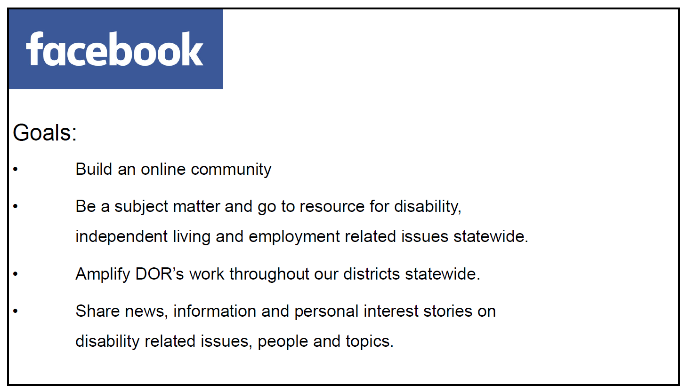

Slide 4
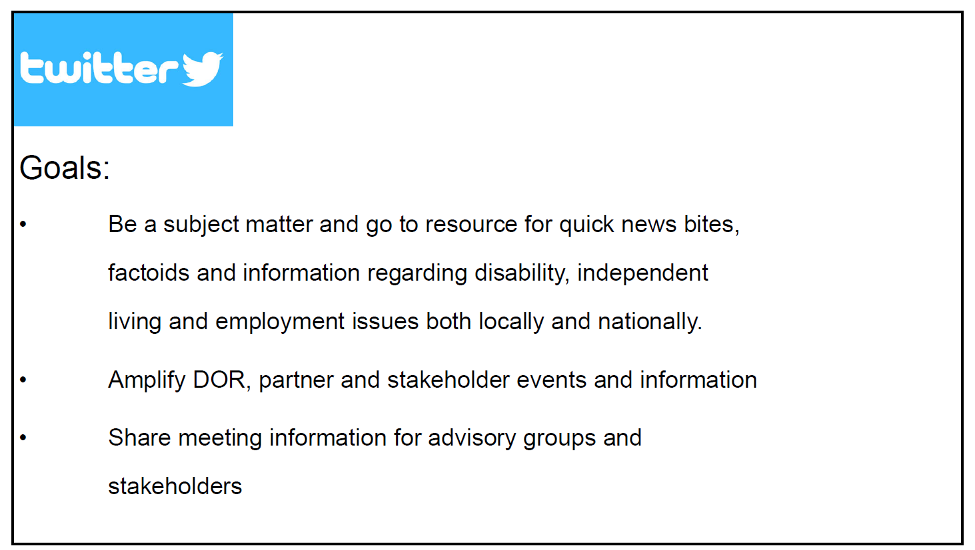

Slide 5
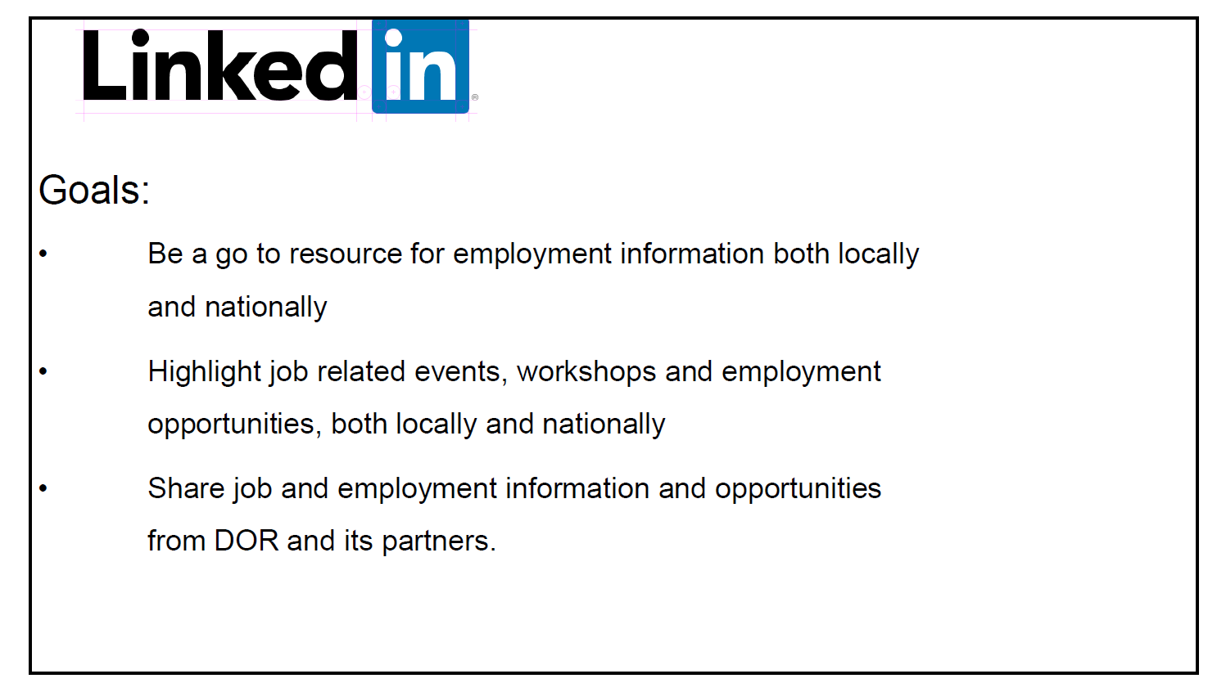

Attachment D – Item 9 PowerPoint Presentation
2020 Comprehensive Statewide Assessment, Review of Section III: Themes and Findings

Slide 1
DOR Logo
- 2020 Comprehensive Statewide Assessment (CSA)
- Program Years 2018-2020
- Review of Section III: Themes and Findings

Slide 2 – Introduction
The Comprehensive Statewide Assessment (CSA) is:
- Mandated by the federal Rehabilitation Act of 1973, as amended by the Workforce Innovation and Opportunity Act (WIOA).
- The study of the Vocational Rehabilitation (VR) needs of individuals with disabilities in California.
- Developed by DOR in partnership with the SRC.
- Research that informs DOR’s understanding of its consumers and their service needs and contributes to the goals and priorities of DOR’s State Plan.

Slide 3 – Five Areas of Focus
The CSA is an assessment of the general VR needs of individuals with disabilities statewide, with a focus on five required areas:
- Individuals with most significant disabilities, including their need for supported employment services.
- Individuals with disabilities served by other components of the State workforce development system.
- Individuals with disabilities who are minorities and those who have been unserved or underserved by DOR.
- Youth and students with disabilities, including their need for pre-employment transition services.
- An assessment of the need to establish, develop, or improve community rehabilitation programs.

Slide 4 – Section III: Caseload Themes and Findings
Minorities and unserved or underserved populations:
- The lowest percentage of DOR consumers served was Pacific Islander.
- Individuals who identify as Asian were identified as underserved.
- Individuals who identify as African American, Native American, and those identifying multiple race/ethnicities had lower successful rehabilitation rates.
- Latinx individuals had a 3.0% lower rate of successful case closures when compared to all DOR consumers.
- Asian consumers were represented with the lowest percentages for both physical and psychiatric disabilities.
- African American consumers were represented with a low percentage for deaf and hard of hearing disabilities.

Slide 5 – Section III: Key Informant Interview Themes and Findings
The following groups were expressed by key informants as being unserved or underserved by DOR’s programs and services:
- Homeless individuals with disabilities.
- Individuals with a dual diagnosis of substance abuse and a behavioral health disability.
- Individuals with behavioral health disabilities.
- Individuals with ID/DD, including those with the most significant disabilities who may need personal care assistance while on the job.
- Non-English-speaking individuals with disabilities.

- Youth ages 16-25, in particular those with dual diagnoses of substance abuse and a behavioral health disability.
- Formerly incarcerated individuals with disabilities, in particular individuals who are African American.
- Justice-involved individuals with behavioral health disabilities

Attachment E – Item 14 PowerPoint Presentation
California Community Transitions (CCT)
Slide 1

Slide 2
Slide 3

Slide 4

Slide 5

Slide 6

Slide 7

Slide 8

Slide 9

Slide 10

Slide 11

Slide 12

Slide 13

Slide 14

Slide 15

Slide 16

Slide 17

Slide 18

Slide 19

Slide 20

Attachment F – Item 15 PowerPoint Presentation
Overview of the DOR Budget Building Process and Program Funding

Slide 1

Slide 2

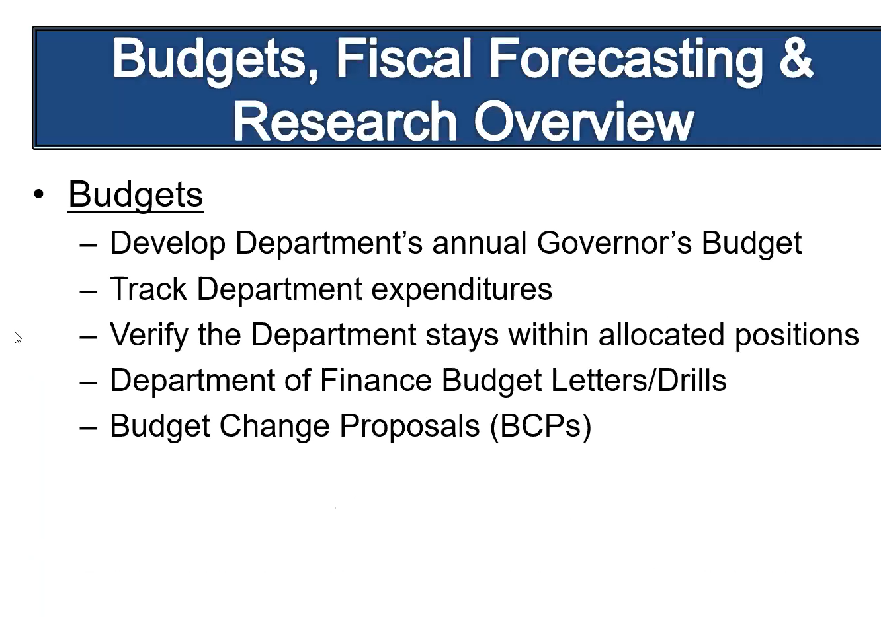

Slide 3

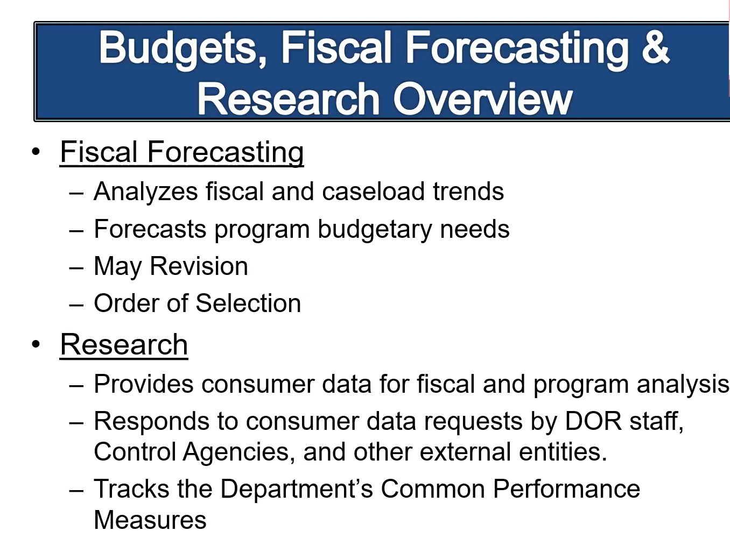

Slide 4

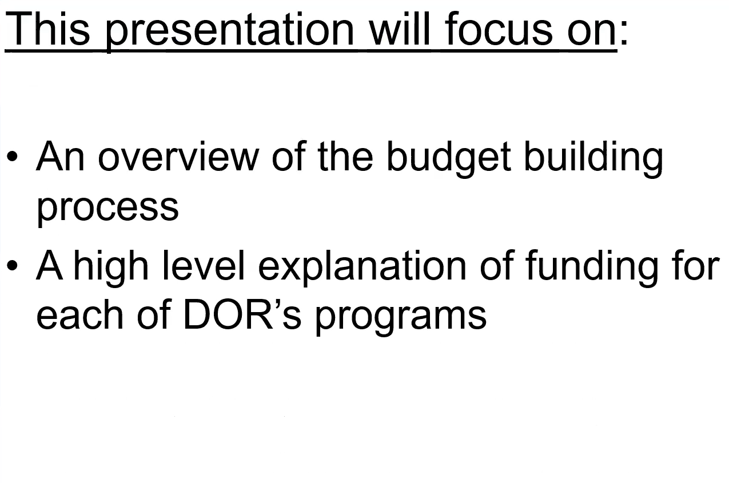

Slide 5

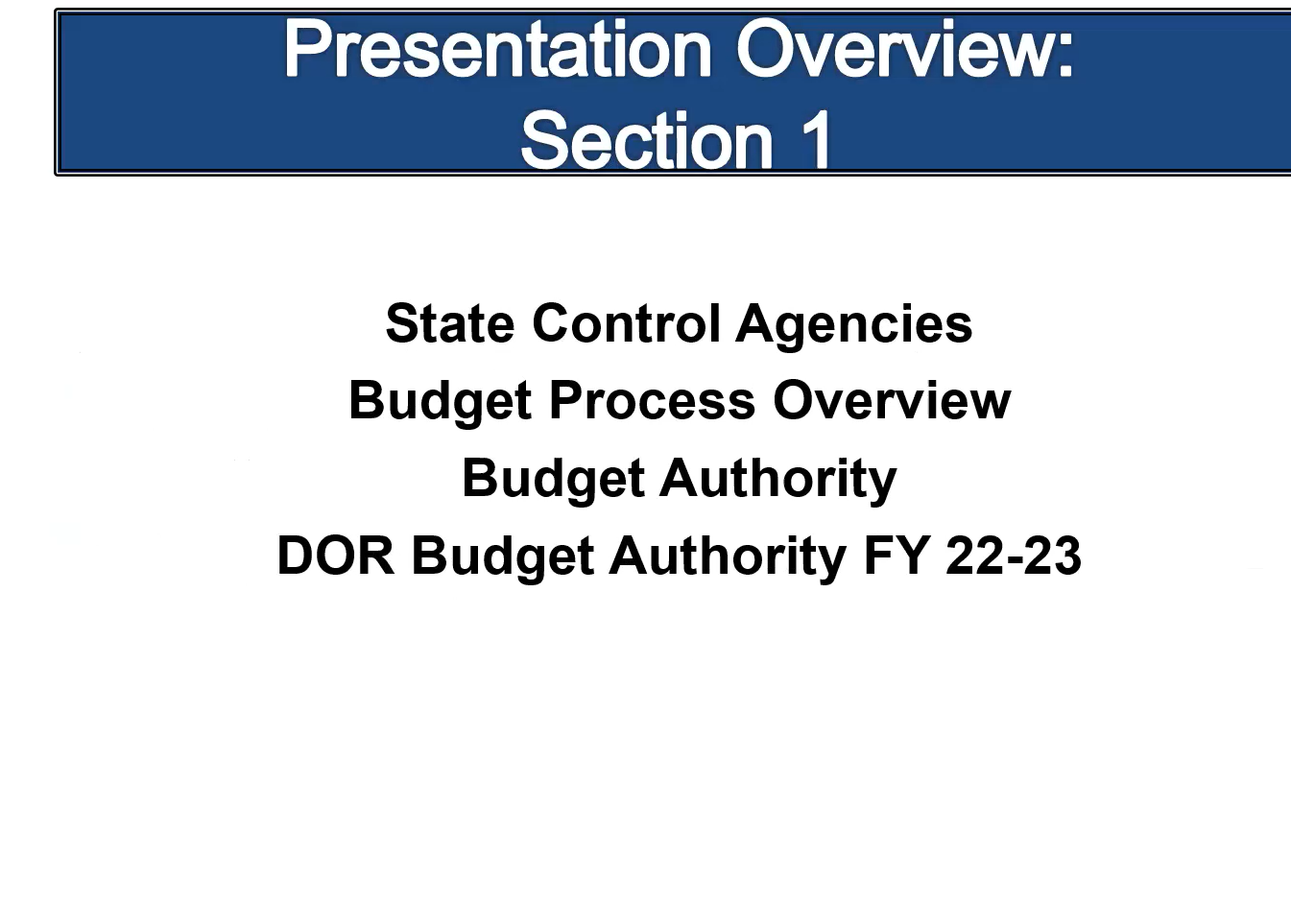

Slide 6

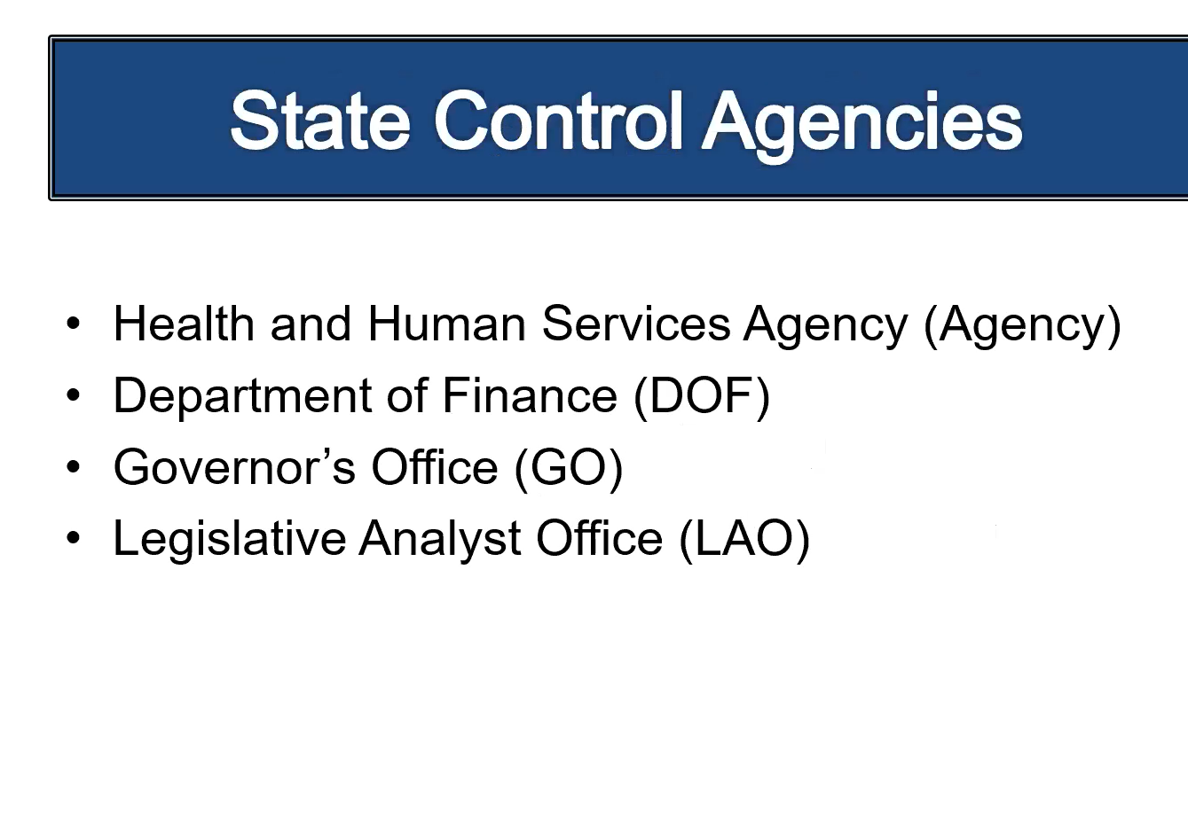
Slide 7

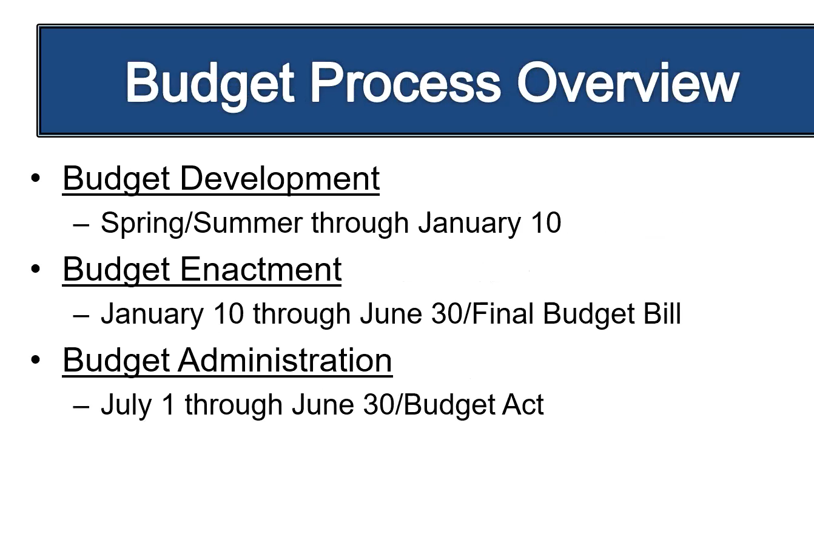

Slide 8

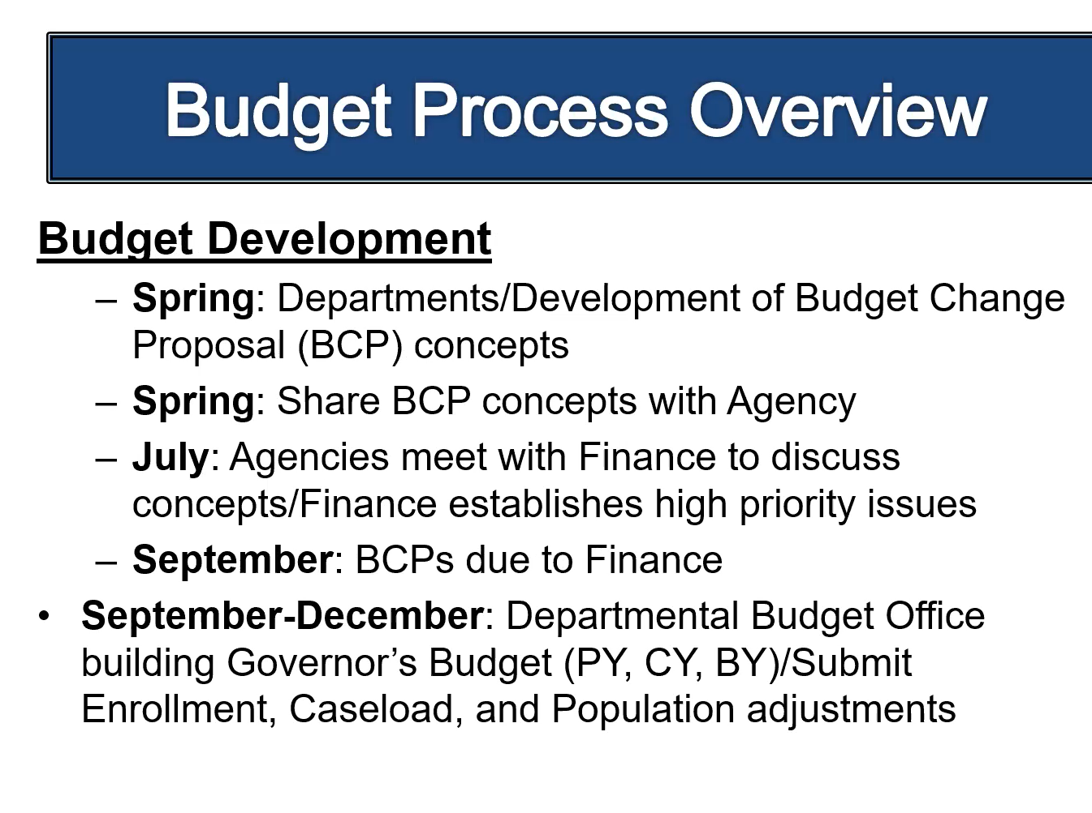
Slide 9

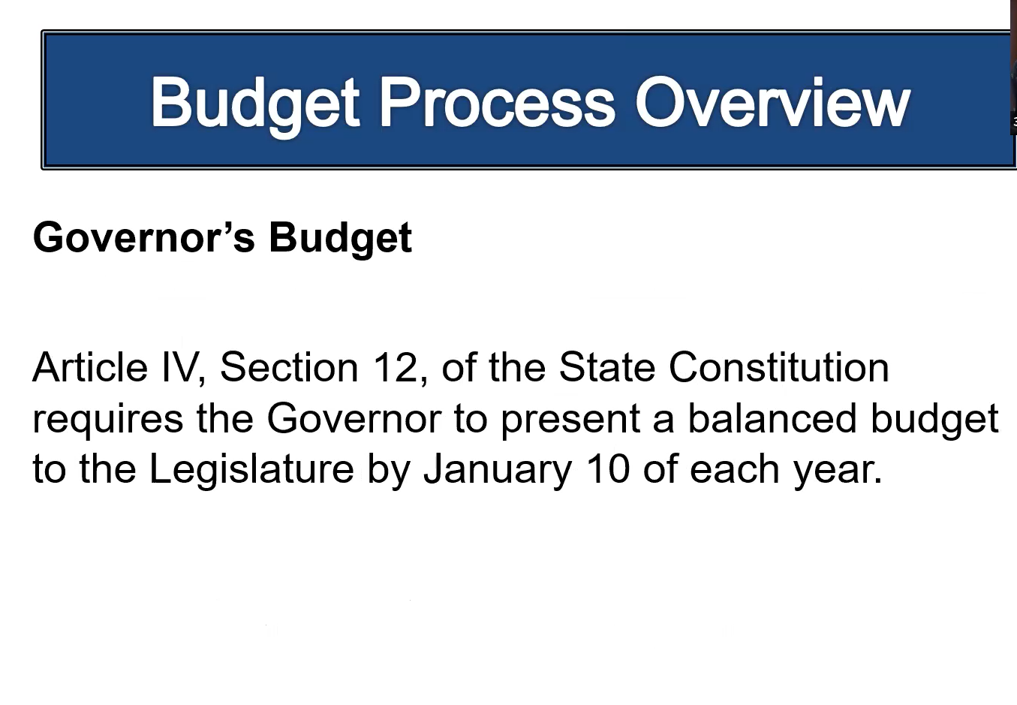

Slide 10

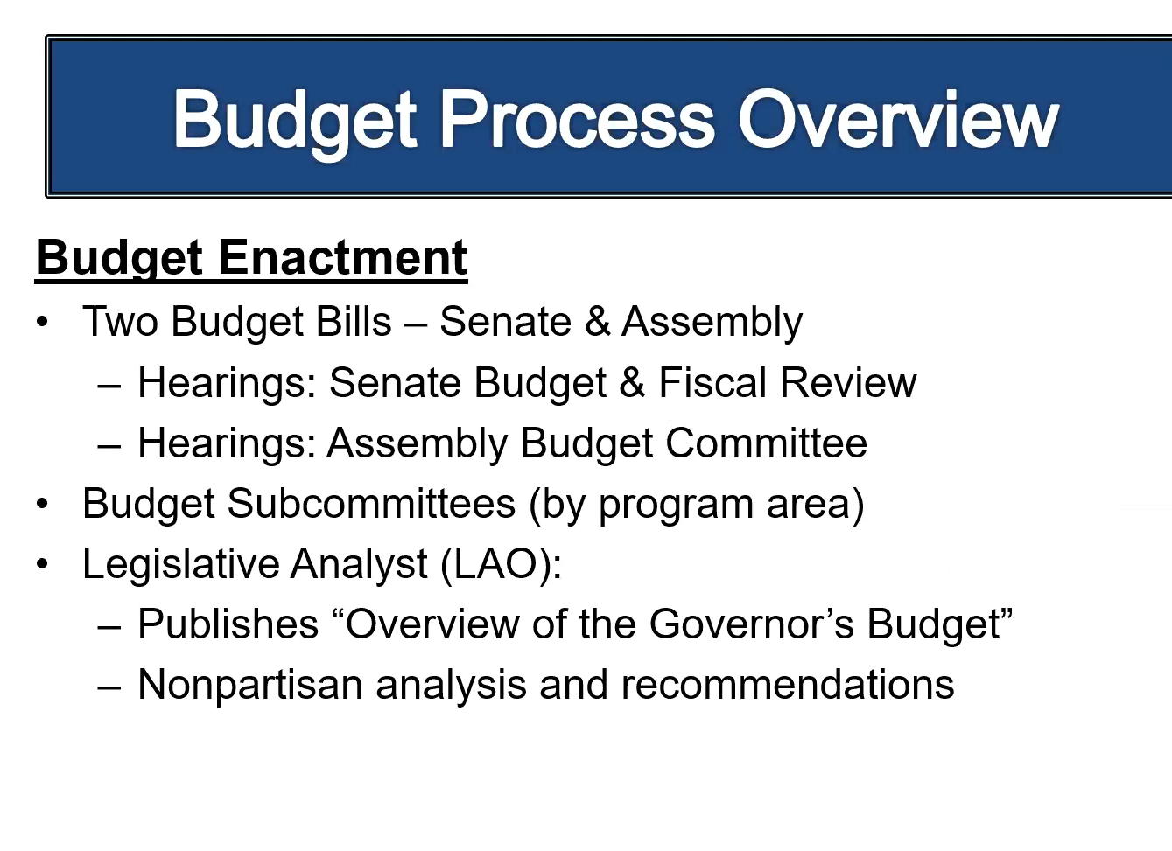

Slide 11

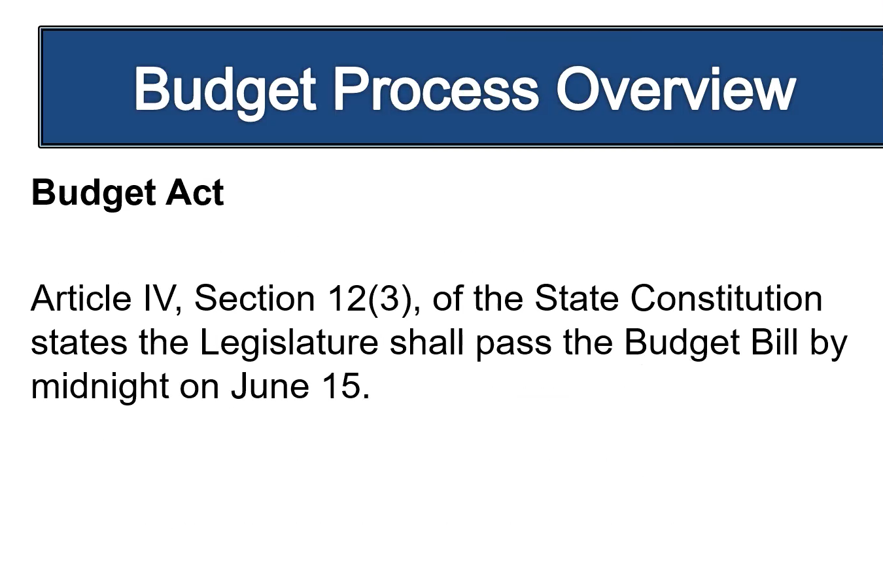

Slide 12

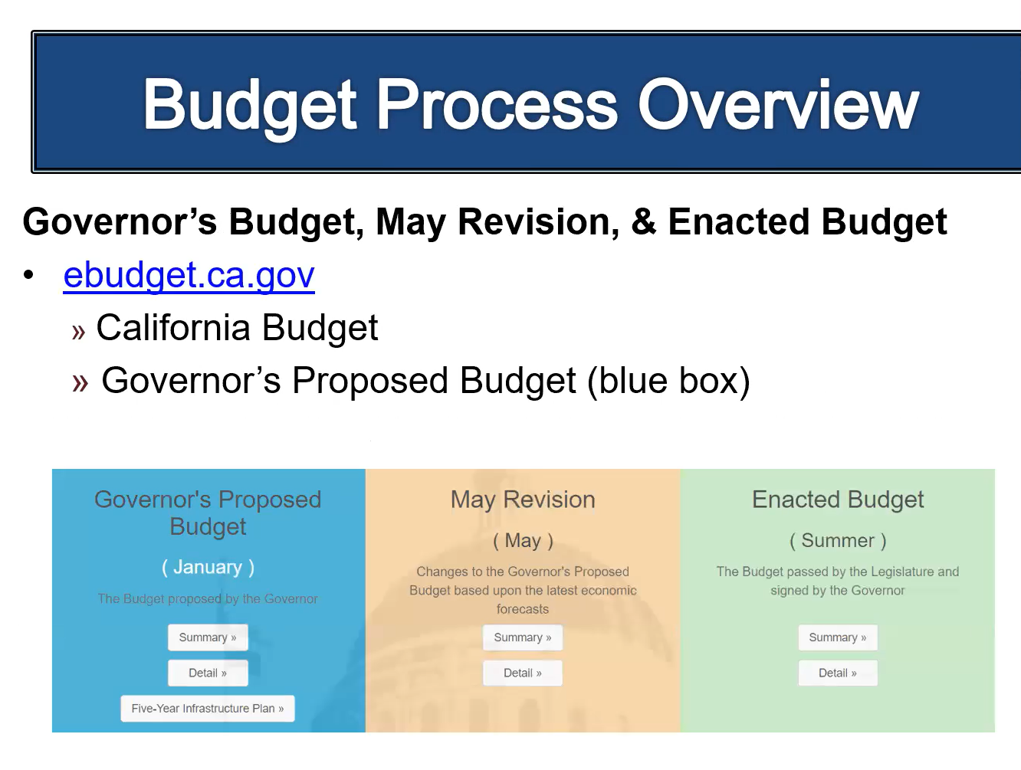
Slide 13

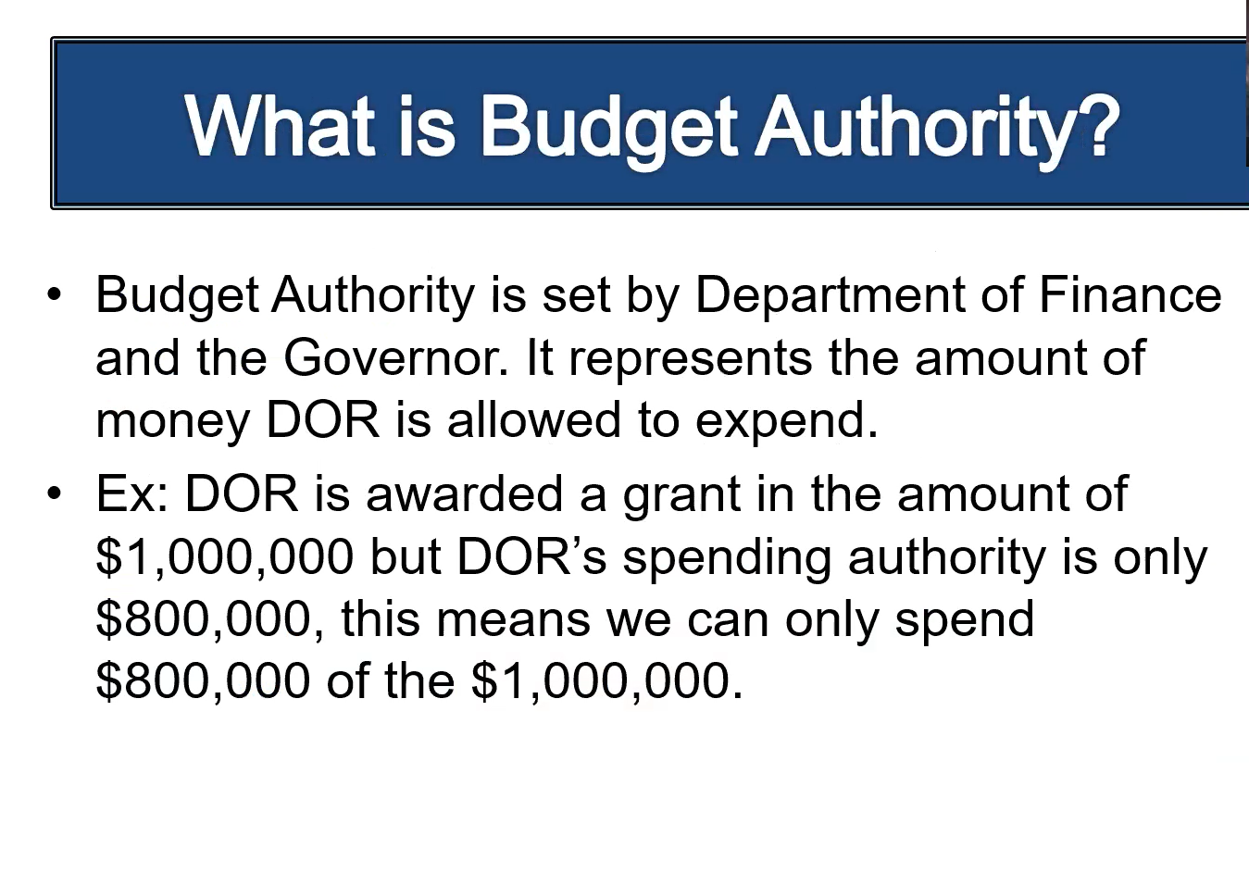

Slide 14

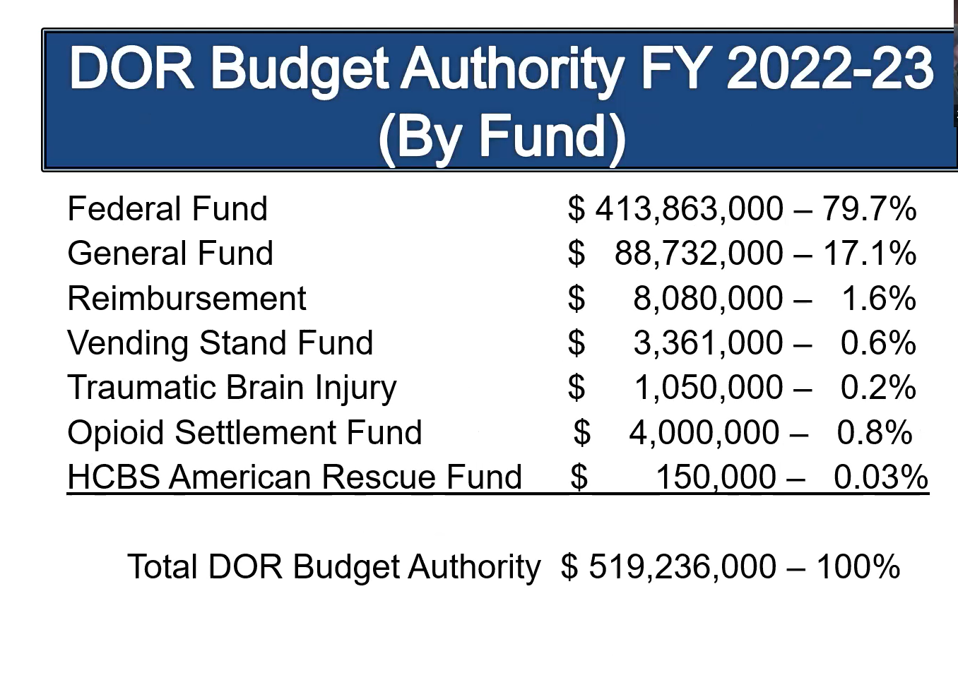

Slide 15

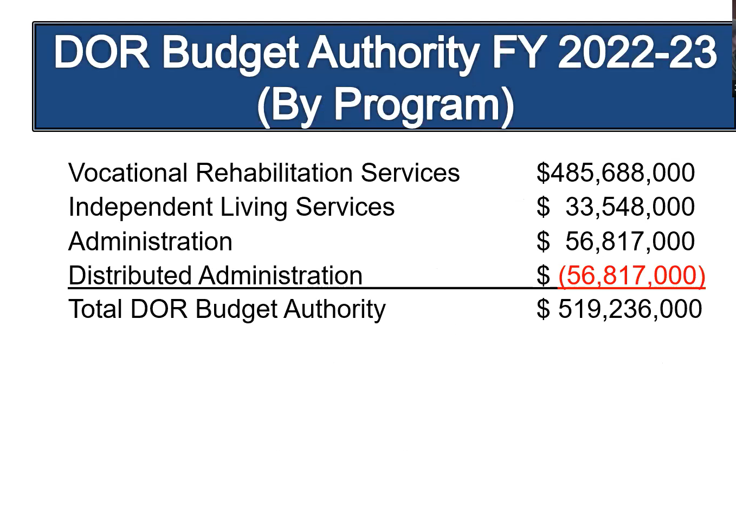

Slide 16

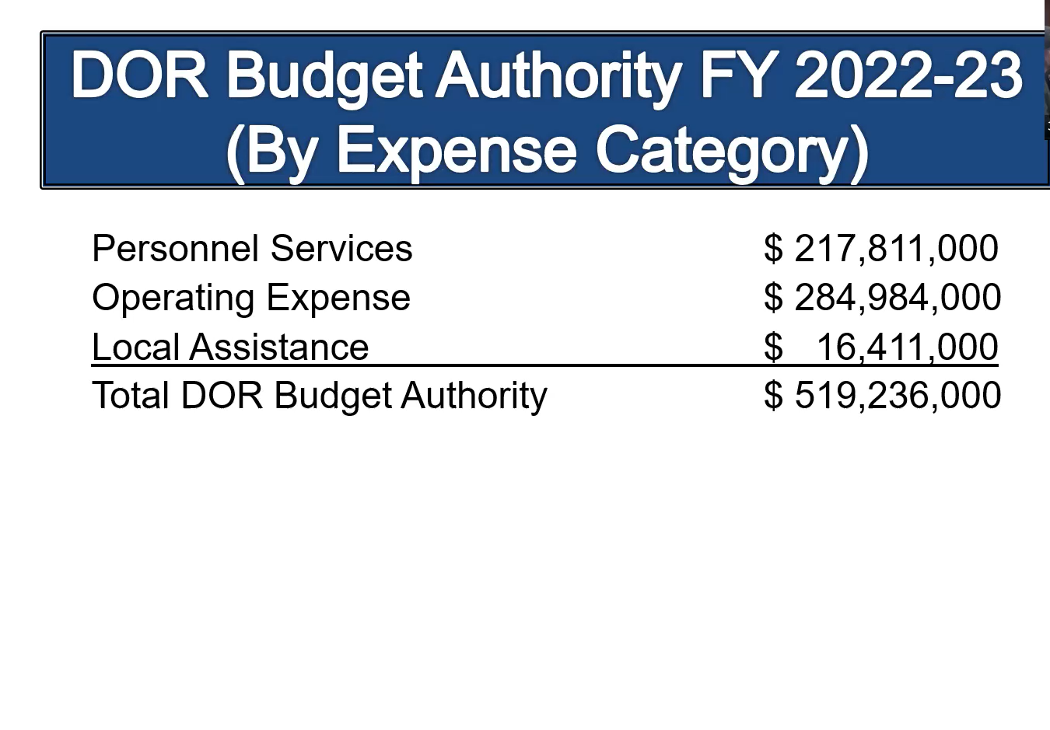
Slide 17

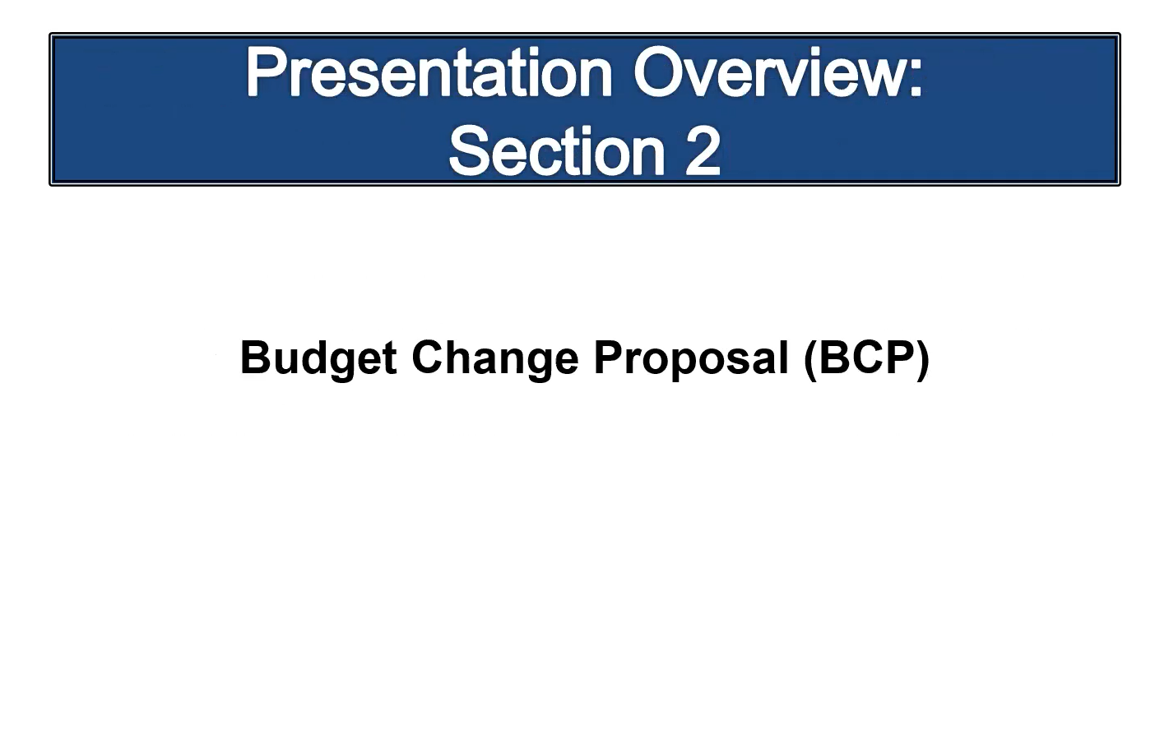

Slide 18

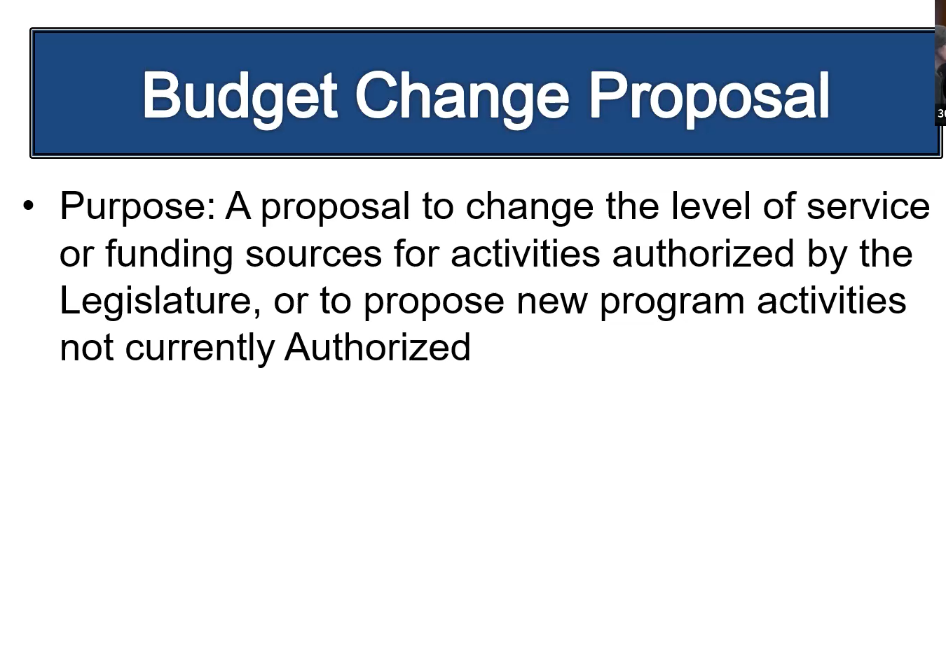

Slide 19

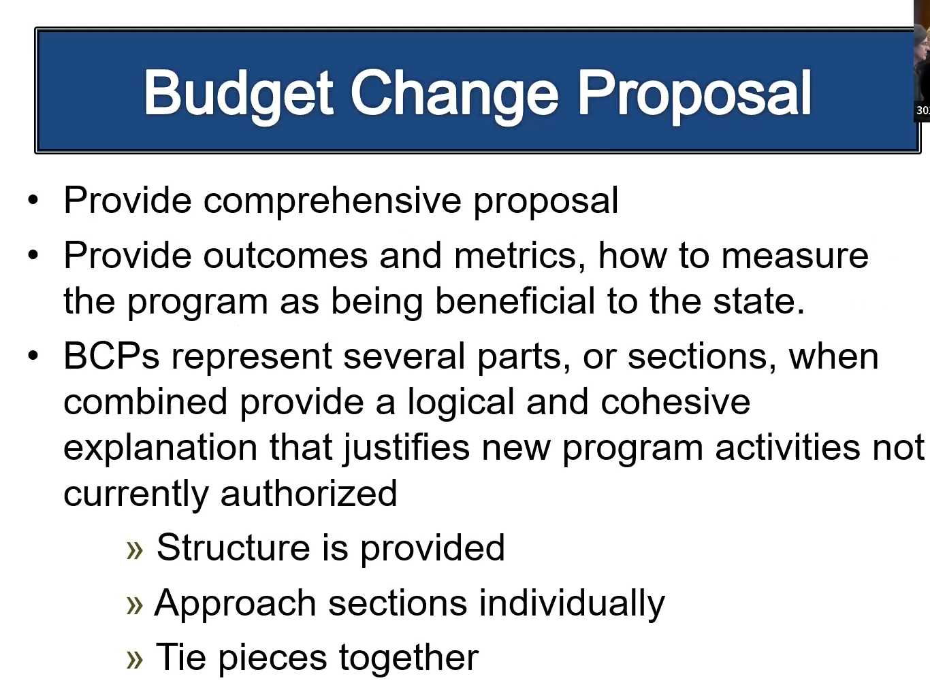

Slide 20

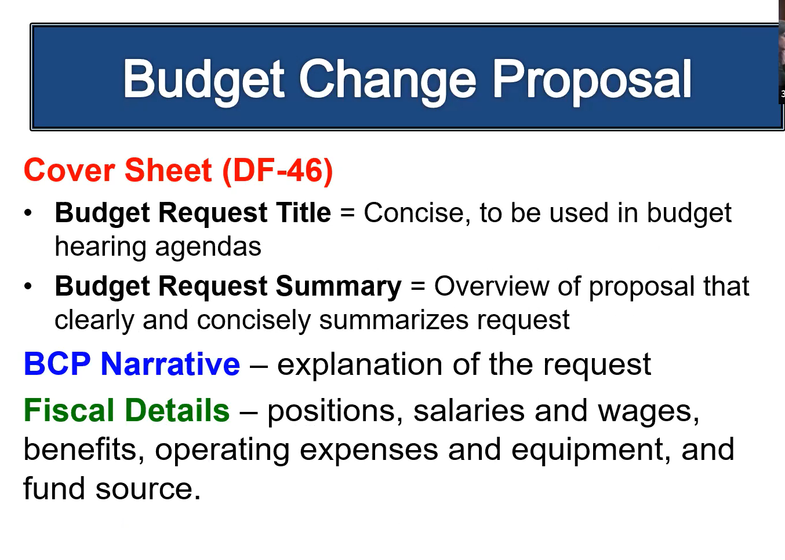
Slide 21

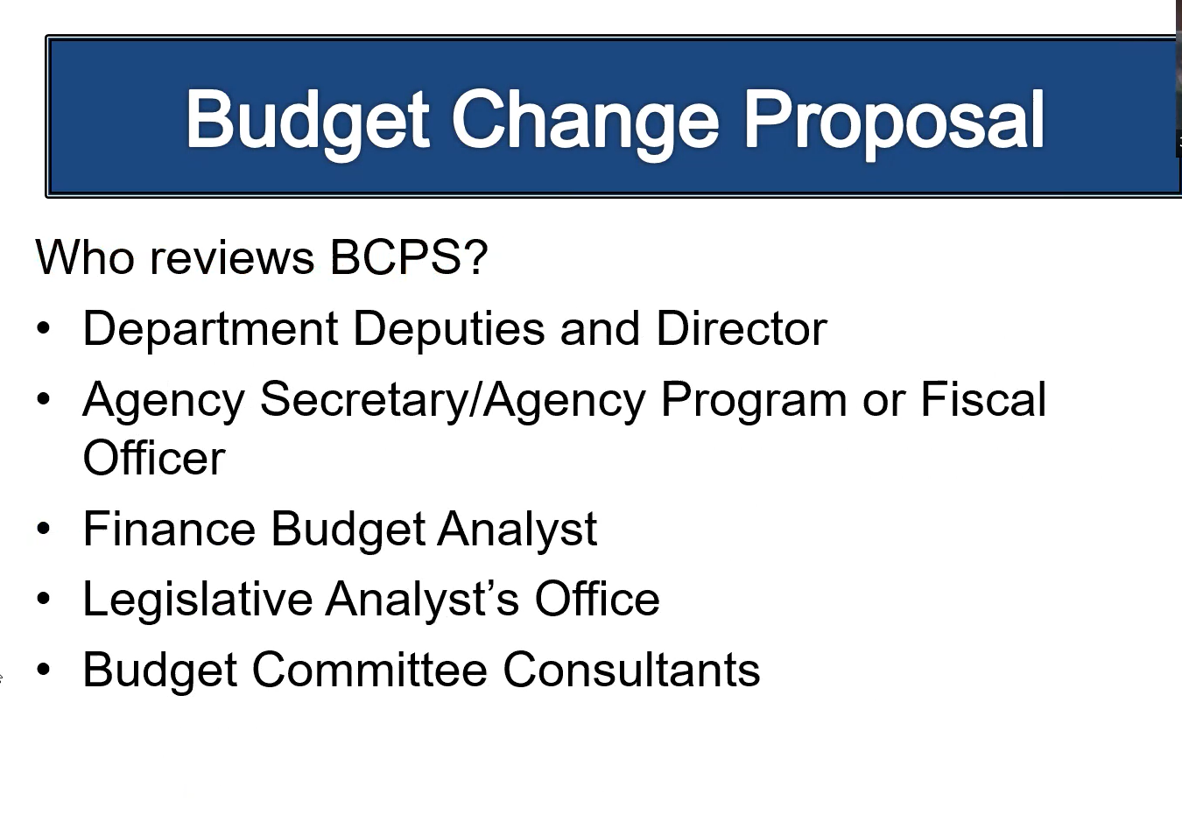

Slide 22

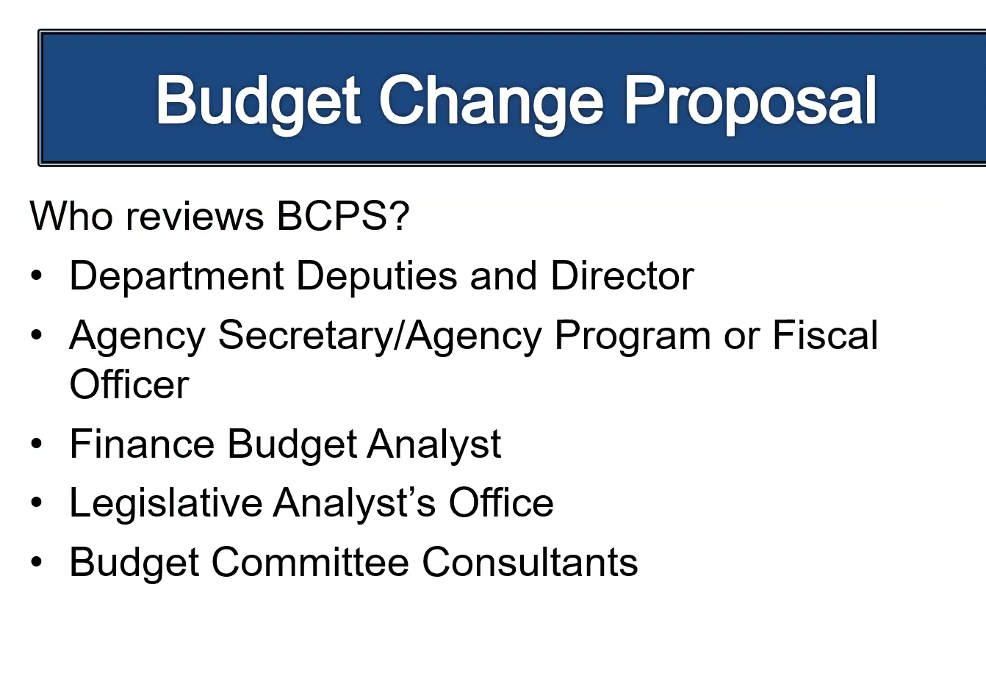

Attachment G – Item 16 PowerPoint Presentation
Intersection of Retention Plans and Order of Selection

Slide 1

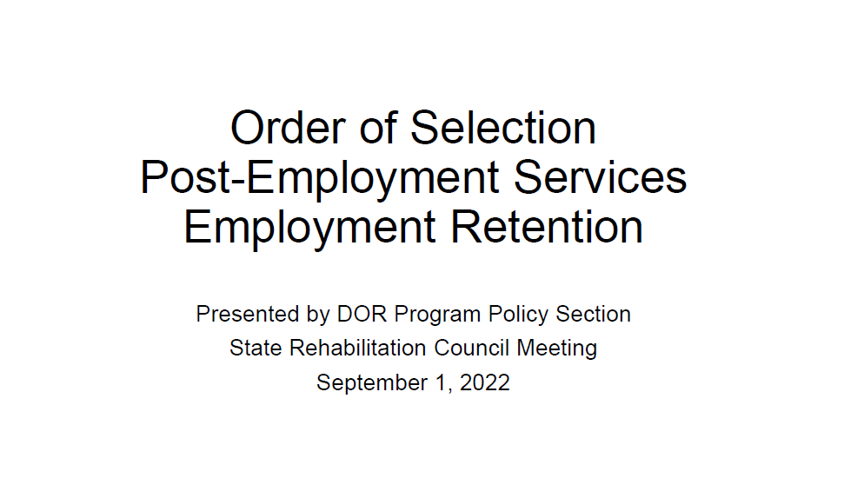

Slide 2

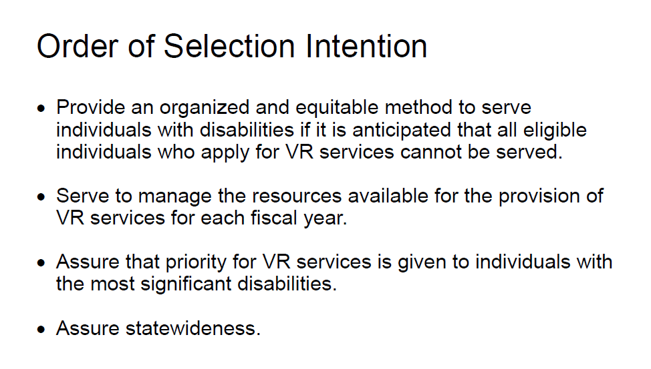

Slide 3

Slide 4

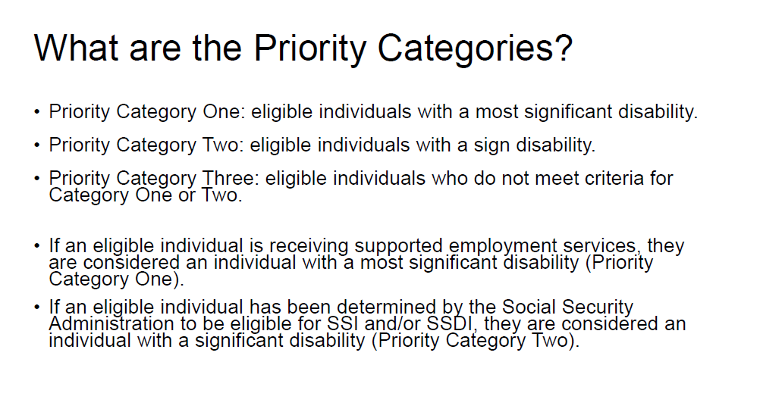

Slide 5

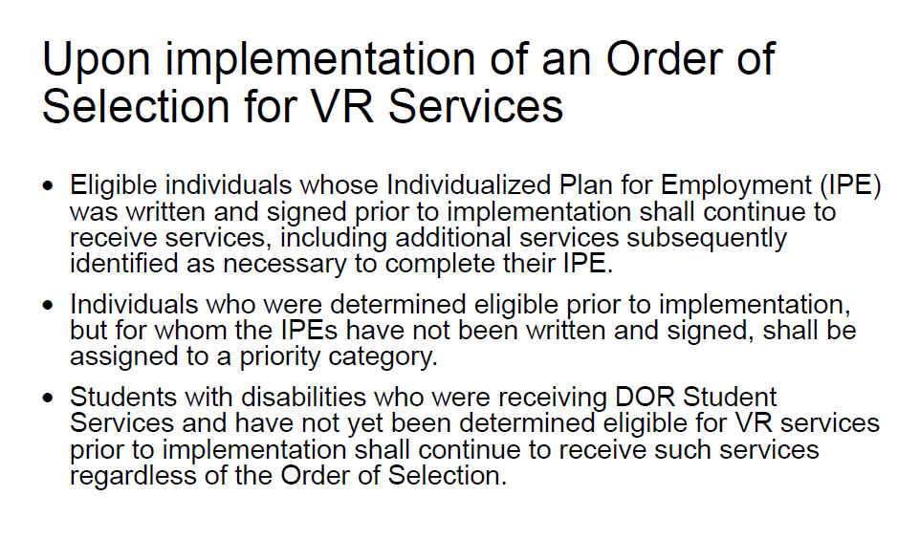

Slide 6

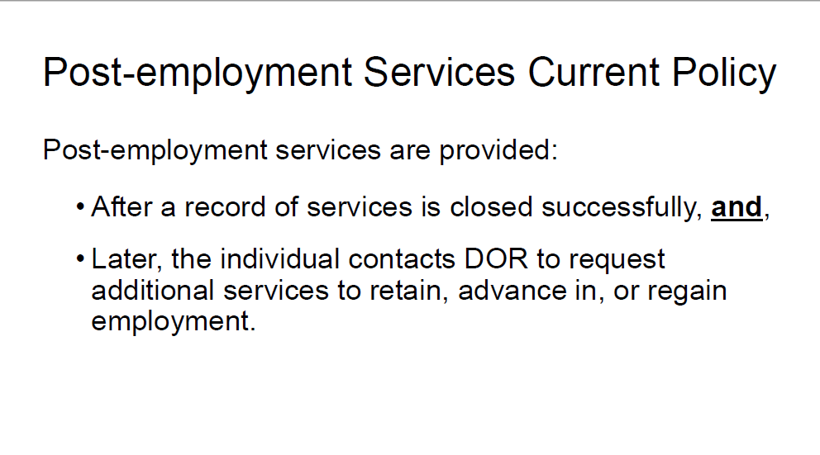

Slide 7

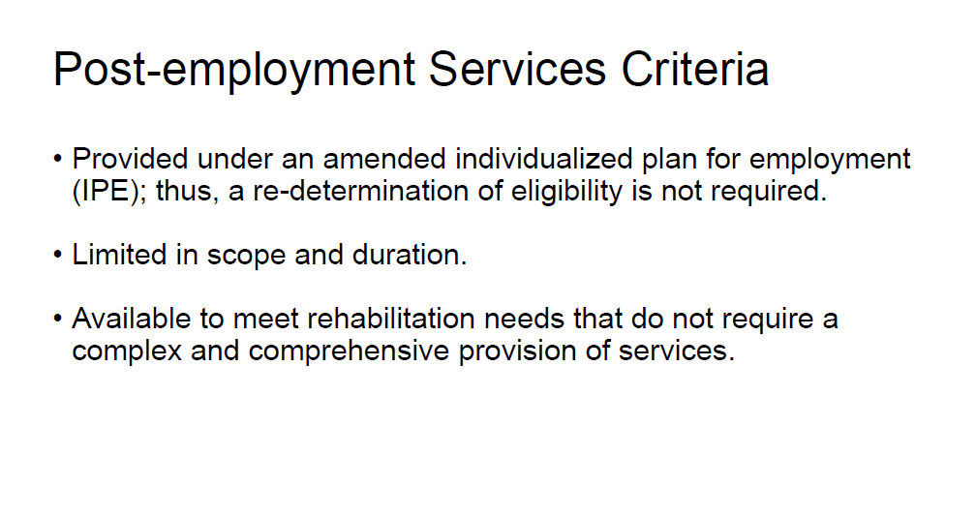

Slide 8

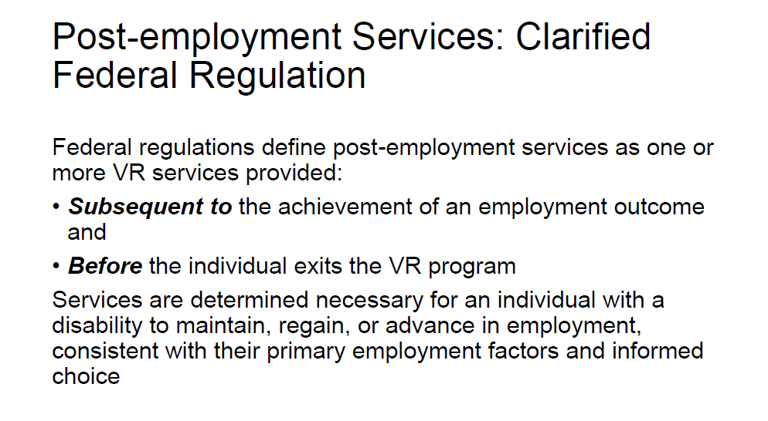

Slide 9

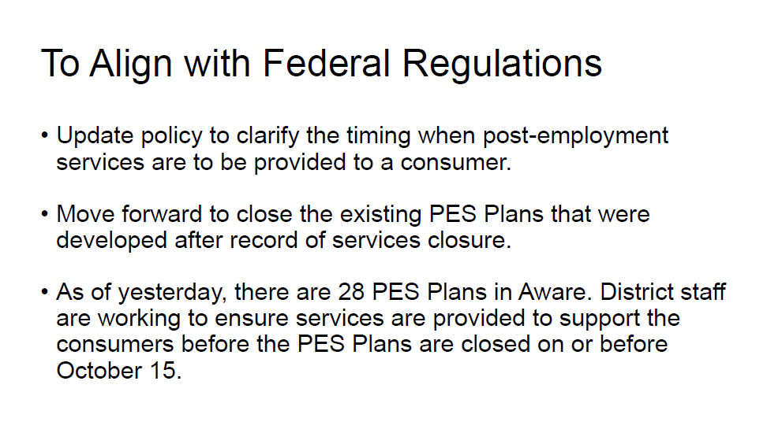

Slide 10

Slide 11

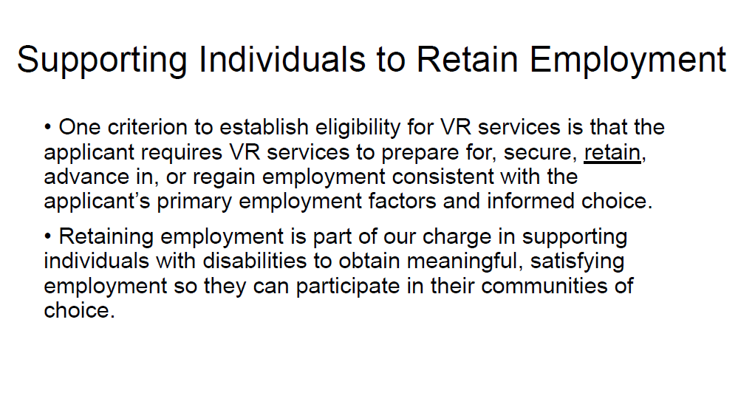

Slide 12

