RE: BUSINESS ENTERPRISES INSURANCE PROGRAM - NEW RATES EFFECTIVE March 1, 2026

Dear BEP Vendor:

The following new rates are effective March 1st, 2026. Be advised, these rates are used for the Monthly Operating Report (MOR), which is due on April 25th, 2026. Please advise your bookkeeping or accounting service of the following if they produce your MOR:

- General Liability: $18.02 (Per $1,000 Net sales)
- Base Rate: $79.18, consisting of:
- $41.11 (to replenish the Deductible fund) &
- $38.07 (to repay Property & Crime premium)

Please note:

- General Liability rate has increased by $5.36 cents increase due to:
- Decrease in vendors causing lower spread of the policy premium and lower net sales compared to last year.

- Base Rates will remain the same at $79.18.

If you have any questions, please feel free to contact me.

Sincerely,
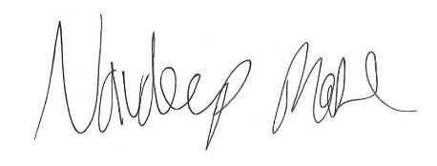
Navdeep Mahl
Associate Risk Analyst

Office of Risk & Insurance Management I State of California I California Government Operations Agency 707 3rd Street , # of Floor I West Sacramento, CA 95605 I t 916.376-5300 f 916.376-5275

