
Governor Gavin Newsom

Dear BEP Vendor:

An actuarial study was recently completed providing great insight into the Workers’ Compensation Fund. The Business Enterprises Program (BEP) made great improvements in the fund strengthening the overall fund position. The favorable development in the Workers’ Compensation Fund reported by the actuarial study included a drop in incurred losses compared to last year and claims settled being less than originally expected.

The BEP, in consultation with the California Vendor’s Policy Committee, has decided to decrease the Workers’ Compensation Rate for 2026. The rate will decrease to $8.50 from $9.00. The rate for the Monthly Operating Report will be effective on March1st 2026 and due by April 25th, 2026, MOR’s.

Work Comp Rate (all facility types): $8.50 per $100 of payroll

Going forward, we will continue to evaluate the Workers’ Compensation Rate periodically to ensure fund solvency.

If you have any questions, please feel free to contact me.

Sincerely,
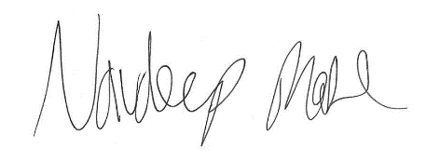
Navdeep Mahl
Associate Risk Analyst

Office of Risk & Insurance Management I State of California I California Government Operations Agency 707 3rd Street I West Sacramento, CA 95605 I t 916.376-5300 f 916.376-5275

