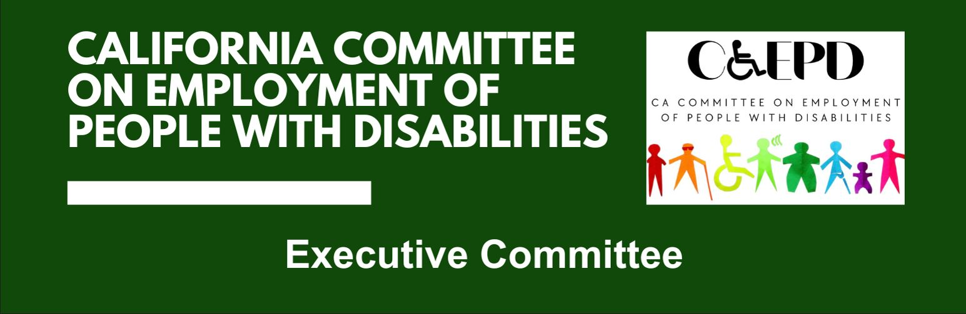

**CCEPD Executive Committee Meeting Minutes - DRAFT**

June 23, 2025

**CCEPD Member:** Dani Anderson (Virtual), Jennifer Fischer (Virtual), Roy Kim (Virtual), Harrison Lane (Virtual), and Taylor Winchell (Virtual)

1. **Welcome and Introductions**

The meeting was called to order at 2:02 p.m. and quorum was established.

1. **Approval of April 2025 Executive Committee Meeting Minutes**

It was moved/seconded (Kim/Fischer) to approve the April meeting minutes. Motion was approved by a 4-0-1 vote. (Yes – 4: Fischer, Kim, Lane, Winchell); (No – 0); (Abstain – 1: Anderson).

1. **Approval of August 2025 Full Committee Meeting Topics**

Executive Officer Maria Aliferis-Gjerde led a discussion on meeting topics for the next Full Committee. There was consensus on inviting Abby Snay, Deputy Secretary of Workforce Strategies for the California Labor and Workforce Development Agency to present, and also have a presentation on the DOR-EDD Collaboration Project.

1. **CCEPD Project Updates**

Executive Officer Aliferis-Gjerde provided an overview of CCEPD project updates.

* Administrative
  + EDD has fully funded the CCEPD for Fiscal Year 25/26.
  + Discussed changes to personnel and how other Division staff will assist the CCEPD team.
  + There is an outreach to fill the vacancy on the CCEPD. Six applications have been received.
  + LaCandice Ochoa will be Deputy Director of the Independent Living and Community Access Division. She will begin the new role in July.
* Subcommittees
  + Employment and Training Subcommittee – continue to work on job coaching project. Met with the Department of Developmental Services and Department of Rehabilitation regarding web and video capabilities. Also requested feedback regarding the business association project.
  + Youth Programming Subcommittee – Met in May and will meet again in August.

YLF Project Manager Matt Baker provided an overview of YLF updates.

* Statewide YLF
  + 60 students are selected to attend YLF 2025. There are 60 volunteer staff, mostly alumni, to support the students throughout the week.
  + Budget is currently $320,434,40, with pledged funds covering the total cost leaving a little carryover for regional events and 2026 planning efforts.
  + The CKB Mentoring Luncheon is now open for registration. Tickets are available at Givebutter.com/YLF2025.
* Regional YLF
  + 30 youth signed up for the San Diego Regional YLF event on August 4-6th. With a potential of up to 30 more from a local school district who is looking to bus students for the event.
  + Sacramento partners will plan an event in October.
  + Los Angeles partners are interested in developing a second regional YLF event.

1. **Agenda Items for Future Meetings**

No new items were raised.

1. **Public Comment**

There were no public comments.

1. **Adjournment**

The meeting adjourned at 2:34 p.m.