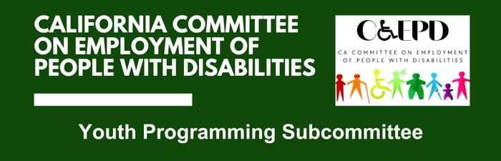

MEETING MINUTES - DRAFT
Wednesday, May 28, 2025

Meeting held through Zoom and in person at the Department of Rehabilitation’s Central Office.

This meeting was being held via teleconference within the meaning of Government Code Section 11123.5.

Subcommittee Members: Dani Anderson (Virtual), Iskra Martinez (Virtual), Lauren Mechals (Virtual), LaCandice Ochoa (Virtual), Marcy Okada (Virtual)

- Welcome and Introductions
Chair Dani Anderson called the meeting to order at 2:01 p.m. and a quorum was established.

- Discussion on Subcommittee Priorities and Goals
YLF Project Manager Matt Baker provided an overview of the YLF program and how it has evolved in recent years.

Members discussed the following priorities and goals for the subcommittee:
- Develop non-state partnerships for YLF to be able to fund both a statewide event and regional YLFs.
- Relationships between regional and statewide – develop goals for both the statewide and regional events.
- Evaluate the regional YLF events and assist in designing approaches, which can include a programming blueprint and partnership opportunities.
- Conduct a Strengths, Weakness, Opportunities and Threats (SWOT) analysis of the statewide YLF to determine areas to strengthen for the statewide YLF event.
- Develop overall goals for the statewide YLF event.

- Agenda Items for Future Meetings
Members indicated they would like to have a deeper discussion at the next meeting regarding funding and the relationships between the state and regional events.

A poll will be sent to members for setting a standing meeting day and time.

- Public Comment
There were no public comments.

- Adjourn
The meeting adjourned at 2:45 p.m.

