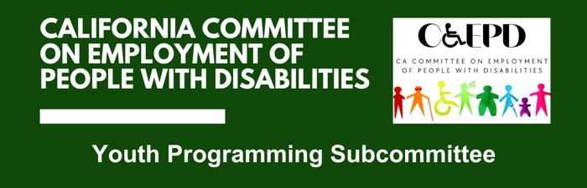

MEETING MINUTES - DRAFT
Wednesday, August 27, 2025

Meeting held through Zoom and in person at the Department of Rehabilitation’s Central Office.

This meeting was being held via teleconference within the meaning of Government Code Section 11123.5.

Subcommittee Members: Dani Anderson (Virtual), Marcy Okada (Virtual)

- Welcome and Introductions
Chair Anderson called the meeting to order at 10:02 a.m. There was no quorum.

- Approval of May Meeting Minutes
May minutes were tabled, as there was no quorum.
- Discussion on Subcommittee Priorities and Goals
Youth Leadership Forum (YLF) Project Manager Matt Baker provided a background and overview of prior statewide and regional YLF program activities, and the need to develop relationships with more private and local partners.

Because there was no quorum, it was decided to hold off on funding discussions.

Prior to the next meeting, outreach will be made to increase subcommittee membership.

- Agenda Items for Future Meetings
Baker stated he would create a Google form for subcommittee and other YLF engagement interests. Other items raised were curriculum, a report on regional YLF events, and the statewide week-at-a-glance schedule. To provide adequate time to recruit additional members, and due to the holidays, the next quarterly meeting will be held in January of 2026.

- Public Comment
There were no public comments.

- Adjourn
Meeting adjourned at 10:32 a.m.

