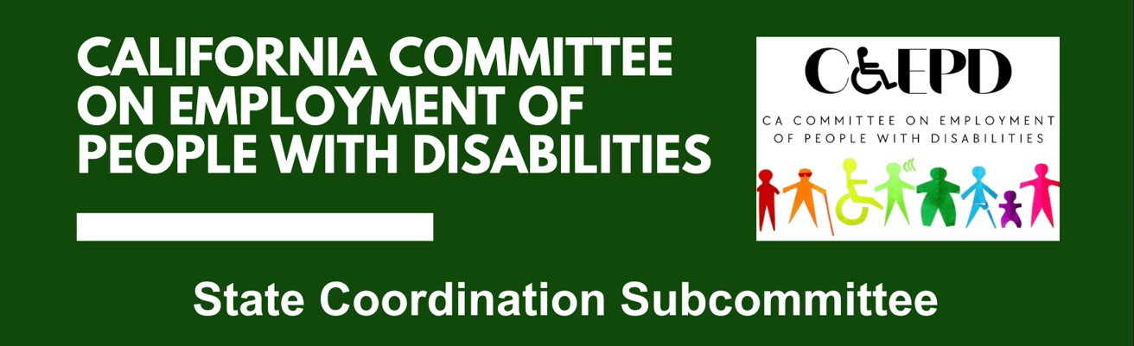

MEETING MINUTES - DRAFT
Thursday, May 28, 2026

Meeting held through Zoom and in-person at the Department of Rehabilitation’s Central Office. Meeting was held via teleconference within the meaning of Government Code Section 11123.5.

Subcommittee Members: Kai Brennan (Virtual), Pearl Burgin (Virtual), Robert Chavez (Virtual), Cathleen Coombs-Stephens (Virtual), Stephanie Crist (Virtual), Jennifer Fischer (Virtual), Stephen Gaitan (Virtual),Shawn Mainville (Virtual), Tanesha Morris (Virtual), Maryam Nateghi (Virtual), Dr. Stacey Shears (Virtual), Arys Scott (Virtual), Zitlali “Tali” Torres (Virtual), Paula Tobler (Virtual), and DJ Tomko (Virtual)

CCEPD Staff Members: Maria-Aliferis-Gjerde (Virtual), Nick Coleman (In-person), and Zachariah Ford (Virtual)

Members of the Public: Kate Bjerke (Virtual) and Suad Bisogno (Virtual)

- Welcome and Introductions
Member Fischer called the meeting to order and confirmed a quorum.
- Discussion on Subcommittee Objectives and Goals
Co-chairs Fischer and Crist introduced the purpose of the reconvened State Coordination Subcommittee: to examine alignment across programs serving people with disabilities and to map service delivery from a cross-program perspective. Staff Member Aliferis-Gjerde provided background on statewide alignment efforts and described the goal of identifying gaps and opportunities for improved coordination.

- Beginning Discussion on Mapping of Services

Challenges Facing People with Disabilities in Accessing Services
Multiple members described challenges related to navigating multiple systems, including the need to repeat information, inconsistent communication, and difficulties understanding eligibility across programs. Several members highlighted lack of awareness among individuals and frontline staff regarding available services and how programs intersect.

Member Tobler noted that individuals may be unaware of their eligibility for services across different agencies, causing delays in accessing supports. Member Crist emphasized challenges when multiple programs cover different components of the same service, leading to confusion over payer responsibility. Member Tomko raised concerns from individuals with IDD regarding delays in accessing DOR services and the varying expertise of counselors.

Multiple members discussed systemic issues such as waiting lists for providers, staff turnover, inconsistent handoffs between agencies, and limitations in interagency collaboration. Member Gaitan pointed to frequent changes in service models and counselor assignments, which complicate referrals and continuity. Member Morris described a lack of coordination contributing to service silos and underutilization of community-based organizations.

Several members noted barriers related to documentation requirements, benefits concerns, transition from youth to adult systems, and inconsistent expertise in mental health and disability-specific needs across agencies. Members also discussed challenges for individuals who do not self-identify as having a disability and therefore do not seek services.

How Individuals Learn About Services
Members described varied referral pathways, including schools, pediatricians, regional centers, community colleges, DOR cooperative programs, American Job Centers, mental health providers, and community-based organizations. Several members emphasized the importance of early identification, warm handoffs, and proactive outreach across educational and workforce systems.

Missing Perspectives
Members identified several perspectives they felt should be included in future conversations, such as educators involved in transition services, tribal communities, benefits planners, individuals with lived experience, private employers, housing and homelessness service providers, and transportation agencies.

Staff noted that future meetings may focus on lived experiences and that additional outreach will be conducted to bring in perspectives not currently represented.

- Agenda Items for Future Meetings
No additional agenda items were raised by members. Staff will compile themes from this meeting for use in future planning and mapping discussions.

- Public Comment
One member of the public, Suad Bisogno, commented on barriers individuals face prior to entering employment services, including concerns related to benefits counseling, provider waitlists, and the impact of delays on individuals deciding whether to pursue employment services.

- Adjourn
Motion (Torres) to adjourn the meeting. Meeting adjourned at 3:09.

