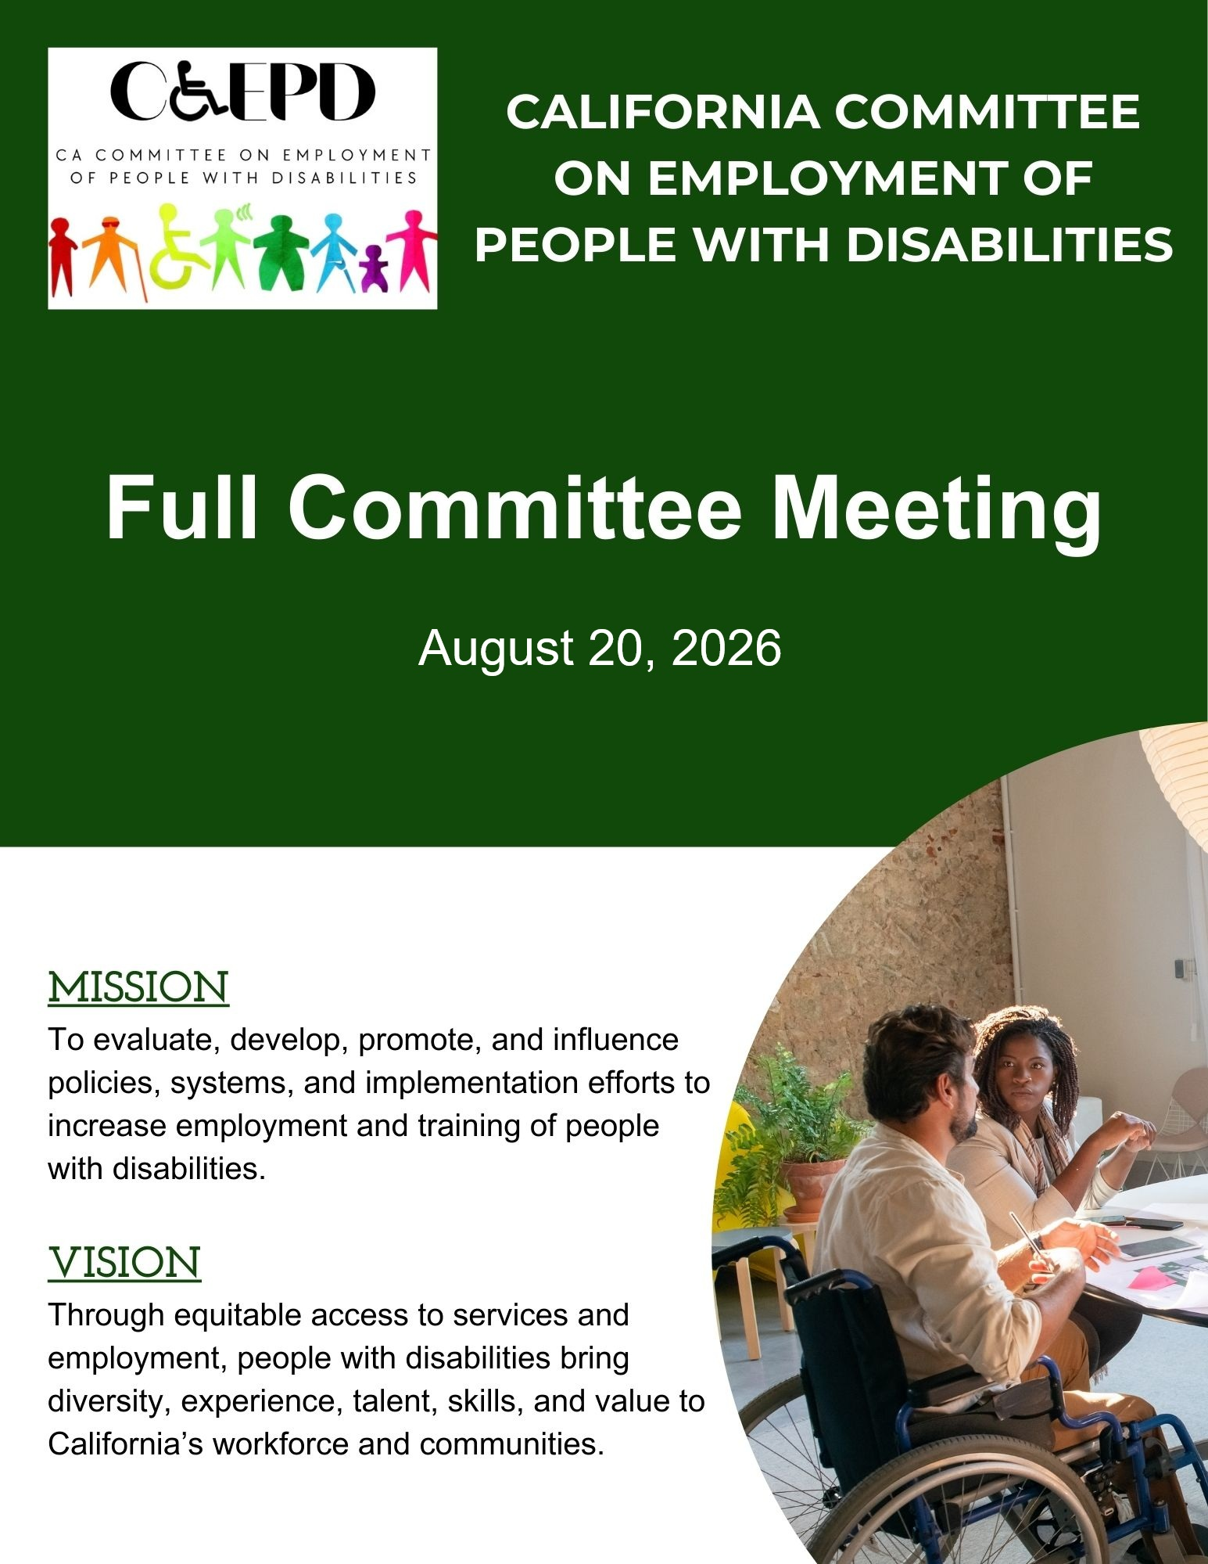

Contents
Meeting Notice and Agenda 3
February Meeting Minutes (Draft) 6
Apprenticeship Series – Departmental Strategies 10


CCEPD Full Committee Meeting

Meeting Notice and Agenda
Thursday, August 20, 2026
9 a.m. until Noon

Public Participation Options
In-person:
- DOR Central Office, Room 242, 721 Capitol Mall, Sacramento, CA 95814
- San Bernardino County Workforce Development, Executive Conference Room, 290 North D Street, 6th floor, San Bernardino, CA 92415

Video Conference Link: Zoom link
Use Meeting ID: 910 5653 9513 and Passcode: Lt.y0WTm

By Phone: (408) 638-0968

This meeting is being held in accordance with Government Code Section 11123. There may be members of the public body participating in the meeting who were granted a reasonable accommodation in accordance with the Americans with Disabilities Act.

Agenda

- Welcome and Introductions
Taylor Winchell, Chair, CCEPD

- Approval of May 2026 Meeting Minutes
Taylor Winchell, Chair, CCEPD

- Apprenticeship Series – Departmental Strategies
Korena Hazen, Supervisor I, Apprenticeship Pathways Project, Children and Family Division, California Department of Social Services
Maureen McIntyre, Regional Director, Department of Rehabilitation

- Discuss Takeaways from Apprenticeship Series and Outline Next Steps in Breakout Rooms
Taylor Winchell, Chair, CCEPD

Break 10:15-10:30 a.m.

- General Local Workforce Development Board Update and Overview of Local Initiatives
Robert Chavez, Assistant Director, San Bernardino County Workforce Development Board

- Discuss Takeaways and Consideration for Policy in Breakout Rooms
Taylor Winchell, Chair, CCEPD

- Youth Leadership Forum Updates
Matt Baker, YLF Program Manager, CCEPD

- Roundtable for Member Updates
All Members

- Agenda Items for Future Meetings

- Public Comment

- Adjournment Noon*
* The meeting will adjourn upon completion of agenda.

Other Meeting Locations
- 1527 Pennsylvania Ave, West Sacramento, CA 95691

MEETING MATERIALS: This meeting notice and agenda and other supplemental materials may also be accessed on the website, located on the Advisory Committee Calendar. All times indicated, and order of business is approximate and subject to change on the day of the noticed meeting. The meeting will adjourn upon completion of the agenda. Interested members of the public may use the teleconference number and video conference link provided to listen to the meeting and/or provide public comment. The CCEPD is not responsible for unforeseen technical difficulties that may occur and is not obligated to postpone or delay its meeting in the event of unforeseen technical difficulties with the teleconference line and video conference.

PUBLIC COMMENT: Public comment on matters not on the agenda is taken at the end of the meeting and members of public can make comments on agenda items prior to any vote of the committee. Depending on the number of individuals wishing to address the committee, public comment may be limited to three minutes per person. Non-English speakers who utilize translators to make public comment will be allotted no more than six minutes unless they utilize simultaneous translation equipment. The CCEPD is precluded from discussing matters not on the agenda; however, CCEPD members may ask questions for clarification purposes.

REASONABLE ACCOMMODATIONS: If you require a disability-related accommodation, materials in alternate format or auxiliary aids/services, please email CCEPD@dor.ca.gov five days prior to the meeting. Any requests received after this date will be given consideration, but logistical constraints may not allow for their fulfillment.

FEBRUARY MEETING MINUTES - DRAFT
Thursday, May 21, 2026

Meeting held through Zoom and in person at the Department of Rehabilitation’s Central Office. This meeting is being held via teleconference in accordance with Government Code Section 11123.

CCEPD Members:
Kathleen Alonzo (virtual), Robert Chavez (virtual), Toija Currie (virtual), Robert Fried (virtual), Sandra Hernandez (virtual), Tim Jin (virtual), Damien Ladd (virtual), Harrison Lane (in-person), Michael Luna (in-person), Kimberlee Meyer (in-person), Michael Trogan (virtual), and Taylor Winchell (virtual)

CCEPD Staff Members: Maria Aliferis-Gjerde (in-person), Matt Baker (virtual), Nick Coleman (in-person), and Zak Ford (in-person)

1) Welcome and Introductions
Chair Taylor Winchell called the meeting to order at 9:04 a.m. and a quorum was met. Members introduced themselves and stated their attendance mode.

2) Approval of February 2025 Meeting Minutes
Moved/seconded (Meyer/Luna) to approve the February meeting minutes. Motion passed on 10-0-2. (Yes – 10: Alonzo, Chavez, Currie, Fried, Ladd, Lane, Luna, Meyer, Trogan, Winchell), (No – 0), (Abstain – 2: Hernandez, Jin).

3) Overview of Interagency Advisory Committee on Apprenticeship (IACA) and California’s Apprenticeship Strategies
Caleb van Docto and Andrea Harlin‑Villanueva presented an overview of California’s apprenticeship strategies, including statewide expansion goals, funding sources, and sector growth efforts. They highlighted the state’s target of expanding apprenticeships in both traditional and emerging industries, emphasized universal design to improve accessibility, and discussed ongoing outreach to employers and education partners.

Members asked questions about data, employer recruitment, and support for individuals with disabilities.

4) IACA People with Disabilities Subcommittee Overview
Executive Officer Aliferis‑Gjerde and Member Fried provided an update on the subcommittee’s work, including identifying best practices, strengthening accessibility in apprenticeships, reviewing equity requirements, and engaging employers. They invited members to share inclusive apprenticeships.

5) Discuss Takeaways from Presentations and Outline Next Steps for Apprenticeship Discussion in Breakout Rooms
Chair Winchell facilitated a brief discussion. Members identified employer engagement, program visibility, universal design, and cross‑system alignment as priority themes for deeper discussion. Group discussion only, no breakout rooms.

6) Update on the Department of Rehabilitation and America’s Job Centers of California Collaboration Grant
Presenters Cortez, Houlemarde, and Robinson provided updates on the statewide collaboration grant. They described assessment findings, regional coordination efforts, staff cross‑training, infrastructure needs, and the creation of a Disability Workforce Leadership Certificate slated for summer 2026.

Members expressed appreciation for progress and highlighted benefits of improved communication between systems.

7) Discuss Takeaways from Collaboration Grant Discussion in Breakout Rooms
Chair Winchell reconvened the group and invited members to share reflections from their breakout discussions. Themes included increased clarity in referral pathways, need for continued staff training, and opportunities to strengthen employer partnerships.

8) CCEPD Project Updates
Executive Officer Aliferis‑Gjerde reported Medicaid Work Requirements and DDS Benefits Planning letters were submitted in March. Job Coaching Policy Recommendations were submitted to agency leadership on May 1. Employment and Training Subcommittee continues work on an entrepreneurship toolkit. State Coordination Subcommittee to review the job seeker experience and develop map on May 28. Outreach to business associations is ongoing; members encouraged to share contacts. Youth Programming Subcommittee remains paused pending reassessment post‑YLF.

9) Youth Leadership Forum Updates
YLF Program Manager Matt Baker shared that sixty delegates were selected for the 2026 Youth Leadership Forum and that approximately sixty‑five staff will support this year’s program, including alumni and returning staff. He provided an overview of current funding, noting that partner commitments have been secured and that DOR authorization is underway. He also shared that regional events continue to operate and remain an important part of ongoing youth engagement.

10) Roundtable for Member Updates
Member Luna shared updates from the Department of Developmental Services, including trailer bill language regarding an interagency agreement between DDS and DOR, proposed removal of CARF accreditation requirements for supported employment vendors with new standards to be developed, and updates to Tailored Day Services that would allow participation on the same day as day program hours so long as the services do not overlap. He also described new pilot programs, including remote job coaching utilizing Meta glasses and expanded transportation supports such as rideshare services.

Member Lane shared that Maristem is preparing an employer‑focused webinar series centered on disability inclusion and outreach efforts to strengthen employer engagement.

Member Trogan raised DOR’s Order of Selection, noting local reports that services are being prioritized by severity of disability due to funding constraints, and requested a future presentation on the topic; staff agreed to provide an update at an upcoming meeting.

Member Meyer reported federal reductions to the WIOA budget and noted anticipated downstream impacts on local workforce areas and on demand for services.

11) Agenda Items for Future Meetings
There were no additional suggestions beyond continuing apprenticeship‑related discussions and receiving updates on DOR’s Order of Selection.

12) Public Comment
No public comments.

13) Adjournment
Meeting adjourned at 11:58 a.m.

Apprenticeship Series – Departmental Strategies

As part of series, members will hear from Korena Hazen, the Supervisor I of the Apprenticeship Pathways Project in the Children and Family Division of the California Department of Social Services, and Maureen McIntyre, Regional Director of the Van Nuys/Foothill District of the Department of Rehabilitation. Hazen and McIntyre will discuss departmental apprenticeship strategies for their respective programs.

A California apprenticeship is an industry-driven, "earn-and-learn" training model combining paid on-the-job training (OJT) with related classroom instruction. Registered with the Department of Industrial Relations Division of Apprenticeship Standards, these programs lead to portable, industry-recognized credentials, often producing skilled journey-level craftspeople. While traditional apprenticeships often include the fields of construction and firefighting, many non-traditional occupation apprenticeship programs are in sectors such as health care and advanced manfucturing.

Governor Gavin Newsom has significantly expanded California’s apprenticeship system. More than 674,735 apprenticeship opportunities, including over 245,000 registered apprenticeships, have been created across the state since 2019, surpassing the Governor’s goal of creating 500,000 apprenticeships by 2029. With these new opportunities, California is creating pathways to economic mobility for thousands of workers.

Governor Newsom’s Master Plan for Career Education is devoted to expanding youth apprenticeships by enhancing career pathways in high school, strengthening workforce training for young people, and bolstering regional partnerships in communities. It also addresses removing barriers for opportunity youth seeking ways to gain skills before having obtained a college degree. The Master Plan for Career Education has led to further policy recommendations from the California Youth Apprenticeship Committee and a report was released in 2025.

Apprenticeships are central to the Jobs First Initiative, the state’s strategy to grow industries by leveraging the unique strengths of each region. Apprenticeship programs also align with several of California’s strategic sectors highlighted in the state’s Economic Blueprint including the high-tech, aerospace, healthcare, and education sectors.

In the CCEPD’s Full Committee Meeting in November of 2025, members adopted partnerships on apprenticeship programs to provide guidance and recommendations on how existing apprenticeships can be more inclusive for people with disabilities, among the committee’s goals and strategies. Apprenticeships also align with the CCEPD’s ongoing work relating to career education and pathways.

In the CCEPD’s Full Committee Meeting in May of this year, Caleb van Docto, Deputy Chief of Apprenticeship Expansion, and Andrea Harlin‑Villanueva, Deputy Regional Director of Strategic Partnerships, from the Division of Apprenticeship Standards, presented an overview of California’s apprenticeship strategies, including statewide expansion goals, funding sources, and sector growth efforts. They highlighted the state’s target of expanding apprenticeships in both traditional and emerging industries, emphasized universal design to improve accessibility, and discussed ongoing outreach to employers and education partners. Additionally, CCEPD Executive Officer Aliferis‑Gjerde and Member Fried provided an update on the Interagency Advisory Committee on Apprenticeship (IACA) People with Disabilities Subcommittee’s work, including identifying best practices, strengthening accessibility in apprenticeships, reviewing equity requirements, and engaging employers.

CCEPD staff are participating in Apprenticeship Community of Practice within the Department of Rehabilitation. It was established to promote and educate on apprenticeship opportunities in various sectors.

The presentation in today’s meeting will assist members to understand departmental apprenticeship strategies and how each department is implementing apprenticeship strategies outlined in strategic California workforce documents for two populations: foster youth and people with disabilities.

Members will be in breakout rooms to discuss the following:
- provide ideas for future presentations and areas to learn about,
- what they have learned that could benefit the CCEPD’s work,
- should think about what apprenticeships are in their areas,
- what challenges they are hearing about,
- and questions we should be asking workforce partners regarding apprenticeships.



