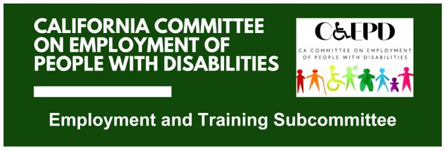

MEETING MINUTES - DRAFT
Tuesday, November 18, 2025

Meeting held through Zoom and in person at the Department of Rehabilitation’s Central Office. Meeting was held via teleconference within the meaning of Government Code Section 11123.5.

Subcommittee Members: Stephanie Crist (Virtual), Jennifer Fischer (Virtual), Harrison Lane (Virtual), Michelle O’Camb (Virtual), Paula Tobler (Virtual), and Sarah Turner (Virtual)

CCEPD/DOR Staff Members: Maria Aliferis-Gjerde (Virtual) and Zak Ford (In-person)

- Welcome and Introductions
Chair Lane called the meeting to order at 2:02 p.m. and a quorum was established.

- Approval of October Meeting Minutes
Motion/second (Crist/O’Camb) to approve the meeting minutes. Motion passed on a 5-0-1 vote. (Yes – 5: Crist, Fischer, Lane, O’Camb, Turner), (No – 0), (Abstain – 1: Tobler)
- Discussion on Job Coaching Policy Recommendations
CCEPD staff member Ford presented the current draft of policy recommendations. Ford shared his screen and facilitated discussion on input.

Policy recommendations focus on changes in the following four areas to improve job coaching services throughout California:
- Developing a job coaching online employer resource
- Implementing and aligning job coaching services across systems and programs
- Improving job coaching training
- Establishing clear supported employment career pathways

Within the four areas, members suggested making updates and additions relating to the following:
- Reference to statute providing the Department of Developmental Services with some ability for rate setting and tiered reimbursement to service providers
- Adding Master Plan for Career Education references
- Reword quality incentive program references for more clarity
- Update Direct Support Professionals (DSP) Internship Program references for potential leverage
- Add information on employers interviewed in appendix

Ford will update the draft of policy recommendations to incorporate the above input. The December meeting will be skipped, and he will solicit one-on-one input from members throughout December. The subcommittee will review and approve the final draft of the policy recommendations in its January meeting and final approval will be voted on by the CCEPD’s Full Committee in February.

- Update on Subcommittee Priorities
Federal and State Updates (Maria Aliferis-Gjerde)
- The federal government has reopened.
- The CCEPD will send a letter to the California Department of Health Care Services regarding the new Medi-Cal work requirements.
- Many federal programs currently in the U.S. Department of Education will be moved to other federal departments.
- The CCEPD has worked on updating its goals and strategies and they will influence subcommittee work in 2026.

Member Roundtable Reports
- O’Camb informed members that Roy Kim, the deputy director at the Sacramento Employment and Training Agency (SETA), has resigned.
- Agenda Items for Future Meetings
Other than items referenced among previous agenda items, no new items were raised.

- Public Comment
There were no public comments.

- Adjourn
The meeting adjourned at 2:51 p.m.

