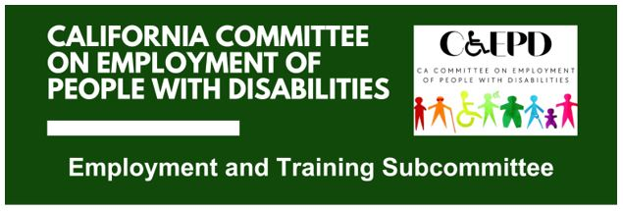

MEETING MINUTES - DRAFT
Tuesday, May 19, 2026

Meeting held through Zoom and in-person at the Department of Rehabilitation’s Central Office. Meeting was held via teleconference within the meaning of Government Code Section 11123.5.

Subcommittee Members: Kathleen Alonzo (Virtual), Stephanie Crist (Virtual), Jennifer Fischer (Virtual), Harrison Lane (Virtual), Kayla Prusia (Virtual), Paula Tobler (Virtual), DJ Tomko (Virtual), Michael Trogan (Virtual)

CCEPD Staff Members: Maria Aliferis-Gjerde (Virtual), Nick Coleman (Virtual), Zak Ford (In-person)

- Welcome and Introductions
Chair Lane called the meeting to order at 2:33 p.m. Members and staff introduced themselves. A quorum was established.

- Approval of April 21, 2026 Meeting Minutes
Motion/second (Trogan/Tobler) to approve the meeting minutes. Motion passed unanimously, 8-0-0. (Yes – 8: Alonzo, Crist, Fischer, Lane, Prusia, Tobler, Tomko, Trogan), (No – 0), (Abstain – 0)
- Discussion on Microenterprises, Self-Employment, and Entrepreneurship
Staff Member Ford reported on a follow‑up meeting with the DOR Self‑Employment Program, including discussions with DOR subject‑matter expert Erwin Petilla regarding connections between DOR, DDS regional centers, and the PIP microenterprise model.

Member Fischer asked clarifying questions and raised concerns related to how DOR defines a self-sustaining wage and the feasibility of meeting program expectations within a 12-month timeframe. Member Tobler discussed challenges Client Assistant Program (CAP) clients experience with business plan preparation and offered to identify a CAP representative to present at a future meeting.

Members Trogan and Tobler discussed opportunities to strengthen early stage preparation for entrepreneurship, and identified potential gaps in support offered by workforce and vocational rehabilitation systems.

Staff Member Ford concluded by outlining next steps, including reviewing existing DOR self-employment materials, confirming whether they remain current, and working with DOR to identify potential consumer panelists for a future meeting.

- Agenda Items for Future Meetings
Members expressed interest in additional presentations related to self‑employment supports, including CAP, workforce development partners, and DOR consumers participating in the Self Employment Program. Staff will follow up on recommended contacts.

- Public Comment
No public comments were received.

- Adjourn
Motion (Crist) to adjourn the meeting. Meeting adjourned at 3:05 p.m.

