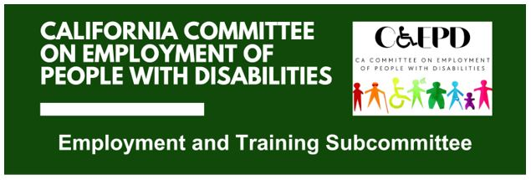

MEETING MINUTES - DRAFT
Tuesday, June 16, 2026

Meeting held through Zoom and in-person at the Department of Rehabilitation’s Central Office. Meeting was held via teleconference within the meaning of Government Code Section 11123.5.

Subcommittee Members: Kathleen Alonzo (Virtual), Stephanie Crist (Virtual), Harrison Lane (Virtual), DJ Tomko (Virtual), Michael Trogan (Virtual)

CCEPD Staff Members: Nick Coleman (Virtual), Zak Ford (In-person)

- Welcome and Introductions
Chair Lane called the meeting to order at 2:33 PM. Members and staff introduced themselves. A quorum was established.

- Approval of May 19, 2026 Meeting Minutes
Motion/second (Crist/Trogan) to approve the meeting minutes. Motion passed unanimously, 5-0-1. (Yes – 5: Alonzo, Crist, Trogan, Tomko, Lane), (No – 0), (Abstain – 1: Anderson, representing Fischer)
- Presentation from Client Assistance Program (CAP) on Self-Employment
Ivan Guillen, Senior Advocate Specialist, Disability Rights California, provided an overview of CAP’s work with DOR clients, including advising on services, rights, and expectations related to self‑employment. He discussed regulations governing business plans, feasibility assessments, common challenges such as counselor experience, delays in the self‑employment process, and available resources including SBA and SCORE. He highlighted success stories and emphasized the importance of consistent communication between consumers and counselors.

- Discussion on Microenterprises, Self-Employment, and Entrepreneurship
Members discussed themes raised in the CAP presentation and previous meetings with DOR and DDS, including concerns about inconsistent counselor knowledge, challenges caused by order of selection, the need for clearer cross‑system coordination between DOR, DDS, and Workforce Development Boards, and the importance of early preparation for individuals pursuing self‑employment. Members noted the difficulty workforce systems face supporting self‑employment due to W‑2‑based structures, and emphasized the need for improved understanding and alignment across agencies to prevent consumers from being bounced between systems.

- Agenda Items for Future Meetings
Staff Member Ford reported that the July meeting will include a panel of DOR consumers participating in the Self‑Employment Program. Updated DOR materials on 2024 self‑employment guidance are expected prior to that meeting. He outlined the timeline for developing a self‑employment preparation toolkit, with an initial outline planned for August, subcommittee approval by end of year, and full committee approval in February.

- Public Comment
No public comments.

- Adjourn
Meeting adjourned at 3:38 PM.

