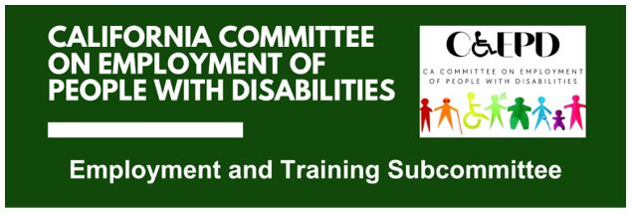

MEETING MINUTES - DRAFT
Tuesday, January 20, 2026

Meeting held through Zoom and in-person at the Department of Rehabilitation’s Central Office. Meeting was held via teleconference within the meaning of Government Code Section 11123.5.

Subcommittee Members: Kathleen Alonzo (Virtual), Stephanie Crist (Virtual), Jennifer Fischer (Virtual), Harrison Lane (Virtual), Sandy Nieves (Virtual), Michelle O’Camb (Virtual), Paula Tobler (Virtual), Dennis Tomko (Virtual), Sarah Turner (Virtual)

CCEPD/DOR Staff Members: Maria Aliferis-Gjerde (Virtual), Nick Coleman (In-person), Zak Ford (In-person)

- Welcome and Introductions
Chair Lane called the meeting to order at 2:02 p.m. and a quorum was established.

- Approval of November Meeting Minutes
Motion/second (Fischer/Turner) to approve the meeting minutes. Motion passed on a 7-0-1 vote. (Yes – 7: Crist, Fischer, Lane, O’Camb, Nieves, Tobler, Turner), (No – 0), (Abstain – 1: Tomko).
- Final Discussion of Job Coaching Policy Recommendations
CCEPD staff member Ford presented the final draft of job coaching policy recommendations, which incorporated input from all 10 members and was reviewed by DOR deputy directors. Ford presented the main changes, including updated terminology, added references to language and statute, and more emphasis on alignment across systems and programs.

The subcommittee then discussed and approved the policy recommendations for job coaching, which will be presented at the February CCEPD Full Committee Meeting.

Motion/second (O’Camb/Tobler) to approve job coaching policy recommendations. Motion passed unanimously, 8-0-0. (Yes – 8: Crist, Fischer, Lane, O’Camb, Nieves, Tobler, Tomko, Turner), (No – 0), (Abstain – 0).

- Discussion on Potential Entrepreneurship Work
The subcommittee discussed the possibility of new work on entrepreneurship for people with disabilities. Members wanted to begin by receiving an update from DOR’s Self Employment Program, which presented before the group in May of 2024. Afterwards, they would like to hear from other groups and review existing resources on the issue.

- Agenda Items for Future Meetings
CCEPD Staff Member Ford will coordinate a meeting with DOR’s Self Employment Program to potentially have them present in the February subcommittee meeting. Additionally, Ford has already confirmed there will be an update on the Workforce Innovation and Opportunity Act (WIOA) State Plan Two-Year Modification for Program Years 2024-27 at the next meeting. The subcommittee may also discuss DOR order of selection and potential paid internship programs in future meetings.

- Public Comment
There were no public comments.

- Adjourn
The meeting adjourned at 2:54 p.m.

