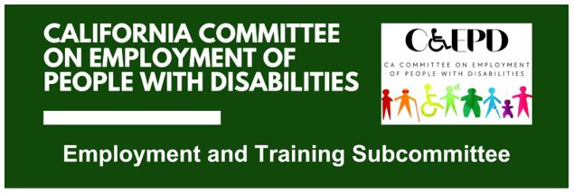

MEETING MINUTES - DRAFT
Tuesday, February 17, 2026

Meeting held through Zoom and in-person at the Department of Rehabilitation’s Central Office. Meeting was held via teleconference within the meaning of Government Code Section 11123.5.

Subcommittee Members: Kathleen Alonzo (Virtual), Alan Cruz (Virtual), Harrison Lane (Virtual), Sandy Nieves (Virtual), Michelle O'Camb (Virtual), Paula Tobler (Virtual), DJ Tomko (Virtual), Sarah Turner (Virtual)

CCEPD Staff Members: Maria Aliferis-Gjerde (Virtual), Nick Coleman (Virtual), Zak Ford (In-person)

- Welcome and Introductions
Chair Lane called the meeting to order at 2:04 p.m. and a quorum was established.

- Approval of January 20, 2026, Meeting Minutes
Motion/second (Tobler/Tomko) to approve the meeting minutes. Motion passed on a 6-0-1 vote. (Yes – 6: Lane, Nieves, O'Camb, Tobler, Tomko, Turner), (No – 0), (Abstain – 1: Cruz).
- Discussion on Self-Employment and Entrepreneurship
CCEPD Staff Member Ford introduced guests Michelle Kaplan, Policy Manager of DOR's Policy and Performance Section, and Erwin Petilla, Regional Director of DOR's Greater Los Angeles District. Kaplan and Petilla presented an overview of DOR's Self Employment Program, covering key regulatory definitions, the process for developing an Individualized Plan for Employment (IPE) in a self-employment setting, scope of services DOR may and may not provide, monitoring of business progress, and criteria for closure.

Following the presentation, the subcommittee discussed potential directions for a CCEPD work product on self-employment and entrepreneurship. Members expressed interest in a toolkit addressing myth busting and expectation setting, scalability considerations, and connections to external resources applicable across DOR, DDS Regional Centers, and other workforce systems.

Petilla noted that some Regional Centers operate micro-enterprise programs and suggested potential for DOR partnership when a business concept demonstrates viability. Ford noted distinctions between micro-enterprise, self-employment, and entrepreneurship as levels to potentially address in the work product.

- Update on WIOA State Plan Two-Year Modification Program Years 2024-27
Subcommittee Member Nieves provided an update on the WIOA State Plan Two-Year Modification for Program Years 2024–27. Key changes include alignment of regional planning units to correspond with the Jobs First initiative, stronger emphasis on regional collaboration, and integration with the Master Plan for Career Education. "High road" language has been replaced with "good quality jobs" terminology. Nieves also noted that at the federal level, WIOA will remain unchanged for one year. Ford noted that the modification includes reference to CCEPD best practices documents.

- Agenda Items for Future Meetings
The March subcommittee meeting will be cancelled due to scheduling conflicts. Ford will distribute a poll to members to establish a new standing meeting date. Two new local Workforce Development Board members will be on board with the CCEPD in March and April. The subcommittee discussed inviting a future presentation from DDS or Regional Center on micro-enterprise programs.

- Public Comment
A member of the public commented on barriers she’s experienced with DOR services. Ford acknowledged her concerns, clarified that the CCEPD is a policy advisory body not directly involved in service delivery, and offered to connect her with the ombudsperson office offline.

- Adjourn
The meeting adjourned at approximately 4:00 p.m.

