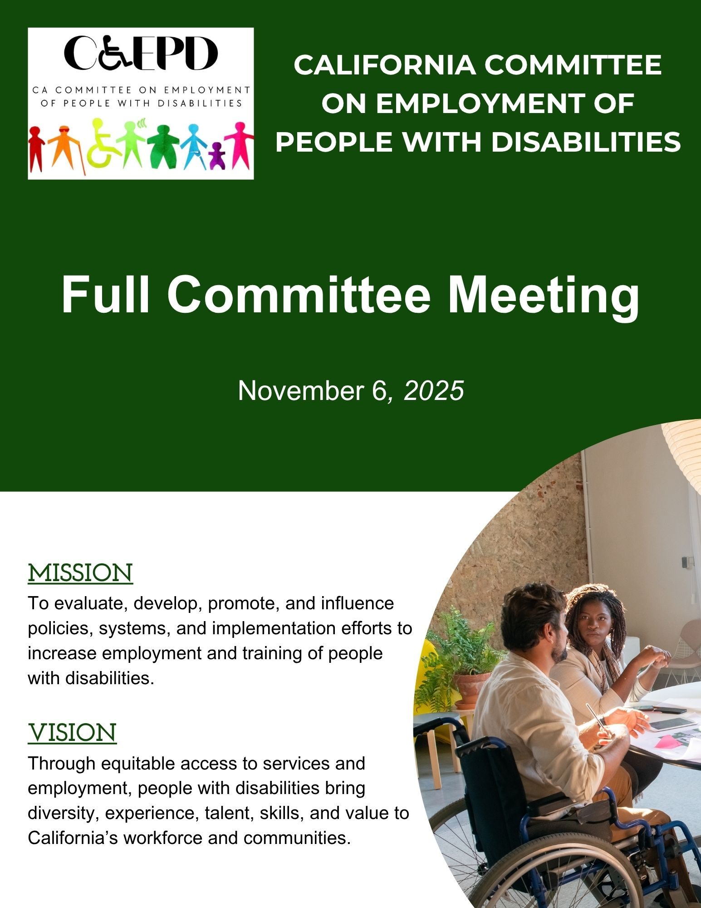

Table of Contents
Meeting Notice and Agenda 3
Meeting Minutes – August 21, 2025 (Draft) 6
Election of Chair and Vice Chair 15
2026 Meeting Calendar 16
Listening Sessions with Business and Industry Associations 17
Multi-Year Goals and Strategies 18
2025 YLF Annual Report 22
2025 CCEPD Annual Report 29

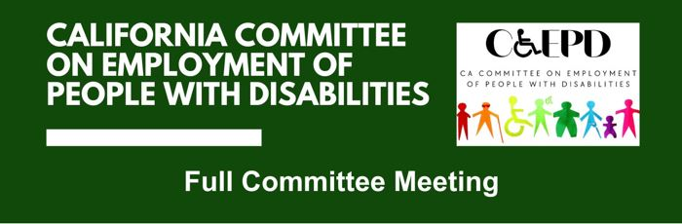
CCEPD Full Committee Meeting

Meeting Notice and Agenda
Thursday, November 6, 2025
9 a.m. until Noon

Public Participation Options
In-person: DOR Central Office, Room 407, 721 Capitol Mall, Sacramento, CA 95814

Video Conference Link: Zoom
Use Meeting ID: 947 6628 1416 and Passcode: f!.=i92b (between exclamation mark and equal sign is a period)

Phone: (408) 638-0968
Passcode: 81506183

This meeting is being held in accordance with Government Code Section 11123. There may be members of the public body participating in the meeting who were granted a reasonable accommodation in accordance with the Americans with Disabilities Act.

Agenda

- Welcome and Introductions
Taylor Winchell, Chair, CCEPD

- Approval of August 2025 Meeting Minutes
Taylor Winchell, Chair, CCEPD

- Election of Chair and Vice-Chair
Maria Aliferis-Gjerde, Executive Officer, CCEPD

- Agreement of 2026 Meeting Calendar
Maria Aliferis-Gjerde, Executive Officer, CCEPD

- Discussion on Medicaid Work Requirements
Yingjia Huang, Deputy Director of Health Care Benefits and Eligibility, Department of Health Care Services

- Listening Session with Business Association
Kim Gusman, President and CEO, California Employers Association
Daniela Devitt, Consultant, Workforce Development, California Employers Association

Break 10:30-10:45 a.m.

- Agreement of Goals, Strategies and Projects
Taylor Winchell, Chair, CCEPD
Maria Aliferis-Gjerde, Executive Officer, CCEPD

- Youth Leadership Forum Updates
Matt Baker, YLF Project Manager, CCEPD

- Agreement of CCEPD and YLF Annual Reports
Maria Aliferis-Gjerde, Executive Officer, CCEPD
Matt Baker, YLF Project Manager, CCEPD

- Member Updates

- Agenda Items for Future Meetings

- Public Comment

- Adjournment Noon*

* The meeting will adjourn upon completion of agenda.

Other Meeting Locations
- 501 N. Brookhurst Street, Suite 102, Anaheim, CA 92801
- 11640 Warner Avenue, Fountain Valley, CA 92708
- 800 Menlo Avenue, Suite 122, Menlo Park, CA 94025
- 555 Technology Ct, Riverside, CA 93507
- 1501 Capitol Avenue, Sacramento, CA
- 800 S. Victoria Avenue, Ventura, CA 93009
- 17 6th Street, West Sacramento, CA 95605

MEETING MATERIALS: This meeting notice and agenda and other supplemental materials may also be accessed on the website, located on the Advisory Committee Calendar. All times indicated, and order of business is approximate and subject to change on the day of the noticed meeting. The meeting will adjourn upon completion of the agenda. Interested members of the public may use the teleconference number and video conference link provided to listen to the meeting and/or provide public comment. The CCEPD is not responsible for unforeseen technical difficulties that may occur and is not obligated to postpone or delay its meeting in the event of unforeseen technical difficulties with the teleconference line and video conference.

PUBLIC COMMENT: Public comment on matters not on the agenda is taken at the end of the meeting and members of public can make comments on agenda items prior to any vote of the committee. Depending on the number of individuals wishing to address the committee, public comment may be limited to three minutes per person. Non-English speakers who utilize translators to make public comment will be allotted no more than six minutes unless they utilize simultaneous translation equipment. The CCEPD is precluded from discussing matters not on the agenda; however, CCEPD members may ask questions for clarification purposes.

REASONABLE ACCOMMODATIONS: If you require a disability-related accommodation, materials in alternate format or auxiliary aids/services, please email CCEPD@dor.ca.gov five days prior to the meeting. Any requests received after this date will be given consideration, but logistical constraints may not allow for their fulfillment.

Meeting Minutes – August 21, 2025 (Draft)

CCEPD Members: Dani Anderson (virtual), Jennifer Fischer (in-person), James Hill (in-person), Tim Jim (in-person), Michael Luna (in-person), Michelle O’Camb (in-person), LaCandice Ochoa (in-person), and Taylor Winchell (virtual)

This meeting is being held via teleconference within the meaning of Government Code Section 11123.

- Welcome and Introductions
Chair Taylor Winchell called the meeting to order at 10:07 a.m. and a quorum was met.

- Approval of February 2025 and May 2025 Meeting Minutes
It was moved/seconded (Luna/Anderson) to approve the February meeting minutes. Motion passed on 6-0-2. (Yes – 6: Anderson, Hill, Jin, Luna, Ochoa, Winchell), (No – 0) (Abstain – 2: Fischer, O’Camb)

It was moved/seconded (Anderson/Ochoa) to approve the May meeting minutes. Motioned passed on 6-0-2. (Yes – 6: Anderson, Hill, Jin, Luna, Ochoa, Winchell), (No – 0) (Abstain – 2: Fischer, O’Camb)

- Overview of Employment Data
Paul Wessen, Senior Economist at the Employment Development Department provided an overview of data for people with disabilities in California’s labor market.

- According to the U.S. Census Bureau’s American Community Survey (ACS), California’s population totaled 39.0 million persons in 2023, of whom 4.7 million were individuals with disabilities.
- In 2023, 12.1 percent (one out of every 8.3) of all Californians were persons with disabilities. In 2013, 11.0 percent (one out every 9.1) were persons with disabilities.
- Many people have more than one type of disability. The U.S. Census Bureau distinguishes six types of disabilities. In 2023, the breakdown by type of disability was as follows:
  - Ambulatory difficulty: 2,297,700 persons.
  - Cognitive difficulty: 1,956,400 persons.
  - Independent living difficulty: 1,931,700 persons
  - Hearing difficulty: 1,224,000 persons.
  - Self-care difficulty: 1,119,800 persons.
  - Vision difficulty: 879,600 persons.
- The incidence of having a disability is highly correlated with age, and more particularly, advanced age.
- Having a disability decreases the likelihood of attaining higher education levels.
- Californians with disabilities had consistently higher unemployment rates than those without disabilities across age cohorts (age 75 excepted) in June 2025, but conditions have improved over the last 10 years.
- Californians with disabilities had consistently much lower labor force participation rates than those without disabilities across age cohorts in June 2025, but their participation rates have increased over the last 10 years—particularly for those under the age of 65.
- All types of disabilities pose an obstacle within the labor market for those who have them, but barriers are particularly high for those with ambulatory, independent living, and self-care difficulties.
- California workers with disabilities are more likely to work part-time than those without disabilities. This is true of both younger (less than 55) and older (55 or more) individuals.
- The share of younger workers with disabilities who work full-time increased by 7.6 percentage points from June 2015 to June 2025 but was little changed for older workers with disabilities.
- California workers with disabilities were slightly more likely to telework than other workers in June 2025.
- In 2023, California workers with disabilities were more likely to work in health care support, service, office and administrative support, and transportation and material moving than were workers without disabilities. The direction of the 10-year changes in the occupational distribution of workers with disabilities largely paralleled those of workers without disabilities, despite some notable differences in the magnitude of change.
- Californians with a disability tend to have lower incomes and earnings than those without a disability.
- The income distribution improved for both Californians with a disability and Californians without a disability from 2013 to 2023, but more so for those without.
- Californians with disabilities are more likely to have health care coverage than those without, but the gap is closing.
- Californians with disabilities are more likely to receive public assistance than those without disabilities.

Member questions and comments:
- Labor force participation rates are a main focus.
- Disability definitions and designations came from the U.S. Census Bureau.
- Balancing benefits and employment were not included in data report.

- Overview of Workforce Strategies
Abby Snay, Deputy Secretary of Workforce Strategy for the California Labor and Workforce Development Agency (LWDA) provided an overview of current workforce strategies in the state.

- Changing demographics across the state have implications for the economy and workforce, and equity has been a driving force for this administration.
- Clear imperative and focus on improving outcomes across education, workforce, and economic systems to better serve California's learners, workers and communities – this has been formalized in the Master Plan for Career Education (April 2025) and the Jobs First Economic Blueprint (February 2025).
- LWDA serves as an implementation engine for these workforce efforts, for the Master Plan, Jobs First, and responses to federal funding and policy changes.
- Current economic climate increases importance of robust education and workforce systems.
- The Master Plan for Career Education aims to prepare all learners for the workforce of tomorrow by guiding California in its efforts to strengthen career pathways, prioritize hands-on learning and real-life skills, and advance access and affordability through streamlined collaboration and partnership so that all Californians can navigate toward family-sustaining jobs.
- The Jobs First initiative is a $400 million investment into a bottom-up economic development strategy that created 13 Regional Collaboratives across California to create their own regional economic plans, rolled up into an Economic Blueprint which identifies the strategic sectors and strategies that best position the state to help create, attract, and increase access to good-paying jobs.
- Impacts of new federal administration on workforce development in California:
  - Proposed reductions in federal funding to workforce system and critical partners
  - White House budget proposal calls for block grant for workforce system and elimination of critical workforce programs
  - Reductions to Medi-Cal and CalFresh
  - House Resolution 1 work requirements for public benefits programs restrict access and increase administrative burden
  - New short-term Pell but reductions in student aid

Member questions and comments:
- CCEPD and DOR can help by advocating for more hirings of people with disabilities in state service.
- The DOR-EDD Collaboration Project will create opportunities.

- Overview of DOR-EDD Collaboration Project
Jennifer Fischer, Deputy Division Chief of the Workforce Services Branch at the Employment Development Department, provided an overview of the DOR-EDD Collaboration Project, now titled the DOR-AJCC Collaboration Project.

The initiative brings together Local Workforce Development Areas in partnership with their local DOR field offices to participate in a collaborative project that will enhance services to people with disabilities in America’s Job Centers of California (AJCCs).

- Partnership Goals
  - Heightened awareness of people with disabilities accessing AJCC services
  - Greater understanding of possibilities
  - Highlighting the knowledge, skills, and abilities of people with disabilities
  - Streamlining services to our shared customers
  - Increase successful employment outcomes
  - Strengthen collaboration between DOR and EDD, and between DOR and AJCCs
  - Increase access to benefits planning services and knowledge of work incentives

- Project Development
  - DOR identified funds to support services to people with disabilities in the AJCCs
  - Jobs for the Future (JFF) facilitated a workgroup with DOR, Labor and Workforce Development Agency, and EDD to develop the goals and objectives for a new project
  - Incorporated lessons learned from past disability projects and CCEPD Toolkit Development
  - JFF conducted stakeholder engagement interviews with EDD, DOR, Local Workforce Development Boards, and people with disabilities
  - Developed DOR/AJCC Collaboration Model

- Project Overview
  - Project Vision
    - Improve employment and training outcomes for individuals with disabilities served by California’s workforce development system.
    - Increase job quality and job satisfaction for people with disabilities.
    - Create a culture of disability inclusion at all AJCCs
    - Investment in sustainable systems change at both the state and local level.
  - Project Components
    - State level partnership between DOR and EDD
    - Statewide workgroup of state and local leaders that gathers feedback from project implementation to inform policy, procedures, and resource development
    - Funded Local Area projects that are serving people with disabilities as a partnership between AJCCs and local DOR Branches
    - Funded technical assistance and developmental evaluation provider
  - System Alignment Activities
    - Co-enrollment Policies and Procedures
    - Partnership Agreements/MOUs
    - Incorporating disability benefits planning into service delivery systems
    - Staff development planning – Onboarding, annual training requirements
    - Streamlining processes for job seekers receiving services from both AJCCs and DOR

- State-Level Workgroup
  - Bringing together state partners to work on policies, procedures, and resources that will assist workforce programs in better serving people with disabilities
  - Workgroup members will conduct stakeholder engagement with their workforce partners within their service area to inform the workgroup’s efforts
  - Workgroup members will conduct stakeholder engagement with case managers and participants for input on services to inform the workgroup’s efforts

- Local Workforce Development Area Projects
  - Center co-enrollment and co-case management between DOR and AJCCs as a core strategy
  - Coordinating services to shared participants/consumers
  - Cross training between DOR, EDD, and AJCC staff
  - Participate in state-level workgroup, technical assistance, and developmental evaluation
  - Enact systems change that ensures sustainability of successful grant strategies
  - Will include three positions – disability resource coordinators, disability services coordinators, disability benefits/work incentives planners

- Technical Assistance and Development Evaluation
  - Provided by Loyola Marymount University
  - Ongoing evaluation of program effectiveness and real-time improvements based on evaluation findings and stakeholder engagement
  - Technical assistance to Local Area Projects
  - Certificate for Leadership in Disability Workforce Development – (Available to DOR and AJCC staff and partners)

There was no time for member questions and comments.

- Approval of Goals and Strategies for 2025 and Agreement of Projects
Executive Officer Maria Aliferis-Gjerde provided an overview of multi-year goals and strategies for the CCEPD and the changes from the August meeting. Then, members broke into two groups to discuss goals and strategies and reported back afterwards with the following input.

Goal 1
- Focus should be on abilities vs. disabilities.
- Listening session should be held for messaging.
- A CCEPD member should be on the state group for the DOR-EDD Collaboration Project.
- Input is needed from businesses
- The state as a model employer should be part of the strategies. Some ideas on engagement can be around LEAP, hiring managers or pathways to careers within state.
- Outreach has begun to industry/business associations. Discussed what call to actions are needed.

Goal 2
- The federal budget bill may create additional changes to programs. Continue to watch developments.
- There might be opportunities to partner through the DOR-EDD Collaboration Project.
- Medicaid work requirements are changing. CCEPD should be engaged in those discussions.
- Discussed how California Volunteers, located within the Governor’s Office, be developed as a partnership.

Changes will be made to goals and strategies at the November meeting.

- Youth Leadership Forum Updates
YLF Project Manager Matt Baker provided an overview of the program and a recap of 2025.

The statewide California YLF is a week-long residential program for sophomores, juniors, and seniors in high school with disabilities. Concentrated on pre‑employment transition services, delegates engage in leadership activities focused on post-secondary education, career readiness, independent living, and self‑advocacy. This year’s YLF statewide program was held at California State University, Sacramento, July 11-19.

After a boost in 2024, 2025 saw a continued increase in the number of youths interested in attending YLF with 180 students applying, 60 delegates selected, and 50 attending and completing the program. There were 26 YLF alumni that returned as staff in 2025. Additionally, there was an additional training day added for small group staff to facilitate team building, mental health support, disability cultural awareness, conflict resolution and logistical support for 2025.

Regarding the budget, current operating expenses are $171,517.79. Invoices and reimbursement requests are being processed, and awaiting funding from state partners. There will be a small carryover for post YLF regional events, and YLF 2026 planning efforts.

The YLF 2026 Governance Meeting kicks off on September 10, 2025. There will be the return of YLF Planning Workgroups. There will also be continued alumni engagement and internship opportunities. Regional events are being held in Sacramento, Los Angeles, and South Bay Los Angeles. Staff is currently evaluating survey data and compiling the annual report, which will lead to improvements to the curriculum and weekly schedule. There will be opportunities for growth with new partnerships made.

- Member Updates
There were no member updates.

- Agenda Items for Future Meetings
Continued discussion on goals and strategies, and a possible business/industry association presentation were raised as potential agenda items.

- Public Comment
Danny Marquez stated jobs within the DOR-EDD Collaboration Project should include people with disabilities.

- Adjournment
Meeting adjourned at 3:20 p.m.

Election of Chair and Vice Chair

The California Committee on Employment of People with Disabilities (CCEPD) will elect a Chair and Vice-Chair at the November 2025 Full Committee meeting.

According to Operating Guidelines, the Executive Committee in September 2025 asked Executive Committee members to work with the Chair, in lieu of creating a nominating committee, for nominations to select a Vice-Chair. Since August 2025, Roy Kim is no longer with the CCEPD. In reviewing the historical information, an election for chair should have been held in November 2024. Therefore, the CCEPD will hold vote for Chair to finish the term until November 2026.

The following nominee as Chair:
- Taylor Winchell

The following nominee as Vice-Chair:
- Harrison Lane

The Chair and Vice-Chair serve a two-year term and may serve two full, two-year terms.

2026 Meeting Calendar

In 2026, the CCEPD meetings will be hybrid with in-person meeting. CCEPD will schedule meetings from 9 a.m. until noon and may change if the meeting is in-person.

CCEPD Full Committee Meetings
The meetings are held on Thursdays on a quarterly basis. The dates of the meetings are:
- February 26
- May 21
- August 20
- November 12

Executive Committee
The administrative meetings are held on Mondays. The dates of the meetings are:
- January 12
- March 23
- June 22
- September 14

Youth Leadership Forum (YLF) for Students with Disabilities
Tentative dates are July 11-18. (These dates include staff training.)

Listening Sessions with Business and Industry Associations

The California Committee on Employment of People with Disabilities (CCEPD) has agreed that one of the strategies for 2025 and 2026 is to increase outreach to business and industry associations. With collaboration from CCEPD members, the Executive Officer has reached out to the California Employers Association and California Chamber of Commerce.
Conversations will include the following areas:
- Understanding workforce needs, including skill sets.
- Do your members work with employment and training programs to find skilled workers? If so, which ones? If not, why?
- When employing people with disabilities, what are the contributions and benefits to your members (e.g., financial, morale, customer relations, etc.)? Have your members identified any best practices?
- Does your membership have challenges in retaining employees who have disabilities? What are those challenges?

Our goal with these listening sessions is to incorporate information into future policy initiatives and create opportunities for partnerships to highlight the talent and skills people with disabilities bring to the workplace.
The CCEPD team shared occupational data from the Employment Development Department, Labor Market Information Division, and prioritized business and industry associations representing the highest employment numbers for people with disabilities. The goal is to have a listening session with a business or industry association at each quarterly meeting. Other business and industry associations to be invited to future meetings include the California Restaurant Association, the California Hotel and Lodging Association, the California Retailers Association, the California Association of Health Facilities, the California Building Industry Association, and the California Association of Hospitals and Health Systems.
After presentations, members will be asked for their take-aways and areas for evaluation and discussion.

Multi-Year Goals and Strategies
November 2026 Full Committee Meeting
Introduction
The CCEPD has been working on the multi-year goals and strategies in 2025. At the November 2025 meeting, members will approve the goals and strategies, as well as the projects and initiatives the CCEPD will undertake for the upcoming year.
At the May 2025 CCEPD Full Committee Meeting, members discussed the goals and strategies for multiple years. Based on the conversation in May, the CCEPD decided to have two goals and three strategies with potential identified projects for the Committee. In August 2025 CCEPD Full Committee, Members focused the strategies and narrowed the scope of projects and initiatives. The Executive Officer made changes to the first goal to make it align with the strategies. The goal is to have actionable items that can be developed by CCEPD.
Goal 1: Develop partnerships and guidance that reframes messaging that people with disabilities are skilled and talented.
Strategies:
- Create partnerships to incorporate inclusive practices so people with disabilities are recognized as skilled and talented.
  - Develop partnership with the California Office of Small Business Advocate or other state entities to incorporate guidance for people with disabilities who want to own businesses and be entrepreneurs.
  - Develop partnerships on apprenticeship programs, such as building and trades programs, to provide guidance and recommendations on how existing apprenticeships can be more inclusive for people with disabilities.
- Evaluate existing State being Model Employer initiatives and propose updated recommendations.
  - CCEPD could leverage resources on pathways to careers and training for hiring managers.
  - CCEPD could focus on the accessibility and inclusiveness of State hiring practices.
  - CCEPD could also look at other public sector hiring, such as counties and cities, and invite associations to discuss employment initiatives.
- Increase outreach to industry associations.
  - CCEPD will conduct listening sessions with industry associations to drive future policy recommendations and develop partnerships.
  - Members can also participate in ongoing business association meetings or local chamber meetings and report back to the Committee.
From these listening sessions, the CCEPD can develop policy recommendations, targeted projects, such as a community of practice, or develop alignment conversations with the above strategies. Throughout 2026, CCEPD can develop panel discussions centered on systems changes within programs serving people with disabilities, hold panel discussions with other advisory boards on employment and training issues, and people with disabilities on challenges in employment and training.
Goal 2: Improve access to services and programs that promote employment and continue to support alignment between programs and services.
Strategies:
- Be partners on the DOR-AJCC collaboration project.
  - Assist with developing a resource guide.
  - Leverage training opportunities throughout the systems and programs.
  - Develop ongoing listening sessions with America’s Job Centers of California, DOR and the evaluator of the project.
- Provide recommendations on the Medicaid and social services work requirements implementation efforts and impacts on people with disabilities.
- Follow federal impacts to workforce and disability impacts and make recommendations on state implementation.
- Develop collaboration with California Volunteers, an office within the Office of the Governor, that provides community service opportunities.
Previous strategies (below) will be considered principles to be used in recommendations and/or discussions.
- Emphasis should be on retention of employment and career advancement of workforce programs.
  - Ensuring person-centered goals for a person seeking employment.
  - Benefits should support employment efforts and not create barriers to employment. (Members did not discuss but included concept from benefits planning report.)
  - Placing skill development and transferable skills at the center of the conversation with client.
- Continuing to promote integration of programming, resource alignment, and service coordination.
  - Prioritize program alignment across programs, focusing on client needs, and then building program cooperation.
  - Support navigators and support leveraging navigators to help bridge systems, guide clients, and support service integration.
  - Continued support for an integrated resource team service model.
- The use of artificial intelligence tools is used for improved access to information about programs and services.
Other policy projects are the development of job coaching recommendations and making comments to the Unified State Plan. The Benefits Planning Cross-Advisory Body Workgroup is meeting, beginning in October, to provide a Department of Developmental Services (DDS) proposal on a tiered approach to benefits planning. The Workgroup will meet until January 2026 to provide feedback to DDS on their proposal.
The Youth Programming Subcommittee will continue to meet and develop recommendations on funding for the Youth Leadership Forum (YLF), and evaluation of regional events. Developing a partnership with California Volunteers can assist with YLF, in terms of volunteer experience for youth with disabilities. The Youth Programming Subcommittee will focus on outcomes and curriculum for regional YLF events and developing private funding for the statewide YLF event.

2025 YLF Annual Report

Overview
The statewide California Youth Leadership Forum for Students with Disabilities (YLF) is a week-long educational program for sophomores, juniors, and seniors in high school with disabilities. Concentrated on pre‑employment transition services, delegates engage in leadership activities focused on post-secondary education, career readiness, independent living, and self‑advocacy. YLF began in California in 1992 and has grown to a national program held in over 30 states.

Activities throughout the week were designed to build delegates’ confidence and self-advocacy skills to set goals for their lives, education and training, and employment. During the program, eight to ten delegates worked in small groups, supported by two co-counselors, two peer mentors and two group assistants. Delegates worked on activities that reinforce the key leadership goals and objectives of the program. Each day had a theme, and scheduled activities reinforced that theme. This year’s themes included “Learning about Disability History”, “Culture and Community”, “Discovering Resources to Reach our Goals”, “Living Independently”, “Engaging in Our Communities”, and “Leading On”. In addition to small group sessions, delegates participated in large group sessions which feature presentations and discussions from young adults and professionals with disabilities who have successfully transitioned out of high school and have explored post-secondary education, work and career life, living independently, and self-advocacy.

This year’s YLF statewide program was held at California State University, Sacramento, July 11-19.

2025 Highlights and Outcomes
After a boost in 2024, 2025 saw a continued increase in the number of youth interested in attending YLF with 180 students applying, 60 delegates selected, and 50 attending and completing the program.

Delegates learned shared experiences from established and emerging leaders with disabilities. Delegates also participated in social activities such as a talent show, a college campus tour, a visit to the California State Capitol, and a dance, which offer delegates the opportunity to socialize with fellow delegates and learn public speaking skills and interaction in a fun atmosphere.

In 2025 an additional staff training day was implemented to include sessions on mental health, conflict resolution, and disability culture awareness. Continued improvements were also made to the risk management policies.

Delegates participated in surveys to measure outcomes and growth in key concepts of self-advocacy and understanding of support needed to live independently. Youth completed a before and after survey measuring their growth in areas such as disability history, self-advocacy, resources, career goals and support needed, and independent living skills.

Topic areas with largest growth were with the following statements:
- I know about the Americans with Disabilities Act.
- I know about the disability rights movement and its leaders.
- I know where to get help finding a job.
- I know other young people with disabilities.
- I know what a CalABLE account is.
- I have a strong connection with the Disability Community.
- I know how to contact my local Independent Living Center.
- I know where to find volunteer or internship opportunities.
- I am proud to have a disability.

Additionally, delegates were asked open-ended questions to find what they learned most from the program. Response themes related to gaining confidence with independence and acceptance with being a member of the disability community, including growing friendships, were very high. Growth in knowledge on resources and advocacy abilities were also high.

2025 Demographics
Many delegates shared multiple identities within demographic categories like disability and race/ethnicity. YLF achieved both gender, disability, and race/ethnicity diversity for 2025, with the highest disability and race/ethnicity group identifications being developmental disabilities including autism and/or neurodivergent, and White (Non-Hispanic/Latino), respectively. Although the majority of delegates identified as male, delegates identified as female were closely matched with remaining identifying as non-binary or did not disclose gender. The highest number of delegates were juniors in high school; the remaining were a mix of recently graduated seniors and sophomores. Delegates resided as south as San Diego county and as north as Tehama county. More delegates resided in Los Angeles county than any other county.

In recent years, an effort has been made to recruit YLF alumni and staff closer to the age of delegates for more effective peer mentorship. Of 57 onsite staff members (excluding contracted or state staff), about 79% of staff were in their 20s and 30s or older and the rest of staff were teenagers. Additionally, the vast majority were people with disabilities, and nearly half were alumni of the YLF program.

2025 Delegate Testimonials
“I’ve learned to be comfortable in myself for having a disability, and so much about what I can use to help my future. I also met so many amazing people that are now like a second family to me.”

“The week at YLF has been the highlight of my year and I’ll continue to remember it for the rest of my life. I appreciate the opportunity and hope to come back as a staff member one day.”

“YLF was such an incredible time to be away from home and explore more of what’s out there in the world for people with disabilities struggling with their lifestyles sometimes. I loved hearing everyone’s different perspectives about their lives, especially the panel discussions with adults. They made the experience more enjoyable to learn. I encourage people to apply and come to YLF. You will learn so much about what you need to know for your education and about making good choices for your future.”

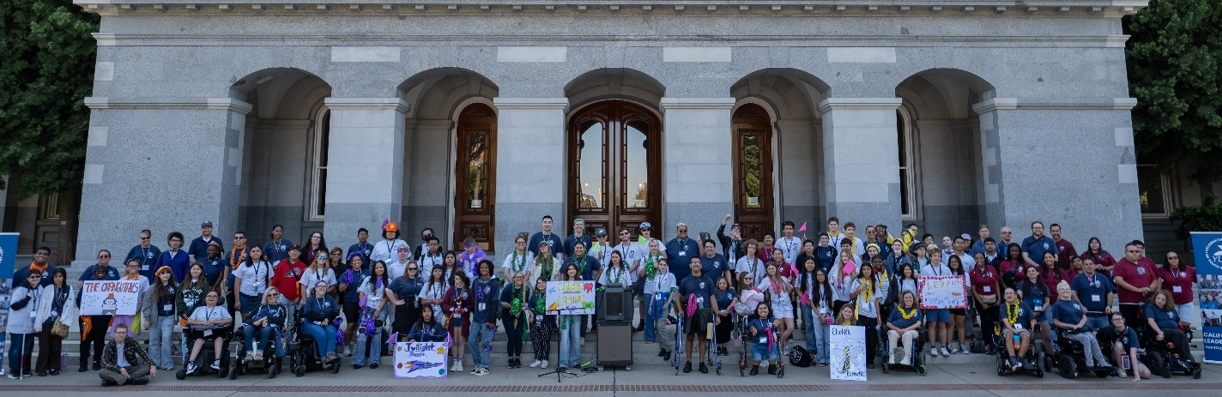
Figure 1 YLF Delegates and Staff pose outside the California State Capitol West Steps
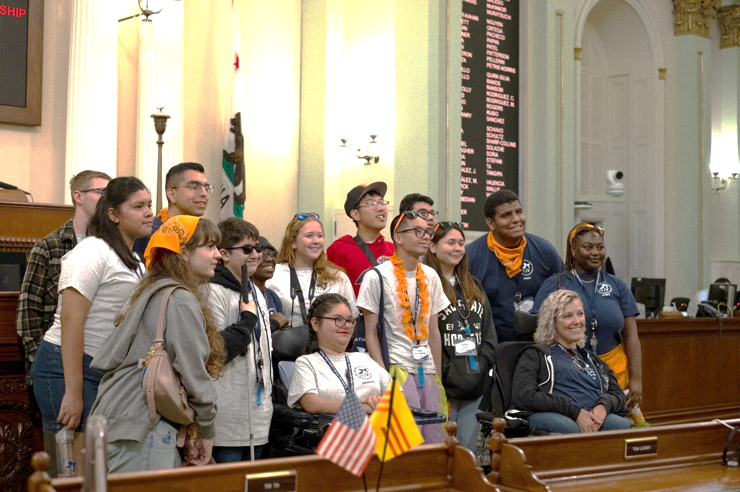
Figure 2 YLF Delegates and Staff from the Orange Group pose on the California State Assembly Floor. Thanks to Assemblymembers Bennett and Bryan for the opportunity and tour.
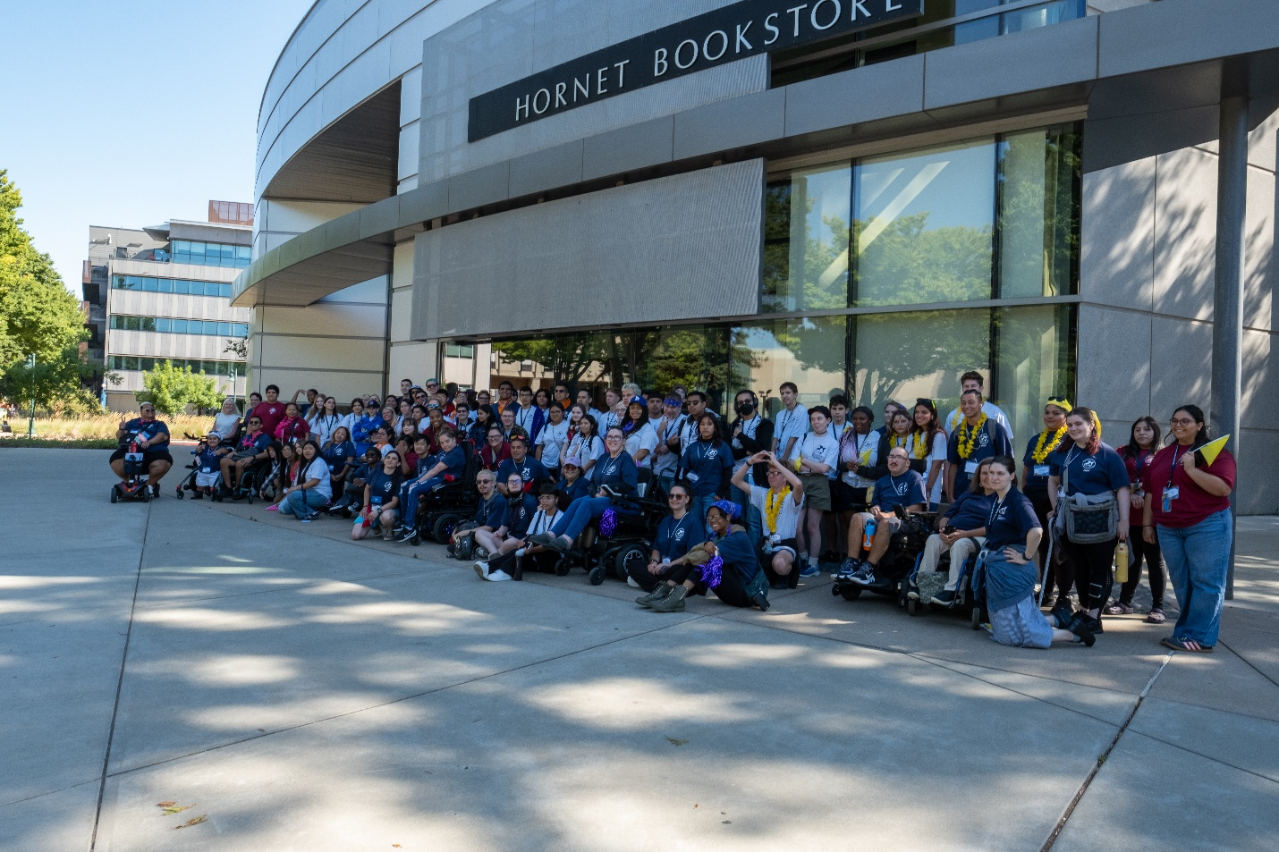
Figure 3 YLF Delegates and Staff pose outside the Hornet Bookstore during our campus tour. Stingers Up!
Year-Round Activities
In addition to the statewide program, additional year-round activities have been developed as opportunities to market the program, serve more students and increase engagement with the YLF alumni network. These opportunities include regional events, statewide conferences and presentations on YLF.

Some of the 2025 highlights include attending the California Workforce Association’s WorkCon presenting on the power of peer mentorship in Youth Programming, attending the Ventura County Government and Disability Summit presenting on the YLF Model, and hosting three regional events. YLF alumni assist in regional events by being on panels discussing their journey to independence and employment or are keynote speakers.

Regional Events
In collaboration with local regional partners, YLF has started piloting regional YLF events in recent years. These shorter programs include some of the same curriculum topics covered in the longstanding summer program and new topics and activities developed by the local partners. These regional events serve both as an opportunity to develop stronger partnerships and investments with our local partners, increase outreach opportunities to serve more students than just our statewide program, and offer YLF alumni to continue their leadership and self-advocacy skill building and serve as peer mentoring opportunities.

For 2025, YLF hosted three regional events including a three-day event in San Diego and two one-day events in Sacramento and Los Angeles.

Additional regional events across California are being developed and new partnerships are being established to continue the great work of YLF.

2025 Partners and Sponsors
Thanks to all our YLF partners and sponsors, YLF continues to offer completely free programming for students. Without their commitment, time, in-kind services, and support, YLF could not deliver the amazing work supporting transition age youth. Thanks to the California Department of Rehabilitation (DOR), the California Department of Education (CDE), the California Department of Developmental Services (DDS), the California Employment Development Department (EDD), the California Department of Social Services (CDSS), Anthem Blue Cross, the Association of California State Employees with Disabilities (ACSED), Disability Rights California (DRC), CalABLE, the State Independent Living Council (SILC), and Friends of Californians with Disabilities, Inc.

2026 Planning
Planning for the 2026 statewide YLF summer program and regional events are already underway. The 2026 statewide YLF will be held in-person from July 13 through July 18, 2026, at California State University, Sacramento.

California residents with any disability who are high school sophomores, juniors, or seniors during the 2025-2026 school year are eligible to apply. Students who demonstrate leadership potential in school and in the community are best suited for this program.

The statewide delegate application for YLF 2026 and more information on regional event programming is available on the YLF website!

Contact Us
855-894-3436
YLF@dor.ca.gov
www.dor.ca.gov/Home/YLF

Please follow us on Facebook, Instagram and YouTube.
https://www.instagram.com/calylf/

2025 CCEPD Annual Report

Overview
The California Committee on Employment of People with Disabilities (CCEPD) advances employment for people with disabilities by making policy recommendations to the Secretary of the Labor and Workforce Development Agency, and the Secretary of the California Health and Human Services Agency. The CCEPD also creates toolkits and reports to advance disability equity, inclusion, and access in all programs and systems throughout California serving people with disabilities. Additionally, the CCEPD supports an annual event for youth with disabilities, the California Youth Leadership Forum for Students with Disabilities (YLF).

Vision: The CCEPD’s vision is through equitable access to services and employment, people with disabilities bring diversity, experience, talent, skills, and value to California’s workforce and communities.

Mission: The CCEPD evaluates, develops, promotes, and influences policies, systems, and implementation efforts to increase employment and training of people with disabilities.

“In 2025, the CCEPD advanced its mission by strengthening partnerships with employers and industry associations to promote inclusive hiring and expand access to job coaching supports. We also reestablished the Youth Programming Subcommittee, which now leads statewide and regional Youth Leadership Forum initiatives and empowers young leaders with disabilities for success in education, employment, and community life.”
~ Taylor Winchell, CCEPD Chair

New Members
The CCEPD welcomed two new members, Alan Cruz, a California State Independent Living Council appointee, and Tim Jin, a Senate Rules appointee.

Alan Cruz is the Youth Community Liaison for the Dayle McIntosh Center (DMC). He is a blind Mexican man. He started with DMC in August 2017 as a youth. In 2018 he became a volunteer through YO! Disabled and Proud. At the end of his time with YO, he got offered a job opportunity at the Dayle McIntosh Center. He has been involved with the California Youth Leadership Forum (YLF) and the Association of Programs for Rural Independent Living (APRIL). Alan was appointed to the California State Independent Living Council in 2023 by the Governor. He enjoys music, technology and helping others be successful in life. Alan has a positive attitude, and he takes his work very seriously. His motto is “Piece of Cake!” when collaborating or taking initiative.

Tim Jin, born with cerebral palsy, is a passionate advocate for the rights of people with speech-related disabilities to access the communication tools and support they deserve. Since the 1980s, he has relied on an augmentative and alternative communication (AAC) device, giving him a unique perspective on the importance of inclusive technology. Tim also believes that all people should have the opportunity to pursue meaningful employment, and he promotes the efforts to expand career pathways for people with disabilities a matter of equity and dignity. He currently serves as a Community Program Specialist II at the California Department of Developmental Services on the Self-Determination Team. A graduate of California State University, Long Beach, with a degree in speech communication, Tim lives in Southern California and embraces a self-determined life.

Policy Highlights
Through listening sessions and discussions with employers, service providers, and policy groups, the CCEPD worked on addressing job coaching needs for employers, employees and service providers. Job coaching is important to support employment outcomes and allows people with disabilities to learn on-the-job skills by having additional support. Policy recommendations on the issue will be completed in early 2026.

The CCEPD evaluated workforce data for people with disabilities and identified industry sectors with the highest percentage of employees with disabilities. Some of the sectors included food preparation and serving related, healthcare support or healthcare practitioner and technical, and installation, maintenance and repair. Staff and members are currently working on outreach to industry/business associations to create a series of listening sessions with CCEPD members that will go into next year.

The CCEPD-led Benefits Planning Cross-Advisory Body workgroup was reestablished in the last quarter of the year to provide feedback to the Department of Developmental Services on their tiered benefits planning project. The workgroup began work in October and will continue into early January 2026. In early 2025, the CCEPD Chair and Executive Officer met with groups to discuss the released benefits planning report and what type of implementation efforts can occur. The CCEPD continues to monitor changes in federal and state programming centered on benefits and its effects on employment.

The CCEPD’s Youth Programming Subcommittee was also reestablished in 2025 to develop goals for both the statewide and regional Youth Leadership Forum events and develop non-state partnerships for the events.

In 2025, the CCEPD evaluated its multi-year goals and strategies and created two goals: 1) Develop partnerships and guidance that reframes messaging that people with disabilities are skilled and talented. 2) Improve access to services and programs that promote employment and continue to support alignment between programs and services. The CCEPD also developed strategies that will inform the work. The CCEPD will continue to monitor federal changes to state programs and services and will engage in implementation efforts for work requirements. Other initiatives include the Department of Rehabilitation and America’s Job Centers of California project that builds capacity in serving people with disabilities. This collaboration has been supported by the CCEPD and will continue to be interested in the best practices for building capacity in the workforce programs to serve people with disabilities.

Youth Leadership Forum (YLF) Highlights
This year’s YLF statewide program was held at California State University, Sacramento, July 11-19. After a boost in 2024, 2025 saw a continued increase in the number of youth interested in attending YLF with 180 students applying, 60 delegates selected, and 50 attending and completing the program.

Delegates learned shared experiences from established and leaders with disabilities. Delegates also participated in social activities such as a talent show, a college campus tour, a visit to the California State Capitol, and a dance, which offer delegates the opportunity to socialize with fellow delegates and learn public speaking skills and interaction in a fun atmosphere.

In 2025 an additional staff training day was implemented to include sessions on mental health, conflict resolution, and disability culture awareness. Continued improvements were also made to the risk management policies.

Planning for the 2026 statewide YLF summer program and regional events is underway. The 2026 statewide YLF will be held in-person July 13-18, 2026, at California State University, Sacramento. After developing two work experiences for youth in 2025, the CCEPD will be offering several paid work experiences for youth to assist in planning of the statewide YLF event.

Regional Youth Leadership Forum Highlights
In collaboration with local regional partners, YLF has started piloting regional YLF events in recent years. These shorter programs include some of the same curriculum topics covered in the longstanding summer program and new topics and activities developed by the local partners. These regional events serve both as an opportunity to develop stronger partnerships and investments with our local partners, increase outreach opportunities to serve more students than just our statewide program, and offer YLF alumni to continue their leadership and self-advocacy skill building and serve as peer mentoring opportunities.

For 2025, YLF hosted three regional events including a three-day event in San Diego and two one-day events in Sacramento and Los Angeles. Additional regional events across California are being developed and new partnerships are being established to continue the great work of YLF.

Contact Us
For more information, including current developments and meetings, visit the CCEPD’s website or email at CCEPD@dor.ca.gov.

[Add “contact us’ block in final version]

