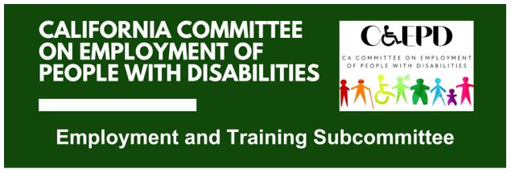

MEETING MINUTES - DRAFT
Tuesday, October 21, 2025

Meeting held through Zoom and in person at the Department of Rehabilitation’s Central Office. Meeting was held via teleconference within the meaning of Government Code Section 11123.5.

Subcommittee Members: Kathleen Alonzo (Virtual), Stephanie Crist (Virtual), Jennifer Fischer (Virtual), Harrison Lane (Virtual), Michelle O’Camb (Virtual), Sandee Nieves (Virtual), Paula Tobler (Virtual), Sarah Turner (Virtual), and Scarlett vonThenen (Virtual)

CCEPD/DOR Staff Members: Maria Aliferis-Gjerde (Virtual) and Zak Ford (In-person)

- Welcome and Introductions
Chair Lane called the meeting to order at 2:03 p.m. and a quorum was established.

- Approval of September Meeting Minutes
Motion/second (Tobler/Crist) to approve the meeting minutes. Motion passed on a 7-0-0 vote. (Yes – 7: Crist, Fischer, Lane, O’Camb, Nieves, Tobler, Turner), (No – 0), (Abstain – 0)
- Discussion on Job Coaching Policy Recommendations
CCEPD staff member Ford presented the initial draft of policy recommendations. Ford shared his screen and facilitated discussion on input.

Policy recommendations focus on changes in the following four areas to improve job coaching services throughout California:
- Developing a job coaching online employer resource
- Implementing and aligning job coaching services across systems and programs
- Improving job coaching training
- Establishing clear supported employment career pathways

Within the four areas, members suggested making updates and additions relating to the following:
- Statute about job coaching services and reference we aren’t requesting statute changes
- More references about job coaching as an accommodation and accommodation plans
- DSP Internship Program
- Reference to job coaching within private organizations and initiatives
- More on core competencies
- More on tiers of job coaching and pathways
- Recruitment from those with lived experiences
- Targeted audiences

Ford will update the draft of policy recommendations to incorporate the above for the November meeting. The subcommittee will continue updates on the policy recommendations until they are finalized and approved by the CCEPD’s Full Committee in February of 2026.

- Update on Subcommittee Priorities
Federal and State Updates (Maria Aliferis-Gjerde)
- The CCEPD continues to watch federal budget and policy conversations for impacts to state programs.
- In November’s CCEPD Full Committee meeting, there will be presentations on Medicaid work requirements and the California Employers Association.

Member Roundtable Reports
- Department of Developmental Services (DDS): Crist reported the department recently held a workgroup meeting on updating their employment services. They are expanding their Employment Service Branch and working on benefits planning and DOR collaboration.
- Department of Social Services (DSS): Turner reported the department is working to address CalFresh changes coming in November.
- Meristem: Lane reported his organization is working with the Sacramento Employment and Training Agency (SETA) on DOR-AJCC collaboration efforts.
- Agenda Items for Future Meetings
Other than items referenced among previous agenda items, no new items were raised.

- Public Comment
There were no public comments.

- Adjourn
The meeting adjourned at 3:33 p.m.

