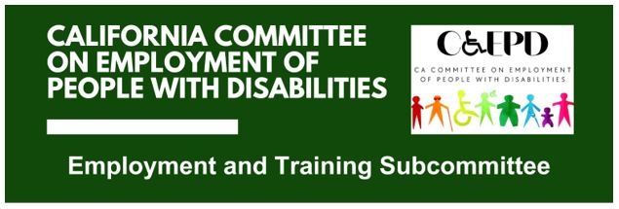

**MEETING MINUTES - DRAFT**

Tuesday, May 20, 2025

*Meeting held through Zoom and in person at the Department of Rehabilitation’s Central Office.*

*This meeting was being held via teleconference within the meaning of Government Code Section 11123.5.*

**Subcommittee Members:** Kathleen Alonzo (Virtual), Stephanie Crist (Virtual), Jennifer Fischer (Virtual), Harrison Lane (Virtual), Tania Morawiec (Virtual), Sandee Nieves (Virtual), Kayla Prusia (Virtual), Paula Tobler (Virtual)

1. **Welcome and Introductions**

Chair Lane called the meeting to order at 2:04 p.m. and a quorum was established.

1. **Approval of April Meeting Minutes**

Motion/second (Crist/Fischer) to approve. Motion passed on an 7-0-0 vote. (Yes – 7: Alonzo, Crist, Fischer, Lane, Nieves, Prusia, Tobler), (No – 0), (Abstain – 0)

1. **Presentation on Paid Internship Program (PIP)**

Member Crist of the Department of Developmental Services provided an overview of PIP.

PIPs in Practice

* Provides access to new paid employment opportunities and supports the transition to competitive integrated employment
* Goal for the internship to lead to direct hire but is not required
* The skills learned at the internship can be applied to another business or position
* Through the PIP, DDS funds wages and employer-related costs for up to 1,040 hours per year, per internship
* A PIP does not need to be through an employment vendor

Uses for PIPs

* To demonstrate the skills of the intern to a prospective employer
* To build out a resume so the individual can get the job they want
* To support someone pursuing self-employment or a microenterprise
* To gain skills needed to pursue self-employment or a microenterprise

Numbers

* Fiscal Year 2022/23 saw 2,578 internships. However, the number of PIPs that turned into a ClE placement remains low.
* Only about 22% of internships were through supported employment, meaning 78% of internships were supported through alternate services.

1. **Discussion on PIP and Job Coaching Project**

Members raised the following issues regarding PIP and job coaching:

* There should be more understanding of the levels of job coaching, including PIP and other services.
* More training is needed for job coaches.
* Retention is a large issue for job coaches, largely due to low pay.
* Career pathways for job coaches could be explored.
* Job coaching trainings and resources of other states should be researched.

Members stated more information on these issues should be researched for discussion at the next subcommittee meeting.

1. **Overview of California State Budget’s May Revision**

CCEPD Executive Officer Maria Aliferis-Gjerde provided a high-level overview of the California State Budget May Revision, as it relates to the employment of people with disabilities and support services.

1. **Update on Subcommittee Priorities**

* Federal and State Updates (Zak Ford)
  + Continue to monitor, changes are happening daily and weekly.
  + As reported previously, state workers will be coming into the office four days a week starting in July and details for various departments are currently being finalized.
* Member Roundtable Reports
  + EDD (Fischer) reported that workforce development board co-enrollment funding will begin in August for EDD and DOR collaboration.
  + SETA (Megan Alford) reported they are a recipient of co-enrollment funding.

1. **Agenda Items for Future Meetings**

Other than items raised in the PIP and job coaching discussion, no additional topics were raised.

1. **Public Comment**

There were no public comments.

1. **Adjourn**

The meeting adjourned at 3:24 p.m.