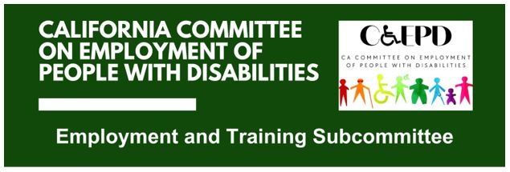

**MEETING MINUTES - DRAFT**

Tuesday, June 17, 2025

*Meeting held through Zoom and in person at the Department of Rehabilitation’s Central Office.*

*This meeting was being held via teleconference within the meaning of Government Code Section 11123.5.*

**Subcommittee Members:** Kathleen Alonzo (Virtual), Stephanie Crist (Virtual), Alan Cruz (Virtual), James Hill (Virtual), Harrison Lane (Virtual), Michelle O’Camb (Virtual), and Kayla Prusia (Virtual)

1. **Welcome and Introductions**

Chair Lane called the meeting to order at 2:06 p.m. and a quorum was established.

1. **Approval of May Meeting Minutes**

Motion/second (Prusia/Alonzo) to approve the meeting minutes. Motion passed on a 3-0-2 vote. (Yes – 3: Alonzo, Lane, Prusia), (No – 0), (Abstain – 2: Hill, O’Camb)

1. **Discussion on Job Coaching Project**

CCEPD staff member Zak Ford provided a brief update on discussions regarding work on an online job coaching resource for employers. While the project is still being pursued, finding financial and staff resources to complete the project has been a challenge. The CCEPD is exploring possibilities.

For the policy discussions on job coaching training, Ford shared what he found for Minnesota, Oregon, and New York. Oregon’s “Introduction to Supported Employment” was the most comprehensive of what he found, which is a 64-hour training curriculum with eight modules.

Members expressed interest in a potential presentation from Oregon staff in the next meeting.

Additionally, CCEPD staff will reach out to other California state departments on the potential online job coaching resource for employers.

1. **CCEPD Business Association Outreach**

CCEPD Executive Officer Maria Aliferis-Gjerde provided a brief overview of the CCEPD’s business association outreach project.

In the last two CCEPD Full Committee meetings, members expressed interest in outreach to business associations for industries that employ high numbers of people with disabilities. Employment data has been explored, and associations have been identified. Outreach will begin shortly.

1. **Update on Subcommittee Priorities**

* Federal and State Updates (Zak Ford and Maria Aliferis-Gjerde)
  + The state and federal budgets are being finalized. There will be more clarity on impacts by the August meeting.
* Member Roundtable Reports
  + SETA (O’Camb) reported they are monitoring the WIOA reauthorization.
  + DDS (Crist) reported they have developed a new [webpage with an employer focus](https://www.dds.ca.gov/services/for-businesses-and-employers/).
  + EDD (Brandon Anderson) reported funding is being awarded for EDD and DOR collaboration efforts focused on capacity building. More information will be available in August.

1. **Agenda Items for Future Meetings**

In addition to standing items, CCEPD staff will pursue a presentation from Oregon state staff on the Introduction to Supported Employment (ISE) training for the August meeting. Due to YLF, the subcommittee will not meet in July.

1. **Public Comment**

Shi Spiker gave a brief overview of their work with individualized placements and supports, and thanked members for the opportunity to attend.

1. **Adjourn**

The meeting adjourned at 3:37 p.m.