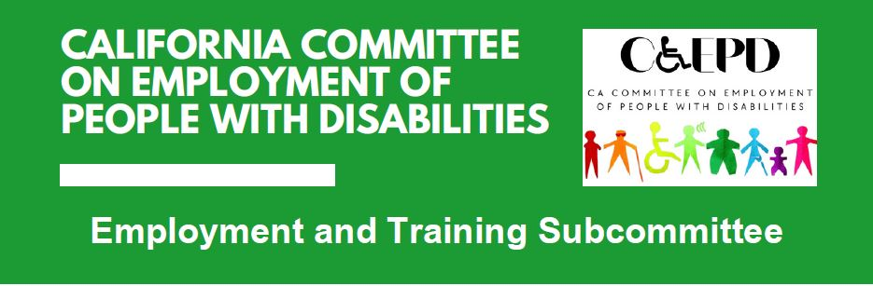

**MEETING MINUTES – DRAFT**

Tuesday, October 15, 2024

*Meeting held through Zoom and in person at the Department of Rehabilitation’s Central Office.*

*This meeting was being held via teleconference within the meaning of Government Code Section 11123.5.*

**Subcommittee Members:** Michael Clay (Virtual), Anisa Escobedo (Virtual), James Hill (Virtual), Harrison Lane (Virtual), Tania Morawiec (Virtual), Michelle O’Camb (Virtual), Paula Tobler (Virtual), Sarah Turner (Virtual- technical problem with camera)

**Members of the public:** Suad Bisogno (Virtual), Brent Mikulski (Virtual), Kayla Prusia (Virtual)

1. **Welcome and Introductions**

The meeting began at 2:03 p.m. and a quorum was established.

1. **Approval of September Meeting Minutes**

Motion/second (Clay/Lane) to approve. Motion passed on 7-0-0 vote. (Yes – 7: Clay, Hill, Lane, Morawiec, O’Camb, Tobler, Turner), (No – 0), (Abstain – 0)

1. **Discussion on Business Engagement and Job Coaching**

CCEPD staff member Zak Ford provided an overview of prior discussions on business engagement and how they have evolved into the topic of job coaching.

Ford asked members who the focused target group should be for this project – employees, job coaches, and/or employers. Members felt although all three groups should find it helpful, it should primarily be targeted towards supporting employers throughout the job coaching process.

Ford reminded members of a document he previously provided of online job coaching resources and requested members forward him any new resources they know of that might be useful as the CCEPD’s work product is developed.

Members provided the following insights for a job coaching project:

* There is not currently a substantial online tool on job coaching to assist employers.
* There are a few outdated videos online about the topic.
* A collection of short two-minute videos on various aspects of job coaching with corresponding information would be ideal.
* Information would cover expectations for all involved.
* There are agencies assisting with employment and job coaching that do not have adequate training.
* More consistency of job coaching information is needed.
* Members agree this is needed in relation to accommodations and job coaches.
* Funding is needed to create high quality content.
* There can be focus on pre-employment but there must also be focus on the person keeping the job and developing as an employee.
* Member Lane has done some in-person job coaching training. There needs to be better communication between the coach, the employer, and the employee.
* Having more business representation would help the subcommittee provide better legitimacy on the issue.

Members agreed job coaching would be a good project for the subcommittee to work on. The CCEPD staff will schedule some initial individual meetings on the topic and draft a briefing document for the next subcommittee meeting that will include an overview of the project, goals, and a timeline. This project may also include policy recommendations.

1. **Follow-up Discussion on Other 2024 Subcommittee Priorities**

Staff member Ford provided the bellow updates:

* Master Plan for Developmental Services
  + Continuing to hold regional meetings where the five workgroups work on their topics and solicit input.
    - Workgroup 1 (Person-centered)
    - Workgroup 2 (Service Systems)
    - Workgroup 3 (Workforce)
    - Workgroup 4 (Data and Outcomes)
    - Workgroup 5 (Lifelong Services)
  + Next is online only – November 6, 10 am – 3 pm
* Master Plan for Career Education
  + No updates since last meeting
  + Executive Order had completion date of October 1, but there have been no updates on when it will be released
  + CWPJAC has been stagnant since April
  + Will continue to monitor
* Local and Regional Workforce Plan Guidance
  + Submitted comment letter last week
  + Letter was among meeting documents for informational purposes
  + Will continue to monitor, review for what was incorporated, then review local and regional plans once developed next year

1. **Agenda Items for Future Meetings**

The following topics were raised.

* Job coaching
* Master Plan for Developmental Services
* Master Plan for Career Technical Education
* WIOA activities and reauthorization
* Bringing employers to this subcommittee

1. **Public Comment**

CCEPD member Anisa Escobedo announced the State Independent Living Council (SILC) has elected new officers and she will be vice chair. She will also continue to work with the CCEPD as the SILC representative.

1. **Adjourn**

The meeting adjourned at 2:52 p.m.