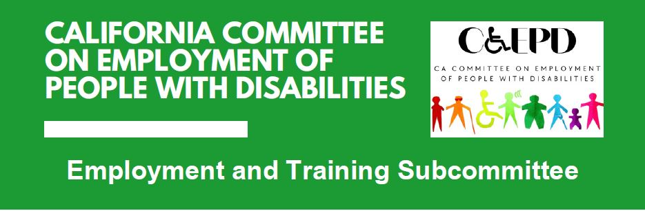

**MEETING MINUTES – DRAFT**

Tuesday, January 21, 2025

*Meeting held through Zoom and in person at the Department of Rehabilitation’s Central Office.*

*This meeting was being held via teleconference within the meaning of Government Code Section 11123.5.*

**Subcommittee Members:** Stephanie Crist (Virtual), Jennifer Fischer (Virtual), Harrison Lane (Virtual), Tania Morawiec (Virtual, technical issues), Sandee Nieves (Virtual), Michelle O’Camb (Virtual), Paula Tobler (Virtual), Sarah Turner (Virtual, potential problem with camera)

**Members of the public:** Brent Mikulski (Virtual), Kayla Prusia (Virtual), Brandon Anderson (Virtual)

1. **Welcome and Introductions**

The meeting began at 2:04 p.m. and a quorum was established.

1. **Approval of October Meeting Minutes**

Motion/second (Tobler/Turner) to approve. Motion passed on 7-0-0 vote. (Yes – 7: Crist, Lane, Morawiec, Nieves, O’Camb, Tobler, Turner), (No – 0), (Abstain – 0)

1. **Discussion on Job Coaching Project and Agreement of Goals**

CCEPD staff member Zak Ford referenced he had sent a document to members the prior week that includes many online job coaching resources. They were not reviewed in the meeting, but the document will be continuously updated to assist with this project. If members find additional resources, he asked that members please forward them to him.

A briefing document was shared which provided an overview of the CCEPD’s potential job coaching project, including goals and a timeline. Members provided input on how job coaching should be presented for employers. While job coaching can be an accommodation, members felt this project should focus on presenting job coaching best practices. Members agreed on the proposed goals and timeline of the project.

Additionally, members brainstormed potential employer partners for the project and will work on outreach to recruit their participation.

1. **Update on Subcommittee Priorities**

* Master Plan for Developmental Services
  + Still holding regional full committee meetings in various regions, as well as committee workgroups. Plan to be complete in spring. Unsure of public release.
* Master Plan for Career Education
  + Framework was released last month and calls for a coordinated, universal design approach through six primary areas of action:
    - Create a State Planning and Coordinating Body
    - Strengthen Regional Coordination
    - Support Skills-Based Hiring Through a Career Passport
    - Develop Career Pathways for High School and College Students
    - Strengthen Workforce Training for Young People and Adults
    - Increase Access to and Affordability of Education and Workforce Training
  + Final Master Plan should be released early this year and the CCEPD will continue to follow developments.
  + CCEPD is also following the CWPJAC which oversees development of the Perkins Plan and original California Plan for Career Technical Education. They did not reference the Master Plan in their November meeting.
* Regional Investment Initiative Plans
  + Through Governor’s California Jobs First Regional Investment Initiative, there have been 13 regional plans developed.
  + CCEPD is unsure how they will align with upcoming WIOA regional and local plans. CCEPD saw very little reference to WIOA activities through local boards and AJCCs. They seemed more like regional workforce environmental scans and high-level recommendations than any service implementation strategies.
  + CCEPD will continue to follow developments.
* Local and Regional Workforce Plan Guidance
  + Overall, the CCEPD was pleased to see many recommendations incorporated into the guidance.

1. **Agenda Items for Future Meetings**

In addition to most of the above priority items, members raised the following as potential future agenda items.

* Subcommittee chair
* DOR/EDD collaboration
* Federal and state updates

1. **Public Comment**

There were no public comments.

1. **Adjourn**

The meeting adjourned at 3:33 p.m.