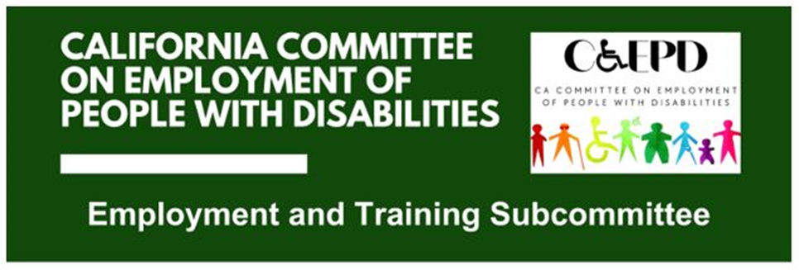

**MEETING MINUTES – DRAFT**

Tuesday, February 18, 2025

*Meeting held through Zoom and in person at the Department of Rehabilitation’s Central Office.*

*This meeting was being held via teleconference within the meaning of Government Code Section 11123.5.*

**Subcommittee Members:** Kathleen Alonzo (Virtual), Stephanie Crist (Virtual), Anisa Escobedo (Virtual), Jennifer Fischer (Virtual), Harrison Lane (Virtual), Sandee Nieves (Virtual), Michelle O’Camb (Virtual), Paula Tobler (Virtual - experiencing technical difficulties), Sarah Turner (Virtual)

**Members of the public:** James Hill, (Virtual), Danny Marquez (Virtual)

Suad Bisogno (Virtual)

1. **Welcome and Introductions**

The meeting began at 2:04 p.m. and a quorum was established. CCEPD staff member Zak Ford announced that Harrison Lane has taken the position of chair of this committee and will facilitate the rest of the meeting.

1. **Approval of January Meeting Minutes**

Motion/second (Escobedo/Tobler) to approve. Motion passed on 7-0-2 vote. (Yes – 7: Crist, Escobedo, Lane, Nieves, O’Camb, Tobler, Turner), (No – 0), (Abstain – 2, Alonzo, Fischer)

1. **Discussion on Job Coaching Project and Employer Outreach**

Chair Lane introduced the topic and passed it on to Ford to provide CCEPD outreach updates.

Ford informed members he and Executive Officer Maria Aliferis-Gjerde have met with DOR’s Policy and Performance section, who introduced them to a couple potential partners. They have been in contact with service provider East Bay Innovations, who are a potential presenter for the March meeting, along with two of their employer partners. They have yet to hear back from the other.

Members shared of their employer outreach and among members, six employers have currently committed to aiding with the job coaching project. Additional member outreach will continue to increase the number of employer partners.

Members discussed potential questions that should be asked of employers. Ford will compile questions and send them to members for any additional input next week.

Ford reported that once the list of questions has been finalized by members, he will begin work to schedule outreach meetings with employers and members to collect responses and gain additional insights. He would like to begin making scheduling requests next week.

1. **Update on Subcommittee Priorities**

Chair Lane introduced the agenda item and passed it on to Ford and Aliferis-Gjerde to report out.

Master Plan for Career Education (Ford)

* Framework for the plan was released in December. The full plan should be released soon.
* The state budget has funding for some areas of the Master Plan on Career Education.
  + $100 million one-time Proposition 98 General Fund for California Community Colleges (CCCs) to expand Credit for Prior Learning and begin building the infrastructure for the state’s first “Career Passport.”
  + $5 million ongoing General Fund for the Government Operations Agency to establish a state planning and coordinating body for TK-12 education, higher education, and state economic and labor agencies, to improve forecasting of needed skills and coordination of resources and initiatives across state government in alignment with recommendations from the Master Plan for Career Education.
  + Regional Coordination for Career Education and Training—$4 million one-time General Fund for the Labor and Workforce Development Agency to evaluate how regional coordination models can be expanded to create sustainable forums where educators, workforce training providers, and employers can work to align programs with employer needs. Additionally, this work will be aligned with the State Economic Blueprint and 13 regional plans.
* The CCEPD will continue to monitor efforts.

Regional Investment Initiative Plans (Ford)

* The CCEPD created a plan for review. We plan to review the 13 regional plans in March and concentrate on sectors, equity (specifically regarding disability), and strategies.
* We believe this review will help us in finding overlap with local/regional WIOA plans when they are developed.
* We will report out on high-level findings in the next subcommittee meetings.

Master Plan for Developmental Services (Aliferis-Gjerde)

* Meetings have been held monthly. We have been monitoring efforts.
* The state budget referenced that the Master Plan on Developmental Services will be released in March. We plan to read and discuss once the master plan has been released.

EDD/DOR Collaboration (Aliferis-Gjerde)

* There are no new developments to report.

Federal and State Updates (Aliferis-Gjerde)

* This was created for members to share information on various federal and state items.
* Items, especially on the federal level, are moving quickly. Items impacting people with disabilities will continue to be followed.
* Stephanie Crist of Department of Developmental Services (DDS) shared about the Paid Internship Program (PIP) and the topic could potentially be presented at a future meeting.
* DB101 was mentioned and it seems they received some funding resulting from the benefits report.

Subcommittee Membership (Aliferis-Gjerde)

* After the last month’s meeting, the CCEPD reached out to DOR for a representative. Kathleen Alonzo will be representing DOR.
* Members did not express a need for additional subcommittee representation.

1. **Agenda Items for Future Meetings**

Members raised the possibility of a presentation from DDS on PIP, and revisiting the topic of self-employment once the job coaching project is complete.

Additionally, it was announced the CCEPD’s Full Committee Meeting will be held on Thursday, February 27, 2025.

1. **Public Comment**

Danny Marquez of CASRA encouraged members to get involved in advocacy at the federal level however possible.

1. **Adjourn**

The meeting adjourned at 3:30 p.m.