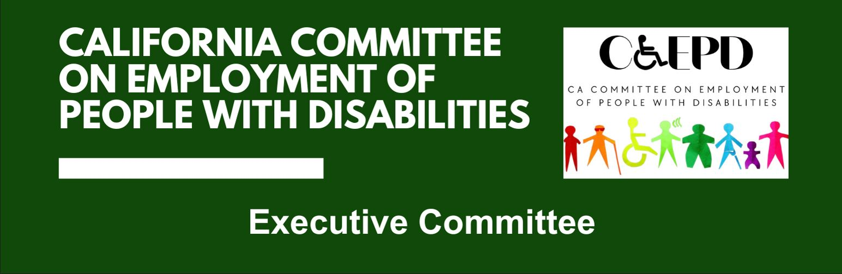

**California Committee on Employment of People with Disabilities (CCEPD)**

**Executive Committee Meeting Minutes- DRAFT**

April 4, 2025

**CCEPD Member:** Jennifer Fischer (Virtual), Roy Kim (Virtual), Harrison Lane (Virtual), and Taylor Winchell (Virtual)

1. **Welcome and Introductions**

The meeting began at 2:01 p.m. and quorum was established.

1. **Approval January 2025, Executive Committee Meeting Minutes**

It was moved/seconded (Kim/Fischer) to approve the January meeting minutes. Motion was approved by a 4-0-0 vote. (Yes – 4, Fischer, Kim, Lane, Winchell); (No – 0); (Abstain – 0).

1. **Approval of May 2025 Full Committee Meeting Topics**

Executive Officer Maria Aliferis-Gjerde shared the topics for discussions:

* Discussion on whether the May or August meeting should be held in person. Members agreed that a survey will depend on their preference.
* Agreed that Director of Department of Developmental Services be invited and a focus on the Master Plan on Developmental Services be topic areas for meeting.
* Discussed goals and strategies and proposed policy goals. Members will further discuss these strategies and goals in May.
* Reframe conversations
* Raise awareness of support services for people with disabilities
* Increase outreach to employers

There was a discussion on which California industry associations to be invited. Document included chart on occupational information and using information to link to various industries. Some of the following industry associations were referenced:

* California Restaurant Association
* California Association of Hospitals and Health Systems
* California Association of Health Facilities
* California Assisted Living Association
* California Realtors Association
* California Hotel and Lodging Association

Feedback was the California Chamber of Commerce and small business associations should be included; occupational data should include total number employed and percentages of people with disabilities employed in occupation.

Members can assist with connections to a couple of industry associations and agreed with approach to the discussion.

1. **Member Updates**

Chair Winchell asked members if there was anything they would like to share at this time.

* DOR/EDD Collaboration Project will be ready to share information in August
* Federal updates are being monitored to see what will be impacted.
* Administration for Community Living is being eliminated.
* Impacts on local workforce development areas, depending on federal cuts.

1. **Project Updates**

Executive Officer provided the updates for ongoing projects:

* Benefits planning report – Meetings occurred with Disability Rights California and California Foundation for Independent Living Centers.

Subcommittee updates:

* Employment and training met with six businesses to help develop a website with training videos for job coaching.
* Zak Ford has been looking at the Regional Investment Initiative Plan for sector strategies and recommendations on diversity and equity so we can be aware of conversations being held.
* Youth Programming Subcommittee was moved to May due to the statewide YLF activities.
* State Coordination Subcommittee is still on hold until there is agreement on our goals and strategies.

Other updates:

* Master Plan on Developmental Services was released last Friday. The Employment and Training Subcommittee will review the plan.
* Master Plan on Career Education was also released and we will continue to follow it.
* A report on homelessness was recently released and will be reviewed to see how it includes strategies on people with disabilities.
* There will be outreach for a representative with a disability on the committee.
* There is an executive order for state workers to be in office four days a week starting July 1. Any meetings such as this one could be moved to possible Monday afternoons since Fridays will be our telework day.
* Meetings can still be held virtually for now.

YLF Project Manager provided the following updates:

* Delegate selection is happening now with the plan to select between 50-60 students. There were more applications this year than last again.
* Staff interviews are just starting, and we are focusing on new staff. There were over 100 applicants also.
* Budget is estimated at $342,454.40. Some responses for funding have not yet come in. Private donors have been making commitments including Anthem who is donating at a higher rate than previously.
* The risk management plan was overhauled and a new Incident reporting system was developed for both staff and delegates, as well as expectations of each.
* Currently, programming activities and workbooks are being updated, using feedback from last year.
* CCEPD mentoring luncheon will be scheduled for Wednesday, July 16, from 11:30 a.m. to 2:30 p.m.. More formal information will be out in a few weeks.
* Regional YLF updates:
  + San Diego is still planning to host an event later this year.
  + Sacramento will have an event in October for the third year.
  + Los Angeles is paused.

1. **Agenda Items for Future Meetings**

Benefits Planning Recommendations – are there any results from that effort yet or is there further work needed? There have not yet been any results.

**7) Public Comment**

There was a public comment about the stated department services and personal experience seeking assistance as a self-employed consultant. Questions were asked about department policy that contradicts the stated self-employment policy and do counselors receive proper training on the services they provide.

When this committee receives these types of comments they are referred to the proper person for response.

**8) Adjournment**

The meeting adjourned at 2:58 p.m.