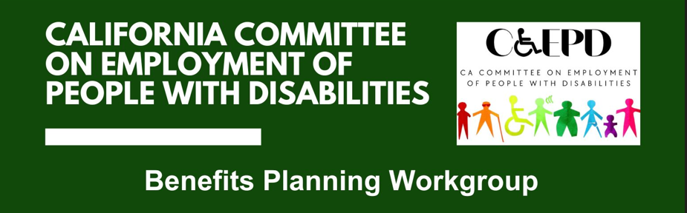

MEETING MINUTES - DRAFT
Tuesday, October 28, 2025

Workgroup Members: Shannon Coe (Virtual), Stephanie Crist (Virtual), Jennifer Fischer (Virtual), Ashneek Nanua (Virtual), Jessica Popjevalo (In-Person), Scarlett VonThenen (Virtual), Taylor Winchell (Virtual)

CCEPD Staff Members: Maria Aliferis-Gjerde (Virtual) and Zak Ford (In-Person)

- Welcome and Introductions 2:00 p.m.
Chair Winchell called the meeting to order at 2:06 p.m.

- Overview of Prior Benefits Planning Workgroup Work
CCEPD Executive Officer Aliferis-Gjerde provided an overview of prior Benefits Planning Workgroup work.

Between April of 2023 and July of 2024, the CCEPD facilitated meetings to create a comprehensive report on benefits planning needs for people with disabilities in California. The report made policy recommendations to the California Health and Human Services and Labor and Workforce Developmental Agency Secretaries in the following four areas:
- Collaboration with the Social Security Administration
- Development of a consistent benefits planning infrastructure in California
- Changes to health care policy
- Changes to the long-term service and supports policy

For this re-establishment of the workgroup, the CCEPD plans to hold four meetings that will result in a comment letter regarding the new Department of Developmental Services (DDS) Benefits Counseling Project. This fits into developing a consistent benefits planning infrastructure in California, as recommended in the report.

- Overview and Background of New Department of Developmental Services (DDS) Benefits Counseling Project
Stephanie Crist, the Assistant Chief of the Employment Development Section-Employment Services Branch at DDS, provided a background and overview of the new benefits planning project.

DDS is working to make employment more attainable for people with intellectual and developmental disabilities. Benefits planning is an important part of reaching this goal. Currently, they are in the information gathering phase and hoping to gather relevant information from the CCEPD Benefits Planning Workgroup on developing a tiered approach benefits planning proposal for Regional Centers.

Some aspects of the proposal will be:
- Supports included for each tier
- Training recommendations for each tier
- Minimum qualifications for each tier
- Number of hours and duration of supports for each tier
- Discussion on New Department of Developmental Services Benefits Counseling Project
Crist facilitated discussion with workgroup members, soliciting input on the following initial two questions.
- How many tiers should there be and how should the tiers be separated/determined?
- What services should be included in each tier?

Members provided the following input.
- Benefits Planning Tier 1
  - Can be provided in group setting.
  - An introduction to benefits planning to address fears, dispel myths, and present possible options of maintaining benefits while working.
  - Provide an overview of what is involved in full benefits counselling, including what information/documentation you will need and the different milestones.
  - Provide high-level information on existing programs like Ticket-to-Work and CalABLE.
  - Services are an opt-out model for transition-aged individuals starting at age 16.
- Benefits Planning Tier 2
  - Services are 1:1
  - Person-centered benefits counselling service prioritizing the long-term goals of the individual.
  - Traditional assessment of all benefits, including other public benefits such as Section 8, CalFRESH, etc.
  - Services also cover reviewing and navigating employer-sponsored benefits and how they interact with benefits.
  - Services shall become available for an individual at any major life event, including but not limited to, promotion, job change, marriage, birth of a child, moving, and retirement.
  - Provide supports for overpayment notices.
  - Coordination with service coordinator and the rest of the support team to identify what services are available and appropriate to supplement a loss of public benefits.
- Financial Empowerment Training
  - Provided in a group setting.
  - Curriculum on budgeting, saving and planning for the future, CalABLE accounts, etc.
  - Utilize existing curriculum from Easter Seals, California Capital, AARP, etc.
- Explore peer mentorship component

For the next meeting, Crist will further develop what was discussed in today’s meeting and solicit input on new questions relating to the project’s development.

- Member Roundtable Reports
No reports were given.
- Agenda Items for Future Meetings
No new items were raised.

- Public Comment
There were no public comments.

- Adjourn
The meeting adjourned at 3:47 p.m.

