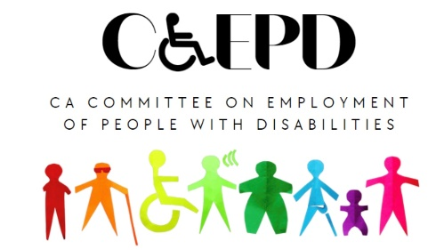

CCEPD Employment and Training Subcommittee
MEETING NOTICE AND AGENDA
Tuesday, April 16, 2024
2:00 – 4:00 p.m.

Public Participation Options
In-Person: Department of Rehabilitation Central Office, 721 Capitol Mall Room 401, Sacramento, CA 95814

Video Conference Link: Zoom
Meeting ID: 885 1188 5098
Passcode: h6Ww$6Pi

Teleconference: (408) 638-0968
Meeting ID: 885 1188 5098
Passcode: 42620272

To access the teleconference via the California Relay Service, Dial 711

This meeting is being held via teleconference within the meaning of Government Code Section 11123.5.

- Welcome and Introductions 2:00 p.m.
Zak Ford, CCEPD Staff
- Approval of March Meeting Minutes
Zak Ford, CCEPD Staff
- Update on DOR’s Disability Access Services Trainings
Monica Handley, DAS Chief Deputy Director
Melissa Langley, DAS Training Project Manager

- Follow-up Discussion on 2024 Subcommittee Priorities
Maria Aliferis-Gjerde, Executive Officer, CCEPD
Zak Ford, CCEPD Staff
- Master Plan for Career Education and discussion on concepts
- Best Practices Work
- Self-Employment
- DOL’s Disability Inclusion in Very Small Businesses Online Dialogue
- Agenda Items for Future Meetings
Zak Ford, CCEPD Staff

- Public Comment
Zak Ford, CCEPD Staff

- Adjourn* 4:00 p.m.
Zak Ford, CCEPD Staff

* The meeting will adjourn upon completion of agenda.

MEETING MATERIALS: This meeting notice and agenda and other supplemental materials may also be accessed on the website, located on the Advisory Committee Calendar. All times indicated, and the order of business is approximate and subject to change on the day of the noticed meeting. The meeting will adjourn upon completion of the agenda. Interested members of the public may use the teleconference number and video conference link provided to listen to the meeting and/or provide public comment. The CCEPD is not responsible for unforeseen technical difficulties that may occur and is not obligated to postpone or delay its meeting in the event of unforeseen technical difficulties with the teleconference line and video conference.

PUBLIC COMMENT: Public comments on matters not on the agenda is taken at the end of the meeting and members of public can make comments on agenda items prior to any vote of the committee. Depending on the number of individuals wishing to address the committee, public comment may be limited to three minutes per person. Non-English speakers who utilize translators to make public comment will be allotted no more than six minutes unless they utilize simultaneous translation equipment. If you are unable to attend the meeting and wish to submit public comment, please send them to CCEPD@dor.ca.gov five days prior to the meeting. The CCEPD is precluded from discussing matters not on the agenda; however, CCEPD members may ask questions for clarification purposes.

REASONABLE ACCOMMODATIONS: If you require a disability-related accommodation, materials in alternate format or auxiliary aids/services, please email Margaret.Balistreri@dor.ca.gov five days prior to the meeting. Any requests received after this date will be given consideration, but logistical constraints may not allow for their fulfillment.

