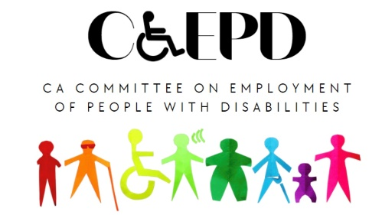

**CCEPD Employment and Training Subcommittee**

**MEETING MINUTES – DRAFT**

Tuesday, June 18, 2024

*Meeting held through Zoom and in person at the Department of Rehabilitation’s Central Office.*

*This meeting was being held via teleconference within the meaning of Government Code Section 11123.5.*

**Subcommittee Members:** Michael Clay (Virtual), Harrison Lane (Virtual), Tania Morawiec (Virtual), Michelle O’Camb (Virtual), Sandee Nieves (Virtual), Paula Tobler (Virtual), Sarah Turner (Virtual)

1. **Welcome and Introductions**

The meeting began at 2:04 p.m. and a quorum was established.

1. **Approval of May Meeting Minutes**

Motion/second (Clay/Nieves) to approve. Motion passed on 3-0-2 vote. (Yes – 3: Moraweic, Nieves, Turner), (No – 0), Abstain – 2: Clay, Tobler)

1. **Discussion on Master Plan for Developmental Services and Next Steps**

CCEPD Executive Officer Maria Aliferis-Gjerde shared a PowerPoint presentation on recent developments with the Master Plan for Developmental Services. She solicited input from members on potential CCEPD recommendations for the five workgroups recently established based on the plan developers’ “Vision of Success” areas.

* Group 1: Individuals and families experience person-centered service systems they trust.
* Group 2: Individuals receive timely, inclusive, and seamless services across all service systems.
* Group 3: Individuals and their families receive services from a high-quality, stable and person-centered workforce.
* Group 4: Individuals and their families experience consistent, transparent, accountable and data-driven systems that focus on outcomes.
* Group 5: Individuals are entitled to life-long services with adequate resources.

Member comments centered around improved exposure to work incentives early, co-enrollment strategies, including the Department of Developmental Services and Regional Centers in workforce discussions, benefits planning, and clearer employment outcome data.

CCEPD staff will develop a initial comment letter for the plan based on this meeting’s input.

The next Master Plan for Developmental Services Committee Meeting will be held on August 21 in Sacramento. There will be a virtual participation option.

1. **Discussion on Master Plan for Career Education and Next Steps**

CCEPD staff member Zak Ford reported on recent developments.

Ford reminded members a virtual engagement session was held on May 15 where participants discussed the preliminary concepts of the Master Plan for Career Education. CCEPD staff attended and provided the following recommendations to the core concepts:

* System alignment with organizations addressing the needs of students with disabilities
* More outreach for inclusion of students with disabilities
* Access and accommodations for work-based learning for students with disabilities
* Incentivizing work for students with disabilities through providing benefits planning information

Developers of the plan are currently forming five constituency workgroups. Workgroup applications will be accepted through June 21 with the plan to announce memberships in July.

This will remain a standing agenda item.

1. **Follow-up Discussion on Other 2024 Subcommittee Priorities**

Members provided high-level insights on next steps for business engagement. They would like to receive a presentation on business engagement from a business advisory council or business.

It was agreed upon that business engagement should be a focus of the subcommittee prior to addressing any universal design discussions, another interest of members.

1. **Agenda Items for Future Meetings**

In addition to standing agenda items on the Master Plan for Developmental Services and the Master Plan for Career Education, members requested a presentation on business engagement. Additionally, it was noted that any new Workforce Innovation and Opportunity Act (WIOA) or State Budget developments should be followed.

1. **Public Comment**

There were no public comments.

1. **Adjourn**

The meeting adjourned at approximately 3:30 p.m.