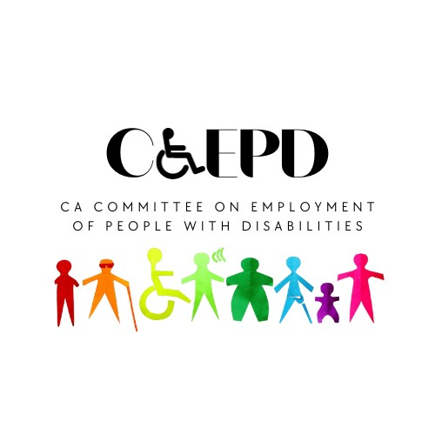
CCEPD Executive Committee Meeting Notice and Agenda
Friday, April 12, 2024
2:00-3:30 p.m.

Public Participation Options
In-Person: Department of Rehabilitation Central Office, 721 Capitol Mall, Room 607, Sacramento, CA 95814

Video Conference Link: Zoom
Use Meeting ID: 845 4188 4454 and Passcode: vJY1K0S!

Teleconference Number: (408) 638-0968
Use Passcode: 04513238

This meeting is being held via teleconference within the meaning of Government Code Section 11123.5.

Meeting Agenda

- Welcome and Introductions
Taylor Winchell, Chair, CCEPD

- Approval of January 2024 Executive Committee Meeting Minutes
Taylor Winchell, Chair, CCEPD

- Approval of May 2024 Full Committee Meeting Topics
Maria Aliferis-Gjerde, Executive Officer, CCEPD

- Approval of Meeting Rules Document
Maria Aliferis-Gjerde, Executive Officer, CCEPD

- Project Updates
Maria Aliferis-Gjerde, Executive Officer, CCEPD

- Agenda Items for Future Meetings

- Public Comment

- Adjournment 3:30 p.m.*

* The meeting will adjourn upon completion of agenda.

MEETING MATERIALS: This meeting notice and agenda and other supplemental materials may also be accessed on the website, located on the Advisory Committee Calendar. All times indicated, and order of business are approximate and subject to change on the day of the noticed meeting. The meeting will adjourn upon completion of the agenda. Interested members of the public may use the teleconference number provided to listen to the meeting and/or provide public comment. The CCEPD is not responsible for unforeseen technical difficulties that may occur and is not obligated to postpone or delay its meeting in the event of unforeseen technical difficulties with the teleconference line.

PUBLIC COMMENT: Public comment on matters not on the agenda is taken at the end of the meeting and members of public can make comments on agenda items prior to any vote of the committee. Depending on the number of individuals wishing to address the committee, public comment may be limited to three minutes per person. Non-English speakers who utilize translators to make public comment will be allotted no more than six minutes, unless they utilize simultaneous translation equipment. The CCEPD is precluded from discussing matters not on the agenda; however, CCEPD members may ask questions for clarification purposes.

REASONABLE ACCOMMODATIONS: If you require a disability-related accommodation, materials in alternate format or auxiliary aids/services, please email Margaret.Balistreri@dor.ca.gov five days prior to the meeting. Any requests received after this date will be given consideration, but logistical constraints may not allow for their fulfillment.

