# Introduction

In late October 2018, the Department of Rehabilitation awarded, as well as finalized, the AT grant agreement to CFILC for 39 months, covering the time period of July 1, 2018 to September 30, 2021. This Assistive Technology Quarterly Report covers the reporting period of January 1st through March 31st, 2022. This report includes all the data elements outlined in the AT grant as well as by Section 4(f) of the AT Act for:

State Level Activities: Public Awareness, Information & Referral - typically referred to as Information and Assistance (I&A), Training, Technical Assistance;

State Level Activities: Device Demonstration, Device Loan, Device Reutilization, and State Financing;

As well as Disaster Management and Special Projects/Events.

This document is hyperlinked to assist in navigating its sections. Use the hyperlinks to move quickly across the document, which, when hovered over, contain a Screen tip to explain where they will take you once selected.

Section 1 - Truncated overview of this quarter’s grant deliverables.

Section 2 - Challenges met implementing this quarter’s grant deliverables and actionable Next Steps and Suggestions to address these challenges.

Section 3 - Appendix unpacking this quarter’s grant deliverables.

Section 4 - Glossary containing definitions and valuable information regarding the keywords used throughout the document.

Section 5 – Bibliography of utilized resources.

# Section 1 - Quarter 2 Outcomes – At-a-Glance View

## State Leadership Activities

### Public Awareness Activities: Jump to Public Awareness Appendix

**59 events, to 31,889 participants**

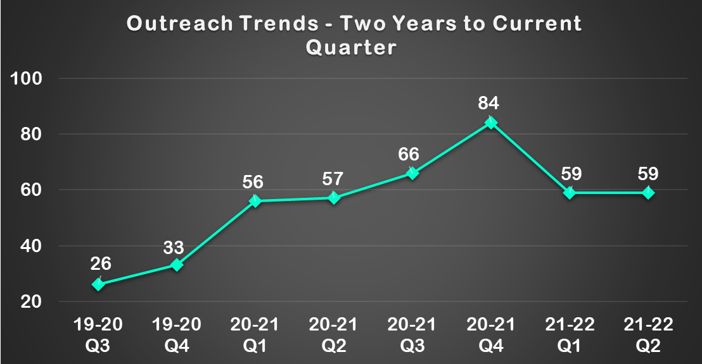

#### Social Media

**Facebook (+0.** **52 %)**

**Twitter (+5.7 %)**

**Instagram (+2.6 %)**

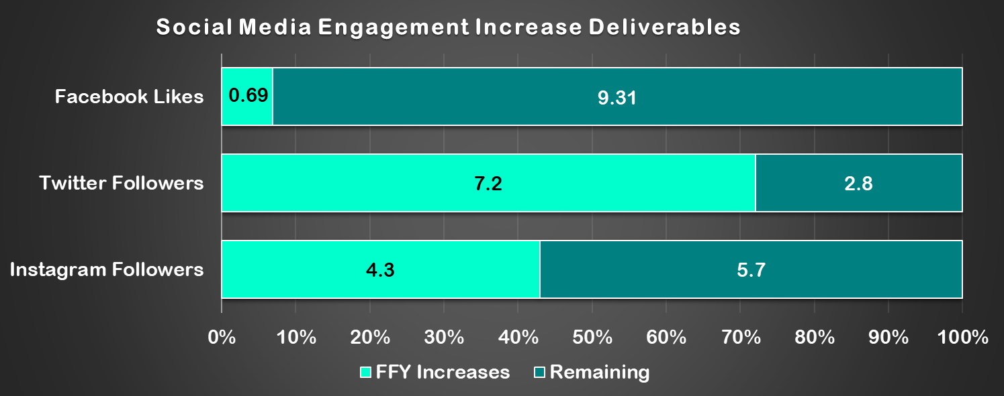

#### Articles

**Ability Tools was featured in two pieces of media from outside organizations.**

#### [Blogs](#_Blogs:_1" \o "Select to jump to the \"Blogs\" section of the Glossary.)

**The Ability Tools blog received 9,423 pageviews.**

**Ability Tools published no blogs this quarter.**

#### [Video Newsletters](#_Video_Newsletter:_1" \o "Select to jump to the \"Video Newsletters\" section of the Glossary.)

**No video newsletters were published.**

#### [Newsletters](#_Newsletters:_1" \o "Select to jump to the \"Newsletters\" section of the Glossary.)

**No newsletters were published.**

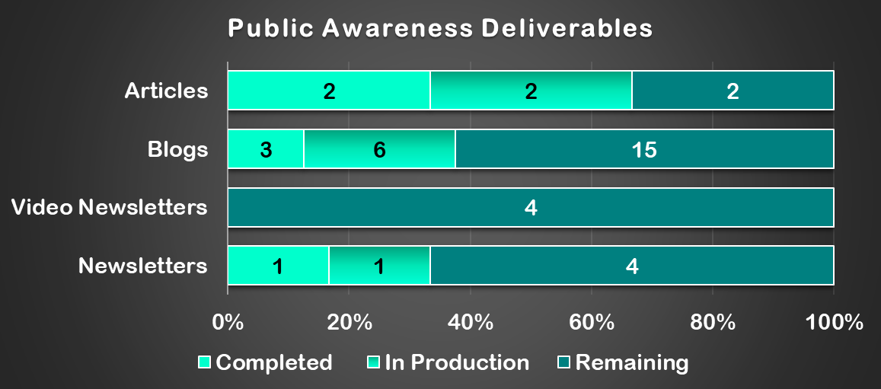

### [Information & Assistance (I&A)](#_Information_&_Referral:_2" \o "Select to jump to the \"Information & Referral\" section of the Glossary.): Jump to I&A Appendix

**239 activities to 283 participants**

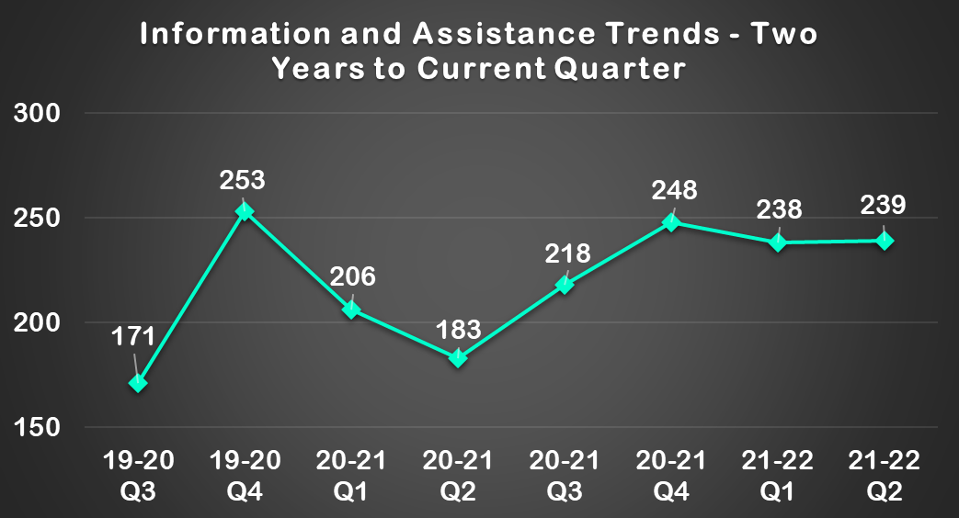

#### [Digital Access Project (DAP)](#_Digital_Access_Project:" \o "Select to jump to the \"Digital Access Project (DAP)\" section of the Glossary.)

**76 homes secured affordable broadband**

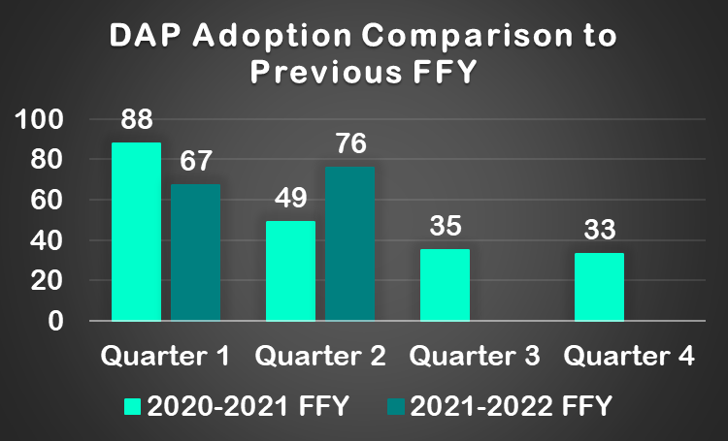

### Training: Jump to Training Appendix

**136 individuals participated in 5 training workshops**

#### [Regional Trainings](#_Regional" \o "Select to jump to the \"Regional Trainings\" section of the Glossary.)

**65 individuals participated in 3 training workshops**

#### AT 1.0 Trainings

**There were no AT 1.0 training workshops this quarter**

#### [AT 2.0 Trainings](#_AT_2.0" \o "Select to jump to the \"AT 2.0 Trainings\" section of the Glossary.)

**71 individuals participated in 2 training workshops**

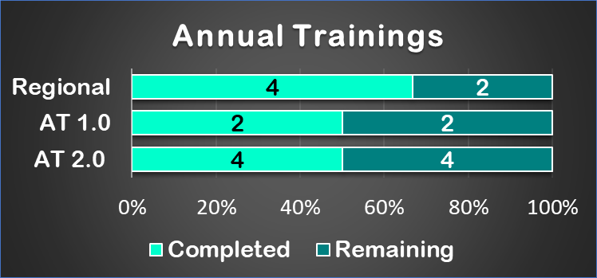

### Technical Assistance: Jump to Technical Assistance Appendix

**There were no actively ongoing Technical Assistance Activities this quarter.**

## State Level Activities

### Device Demonstration: Jump to Device Demonstration Appendix

#### 172 Device Demonstration activities performed to 204 participants

**Most consumers served during this quarter reported being satisfied or highly satisfied with the service, with the exception of three consumers being somewhat satisfied and one consumer being not at all satisfied.**

### Device Loan: Jump to Device Loan Appendix

#### 338 devices were loaned through 263 device loans

**With the exception of two consumers being not at all satisfied, all consumers reported being satisfied or highly satisfied with the service.**

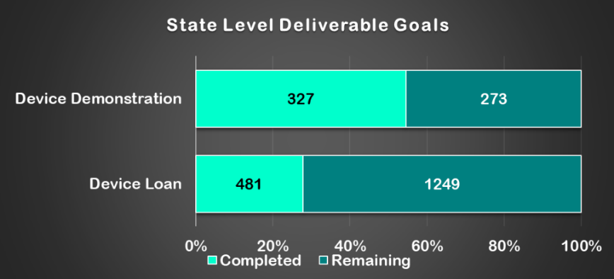

### [Device Reutilization](#_Device_Reutilization:" \o "Select to jump to the \"Device Reutilization\" section of the Glossary.): Jump to Device Reutilization Appendix

#### 622 reutilization devices were distributed through 458 reutilization activities.

**All consumers reported being satisfied or highly satisfied with the service.**

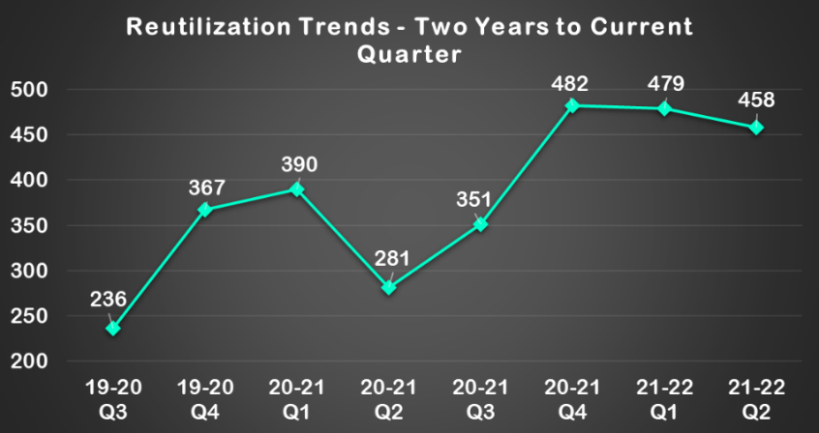

#### [Keep the Wheels Rolling Repair Fund (KWRF)](#_Keep_the_Wheels" \o "Select to jump to the \"Keep the Wheels Rolling Repair Fund\" section of the Glossary.)

**There were four applications in the second quarter with four approved.**

### State Financing: Jump to State Financing Appendix

**There were no State Financing Activities in this quarter.**

#### Alternative Financing Program – California’s AT Loan Guarantee Program

**This program is not currently active**

#### AT Lease to Own Program

**This program is not currently active**

#### Alternative Loan Financing

**Ability Tools received 13 inquiries. No applications were received****.**

## Coordination, Collaboration and Leveraged Funding

### [Disaster Management](#_Disaster_Management:_1" \o "Select to jump to the \"Disaster Management\" section of the Glossary.): Jump to Disaster Management Appendix

#### [Disability Disaster Access & Resources (DDAR)](#_Disability_Disaster_Access_2" \o "Select to jump to the \"Disability Disaster Access & Resources (DDAR)\" section of the Glossary.)

**The** **Disability Disaster Access and Resources (DDAR) program continues to develop and build the capacity of Disability Disaster Access and Resource Centers (DDARCs) across the state to best serve Californians with disabilities experiencing disaster events.**

### [Special Projects/Events](#_Special_Projects:" \o "Select to jump to the \"Special Projects/Events\" section of the Glossary.): Jump to Special Projects/Events Appendix

***#DisabilityClimATe Assistive Technology Earth Day Conference***

**Preparation for the Ability Tools Conference**

***HCBS Waiver Advocacy***

**Ability Tools and Department of Healthcare Services (DHS) engagement**

#### AT3 Leadership Symposium

**The Ability Tools team virtually attended AT Program Symposium**

# Section 2 - Notable Challenges, Next Steps and Suggestions

## NATADS Underreporting

The total number of actual performed AT Act activities remains undercounted at this time due to, staff turnover at Independent Living Centers (ILC) creating gaps in reporting competency and newly implemented AT programs (Disability Disaster Access and Resources and Voice Options) have been working to finetune their services and are now working to solidify their reporting structures.

CFILC has provided multiple [trainings, that are archived on the Ability Tools playlist on CFILC’s YouTube channel](https://www.youtube.com/playlist?list=PLgM5nplp1PgWZrbrR9VLqiF_qCIC_INRq), along with detailed written guides on each section of the AT Act. However, the majority of centers continue to not participate, which will, once again, impact our ACL annual performance report.

* CFILC will continue to support the ILC AT advocates and contracted DLDC staff across the state with NATADS trainings and technical assistance performed by CFILC staff and AT3 Center specialists.
* CFILC implemented an AT Act Activity Training series which has a focus on understanding more fully the activities required by the AT Act, and also how these activities are to be reported in NATADS. Each training is accompanied by one or more NATADS Activity Entry Training Guides to support best practices for reporting throughout the state of California.
* Recordings of the AT Act Activity Trainings and virtual versions of the NATADS Activity Entry Training Guides are made available on the Ability Tools Training Library in order to support new staff across the state and serve as a resource for established staff to refer to when in need. This additional support for the transition into NATADS assists in ensuring consistent and accurate reporting of state level and state leadership activities as defined in the AT Act law.
* One on one support and training is provided on an as-needed basis. Advocate need only email or call for support.
* The Disability Disaster Access and Resources and Voice Options programs have done excellent work in providing demonstrations, device loans and open-ended loans to consumers across the state, but unfortunately, this work has gone mostly uncaptured in the NATADS reporting system. CFILC is actively providing support to these programs, to ensure all of their hard work is recognized in the quarters to come.
* CFLIC continues to work with the Department of Rehabilitation to improve Independent Living center AT reporting across the state. Ability Tools has been conversing with the NATADS developers to work toward a mass inputting tool. NATADS developers have been informed about the massive benefits the state of California would see if the ILC’s were able to simply input data, rather than report using multiple databases.

**Audit of DLDC’s performance under COVID-19**

As a result of the Coronavirus Pandemic, Device Lending and Demonstration Centers have had to pivot to deliver services in a virtual environment. While some centers were already providing services virtually, it has been a challenge for others to flourish in a virtual environment. CFILC conducted third quarter deliverable check-ins regarding DLDC performance. One of the findings from these check-ins was that the DLDC’s were performing the required activities but that they were underreporting. Another finding was that DLDC’s were expressing a need for sanitation supplies.

* In response to the finding that DLDC’s were performing activities, but were not reporting in a timely fashion, CFILC wrote into the extended year’s contract that DLDCs were required to have their activities entered into NATADS by the end of the month, and that centers that were not meeting their monthly deliverable goals would not have their invoices paid out until the reporting was in. Additionally, centers were informed that CFILC would not look past the current quarter when recording activities, so any submissions would need to be in before the close of a 14-day grace period at the close of a quarter, with any older activities going unrecorded for the purposes of their contracted deliverables. This resulted in much higher-than-average reporting in the first quarter of the FFY.
* In response to the sanitation supply finding, CFILC added a sanitation line item in the 2022 budget to support this need. This was financed from the money retained from RIL not continuing their contract into the extension year.
* Many of the underperforming DLDC’s have been making great strides in improving their contract deliverable statuses. The close of the first quarter saw six DLDCs not within range of meeting deliverables, with two only one activity category off and only two fully meeting goals. After implementing more stringent reporting guidelines, the close of the second quarter saw only two DLDCs not within range of meeting deliverables, with four only one activity category off and four fully meeting goals. This is an astonishing turn about in only the course of a single quarter, and centers should be commended for their work.

## DDAR

CFILC’s DDAR program has been met with abundant requests for services. Some notable challenges are that DDARC Staff continue to underreport their AT Act Activity implementation. Additionally, with dry weather, the public reaches out with questions about whether they can secure a battery due to any power outage, not just a PSPS event.

* In response to the underreporting, DDAR’s Program Manager and Ability Tools hub staff will continue to provide more extensive training on NATADS Reporting, NATADS Activity Entry Training Guides and tips to streamline the reporting process. Additionally, DDAR hub staff and Ability Tools hub staff continue to hold twice monthly office hours for DDARC staff to drop-in as needed to ask questions regarding NATADS and DDAR policy.
* Conversations with PG&E have continued to build awareness among PG&E staff regarding the importance of striving toward uninterrupted access to electrical support for electricity dependent medical devices, regardless of the type of electrical outage, and a recognition of the trauma associated with not having the needed access to electricity dependent devices, and how that may manifest in consumers, in the time of an active event, needing to be transported and sheltered in a location where electricity access is secure.

# Section 3 - Quarter 4 Grant Deliverable Outcome Appendix

## State Leadership

### Public Awareness Activities:

**The Ability Tools Network conducted outreach and tabling at 59 events, to 31,889 participants**

* 1/4/2022 – SCIL AT orientation. 4 participants.
* 1/5/2022 – DRC Group Orientation. 21 participants.
* 1/10/2022 – DRC Cal State LB Transitional Youth Group. 46 participants.
* 1/10/2022 – SVILC Monthly newsletter. 2,000 recipients.
* 1/11/2022 – CAC Riverside County CARE Team. 2 participants.
* 1/12/2022 – SDATC Facebook post. 253 followers.
* 1/13/2022 – SDATC Adobe Bluffs Ability Awareness. 75 attendees.
* 1/18/2022 – CAC Inland Empire Disability Collaborative. 2 participants.
* 1/21/2022 – ILRCSF TheCIL Zoom meeting. 9 participants.
* 1/25/2022 – CCATC Parents Helping Parents of SLO. 2 participants.
* 1/26/2022 – ATEC My Day Counts Presentation. 6 participants.
* 1/26/2022 – CCATC Parents Helping Parents. 10 participants.
* 1/31/2022 – CART brochures to local MTU. 12 recipients.
* 1/31/2022 – SDATC website views. 127 visitors.
* 1/31/2022 – CRIL website views. 742 visitors.
* 1/31/2022 – SDATC AT presentation. 13 participants.
* 2/1/2022 – CART OTR in-service. 7 participants.
* 2/1/2022 – CART Communication Horizons discussion. 10 recipients.
* 2/2/2022 – SDATC Facebook post. 270 followers.
* 2/2/2022 – DRC Children's Bureau of S. CA presentation. 105 attendees.
* 2/7/2022 – ILRCSF SF Tech Council presentation. 26 attendees.
* 2/7/2022 – DRC Cal State Long Beach presentation. 41 participants.
* 2/7/2022 – SVILC Monthly newsletter. 2,000 recipients.
* 2/11/2022 – DRC Luther Social Services presentation. 21 attendees.
* 2/14/2022 – DRC ACT Spring Semester presentation. 60 attendees.
* 2/16/2022 – CCATC Parents Helping Parents of SLO. 15 participants.
* 2/16/2022 – ATEC AT Collaborative presentation. 28 participants.
* 2/16/2022 – ATEC AT Consultation Lab. 7 participants.
* 2/17/2022 – SVILC Stanford Assistive Technology Fair. 30 attendees.
* 2/17/2022 – CRIL AT Virtual Workshop. 15 attendees.
* 2/23/2022 – CCATC Parents Helping Parents of SLO. 48 participants.
* 2/24/2022 – CRIL AT Virtual Workshop. 12 attendees.
* 2/24/2022 – ATEC Easterseals and FDLRC presentation. 8 participants.
* 2/28/2022 – CRIL website views. 845 visitors.
* 3/1/2022 – SDATC Facebook post. 263 followers.
* 3/1/2022 – SDATC AT presentation. 14 participants.
* 3/1/2022 – SDATC website views. 128 visitors.
* 3/2/2022 – CCATC Parents Helping Parents of SLO. 2 participants.
* 3/7/2022 – DRC Personal Assistance Service Council. 26 attendees.
* 3/7/2022 – SVILC Monthly newsletter. 2,000 recipients.
* 3/7/2022 – ATEC Ability Central Grantee. 40 participants.
* 3/8/2022 – CRIL AT Virtual Workshop. 12 participants.
* 3/9/2022 – CCATC Parents Helping Parents of SLO. 32 participants.
* 3/10/2022 – CCCIL Blind & Visually Impaired Center presentation. 12 participants.
* 3/11/2022 – CRIL Vineyard Village Senior Apartments. 15 participants.
* 3/15/2022 – CRIL AT Virtual Workshop. 100 attendees.
* 3/15/2022 – CID Peninsula Family Services presentation. 8 attendees.
* 3/16/2022 – CART Abilities Expo table. 100 recipients.
* 3/16/2022 – ATEC O.C. AT Collaborative Presentation. 19 participants.
* 3/17/2022 – CRIL Dublin Ranch presentation. 46 recipients.
* 3/22/2022 – CRIL AT Virtual Workshop. 20 attendees.
* 3/22/2022 – SDATC Poway Unified Transition Fair. 46 recipients.
* 3/22/2022 – CCATC Parents Helping Parents of SLO. 9 participants.
* 3/23/2022 – CRIL AT Virtual Workshop. 27 participants.
* 3/25/2022 – DRC Spring Newsletter. 565 recipients.
* 3/28/2022 – DRC Cal State presentation. 32 attendees.
* 3/28/2022 – CAC Emergency Preparedness Fair. 2 participants.
* 3/30/2022 – CRIL website views. 848 visitors.
* 3/30/2022 – ATEC New Board of Directors Tour. 4 participants.
* CFILC Ability Tools website and Where it’s AT blogs - 20,647 pageviews for the quarter

#### Social Media

**Ability Tools’ social media outlets tracked increases in readership from last quarter to current reporting period as follows:**

* Facebook
  + Likes: Increase of 0.52% from 1,722 to 1,731 likes.
  + Engagement: A monthly average of 503 unique users who had any content from/about the Ability Tools Page enter their screen.
  + Impressions: Ability Tools posts from 1/1/22-3/31/22 earned 1.6K impressions total.
  + Notable:
    - 2/19/22: Shared NYTimes Article: “The Hidden Descriptions Making the Internet Accessible (511 impressions, 12 engagements)
* Twitter
  + Followers: Increase of 5.7% from 1,003 to 1,060 followers.
  + Impressions: Ability Tools tweets from 1/1/22-3/31/22 earned 4.6K impressions.
  + Notable:
    - 3/5/22: CFILC Team at the 2022 Abilities Expo in Los Angeles (511 impressions; 25 engagements)
* Instagram
  + Followers: Increase of 2.6% from 1,350 to 1,385 followers.
  + Impressions: Ability Tools posts from 1/1/22-3/31/22 earned 1.6K impressions total.
  + Notable:
    - 2/12/22: AT Spotlight: Foam Utensil Grip (317 impressions)

#### Articles

**Ability Tools was featured in two pieces of media from outside organizations this quarter.**

* The AT3 Center reposted the FREED Success Story "Wally Moves Home" to their Blog

<https://at3centerblog.com/>

* Ability Tools submitted a One Big Thing video, a short video article highlighting the biggest thing our program had done all year, our 2021 AT Earth Day conference, and the AT3 Center shared it with the nation’s AT Programs.

<https://www.youtube.com/watch?v=eJVIG8QJPTc>

#### Blogs

**The Ability Tools blog received 9,423 pageviews**

**Ability Tools published no blogs this quarter.**

#### Video Newsletters

**No video newsletters were published this quarter.**

#### Newsletters

**Ability Tools distributed no newsletters this quarter.**

### Information & Assistance (I&A):

#### Information and Assistance

**283 individuals, through 239 activities, were assisted through the I&A line and email during this time period.**

#### Digital Access Project

**CFILC’s Information and Assistance staff assisted consumers calling in for low-cost internet service. Through this work, our Digital Access Project has assisted 76 homes in securing affordable broadband.**

### Training:

**136 individuals participated in 5 training workshops in this reporting quarter.**

#### Regional Trainings

**65 individuals participated in 3 training workshops**

* 3/8/2022 – DDAR NATADS Reporting. 31 Participants
  + Kathrine Crowley, CFILC’s program Manager, provided an overview of NATADS reporting protocol for DDARC staff.
* 3/10/2022 – AT Advocates Monthly Meeting: Digital Access Project (DAP) presentation. 24 Participants.
  + Victor Mendoza and Anthony Lee, CFILC’s Program Coordinators and DAP Staff, provided an overview of the DAP program, the Emergency Broadband Fund (EBB) and Affordable Connectivity Program (ACP) to assist consumers in obtaining low-cost internet.
* 3/29/2022 – DDAR NATADS Reporting. 10 Participants
  + Kathrine Crowley, CFILC’s program Manager, provided a second overview of NATADS reporting protocol for DDARC staff who were unable to attend the first webinar.

#### AT 1.0 Trainings

**There were no AT 1.0 training workshops this quarter**

#### AT 2.0 Trainings

**71 individuals participated in 2 training workshops**

* 1/25/2022 - Smart AT Home: Customization. 53 Participants.
  + Ability Tools continued our Smart AT Home series with the fourth installment: Customization. This session, presented by smart home expert Forrest Holleman from Bay Area Smart Homes and World Wide Smart Homes, covered the process of setting up routines, scenes and customized automations to greatly increase independence, safety and quality of life. Future sessions will include topics, such as: programming your smart home hub to interact properly with your AAC devices, lightbulbs, and environmental controls.
* 2/10/2022 - AT Advocates Meeting Trainings - Quarterly Social Media Session – Inclusivity. 18 Participants.
  + This is a part of a quarterly recurring series to train AT Specialists about social media and its relevancy to their work. This series will be presented by communication and marketing manager, Cameron Moore. This installment covered Inclusivity and representation when using social media to promote ILC’s.
    - Importance of inclusivity
    - Review of implicit lack of representation
    - Ways to me more mindful about being inclusive
    - Free resources for visual media that is inclusive
    - Break out room scenarios – critique of a mixed media ad and how it was good and how it could be improved.

### Technical Assistance:

**There were no actively ongoing Technical Assistance Activities this quarter.**

## State Level

### Device Demonstration:

#### 172 Device Demonstration activities performed to 204 participants

**Most consumers served during this quarter reported being satisfied or highly satisfied with the service, with the exception of three consumers being somewhat satisfied and one consumer being not at all satisfied.**

[**Center for Applied Rehabilitation Technology (CART)**](https://www.cartla.org/) **Success Story**

Rogelio is an active 30-year-old man who enjoys socializing with friends and family. After he experienced an incomplete C4 spinal cord injury, he was referred to our program to explore alternative means to use a computer and other technology. Rogelio is a power wheelchair user which he drives with his chin. He has limited control of his fingers, hands, and arms. Before his injury, Rogelio was an avid gamer who loved to play sports games with his friends on an Xbox console. One of his main goals was to be able to regain the ability to game again.

Rogelio was assisted by specialists at CART and was accompanied by his mother. He was provided a demonstration utilizing equipment through Ability Tools which included the Xbox Adaptive Controller, The LogiTech Adaptive Switch kit, the Evil Controller Thumbstick, the Handrest Joystick, as well as microlight switches, Spec Switches and Jelly Bean switch with use of lock-line mounts for positioning of switches. He was able to utilize his chin to control the Evil Controller Thumbstick and activate switches that come with the Logitech Adaptive Gaming Kit. The switches were positioned at both sides of his head using custom loc-line mounts, below his right hand, and in front of his left hand. By moving his head from side to side and moving his arms down and forward while supported by mobile arm supports, he was able to efficiently and reliably control the switches. With this adaptive gaming setup, Rogelio played several video games on the Xbox One including NBA 2K20, something he had been unable to do since his injury.

After several sessions and discussions with staff regarding the features and benefits of the equipment demonstrated and tried by Rogelio it was determined that the Evil Controller Thumbstick, the Xbox Adaptive Controller and the LogiTech Adaptive Switch Kit would best meet his needs. He was provided a list of vendors/companies to contact in order to purchase the equipment. He is currently in the process of obtaining the adaptive gaming equipment and will soon have a complete setup including a new Xbox to return to his status as an active gamer again. He was excited and enthusiastically looks forward to telling other individuals with disabilities about his path back into gaming.

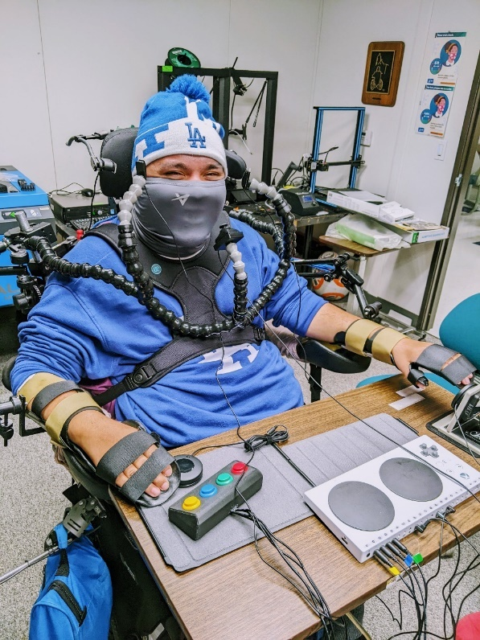

### Device Loan:

***338 devices were loaned through 263 device loans***

**With the exception of two consumers being not at all satisfied, all consumers reported being satisfied or highly satisfied with the service.**

[**Assistive Technology Exchange Center (ATEC)**](https://www.ocgoodwill.org/programs-list/)**Success Story**

Hi! My name is Micah and I’m three years old. I’m smart, strong, brave, curious, and athletic. I also have Down syndrome, which – for me- makes communication a bit tricky. I understand everything that goes on around me, and I really wanted a way to communicate back with others. I use sign language and gestures, which are very helpful, but sometimes I want another way to communicate – incase my listeners don’t know ASL.

UCP allowed me to borrow an iPad with LAMP and TouchChat. It also had a really sturdy case, which is great since I’m a rambunctious toddler. My family and speech therapist helped me learn to use it. We started off by using it during play with some of my favorite toys. My mom would model using the device to say things like “ball,” then we would play catch. She did this over, and over, and over. Once I got the hang of it, I used it to say and request things like “bubbles,” “ball,” or “book.”

I really liked getting to use the device and try out the two programs. It was also helpful for my parents to get more hands-on time and practice individualizing it. Mom did say it was a bit tricky really personalizing both programs. Since I’m so little, a lot of choices on one page are overwhelming; it was hard for her to learn to remove some of those choices. We did learn that selecting the tiny (many) choices was a bit tricky for my little fingers, since fine motor is tough for me. Moving forward, we think a key guard would help with that.

Overall, borrowing the iPad helped us decide that LAMP may be the better option for me and my family. I loved getting to make requests and play around with new word options. It was also great being able to communicate things when I didn’t know the sign. My baby sister even loved using the device, so it really was a family event.

Now I’ve started preschool, and we’re in the AAC evaluation process. Having the experience with the UCP device is really helpful, and is getting me off to a great start with a long-term device of my own.

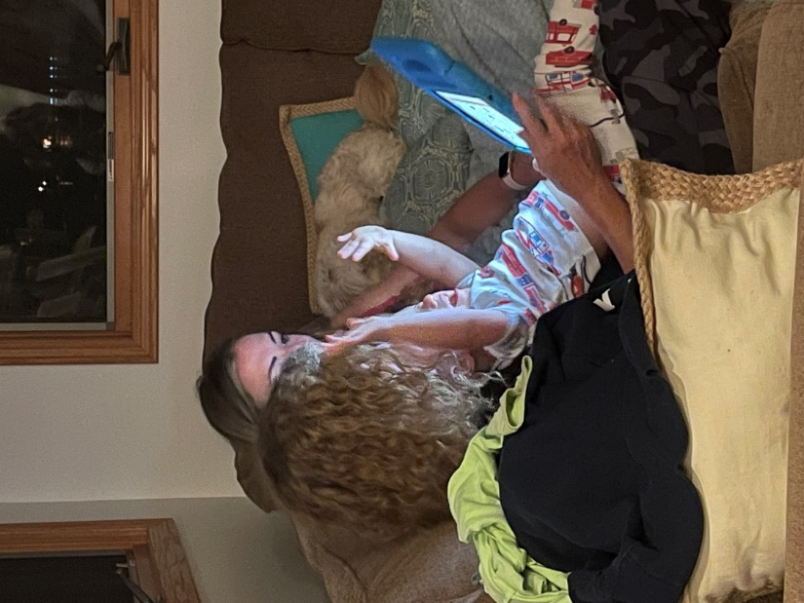

### Device Reutilization:

#### 622 reutilization devices were distributed through 458 reutilization activities.

**All consumers reported being satisfied or highly satisfied with the service.**

#### Keep the Wheels Rolling Repair Fund

**There were four applications in the second quarter with four approved.**

[**CAC - Community Access Center**](https://ilcac.org/) **Wheelchair Reutilization**

**Alejandro Esgardo receives his free refurbished wheelchair.**

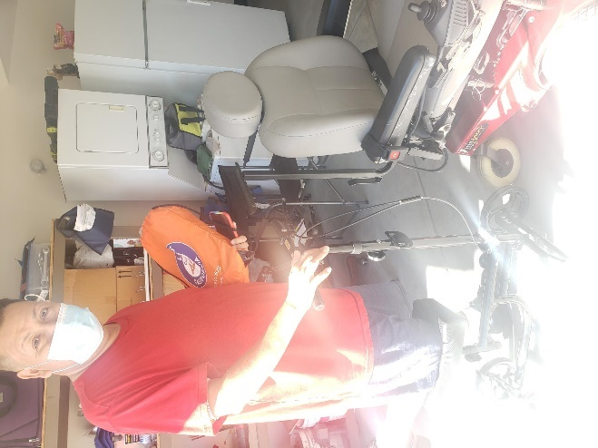

### State Financing:

**There were no State Financing Activities in this quarter.**

#### Alternative Financing Program – California’s AT Loan Guarantee Program

**This program is not currently active**

#### AT Lease to Own Program

**This program is not currently active**

#### Alternative Loan Financing

The data for this state level activity is reported from the Freedom Tech alternative loan program that was developed and is managed by the State AT Program Grantee, CFILC. Alternative loans can be granted to an individual up to the amount of $15,000. This loan program is separate from the required State Loan Guarantee Program, which is not currently active. While the FreedomTech Program is continually receiving referrals, the loan application process is taking longer than usual at this time. During this quarter, Ability Tools received 13 inquiries; with no loan applications received.

## Coordination, Collaboration and Leveraged Funding

### Disaster Management

#### Disability Disaster Access & Resources (DDAR)

**The** **Disability Disaster Access and Resources (DDAR) program continues to develop and build the capacity of Disability Disaster Access and Resource Centers (DDARCs) across the state to best serve Californians with disabilities experiencing disaster events.**

* The program responded to 997 calls, emails and texts regarding 1 active event, one event starting in December of the first quarter and continuing into the second; The December 2021 information was included in the previous quarterly report and this report concludes the event by including the information ranging from January 1st 2022 to the event’s close. Close of winter storm event info As a whole, 555 batteries were deployed statewide, with 55 transportation vouchers, 39 hotel vouchers and 147 food vouchers provided. DDAR staff performed 58 trainings 69 outreach events throughout the second quarter. DDAR staff are continuing to develop relationships with PG&E's portable battery providers to best provide services across the state.

### Special Projects/Events

***#DisabilityClimATe Assistive Technology Earth Day Conference***

**Preparation for the Ability Tools Conference**

* The #DisabilityClimATe Assistive Technology Earth Day Conference is a special one-day virtual web conference on Friday, April 22 (Earth Day) focused on assistive technology, environmental conservatorship, the disability community and actionable resources. The early to middle development phase of the conference was during this quarter.

***Home and Community Based (HCBS) Waiver Advocacy***

**Ability Tools and Department of Healthcare Services (DHS) engagement**

* Ability Tools conducted research regarding the implementation of HCBS Waivers in other states. It was learned that other states do have assistive technology access options in their waivers and these waivers are used to obtain assistive technology and smart AT for consumers within their state.

CFILC had a conversation with the Department of Healthcare Services and learned that home modifications are an option in California, but AT is not. CFILC recommended that DHS expand the waiver to include AT and smart AT options in the next fiscal year, with the new federal funds available for home and community based services.

#### AT3 Leadership Symposium

**The Ability Tools team virtually attended** **the annual AT Program Symposium**

* The AT3 Leadership Symposium is an annual conference, typically held in Washington, DC. This year’s conference was held from March 22nd -24th and was virtual, in consideration of COVID-19. At this event, staff from State AT programs meet in order to share resources, successes, challenges and better get to know one another, in order to strengthen our communities’ capacities.

Ability Tools submitted a One Big Thing video, a short video article highlighting the biggest thing our program had done all year. We highlighted our 2021 AT Earth Day conference.

* + <https://www.youtube.com/watch?v=eJVIG8QJPTc>

# Section 4 - Glossary

### Ability Tools:

Ability Tools, formerly the AT Network, is California’s Assistive Technology Act Program. They provide a variety of services for Californians with disabilities of all ages, including:

* NATADS Assistive Technology Portal
* Device Lending and Demo Centers
* Financial loan program for AT
* Information & Referral
* Reuse program in affiliation with organizational partners

In addition, Ability Tools provides in-person/webinar trainings, technical assistance to organizations on AT issues and coordinates the California Assistive Technology Reuse Coalition.

Ability Tools offers a free membership to anyone interested in learning more about AT and looking to connect with other like-minded individuals via the Ability Tools listserv.

Ability Tools is made possible through funding from the Department of Rehabilitation, financed by the U.S. Department of Education, Rehabilitation Services Administration with funds allocated by the Assistive Technology Act of 2004. (“About Ability Tools”)

### Articles:

CFILC will submit a minimum of six articles annually to be featured in newsletters and media from other organizations. (“Grant Narrative/Work Plan”)

### The Assistive Technology Advisory Committee (ATAC):

The Assistive Technology Advisory Committee (ATAC) is established pursuant to Section 4(c)(2) of the Assistive Technology Act of 2004 (AT Act). AT Act programs all have a public agency that serves as the Lead Entity. The Department of Rehabilitation (DOR) is the Lead Entity for California and controls and administers the AT Act funds, submits the application, and implements other duties required of AT Act programs.

The AT Act describes the requirement to establish an advisory council "to provide consumer-responsive, consumer-driven advice to the State for, planning of, implementation of, and evaluation of the activities carried out through the grant, including setting the measurable goals described in subsection (d)(3)." (“Assistive Technology Advisory Committee (ATAC)”)

### Blogs:

CFILC will publish 24 blogs annually on the “Where it’s AT” Ability Tools Blog. These will include assistive technology content including success stories that will be seen as peer-to-peer resources for individuals with disabilities looking for interventions or solutions to improve their quality of life and maintain their independence. (“Grant Narrative/Work Plan”)

### California Association of Area Agencies on Aging (C4A):

The California Association of Area Agencies on Aging (C4A) is a nonprofit organization representing California’s 33 area agencies on aging and is the leading voice on aging issues in California. C4A works closely with the Administration on Aging, the California Department of Aging, Department of Social Services, Department of Rehabilitation as well as key provider associations. C4A and its members administer programs that enable older Californians to live independently for as long as possible. (“What is C4A?”)

### California Foundation for Independent Living Centers (CFILC):

California Foundation for Independent Living Centers (CFILC) started as a peer support mechanism for executive directors of the fledgling Independent Living Centers in California (ILC) in 1976. Originally the directors were the usual representatives who went to Sacramento to educate public policy makers on issues affecting persons with disabilities.

In 1982, they incorporated as CFILC and formalized their organization. Each member center pays dues based on the amount of Title VII (federal) and AB 204 (state) funding it receives. Full voting members are the Executive Directors (or representative) of an Independent Living Center that meets the requirements of Title VII of the federal Rehabilitation Act. (“Our History”)

To assist in focusing on each of the important areas of advocacy, CFILC has created programs to drive those needs, including:

* Ability Tools
* Digital Access Project
* Disability Disaster Access and Resources
* Disability Organizing Network
* FreedomTech
* Youth Organizing! Disabled and Proud

### Coordination, Collaboration and Leveraged Funding:

State AT Programs leverage significant amounts of additional funding from other public and private sources and deliver a large return on investment for the small amount of federal appropriations received. (“AT Act Information”)

Organizations coordinate and collaborate on projects and initiatives in order to expand the reach of their networks and to better serve intersections between their respective communities.

California’s state AT program, Ability Tools, participates in nationwide events, in order to build the capacities of California’s program. Ability Tools collaborates with other state AT programs, Assistive Technology organizations, AT centers and vendors in order to ensure the most relevant and up to date service implementation is available to the citizens of the state of California.

### Device Demonstration:

A demonstration is an interaction with an AT specialist who has technical expertise related to device(s), where the specialist provides an interactive exploration of, typically, more than one device, in real-time, in order to increase the participant’s knowledge and understanding about the details and functions of a device with the intention of enabling the participant to make an informed choice regarding acquiring the appropriate device for their needs; the participant drives the demonstration and has the ability to have their individual questions about the device addressed.

The 12 DLL/ Demo Centers (including CFILC) have a goal to provide 600 “hands on” demos to persons with disabilities and family members annually. (“Grant Narrative/Work Plan”)

### Device Loan:

The AT Act requires state AT programs to “provide short-term loans of assistive technology devices to individuals, employers, public agencies, or others seeking to meet the needs of targeted individuals and entities, including others seeking to comply with the Individuals with Disabilities Education Act (20 U.S.C. 1400 et seq.), the Americans with Disabilities Act of 1990 (42 U.S.C. 12101 et seq.), and section 504 of the Rehabilitation Act of 1973 (29 U.S.C. 794)”. The purpose of a short-term device loan may be (1) to assist in decision-making; (2) to serve as a loaner while the consumer is waiting for device repair or funding; (3) to provide an accommodation on a short-term basis; or (4) for professional development. In the Annual Program Report (APR) Instruction Manual (word) a loan (counted as one) is defined as an occasion on which a device or devices were borrowed by an individual/entity who will use the device for one of the listed purposes (“Device Lending”).

CFILC’s goal is to process 50-75 onsite loans to individuals annually. With the 11 other DLL/Demo Centers, CFILC expects to process a minimum of 1,680 AT device loans to people with disabilities, family, and providers annually. (“Grant Narrative/Work Plan”)

### Device Reutilization:

Although the AT Act does not include a formal definition of device reutilization programs, the Act describes reutilization programs as programs that provide for the exchange, repair, recycling or other reutilization of assistive technology devices, which may include redistribution through device sales, loans, rentals or donations, carried out either directly or in collaboration with public or private entities (Section 4(e)(2)(B)) (“Device Reutilization”).

CFILC will continue to operate and expand Reuse Programs through partnerships with contracted Reuse Centers and the larger Reuse community throughout California. Reuse Centers are places that accept donations of gently used medical equipment or other AT devices. Centers are responsible for storing, cleaning and/or repairing devices before giving them away or selling them at low or no cost to people with disabilities.

CFILC will increase the number of Reuse items available on NATADS annually by providing training and technical assistance on NATADS where Reuse partners can list AT devices available for no or low-cost. CFILC will provide an updated annual training workshop on how to use NATADS for reuse activities and to expand services. The Reuse Training Workshop will be archived in accessible format and made available through the Ability Tools and CATRC websites and uploaded to the Ability Tools YouTube. CFILC staff will continue to facilitate and participate in CATRC regular meetings and Disaster Strategies Coalition meetings. Staff will provide updates to both coalitions and facilitate partnership opportunities between reuse and disaster preparedness partners. CFILC will organize an annual Reuse Event in collaboration with the CATRC, Disaster Strategies Coalition and the AT and IL Network to limit reusable durable medical equipment and AT devices from being disposed of in landfills. CFILC will provide Reuse Best Practice Training Workshops and technical assistance to the CATRC, Reuse Centers and AT Network. (“Grant Narrative/Work Plan”)

#### Annual Earth Day Reuse Event

CFILC will organize an annual Reuse Event in collaboration with the CATRC, Disaster Strategies Coalition, the AT community and IL Network to limit reusable durable medical equipment and AT devices from being disposed of in landfills in coordination with Earth Day. (“Grant Narrative/Work Plan”)

#### Keep the Wheels Rolling Repair Fund:

In 2012 CFILC established the Keep the Wheels Rolling Fund, and will continue to seek supplemental funding for the program that allows reuse organizations to apply for small grants to keep mobility devices usable. For example, replacement batteries on a motorized scooter that keeps the device reusable. (“Grant Narrative/Work Plan”)

The Keep the Wheels Rolling Repair Fund (KWRF) will provide small grants of up to $450 for the purchase of parts and/or repairs needed to refurbish a wheelchair or scooter so it may be reassigned to a low-income Californian with a disability for free. Only nonprofit organizations may apply.

Important Note: The KWRF may not be used to pay for repairs to a device already owned by an individual with a disability. The fund is intended to support the reassignment of used devices to new individuals who need them. (“Keep the Wheels Rolling Repair Fund”)

### Digital Access Project (DAP):

The Digital Access Project (DAP), a statewide program of CFILC, was created in 2013 and is in-part funded by the California Emerging Technology Fund. The Digital Access Project assists low-income individuals in enrolling in affordable broadband service, provides digital literacy referrals and extends the opportunity to own new and refurbished equipment.

The Digital Access Project aims to help those who do not have the digital literacy skills they need to succeed by organizing digital literacy classes.

Those who are interested in an affordable internet service are encouraged to contact the Digital Access Project. DAP staff will assist in supporting individuals through the enrollment process by calling the toll-free line: (800) 390-2699 or (800) 900-0706 TTY or visiting [the Digital Access Project website](http://digitalaccessproject.org/).

### Disaster Management:

CFILC organizes and facilitates The California Disaster Strategies Coalition which consists of a broad group of community service providers, stakeholders and advocates working on inclusive emergency readiness, response, recovery, and mitigation. The Disaster Strategies Coalition is dedicated to keeping the disaster and emergency dialogue for disabled individuals moving forward. The coalition works to ensure that disabled people are integrated and prepared for disasters and/or emergencies through public policy advocacy and program procedures. This work is implemented through programs like: (“About Us”)

#### Disability Disaster Access & Resources (DDAR):

Disability Disaster Access & Resources is a pilot program of CFILC that assists individuals with disabilities and older adults in disaster readiness and recovery.

This program provides individuals with information & assistance, disaster readiness training, backup electricity support, personal preparedness planning assistance, public awareness, and Assistive Technology and Durable Medical Equipment reuse and loan closet referrals; before, during and after a disaster or electricity shut-off. (“Programs and Coalitions of CFILC”)

#### The Richard Devylder Disaster Relief Fund

The Richard Devylder Disaster Relief Fund assists individuals with disabilities replace lost critical assistive technology, tools and devices, and is also covering some motel/hotel stays. (“Wildfires”)

### DOR:

The California Department of Rehabilitation (DOR) works in partnership with consumers and other stakeholders to provide services and advocacy resulting in employment, independent living, and equality for individuals with disabilities.DOR administers the largest vocational rehabilitation and independent living programs in the country. Vocational rehabilitation services are designed to help job seekers with disabilities obtain competitive employment in integrated work settings. Independent living services may include peer support, skill development, systems advocacy, referrals, assistive technology services, transition services, housing assistance, and personal assistance services. (“Department Overview”)

### Information & Referral:

Typically referred to as Information & Assistance activities… “The AT Act does not include a formal definition of a statewide information and referral system, but describes the requirement of the State to provide for the ‘continuation and enhancement of a statewide information and referral system designed to meet the needs of targeted individuals and entities’. It further describes the content of the system as one that shall ‘…deliver information on assistive technology devices, assistive technology services (with specific data regarding provider availability within the State), and the availability of resources, including funding through public and private sources, to obtain assistive technology devices and assistive technology services. The system shall also deliver information on the benefits of assistive technology devices and assistive technology services with respect to enhancing the capacity of individuals with disabilities of all ages to perform activities of daily living.’ ” and also include assistance to an individual in troubleshooting problems with an AT device (“Public Awareness and Information and Assistance”).

To assure good customer service, CFILC is committed to following the I&A standards and best practices established by the Alliance of Information and Referral Services. The I&A line will be answered by two bilingual staff Monday - Friday during CFILC’s hours of operation. CFILC will track and record I&A contacts in NATADS. This information will be analyzed and used to target underrepresented geographic counties and regions on an annual basis. CFILC will connect consumers with other programs and resources using a warm hand-off technique by initiating a three-way call to a referring agency that can provide the consumer with additional support. (“Grant Narrative/Work Plan”)

#### Refueling Act

In 1997, Californians for Disability Rights (CDR) sponsored Assembly Bill 1277 (Thomson) in order to update and clarify state law regarding refueling assistance for persons with disabilities at gasoline service stations. AB 1277 was passed by the Legislature, signed by Governor Wilson and enacted as Chapter 836, Statutes of 1997, effective January 1, 1998.

CFILC will operate one toll-free voice line and one toll-free TTY line. I&A Staff will answer all refueling calls from gas station patrons and employees who wish to know more about California’s refueling law for people with disabilities. (“Law: Refueling Act”)

### Newsletters:

CFILC will publish 6 written newsletters annually. These articles will include assistive technology content including success stories that will be seen as peer-to-peer resources for individuals with disabilities looking for interventions or solutions to improve their quality of life and maintain their independence. (“Grant Narrative/Work Plan”)

### Public Awareness:

Although the AT Act does not provide a formal definition of public awareness, the Act described public awareness activities as activities “to provide information to targeted individuals and entities relating to the availability, benefits, appropriateness and costs of assistive technology devices and services”. This includes the development and distribution of informational materials regarding the state AT program’s efforts related to assistive technology, and communication between providers of assistive technology and targeted individuals and entities, including partnerships with employers, vocational rehabilitation, and public schools (“Public Awareness and Information and Assistance”).

CFILC plans to work with community-based groups, organizations, and state agencies to conduct targeted outreach statewide. CFILC has updated and will continue to distribute the Ability Tools rack card describing our role in the CA AT Program in English, Spanish, Braille, Mandarin/Cantonese and accessible electronic formats. IL Network partners and CFILC staff will track and report on the number of materials distributed quarterly (September 30th, December 30th, March 30th, and June 30th) and annually (December 15th). (“Grant Narrative/Work Plan”)

### Social Media:

CFILC will post weekly and increase readership by 10% annually on the Ability Tools Facebook page, Twitter feed, Instagram and Pinterest. Staying on top of social media trends, we’ll host Facebook live sessions with ASL Interpreters to build public awareness of Ability Tools and be inclusive of the Deaf and HoH communities. (“Grant Narrative/Work Plan”)

### Special Projects/Events:

Special Projects, for the purposes of this document, encompass projects/events that may or may not intersect with grant deliverables, but have such a powerful scope or focus that they impact the successful implementation of grant deliverables directly, or have the indirect effect of increasing the capacity of state AT program staff and/or partners to serve the assistive technology needs of the citizens of the state of California.

### State Financing:

The AT Act describes state financing activities as activities that increase “access to, and funding for, assistive technology devices and assistive technology services (which shall not include direct payment for such a device or service for an individual with a disability but may include support and administration of a program to provide such payment), including development of systems to provide and pay for such devices and services, for targeted individuals and entities (“State Financing”).

CFILC will distribute applications for the State Loan Guarantee Program when established as well as the CFILC Freedom Tech Alternative Loan Program that began in 2016. I&A specialists will assist callers with applications and additional referrals as needed. CFILC will track quarterly activities on loans processed and approved, and activities on financial literacy. CFILC will work in partnership with the Department of Rehabilitation (DOR) to establish an AT Lease to Own program, if funds become available through the Revolving Loan Guarantee Fund. (“Grant Narrative/Work Plan”)

#### Alternative Financing Program

California's AT Loan Guarantee Program (LGP) is designed to provide low cost loans to Californians with disabilities, regardless of age, for the purchase of modified vehicles, durable medical equipment, adaptive aids and other assistive technology devices to live more independently or to engage in employment. Loans are guaranteed by a state supported fund through the Department of Rehabilitation.

CFILC is committed and continues to work with the department to seek opportunities to administer the LGP. CFILC has cultivated relationships with lending institutions through the Freedom Tech Financial Loan program and introduced lending stakeholders to the DOR.

CFILC will continue to work in collaboration with the DOR to implement the LGP through the development and expansion of alternative financing programs, FreedomTech and AT Lease to Own Program. (“Grant Narrative/Work Plan”)

#### FreedomTech Financial Loan Program

The data for this state level activity is reported from the Freedom Tech alternative loan program that was developed and is managed by the State AT Program Grantee, CFILC. Alternative loans can be granted to an individual ranging from $500 to $15,000. This loan program is separate from the required State Loan Guarantee Program, which has not been implemented by DOR.

The FreedomTech Financial Loan Program can lend money to purchase a variety of assistive technology.

Those who are interested in an assistive technology loans are encouraged to contact the FreedomTech Loan Program. FreedomTech staff will assist in supporting individuals through the application process by calling: (916) 737-5358 or (916) 325-1695 TTY, emailing: info@FreedomTech.org or visiting [the FreedomTech Loan website](https://freedomtech.org/).

#### AT Lease to Own Program

CFILC will work in partnership with the Department of Rehabilitation (DOR) to establish an AT Lease to Own program, if funds become available through the Revolving Loan Guarantee Fund. The AT Lease to Own Program would allow CFILC to offer consumers additional opportunities that are not currently available. AT Lease to Own Program would provide AT to consumers on a leased arrangement which provides savings over a direct purchase and would allow individuals to build their financial credit without added interest fees, underwriting or specific loan qualifications. The Grantee will propose, develop, and establish an AT Lease to Own program to help alleviate some of the challenges that communities with disabilities face when obtaining AT. The Grantee will collaborate with ILCs, Device Lending Libraries, and other qualified non-profits to provide the Lease to Own Program services. The AT Lease to Own Program funding amounts for the lease to own option would be from $250 to $2,499. These funding amounts are in alignment with the California Financial Code Section 22066 for non-profit entities.

The Grantee would purchase the AT and manage the lease to own contracts with consumers. The recovery of funds will be reallocated to the AT Lease to Own Program Fund. The Grantee would also support outreach efforts for the program and respond to external inquiries for services from consumers with information and referral and monitor lease to own activity to ensure compliance with grant provisions and state and federal laws. The Grantee will also work in collaboration with DOR to develop and expand the AT Lease to Own Program as part of the alternative financing program activities for the California AT Program. (“Grant Narrative/Work Plan”)

### State Leadership Activities:

The Assistive Technology Act of 2004 specifies the statewide activities required of programs receiving funds under Section 4 of the AT. State leadership activities authorized by the AT Act include providing training, technical assistance, information and referral, and public awareness throughout the state. A portion of training and technical assistance efforts are focused on transition (from school to work; from school to other aspects of adult life; or from congregate to community-based settings). Additionally, activities to improve accessibility of information and communication technology (ICT) are conducted (“State Leadership”).

### State Level Activities:

The Assistive Technology Act of 2004 specifies the statewide activities required of programs receiving funds under Section 4 of the AT Act. These include four “state level” activities that are designed to help people with disabilities, their families, service providers and others Access and Acquire assistive technology devices (“State Level”).

### Technical Assistance:

Technical assistance (TA) is the process of providing targeted support to an organization with a development need or problem (Compassion Capital Fund [CCF] National Resource Center, 2010). The Assistive Technology Act does not include a formal definition of technical assistance (TA), one of the required state leadership activities. However, the AT Act does refer to potential recipients of such assistance to include “representatives of State and local educational agencies, other State and local agencies, early intervention programs, adult service programs, hospitals and other health care facilities, institutions of higher education, and businesses.” Generally, the purpose of technical assistance is to improve the capacity of the beneficiary organization, as evidenced by increased efficiency, increased effectiveness, and/or increased funding (CCF, 2010) (“Technical Assistance”).​

### Training:

Training activities are instructional events, usually planned in advance for a specific purpose or audiences, which are designed to increase participants’ knowledge, skills, and competencies regarding AT. Such events can be delivered to large or small groups, in-person, or via telecommunications or other distance education mechanisms. In general, participants in training can be individually identified and could complete an evaluation of the training. Examples of training include classes, workshops, conference sessions, and presentations that have a goal of increasing skills, knowledge, and competency. Training and/or presentations intended only to increase general awareness of AT are considered public awareness events (“Training”). ​

#### ***Regional Trainings***

Ability Tools must conduct at least eight regional presentations annually across California. These regional training workshops are offered to AT Center staff and are designed to enrich center staff’s professional development efforts, expand their understanding (execution, reporting, ect.) of the activities under the AT Act, and inform them of developments in AT products and services.

#### ***AT 1.0*** Trainings

Ability Tools must deliver at least four AT 1.0 training workshops annually - AT 1.0 training workshops will include topics such as what is assistive technology, where to go for assistive technology, how to use it, etc. (“Grant Narrative/Work Plan”)

#### ***AT 2.0*** Trainings

Ability Tools must deliver at least six AT 2.0 training workshops annually - AT 2.0 training workshops will include topics such as what is Latest and Greatest devices in AT, emerging technologies, methods for reaching disenfranchised populations, ect. (“Grant Narrative/Work Plan”)

### Video Newsletters:

CFILC will work with a professional videographer to create up to four two-minute video newsletters with open captions annually. They will include individuals with disabilities who use AT to maintain their independence at home, in school, at work and in the community. (“Grant Narrative/Work Plan”)

# Section 5 - Bibliography

“About Ability Tools.” *Ability Tools,* California Foundation for Independent Living Centers,<https://abilitytools.org/about/about-at.php>. Accessed 5 May. 2021.

“About Us.” *Disability Disaster Access & Resources*, California Foundation for Independent Living Centers, <https://disabilitydisasteraccess.org/about-us/>. Accessed 5 May. 2021.

“Assistive Technology Advisory Committee (ATAC).” *Department of Rehabilitation*, United States Federal Government, [https://dor.ca.gov/Home/ATAC. Accessed 5 May. 2021](https://dor.ca.gov/Home/ATAC.%20Accessed%205%20May.%202021).

“AT Act Information.” *AT3 Center*, National Assistive Technology Act Technical Assistance and Training (AT3) Center, <https://www.at3center.net/repository/atactinformation>. Accessed 23 Jul. 2021.

“Department Overview.” *Department of Rehabilitation*, United States Federal Government, <https://dor.ca.gov/Home/DepartmentOverview>. Accessed 5 May. 2021.

“Device Lending.”*AT3 Center*, National Assistive Technology Act Technical Assistance and Training (AT3) Center, <https://www.at3center.net/repository/deviceloan>. Accessed 29 Apr. 2021.

“Device Reutilization.”*AT3 Center*, National Assistive Technology Act Technical Assistance and Training (AT3) Center, <https://www.at3center.net/repository/devicereuse>. Accessed 29 Apr. 2021.

“Grant Narrative/Work Plan California Assistive Technology Program Federal Assistive Technology Program State and Social Security Reimbursement (SSR).” Assistive Technology Act Grant Deliverables Proposed Workplan. Oct. 2018. Typescript.

“Keep the Wheels Rolling Repair Fund.” *Ability Tools*, California Foundation for Independent Living Centers, [https://abilitytools.org/services/repair-fund.php. Accessed 5 May. 2021](https://abilitytools.org/services/repair-fund.php.%20Accessed%205%20May.%202021).

“Law: Refueling Act.” *Ability Tools*, California Foundation for Independent Living Centers, <https://abilitytools.org/resources/refueling-act.php>. Accessed 5 May. 2021.

“Our History.” *CFILC*, California Foundation for Independent Living Centers, <https://cfilc.org/about/our-history.php>. Accessed 5 May. 2021.

“Programs and Coalitions of CFILC.” *CFILC*, California Foundation for Independent Living Centers, <https://cfilc.org/about/programs-coalitions.php>. Accessed 5 May. 2021.

“Public Awareness and Information and Assistance.”*AT3 Center*, National Assistive Technology Act Technical Assistance and Training (AT3) Center, <https://www.at3center.net/repository/publicawareness>. Accessed 29 Apr. 2021.

“State Financing.”*AT3 Center*, National Assistive Technology Act Technical Assistance and Training (AT3) Center, <https://www.at3center.net/repository/statefinancing>. Accessed 29 Apr. 2021.

“State Leadership.”*AT3 Center*, National Assistive Technology Act Technical Assistance and Training (AT3) Center, <https://www.at3center.net/repository/stateleadership>. Accessed 29 Apr. 2021.

“State Level.”*AT3 Center*, National Assistive Technology Act Technical Assistance and Training (AT3) Center, <https://www.at3center.net/repository/StateLevelActivities>. Accessed 29 Apr. 2021.

“Technical Assistance.”*AT3 Center*, National Assistive Technology Act Technical Assistance and Training (AT3) Center, <https://www.at3center.net/repository/TA>. Accessed 29 Apr. 2021.

“Training.”*AT3 Center*, National Assistive Technology Act Technical Assistance and Training (AT3) Center, <https://www.at3center.net/repository/training>. Accessed 29 Apr. 2021.

“What is C4A?.” *C4A*, California Association of Area Agencies on Aging, [https://c4a.info/about-us/what-is-c4a/#](https://c4a.info/about-us/what-is-c4a/). Accessed 5 May. 2021.

“Wildfires.” *Disability Disaster Access & Resources*, California Foundation for Independent Living Centers, <https://disabilitydisasteraccess.org/wildfires/>. Accessed 5 May. 2021.