Introduction
In late October 2018, the Department of Rehabilitation awarded, as well as finalized, the AT grant agreement to CFILC for 39 months, covering the time period of July 1, 2018 to September 30, 2021. This Assistive Technology Quarterly Report covers the reporting period of April 1st through June 30th, 2022. This report includes all the data elements outlined in the AT grant as well as by Section 4(f) of the AT Act for:
State Level Activities: Public Awareness, Information & Referral - typically referred to as Information and Assistance (I&A), Training, Technical Assistance;
State Level Activities: Device Demonstration, Device Loan, Device Reutilization, and State Financing;
As well as Disaster Management and Special Projects/Events.
This document is hyperlinked to assist in navigating its sections. Use the hyperlinks to move quickly across the document, which, when hovered over, contain a Screen tip to explain where they will take you once selected.
Section 1 - Truncated overview of this quarter’s grant deliverables.
Section 2 - Challenges met implementing this quarter’s grant deliverables and actionable Next Steps and Suggestions to address these challenges.
Section 3 - Appendix unpacking this quarter’s grant deliverables.
Section 4 - Glossary containing definitions and valuable information regarding the keywords used throughout the document.
Section 5 – Bibliography of utilized resources.

Section 1 - Quarter 3 Outcomes – At-A-Glance View

State Leadership Activities

Public Awareness Activities: Jump to Public Awareness Appendix
59 events, to 32,050 participants
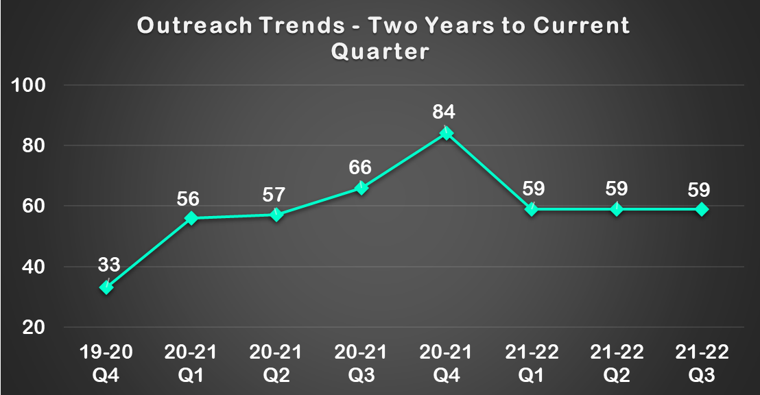

Social Media
The below chart reflects the Social Media Deliverable progress as of the end of the second quarter.
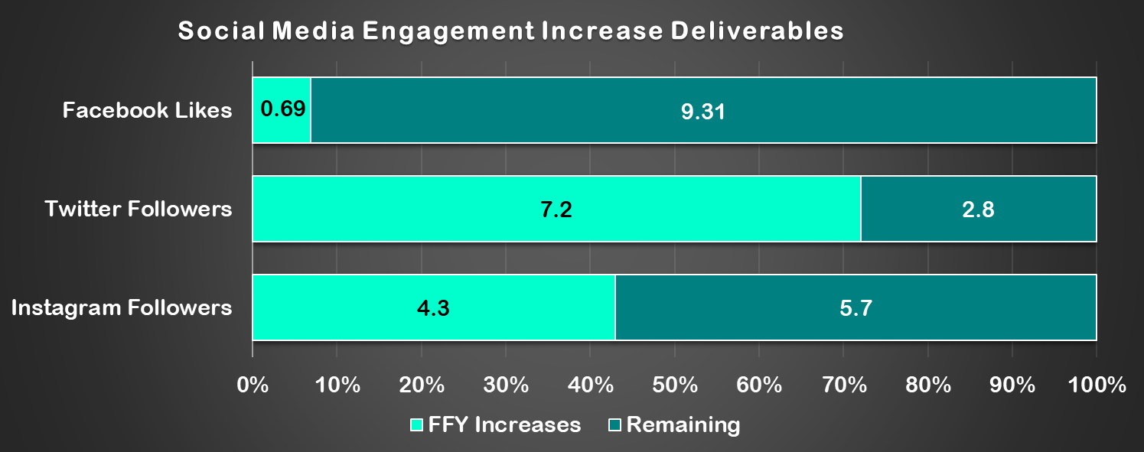

Articles
Ability Tools was featured in two pieces of media from outside organizations.

Blogs
The Ability Tools blog received 9,729 pageviews.
Ability Tools published seven blogs this quarter.

Video Newsletters
No video newsletters were published.

Newsletters
2 newsletters were published.
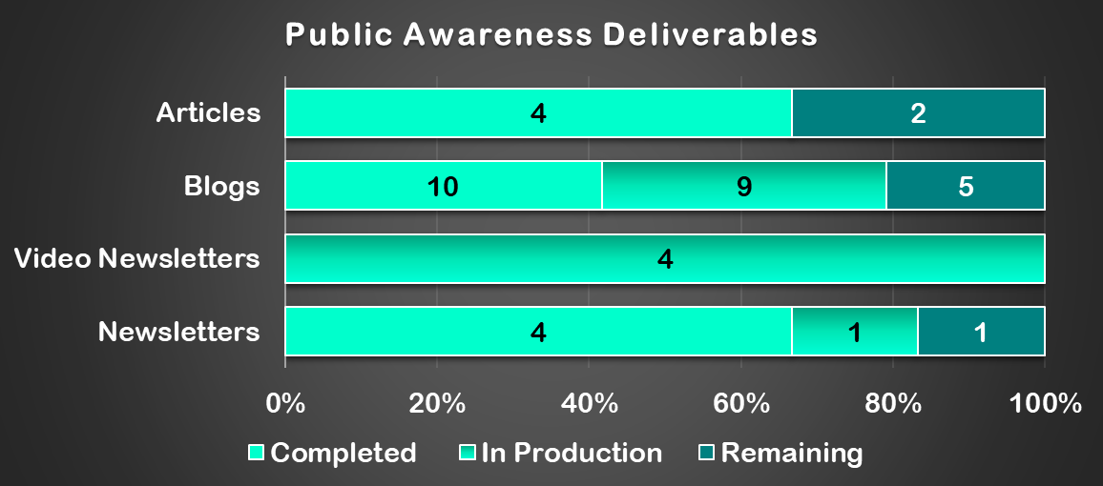

Information & Assistance (I&A): Jump to I&A Appendix
204 activities to 266 participants
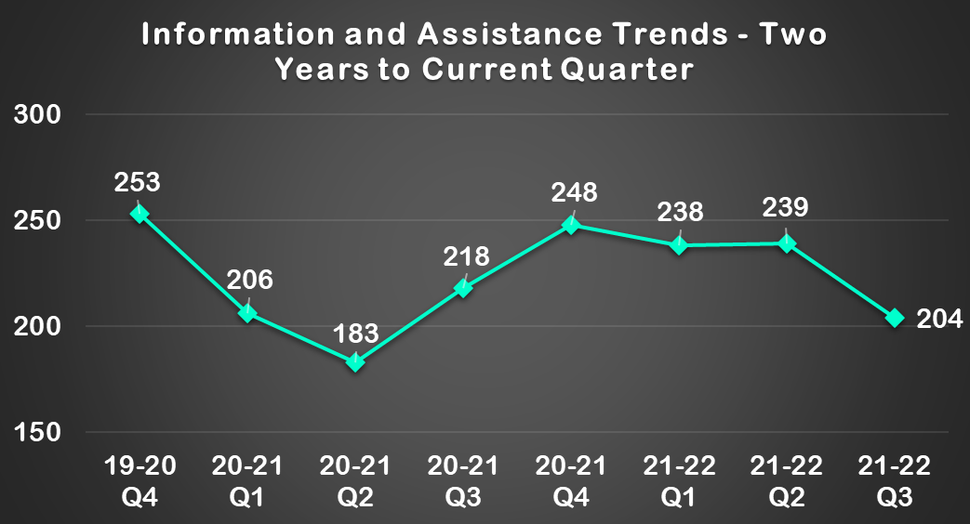

Digital Access Project (DAP)
120 homes secured affordable broadband
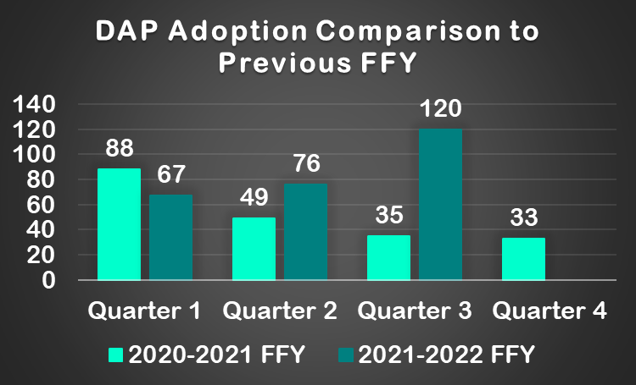

Training: Jump to Training Appendix
344 individuals participated in 9 training workshops

Regional Trainings
38 individuals participated in 2 training workshops

AT 1.0 Trainings

111 individuals participated in 3 training workshops

AT 2.0 Trainings
195 individuals participated in 4 training workshops
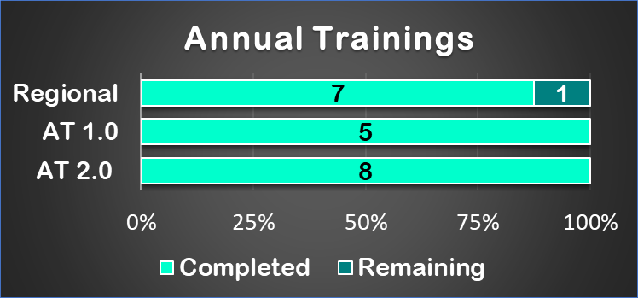

Technical Assistance: Jump to Technical Assistance Appendix
There were no actively ongoing Technical Assistance Activities this quarter.

State Level Activities

Device Demonstration: Jump to Device Demonstration Appendix

151 Device Demonstration activities performed to 171 participants
Most consumers served during this quarter reported being satisfied or highly satisfied with the service, with the exception of eleven consumers being somewhat satisfied.

Device Loan: Jump to Device Loan Appendix

356 devices were loaned through 272 device loans
With the exception of two consumers being somewhat satisfied, all consumers reported being satisfied or highly satisfied with the service.
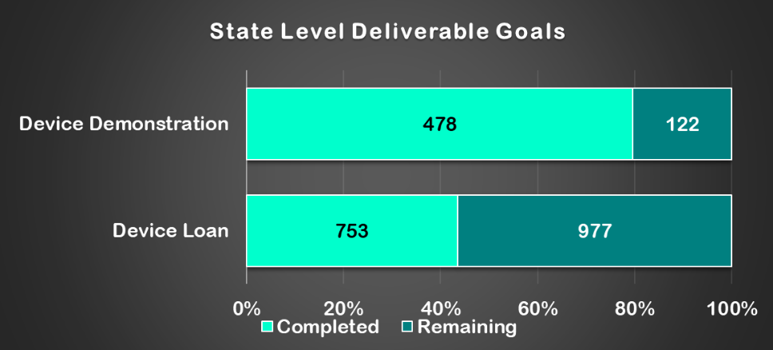

Device Reutilization: Jump to Device Reutilization Appendix

809 reutilization devices were distributed through 512 reutilization activities.
All consumers reported being satisfied or highly satisfied with the service.
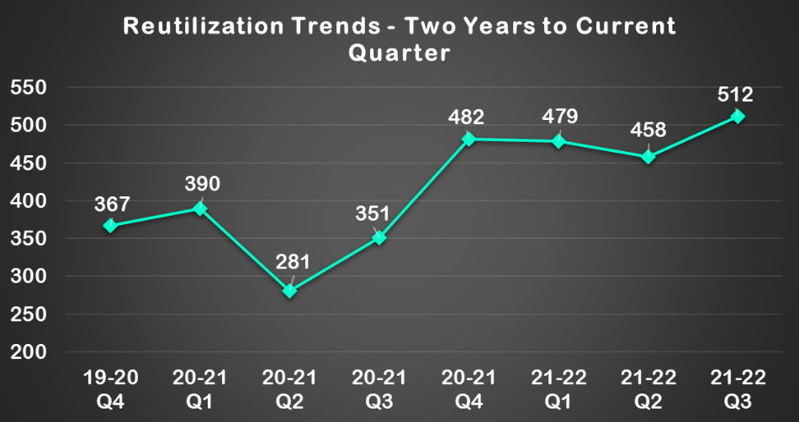

Keep the Wheels Rolling Repair Fund (KWRF)
There were three applications in the third quarter with three approved.

State Financing: Jump to State Financing Appendix
There were no State Financing Activities in this quarter.

Alternative Financing Program – California’s AT Loan Guarantee Program
This program is not currently active

AT Lease to Own Program
This program is not currently active

Alternative Loan Financing
Ability Tools received nine inquiries. No applications were received.

Coordination, Collaboration and Leveraged Funding

Disaster Management: Jump to Disaster Management Appendix

Disability Disaster Access & Resources (DDAR)
The Disability Disaster Access and Resources (DDAR) program continues to develop and build the capacity of Disability Disaster Access and Resource Centers (DDARCs) across the state to best serve Californians with disabilities experiencing disaster events.

Special Projects/Events: Jump to Special Projects/Events Appendix

#DisabilityClimATe Assistive Technology Earth Day Conference

Annual Ability Tools Conference

HCBS Waiver Advocacy
Ability Tools and Department of Healthcare Services (DHS) engagement

Section 2 - Notable Challenges, Next Steps and Suggestions

NATADS Underreporting
The total number of actual performed AT Act activities remains undercounted at this time due to, staff turnover at Independent Living Centers (ILC) creating gaps in reporting competency and newly implemented AT programs (Disability Disaster Access and Resources and Voice Options) have been working to finetune their services and are now working to solidify their reporting structures.
CFILC has provided multiple trainings, that are archived on the Ability Tools playlist on CFILC’s YouTube channel, along with detailed written guides on each section of the AT Act. However, the majority of centers continue to not participate, which will, once again, impact our ACL annual performance report.
- Ability Tools has been in contact with nationwide AT Act technical assistance providers, AT3, to determine best practices for streamlining the reporting guidelines.
- CFLIC continues to work with the Department of Rehabilitation to improve Independent Living center AT reporting across the state. Ability Tools has been conversing with the NATADS developers to work toward a mass inputting tool. NATADS developers have been informed about the massive benefits the state of California would see if the ILC’s were able to simply input data, rather than report using multiple databases.
- CFILC will continue to support the ILC AT advocates and contracted DLDC staff across the state with NATADS trainings and technical assistance performed by CFILC staff and AT3 Center specialists.
- CFILC implemented an AT Act Activity Training series which has a focus on understanding more fully the activities required by the AT Act, and also how these activities are to be reported in NATADS. Each training is accompanied by one or more NATADS Activity Entry Training Guides to support best practices for reporting throughout the state of California.
- Recordings of the AT Act Activity Trainings and virtual versions of the NATADS Activity Entry Training Guides are made available on the Ability Tools Training Library in order to support new staff across the state and serve as a resource for established staff to refer to when in need. This additional support for the transition into NATADS assists in ensuring consistent and accurate reporting of state level and state leadership activities as defined in the AT Act law.
- One on one support and training is provided on an as-needed basis. Advocate need only email or call for support.
- The Disability Disaster Access and Resources and Voice Options programs have done excellent work in providing demonstrations, device loans and open-ended loans to consumers across the state, but unfortunately, this work has gone mostly uncaptured in the NATADS reporting system. CFILC is actively providing support to these programs, to ensure all of their hard work is recognized in the quarters to come.

CFILC Understaffing
California Foundation for Independent Living Centers is experiencing a severe staff shortage. There are currently eight staff vacancies and all but two vacancies directly relate or are positions in the Ability Tools program. One of the vacancies is the Executive Director position, making the staff deficit even more of a challenge to remedy.
- Filling staff vacancies is the priority of current staff and interviews are being held to hire qualified candidates.
- The organization chart has been updated and Ability Tools has had positions added to the program to return staffing to closer alignment with the initial contract language. The programs tasks have been distributed amongst the positions and will filled with qualified candidates.

Section 3 - Quarter 3 Grant Deliverable Outcome Appendix

State Leadership

Public Awareness Activities:
The Ability Tools Network conducted outreach and tabling at 59 events, to 32,050 participants
- 4/1/2022 – CFILC Blog Post. 2 participants.
- 4/5/2022 – CCCIL Resource Fair. 150 participants.
- 4/5/2022 – DRC ACT-Adult Community Transition. 161 attendees.
- 4/5/2022 – CCATC Parents Helping Parents of SLO. 12 participants.
- 4/8/2022 – DRC Community Resource event. 50 participants.
- 4/8/2022 – CCATC Parents Helping Parents of SLO. 8 participants.
- 4/11/2022 – SDATC website traffic. 124 visits.
- 4/13/2022 – CART brochures to MTUs. 12 participants.
- 4/14/2022 – CAC Senior Center Health Fair. 2 participants.
- 4/16/2022 – DRC Autism Awareness Event. 60 participants.
- 4/20/2022 – CCATC Parents Helping Parents of SLO. 9 participants.
- 4/20/2022 – ATEC Down Syndrome Connection. 8 participants.
- 4/20/2022 – ATEC AT Collaborative Meeting. 12 participants.
- 4/22/2022 – CCCIL resource fair. 50 attendees.
- 4/23/2022 – FREED Emergency Preparedness Fair. 100 attendees.
- 4/26/2022 – CCATC Parents Helping Parents of SLO. 5 participants.
- 4/28/2022 – ATEC OTA Class. 21 participants.
- 4/29/2022 – SCIL Community Spring Event. 2 participants.
- 4/29/2022 – CRIL website views. 785 visitors.
- 4/29/2022 – CART tour. 7 attendees.
- 4/30/2022 – SDATC resource fair. 16 participants.
- 4/30/2022 – SDATC website views. 115 visitors.
- 4/30/2022 – ILRCSF Support for Families Conference. 50 attendees.
- 5/7/2022 – FREED community safety awareness fair. 500 participants.
- 5/10/2022 – DRC Human Services Outreach. 22 participants.
- 5/10/2022 – FREED Volunteer training. 11 participants.
- 5/14/2022 – FREED Resource Fair. 750 attendees.
- 5/18/2022 – CART ST Outreach meeting. 15 attendees.
- 5/18/2022 – ATEC AT Consultation Lab. 5 participants.
- 5/18/2022 – ATEC AT Collaborative Meeting. 16 attendees.
- 5/18/2022 – ATEC AAC Network Meeting. 15 participants.
- 5/19/2022 – SVILC newsletter. 2000 recipients.
- 5/19/2022 – FREED Be Prepared Fair. 500 attendees.
- 5/21/2022 – FREED emergency preparedness event. 50 attendees.
- 5/23/2022 – CRIL AT Workshop. 15 attendees.
- 5/24/2022 – CRIL AT Workshop. 25 attendees.
- 5/25/2022 – CART tour. 8 attendees.
- 5/25/2022 – ATEC Regional Center Presentation. 41 participants.
- 5/27/2022 – CFILC Blog Post. 2 participants.
- 5/27/2022 – CFILC Newsletter. 2,002 participants.
- 5/31/2022 – CRIL website views. 685 visitors.
- 6/1/2022 – SVILC newsletter. 2000 recipients.
- 6/1/2022 – CAC Vendor Symposium. 2 attendees.
- 6/3/2022 – SDATC website views. 170 visitors.
- 6/3/2022 – SDATC Facebook Post. 2 views.
- 6/3/2022 – CFILC Blog Post. 2 participants.
- 6/6/2022 – DRC Resource Fair. 100 participants.
- 6/9/2022 – CAC Facebook post. 14 views.
- 6/10/2022 – CFILC Blog Post. 2 participants.
- 6/13/2022 – SVILC brochure distribution. 2 participants.
- 6/15/2022 – ATEC AT Collaborative Meeting. 10 participants.
- 6/17/2022 – CFILC Blog Post. 2 participants.
- 6/18/2022 – ILRCSF Support for Families. 34 attendees.
- 6/23/2022 – CRIL AT Virtual Workshop. 97 attendees.
- 6/24/2022 – CRIL AT Virtual Workshop. 200 attendees.
- 6/24/2022 – CFILC Newsletter. 1,997 participants.
- 6/27/2022 – CCATC VTUC group presentation. 20 participants.
- 6/30/2022 – SDATC website visits. 116 visitors.
- 6/30/2022 – CRIL website visits. 798 visitors.
- CFILC Ability Tools website and Where it’s AT blogs - 20,744 pageviews for the quarter

Social Media
Due to staffing shortages, access to social media analytics is temporarily unavailable.

Articles
Ability Tools was featured in two pieces of media from outside organizations this quarter.
- The AT3 Center posted "Celebrating AT Awareness and Housing" to their Blog
https://at3centerblog.com/
- The AT3 Center published "Assistive Technology Is A Part Of Everyday Life:
Housing" for #ATAwarenessDay
https://at3center.net/wp-content/uploads/publications/accessible-at-awareness-for-housing.pdf

Blogs
The Ability Tools blog received 9,729 pageviews
Ability Tools published seven blogs this quarter.

Video Newsletters
No video newsletters were published this quarter.

Newsletters
Ability Tools distributed two newsletters to 3,999 recipients this quarter.
- Gear Up! With Ability Tools – Outdoors Newsletter with topics including:
  - Celebrating CommUnity Work
  - Trainings & Events
  - What’s New With Where It’s AT – The Ability Tools Blog
  - AT Catalog Highlight
  - AT Spotlight
  - Community Stories
  - AT Tip
2,002 recipients, with a 35 % open rate and a 2% click rate.
- Gear Up! With Ability Tools – Sports Newsletter with topics including:
  - Celebrating CommUnity Work
  - Trainings & Events
  - What’s New With Where It’s AT – The Ability Tools Blog
  - AT Catalog Highlight
  - AT Spotlight
  - Community Stories
  - AT Tip
1,997 recipients, with a 35 % open rate and a 1% click rate.

Information & Assistance (I&A):

Information and Assistance
266 individuals, through 204 activities, were assisted through the I&A line and email during this time period.

Digital Access Project
CFILC’s Information and Assistance staff assisted consumers calling in for low-cost internet service. Through this work, our Digital Access Project has assisted 120 homes in securing affordable broadband this quarter.

Training:
344 individuals participated in nine training workshops in this reporting quarter.

Regional Trainings
38 individuals participated in two training workshops
- 4/7/2022 – DLDC Monthly Meeting: DLDC device loan presentation. 13 Participants
  - Kathrine Crowley, CFILC’s program Manager, provided an overview of the device loan activity for DLDC staff. Covered the definition, examples of activities, commonly conflated activities, process to fulfill requests, frequently asked questions, shipping equipment, closing out loans, and calculating deliverables.
- 4/14/2022 – AT Advocates Monthly Meeting: Non-apparent disability presentation. 25 Participants.
  - Kathrine Crowley, CFILC’s program Manager, presented on non-apparent disabilities. Covered definition, outdated terminology, disabilities that fall under the umbrella, Assistive technology, and methods of support for individuals with non-apparent disabilities.

AT 1.0 Trainings
111 individuals participated in three training workshops
- 4/22/2022– AT Earth Day Conference - Workshop #1: Meeting AT Needs During Climate Disaster Responses. 43 Participants
  - Shaylin Sluzalis & Germán Parodi, Co-Executive Directors of The Partnership for Inclusive Disaster Strategies, provided an overview of the importance of reuse devices in emergency response, and informed participants on ways that they can be involved.
- 4/22/2022 – AT Earth Day Conference - Workshop #3: Accessible Farming: It Can Be Done. 32 Participants.
  - Heidi Cartan, Executive Director of Common Roots Farm, presented on accessible farming, providing methods and tools to make gardening as accessible as possible for a wide diversity of community members.
- 4/22/2022 – AT Earth Day Conference - Workshop #4: Keeping Wheels out of Landfills. 36 Participants.
  - Vincent Lopez, Assistive Technology Manager for Center for Independence of Individuals with Disabilities San Mateo, presented on the process of refurbishing used wheelchairs, providing guidance on vetting donations and best practices for the refurbishment process.

AT 2.0 Trainings
195 individuals participated in 4 training workshops
- 4/22/2022– AT Earth Day Conference - Workshop #2: Smart AT: Smart for Your Needs and Smart for the Environment. 47 Participants
  - Forrest Holleman, Owner/operator of Bay Area Smart Homes, provided an overview of how smart devices can streamline your home and make it more energy efficient.
- 4/22/2022 – AT Earth Day Conference - Workshop #5: Making Assistive Technology Solutions in Minutes – Using Everyday Items to Create Extraordinary Solutions. 77 Participants.
  - Therese Willkomm, PhD, Director of New Hampshire’s State Assistive Technology Program with the Institute on Disability at the University of New Hampshire (UNH), presented on using recycled materials to make cheap DIY assistive technology.
- 6/9/2022– AT Advocates Meeting Trainings - Quarterly Social Media Session - YouTube. 15 Participants
  - This is a part of a quarterly recurring series to train AT Specialists about social media and its relevancy to their work. This series will be presented by communication and marketing manager, Cameron Moore. This installment gave an overview of utilizing Instagram to promote their ILC’s.
    - Overview of the platform
    - Overview of the reach of the platform
    - Ways Instagram can work for ILC’s
    - Break out room scenarios
- 6/28/2022 – Smart AT Home: Customization Part 2. 53 Participants.
  - Ability Tools continued our Smart AT Home series with the fifth installment: Customization Part 2. This session, presented by smart home expert Forrest Holleman from Bay Area Smart Homes and World Wide Smart Homes, covered the process of setting up routines, scenes and customized automations to greatly increase independence, safety and quality of life utilizing case studies to provide specific information on each activity. Future sessions will include topics, such as: programming your smart home hub to interact properly with your AAC devices, lightbulbs, and environmental controls.

Technical Assistance:
There were no actively ongoing Technical Assistance Activities this quarter.

State Level

Device Demonstration:

151 Device Demonstration activities performed to 171 participants
Most consumers served during this quarter reported being satisfied or highly satisfied with the service, with the exception of eleven consumers being somewhat satisfied.
Silicon Valley Independent Living Center (SVILC) Success Story
Jessica is a 30-year-old woman with a bad back. She was interested in trying out a standing desk to alleviate the pain she feels when sitting for an extended period of time. Her job required her to be at her computer full-time.
Jessica was demonstrated a portable standing desk that adjusted upward, so that the monitor would be at least 12 inches higher than normal. This would allow for the monitor to be risen safely instead of being placed on a stack of books. The consumer decided to buy he adjustable stand for a desktop.
Jessicawas pleased with the opportunity to receive a demonstration for herself how a desktop standing desk works. She also was happy with the opportunity to try it out in her workstation at the office. She wound up requesting her own adjustable height desk very similar to what was available at the DLDC.
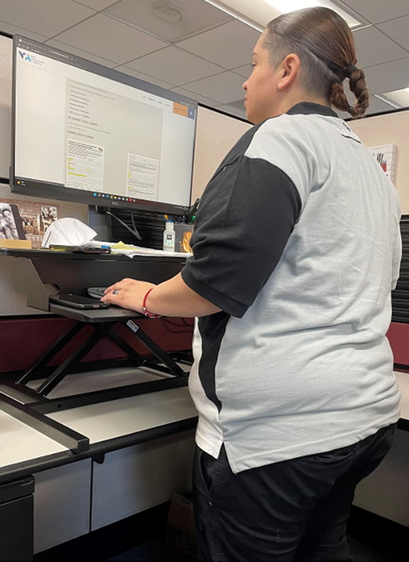

Device Loan:

356 devices were loaned through 272 device loans
With the exception of two consumers being somewhat satisfied, all consumers reported being satisfied or highly satisfied with the service.
Assistive Technology Exchange Center (ATEC) Success Story
Deborah Lim sought us out to assist her client (3 year old) who has physical limitations and wanted information and resources to assist with learning more about what switches may work for her client. ATEC was able to schedule a demonstration with our Rehabilitation Engineer, Kevin Daugherty, who provided a demonstration on May 16th, 2022. Kevin demonstrated the Blue2 Bluetooth switch, iOS switch control and other accessibility features on an iPad. He also demonstrated other switches and showed how the scanning and switch control works with Proloquo2Go and TouchChat on an iPad.
Deborah also followed up to seek out some loan items to try with her client. A couple days later we loaned out a Blue2 Bluetooth switch, a couple Big Red Switches, and a couple switch adapted toys (Flappy the Elephant and a Baby Panda) so she could trial with her client.
Quote from Deborah: “Lauren and Kevin were amazing to work with! Lauren was professional and I am grateful for the time she took to answer my many questions when I first reached out to ATEC. This lending program enabled me to do my job more efficiently and thoroughly. Kevin was a wealth of information during my AT consultation with him; it was so helpful to me as a clinician to talk through the different switch types and features, how to use them, and learn about other online resources. ATEC is truly invaluable!”
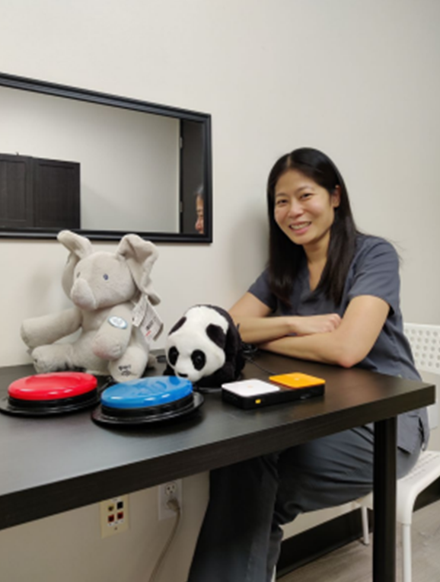

Device Reutilization:
809 reutilization devices were distributed through 512 reutilization activities.
All consumers reported being satisfied or highly satisfied with the service.

Keep the Wheels Rolling Repair Fund
There were three applications in the third quarter with three approved.
Silicon Valley Independent Living Center (SVILC) Wheelchair Reutilization
Barbara Zoto receives her free refurbished wheelchair.
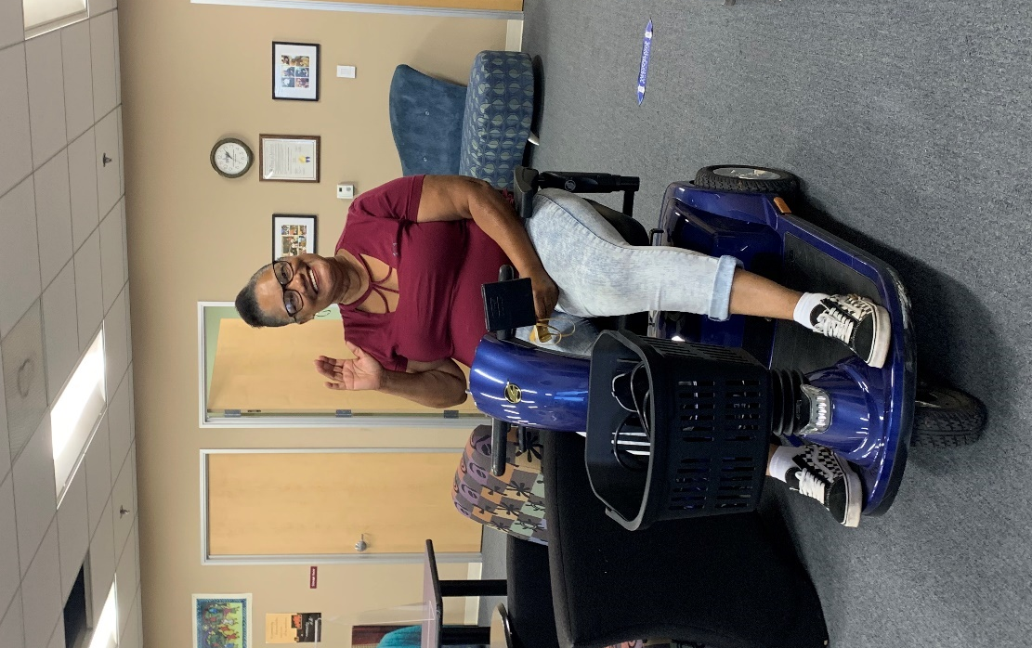

State Financing:
There were no State Financing Activities in this quarter.

Alternative Financing Program – California’s AT Loan Guarantee Program
This program is not currently active

AT Lease to Own Program
This program is not currently active

Alternative Loan Financing
The data for this state level activity is reported from the Freedom Tech alternative loan program that was developed and is managed by the State AT Program Grantee, CFILC. Alternative loans can be granted to an individual up to the amount of $15,000. This loan program is separate from the required State Loan Guarantee Program, which is not currently active. While the FreedomTech Program is continually receiving referrals, the loan application process is taking longer than usual at this time. During this quarter, Ability Tools received nine inquiries; with no loan applications received.

Coordination, Collaboration and Leveraged Funding

Disaster Management

Disability Disaster Access & Resources (DDAR)
The Disability Disaster Access and Resources (DDAR) program continues to develop and build the capacity of Disability Disaster Access and Resource Centers (DDARCs) across the state to best serve Californians with disabilities experiencing disaster events.

Special Projects/Events

#DisabilityClimATe Assistive Technology Earth Day Conference

Preparation for the Ability Tools Conference
- The #DisabilityClimATe Assistive Technology Earth Day Conference was a special one-day virtual web conference on Friday, April 22 (Earth Day) focused on assistive technology, environmental conservatorship, the disability community and actionable resources. There were MCs, Speakers, 5 workshops and regional workshops. There were over 100 attendees.

Home and Community Based (HCBS) Waiver Advocacy
Ability Tools and Department of Healthcare Services (DHS) engagement
- Ability Tools conducted research regarding the implementation of HCBS Waivers in other states. It was learned that other states do have assistive technology access options in their waivers and these waivers are used to obtain assistive technology and smart AT for consumers within their state.
CFILC had a conversation with the Department of Healthcare Services and learned that home modifications are an option in California, but AT is not. CFILC recommended that DHS expand the waiver to include AT and smart AT options in the next fiscal year, with the new federal funds available for home and community based services.
After CFILC presented the Ability Tools findings to DHS, Assistive Technology was added to HCBS waivers.

Section 4 - Glossary

Ability Tools:
Ability Tools, formerly the AT Network, is California’s Assistive Technology Act Program. They provide a variety of services for Californians with disabilities of all ages, including:
- NATADS Assistive Technology Portal
- Device Lending and Demo Centers
- Financial loan program for AT
- Information & Referral
- Reuse program in affiliation with organizational partners
In addition, Ability Tools provides in-person/webinar trainings, technical assistance to organizations on AT issues and coordinates the California Assistive Technology Reuse Coalition.
Ability Tools offers a free membership to anyone interested in learning more about AT and looking to connect with other like-minded individuals via the Ability Tools listserv.
Ability Tools is made possible through funding from the Department of Rehabilitation, financed by the U.S. Department of Education, Rehabilitation Services Administration with funds allocated by the Assistive Technology Act of 2004. (“About Ability Tools”)

Articles:
CFILC will submit a minimum of six articles annually to be featured in newsletters and media from other organizations. (“Grant Narrative/Work Plan”)

The Assistive Technology Advisory Committee (ATAC):
The Assistive Technology Advisory Committee (ATAC) is established pursuant to Section 4(c)(2) of the Assistive Technology Act of 2004 (AT Act). AT Act programs all have a public agency that serves as the Lead Entity. The Department of Rehabilitation (DOR) is the Lead Entity for California and controls and administers the AT Act funds, submits the application, and implements other duties required of AT Act programs.
The AT Act describes the requirement to establish an advisory council "to provide consumer-responsive, consumer-driven advice to the State for, planning of, implementation of, and evaluation of the activities carried out through the grant, including setting the measurable goals described in subsection (d)(3)." (“Assistive Technology Advisory Committee (ATAC)”)

Blogs:
CFILC will publish 24 blogs annually on the “Where it’s AT” Ability Tools Blog. These will include assistive technology content including success stories that will be seen as peer-to-peer resources for individuals with disabilities looking for interventions or solutions to improve their quality of life and maintain their independence. (“Grant Narrative/Work Plan”)

California Association of Area Agencies on Aging (C4A):
The California Association of Area Agencies on Aging (C4A) is a nonprofit organization representing California’s 33 area agencies on aging and is the leading voice on aging issues in California. C4A works closely with the Administration on Aging, the California Department of Aging, Department of Social Services, Department of Rehabilitation as well as key provider associations. C4A and its members administer programs that enable older Californians to live independently for as long as possible. (“What is C4A?”)

California Foundation for Independent Living Centers (CFILC):
California Foundation for Independent Living Centers (CFILC) started as a peer support mechanism for executive directors of the fledgling Independent Living Centers in California (ILC) in 1976. Originally the directors were the usual representatives who went to Sacramento to educate public policy makers on issues affecting persons with disabilities.
In 1982, they incorporated as CFILC and formalized their organization. Each member center pays dues based on the amount of Title VII (federal) and AB 204 (state) funding it receives. Full voting members are the Executive Directors (or representative) of an Independent Living Center that meets the requirements of Title VII of the federal Rehabilitation Act. (“Our History”)
To assist in focusing on each of the important areas of advocacy, CFILC has created programs to drive those needs, including:
- Ability Tools
- Digital Access Project
- Disability Disaster Access and Resources
- Disability Organizing Network
- FreedomTech
- Youth Organizing! Disabled and Proud

Coordination, Collaboration and Leveraged Funding:
State AT Programs leverage significant amounts of additional funding from other public and private sources and deliver a large return on investment for the small amount of federal appropriations received. (“AT Act Information”)
Organizations coordinate and collaborate on projects and initiatives in order to expand the reach of their networks and to better serve intersections between their respective communities.
California’s state AT program, Ability Tools, participates in nationwide events, in order to build the capacities of California’s program. Ability Tools collaborates with other state AT programs, Assistive Technology organizations, AT centers and vendors in order to ensure the most relevant and up to date service implementation is available to the citizens of the state of California.

Device Demonstration:
A demonstration is an interaction with an AT specialist who has technical expertise related to device(s), where the specialist provides an interactive exploration of, typically, more than one device, in real-time, in order to increase the participant’s knowledge and understanding about the details and functions of a device with the intention of enabling the participant to make an informed choice regarding acquiring the appropriate device for their needs; the participant drives the demonstration and has the ability to have their individual questions about the device addressed.
The 12 DLL/ Demo Centers (including CFILC) have a goal to provide 600 “hands on” demos to persons with disabilities and family members annually. (“Grant Narrative/Work Plan”)

Device Loan:
The AT Act requires state AT programs to “provide short-term loans of assistive technology devices to individuals, employers, public agencies, or others seeking to meet the needs of targeted individuals and entities, including others seeking to comply with the Individuals with Disabilities Education Act (20 U.S.C. 1400 et seq.), the Americans with Disabilities Act of 1990 (42 U.S.C. 12101 et seq.), and section 504 of the Rehabilitation Act of 1973 (29 U.S.C. 794)”. The purpose of a short-term device loan may be (1) to assist in decision-making; (2) to serve as a loaner while the consumer is waiting for device repair or funding; (3) to provide an accommodation on a short-term basis; or (4) for professional development. In the Annual Program Report (APR) Instruction Manual (word) a loan (counted as one) is defined as an occasion on which a device or devices were borrowed by an individual/entity who will use the device for one of the listed purposes (“Device Lending”).
CFILC’s goal is to process 50-75 onsite loans to individuals annually. With the 11 other DLL/Demo Centers, CFILC expects to process a minimum of 1,680 AT device loans to people with disabilities, family, and providers annually. (“Grant Narrative/Work Plan”)

Device Reutilization:
Although the AT Act does not include a formal definition of device reutilization programs, the Act describes reutilization programs as programs that provide for the exchange, repair, recycling or other reutilization of assistive technology devices, which may include redistribution through device sales, loans, rentals or donations, carried out either directly or in collaboration with public or private entities (Section 4(e)(2)(B)) (“Device Reutilization”).
CFILC will continue to operate and expand Reuse Programs through partnerships with contracted Reuse Centers and the larger Reuse community throughout California. Reuse Centers are places that accept donations of gently used medical equipment or other AT devices. Centers are responsible for storing, cleaning and/or repairing devices before giving them away or selling them at low or no cost to people with disabilities.
CFILC will increase the number of Reuse items available on NATADS annually by providing training and technical assistance on NATADS where Reuse partners can list AT devices available for no or low-cost. CFILC will provide an updated annual training workshop on how to use NATADS for reuse activities and to expand services. The Reuse Training Workshop will be archived in accessible format and made available through the Ability Tools and CATRC websites and uploaded to the Ability Tools YouTube. CFILC staff will continue to facilitate and participate in CATRC regular meetings and Disaster Strategies Coalition meetings. Staff will provide updates to both coalitions and facilitate partnership opportunities between reuse and disaster preparedness partners. CFILC will organize an annual Reuse Event in collaboration with the CATRC, Disaster Strategies Coalition and the AT and IL Network to limit reusable durable medical equipment and AT devices from being disposed of in landfills. CFILC will provide Reuse Best Practice Training Workshops and technical assistance to the CATRC, Reuse Centers and AT Network. (“Grant Narrative/Work Plan”)

Annual Earth Day Reuse Event
CFILC will organize an annual Reuse Event in collaboration with the CATRC, Disaster Strategies Coalition, the AT community and IL Network to limit reusable durable medical equipment and AT devices from being disposed of in landfills in coordination with Earth Day. (“Grant Narrative/Work Plan”)

Keep the Wheels Rolling Repair Fund:
In 2012 CFILC established the Keep the Wheels Rolling Fund, and will continue to seek supplemental funding for the program that allows reuse organizations to apply for small grants to keep mobility devices usable. For example, replacement batteries on a motorized scooter that keeps the device reusable. (“Grant Narrative/Work Plan”)
The Keep the Wheels Rolling Repair Fund (KWRF) will provide small grants of up to $450 for the purchase of parts and/or repairs needed to refurbish a wheelchair or scooter so it may be reassigned to a low-income Californian with a disability for free. Only nonprofit organizations may apply.
Important Note: The KWRF may not be used to pay for repairs to a device already owned by an individual with a disability. The fund is intended to support the reassignment of used devices to new individuals who need them. (“Keep the Wheels Rolling Repair Fund”)

Digital Access Project (DAP):
The Digital Access Project (DAP), a statewide program of CFILC, was created in 2013 and is in-part funded by the California Emerging Technology Fund. The Digital Access Project assists low-income individuals in enrolling in affordable broadband service, provides digital literacy referrals and extends the opportunity to own new and refurbished equipment.
The Digital Access Project aims to help those who do not have the digital literacy skills they need to succeed by organizing digital literacy classes.
Those who are interested in an affordable internet service are encouraged to contact the Digital Access Project. DAP staff will assist in supporting individuals through the enrollment process by calling the toll-free line: (800) 390-2699 or (800) 900-0706 TTY or visiting the Digital Access Project website.

Disaster Management:
CFILC organizes and facilitates The California Disaster Strategies Coalition which consists of a broad group of community service providers, stakeholders and advocates working on inclusive emergency readiness, response, recovery, and mitigation. The Disaster Strategies Coalition is dedicated to keeping the disaster and emergency dialogue for disabled individuals moving forward. The coalition works to ensure that disabled people are integrated and prepared for disasters and/or emergencies through public policy advocacy and program procedures. This work is implemented through programs like: (“About Us”)

Disability Disaster Access & Resources (DDAR):
Disability Disaster Access & Resources is a pilot program of CFILC that assists individuals with disabilities and older adults in disaster readiness and recovery.
This program provides individuals with information & assistance, disaster readiness training, backup electricity support, personal preparedness planning assistance, public awareness, and Assistive Technology and Durable Medical Equipment reuse and loan closet referrals; before, during and after a disaster or electricity shut-off. (“Programs and Coalitions of CFILC”)

The Richard Devylder Disaster Relief Fund
The Richard Devylder Disaster Relief Fund assists individuals with disabilities replace lost critical assistive technology, tools and devices, and is also covering some motel/hotel stays. (“Wildfires”)

DOR:
The California Department of Rehabilitation (DOR) works in partnership with consumers and other stakeholders to provide services and advocacy resulting in employment, independent living, and equality for individuals with disabilities.
DOR administers the largest vocational rehabilitation and independent living programs in the country. Vocational rehabilitation services are designed to help job seekers with disabilities obtain competitive employment in integrated work settings. Independent living services may include peer support, skill development, systems advocacy, referrals, assistive technology services, transition services, housing assistance, and personal assistance services. (“Department Overview”)

Information & Referral:
Typically referred to as Information & Assistance activities… “The AT Act does not include a formal definition of a statewide information and referral system, but describes the requirement of the State to provide for the ‘continuation and enhancement of a statewide information and referral system designed to meet the needs of targeted individuals and entities’. It further describes the content of the system as one that shall ‘…deliver information on assistive technology devices, assistive technology services (with specific data regarding provider availability within the State), and the availability of resources, including funding through public and private sources, to obtain assistive technology devices and assistive technology services. The system shall also deliver information on the benefits of assistive technology devices and assistive technology services with respect to enhancing the capacity of individuals with disabilities of all ages to perform activities of daily living.’ ” and also include assistance to an individual in troubleshooting problems with an AT device (“Public Awareness and Information and Assistance”).
To assure good customer service, CFILC is committed to following the I&A standards and best practices established by the Alliance of Information and Referral Services. The I&A line will be answered by two bilingual staff Monday - Friday during CFILC’s hours of operation. CFILC will track and record I&A contacts in NATADS. This information will be analyzed and used to target underrepresented geographic counties and regions on an annual basis. CFILC will connect consumers with other programs and resources using a warm hand-off technique by initiating a three-way call to a referring agency that can provide the consumer with additional support. (“Grant Narrative/Work Plan”)

Refueling Act
In 1997, Californians for Disability Rights (CDR) sponsored Assembly Bill 1277 (Thomson) in order to update and clarify state law regarding refueling assistance for persons with disabilities at gasoline service stations. AB 1277 was passed by the Legislature, signed by Governor Wilson and enacted as Chapter 836, Statutes of 1997, effective January 1, 1998.
CFILC will operate one toll-free voice line and one toll-free TTY line. I&A Staff will answer all refueling calls from gas station patrons and employees who wish to know more about California’s refueling law for people with disabilities. (“Law: Refueling Act”)

Newsletters:
CFILC will publish 6 written newsletters annually. These articles will include assistive technology content including success stories that will be seen as peer-to-peer resources for individuals with disabilities looking for interventions or solutions to improve their quality of life and maintain their independence. (“Grant Narrative/Work Plan”)

Public Awareness:
Although the AT Act does not provide a formal definition of public awareness, the Act described public awareness activities as activities “to provide information to targeted individuals and entities relating to the availability, benefits, appropriateness and costs of assistive technology devices and services”. This includes the development and distribution of informational materials regarding the state AT program’s efforts related to assistive technology, and communication between providers of assistive technology and targeted individuals and entities, including partnerships with employers, vocational rehabilitation, and public schools (“Public Awareness and Information and Assistance”).
CFILC plans to work with community-based groups, organizations, and state agencies to conduct targeted outreach statewide. CFILC has updated and will continue to distribute the Ability Tools rack card describing our role in the CA AT Program in English, Spanish, Braille, Mandarin/Cantonese and accessible electronic formats. IL Network partners and CFILC staff will track and report on the number of materials distributed quarterly (September 30th, December 30th, March 30th, and June 30th) and annually (December 15th). (“Grant Narrative/Work Plan”)

Social Media:
CFILC will post weekly and increase readership by 10% annually on the Ability Tools Facebook page, Twitter feed, Instagram and Pinterest. Staying on top of social media trends, we’ll host Facebook live sessions with ASL Interpreters to build public awareness of Ability Tools and be inclusive of the Deaf and HoH communities. (“Grant Narrative/Work Plan”)

Special Projects/Events:
Special Projects, for the purposes of this document, encompass projects/events that may or may not intersect with grant deliverables, but have such a powerful scope or focus that they impact the successful implementation of grant deliverables directly, or have the indirect effect of increasing the capacity of state AT program staff and/or partners to serve the assistive technology needs of the citizens of the state of California.

State Financing:
The AT Act describes state financing activities as activities that increase “access to, and funding for, assistive technology devices and assistive technology services (which shall not include direct payment for such a device or service for an individual with a disability but may include support and administration of a program to provide such payment), including development of systems to provide and pay for such devices and services, for targeted individuals and entities (“State Financing”).
CFILC will distribute applications for the State Loan Guarantee Program when established as well as the CFILC Freedom Tech Alternative Loan Program that began in 2016. I&A specialists will assist callers with applications and additional referrals as needed. CFILC will track quarterly activities on loans processed and approved, and activities on financial literacy. CFILC will work in partnership with the Department of Rehabilitation (DOR) to establish an AT Lease to Own program, if funds become available through the Revolving Loan Guarantee Fund. (“Grant Narrative/Work Plan”)

Alternative Financing Program
California's AT Loan Guarantee Program (LGP) is designed to provide low cost loans to Californians with disabilities, regardless of age, for the purchase of modified vehicles, durable medical equipment, adaptive aids and other assistive technology devices to live more independently or to engage in employment. Loans are guaranteed by a state supported fund through the Department of Rehabilitation.
CFILC is committed and continues to work with the department to seek opportunities to administer the LGP. CFILC has cultivated relationships with lending institutions through the Freedom Tech Financial Loan program and introduced lending stakeholders to the DOR.
CFILC will continue to work in collaboration with the DOR to implement the LGP through the development and expansion of alternative financing programs, FreedomTech and AT Lease to Own Program. (“Grant Narrative/Work Plan”)

FreedomTech Financial Loan Program
The data for this state level activity is reported from the Freedom Tech alternative loan program that was developed and is managed by the State AT Program Grantee, CFILC. Alternative loans can be granted to an individual ranging from $500 to $15,000. This loan program is separate from the required State Loan Guarantee Program, which has not been implemented by DOR.
The FreedomTech Financial Loan Program can lend money to purchase a variety of assistive technology.
Those who are interested in an assistive technology loans are encouraged to contact the FreedomTech Loan Program. FreedomTech staff will assist in supporting individuals through the application process by calling: (916) 737-5358 or (916) 325-1695 TTY, emailing: info@FreedomTech.org or visiting the FreedomTech Loan website.

AT Lease to Own Program
CFILC will work in partnership with the Department of Rehabilitation (DOR) to establish an AT Lease to Own program, if funds become available through the Revolving Loan Guarantee Fund. The AT Lease to Own Program would allow CFILC to offer consumers additional opportunities that are not currently available. AT Lease to Own Program would provide AT to consumers on a leased arrangement which provides savings over a direct purchase and would allow individuals to build their financial credit without added interest fees, underwriting or specific loan qualifications. The Grantee will propose, develop, and establish an AT Lease to Own program to help alleviate some of the challenges that communities with disabilities face when obtaining AT. The Grantee will collaborate with ILCs, Device Lending Libraries, and other qualified non-profits to provide the Lease to Own Program services. The AT Lease to Own Program funding amounts for the lease to own option would be from $250 to $2,499. These funding amounts are in alignment with the California Financial Code Section 22066 for non-profit entities.
The Grantee would purchase the AT and manage the lease to own contracts with consumers. The recovery of funds will be reallocated to the AT Lease to Own Program Fund. The Grantee would also support outreach efforts for the program and respond to external inquiries for services from consumers with information and referral and monitor lease to own activity to ensure compliance with grant provisions and state and federal laws. The Grantee will also work in collaboration with DOR to develop and expand the AT Lease to Own Program as part of the alternative financing program activities for the California AT Program. (“Grant Narrative/Work Plan”)

State Leadership Activities:
The Assistive Technology Act of 2004 specifies the statewide activities required of programs receiving funds under Section 4 of the AT. State leadership activities authorized by the AT Act include providing training, technical assistance, information and referral, and public awareness throughout the state. A portion of training and technical assistance efforts are focused on transition (from school to work; from school to other aspects of adult life; or from congregate to community-based settings). Additionally, activities to improve accessibility of information and communication technology (ICT) are conducted (“State Leadership”).

State Level Activities:
The Assistive Technology Act of 2004 specifies the statewide activities required of programs receiving funds under Section 4 of the AT Act. These include four “state level” activities that are designed to help people with disabilities, their families, service providers and others Access and Acquire assistive technology devices (“State Level”).

Technical Assistance:
Technical assistance (TA) is the process of providing targeted support to an organization with a development need or problem (Compassion Capital Fund [CCF] National Resource Center, 2010). The Assistive Technology Act does not include a formal definition of technical assistance (TA), one of the required state leadership activities. However, the AT Act does refer to potential recipients of such assistance to include “representatives of State and local educational agencies, other State and local agencies, early intervention programs, adult service programs, hospitals and other health care facilities, institutions of higher education, and businesses.” Generally, the purpose of technical assistance is to improve the capacity of the beneficiary organization, as evidenced by increased efficiency, increased effectiveness, and/or increased funding (CCF, 2010) (“Technical Assistance”).​

Training:
Training activities are instructional events, usually planned in advance for a specific purpose or audiences, which are designed to increase participants’ knowledge, skills, and competencies regarding AT. Such events can be delivered to large or small groups, in-person, or via telecommunications or other distance education mechanisms. In general, participants in training can be individually identified and could complete an evaluation of the training. Examples of training include classes, workshops, conference sessions, and presentations that have a goal of increasing skills, knowledge, and competency. Training and/or presentations intended only to increase general awareness of AT are considered public awareness events (“Training”). ​

Regional Trainings
Ability Tools must conduct at least eight regional presentations annually across California. These regional training workshops are offered to AT Center staff and are designed to enrich center staff’s professional development efforts, expand their understanding (execution, reporting, ect.) of the activities under the AT Act, and inform them of developments in AT products and services.

AT 1.0 Trainings
Ability Tools must deliver at least four AT 1.0 training workshops annually - AT 1.0 training workshops will include topics such as what is assistive technology, where to go for assistive technology, how to use it, etc. (“Grant Narrative/Work Plan”)

AT 2.0 Trainings
Ability Tools must deliver at least six AT 2.0 training workshops annually - AT 2.0 training workshops will include topics such as what is Latest and Greatest devices in AT, emerging technologies, methods for reaching disenfranchised populations, ect. (“Grant Narrative/Work Plan”)

Video Newsletters:
CFILC will work with a professional videographer to create up to four two-minute video newsletters with open captions annually. They will include individuals with disabilities who use AT to maintain their independence at home, in school, at work and in the community. (“Grant Narrative/Work Plan”)

Section 5 - Bibliography
“About Ability Tools.” Ability Tools, California Foundation for Independent Living Centers, https://abilitytools.org/about/about-at.php. Accessed 5 May. 2021.
“About Us.” Disability Disaster Access & Resources, California Foundation for Independent Living Centers, https://disabilitydisasteraccess.org/about-us/. Accessed 5 May. 2021.
“Assistive Technology Advisory Committee (ATAC).” Department of Rehabilitation, United States Federal Government, https://dor.ca.gov/Home/ATAC. Accessed 5 May. 2021.
“AT Act Information.” AT3 Center, National Assistive Technology Act Technical Assistance and Training (AT3) Center, https://www.at3center.net/repository/atactinformation. Accessed 23 Jul. 2021.
“Department Overview.” Department of Rehabilitation, United States Federal Government, https://dor.ca.gov/Home/DepartmentOverview. Accessed 5 May. 2021.
“Device Lending.”AT3 Center, National Assistive Technology Act Technical Assistance and Training (AT3) Center, https://www.at3center.net/repository/deviceloan. Accessed 29 Apr. 2021.
“Device Reutilization.”AT3 Center, National Assistive Technology Act Technical Assistance and Training (AT3) Center, https://www.at3center.net/repository/devicereuse. Accessed 29 Apr. 2021.
“Grant Narrative/Work Plan California Assistive Technology Program Federal Assistive Technology Program State and Social Security Reimbursement (SSR).” Assistive Technology Act Grant Deliverables Proposed Workplan. Oct. 2018. Typescript.
“Keep the Wheels Rolling Repair Fund.” Ability Tools, California Foundation for Independent Living Centers, https://abilitytools.org/services/repair-fund.php. Accessed 5 May. 2021.
“Law: Refueling Act.” Ability Tools, California Foundation for Independent Living Centers, https://abilitytools.org/resources/refueling-act.php. Accessed 5 May. 2021.
“Our History.” CFILC, California Foundation for Independent Living Centers, https://cfilc.org/about/our-history.php. Accessed 5 May. 2021.
“Programs and Coalitions of CFILC.” CFILC, California Foundation for Independent Living Centers, https://cfilc.org/about/programs-coalitions.php. Accessed 5 May. 2021.
“Public Awareness and Information and Assistance.”AT3 Center, National Assistive Technology Act Technical Assistance and Training (AT3) Center, https://www.at3center.net/repository/publicawareness. Accessed 29 Apr. 2021.
“State Financing.”AT3 Center, National Assistive Technology Act Technical Assistance and Training (AT3) Center, https://www.at3center.net/repository/statefinancing. Accessed 29 Apr. 2021.
“State Leadership.”AT3 Center, National Assistive Technology Act Technical Assistance and Training (AT3) Center, https://www.at3center.net/repository/stateleadership. Accessed 29 Apr. 2021.
“State Level.”AT3 Center, National Assistive Technology Act Technical Assistance and Training (AT3) Center, https://www.at3center.net/repository/StateLevelActivities. Accessed 29 Apr. 2021.
“Technical Assistance.”AT3 Center, National Assistive Technology Act Technical Assistance and Training (AT3) Center, https://www.at3center.net/repository/TA. Accessed 29 Apr. 2021.
“Training.”AT3 Center, National Assistive Technology Act Technical Assistance and Training (AT3) Center, https://www.at3center.net/repository/training. Accessed 29 Apr. 2021.
“What is C4A?.” C4A, California Association of Area Agencies on Aging, https://c4a.info/about-us/what-is-c4a/#. Accessed 5 May. 2021.
“Wildfires.” Disability Disaster Access & Resources, California Foundation for Independent Living Centers, https://disabilitydisasteraccess.org/wildfires/. Accessed 5 May. 2021.

